|  |  |
| --- | --- |
|  | **MINISTRY OF**  **EDUCATION AND TRAINING** |

|  |
| --- |
| **FPT UNIVERSITY** |
| Capstone Project Document |
| 4HealthyNutrium Website System |

|  |  |
| --- | --- |
| **SWP493-G5** | |
| **Group Members** | Nguyễn Hoàng Việt – HE140725  Lê Mạnh Cường – HE130386  Nguyễn Đức Sơn – HE140443  Nguyễn Viết Long – HE140051 |
| **Supervisors** | Bùi Ngọc Anh |
| **Capstone Project Code** | 4HTN |

– Hanoi, December 2022 –

# Table of Contents

Table of Contents ii

Acknowledgement 1

Acronyms & Definitions 2

I. Project Introduction (プロジェクトの紹介） 4

1. Overview（概要） 4

1.2.1. Supervisor (スーパーバイザー) 4

1.2.2. Team Members (チームメンバー) 4

2. Product Background（プロダクトのバックグラウンド） 5

3. Existing Systems （既存のシステム） 14

3.1. Eat this much 14

3.2. Fatsecret 15

3.3. Myfitnesspal 16

4. Business Opportunity（ビジネスチャンス） 17

5. Software Product Vision (ソフトウェアプロダクトのビジョン) 19

6. Project Scope & Limitation（プロジェクト範囲と制限事項） 19

6.1 Major Features（主な特長） 19

6.2 Limitations & Exclusions（制限事項と除外） 21

II. Project Management Plan (プロジェクト管理計画 ） 23

1. Overview（概要） 23

1.1. WBS & Estimation 作業分解図と見積もり 23

1.2. Project Objectives プロジェクトの目的 26

1.2.1. Project Objectives プロジェクトの目的 26

1.2.2. Team Objectives チームの目的 26

1.3. Project Risks プロジェクトのリスク 26

2. Management Approach（マネジメントアプローチ） 28

2.1 Project Process（プロジェクトのプロセス） 28

2.2. Meeting Minutes 議事録 28

2.3 Training Plan （訓練計画） 29

3. Master Plan マスタープラン 30

4. Project Organization（プロジェクト組織） 32

4.1. Team & Structure（チームと構造） 32

4.2. Roles & Responsibilities（役割と責任） 32

5. Project Communications（プロジェクトコミュニケーション） 34

5.1. Communication Plan（コミュニケーション計画） 34

5.2. External Interface（外部インターフェース） 34

6. Configuration Management（構成管理） 35

6.1. Tools & Infrastructures（ツールとインフラ） 35

6.2. Document Management（ドキュメント管理） 35

7. Responsibility Assignments（責任の割り当て） 37

III. Software Requirement Specification（システム要求仕様） 38

1. Product Overview（製品の概要） 38

2. User Requirements（ユーザー要件） 38

2.1 Actors（アクター） 38

2.2 Use Cases ユースケース 40

2.2.1. Overview （概要） 40

2.2.2. Feature “Login and Register” 41

2.2.2.1. Login ログイン 41

2.2.2.2. Register 登録 42

2.2.2.3. Forgot password パスワードをお忘れた 43

2.2.3. Feature “Manage personal profile” プロフィール管理機能 46

2.2.3.1. View personal profile プロフィール表示 46

2.2.3.2. Edit personal profile 個人プロフィールを編集する 47

2.2.3.3. Change password パスワード変更 48

2.2.4. Feature “Manage system accounts” システム アカウントの管理 49

2.2.4.1. View system account list システム アカウント リストの表示 49

2.2.4.2. View account detail アカウントの詳細を表示 51

2.2.4.3. Search system account 検索システム アカウント 51

2.2.4.4. Create Nutritional Expert Account 栄養専門家アカウントを作成 52

2.2.5. Feature “Search fiFood” 食べ物を探す 54

2.2.5.1. Search Food 食べ物を探す 54

2.2.5.2. Search Ingredient 材料を探す 56

2.2.6. Feature “Manage Personal Nutrition” 個人の栄養を管理 57

2.2.6.1. View nutrition regime 個人の栄養管理をビュー 57

2.2.6.2. Receive nutrition regime 栄養管理を受ける 58

2.2.6.3. Change nutrition regime 栄養体制を変える 59

2.2.7. Feature “Manage Food” 食べ物を管理する 60

2.2.7.1. Add Food 食べ物を追加 62

2.2.7.2. Add Ingredient 材料を加える 63

2.2.7.3. Update Food Information 食品情報を更新する 64

2.2.7.4. Update Ingredient Information 材料情報を更新する 65

3. Functional Requirements（機能要件） 67

3.1 System Functional Overview（システム機能の概要） 67

3.1.1 Screen Flow スクリーンフロー 67

3.1.1.1. User ユーザー 67

3.1.1.2. Admin 管理者 68

3.1.1.3. Nutrition Expert 栄養士 70

3.1.2.1. User ユーザー 71

3.1.2.2. Nutrition Expert 栄養士 72

3.1.2.3. Admin 管理者 72

3.1.3. Screen Authorization 画面認可 72

3.1.4. Entity Relationship Diagram 実体関連図 74

3.2. Feature “Login and register” 特徴「ログインして登録」 76

3.2.1. Login ログイン 76

3.2.2. Register 登録 77

3.2.3. Forgot password パスワードをお忘れた 78

3.2.4. Email Validation 電子メールの検証 78

3.3. Feature “Manage personal profile” 特徴「個人プロフィールの管理」 79

3.3.1. View Personal profile 個人プロフィールを見る 80

3.2.2. Edit personal profile 個人プロフィールを編集 80

3.2.3. Change password パスワードを変更する 81

3.2.4. Personal Schedule 個人スケジュール 82

3.4. Feature “Manage system accounts” 特徴「システム アカウントの管理」 84

3.4.1. System account management システム アカウント管理 84

3.4.2. View Account details アカウントの詳細を表示 85

3.5. Feature “Search foods” 86

3.5.1. Search Food 食べ物を探す 87

3.5.2. Search Ingredient 検索材料 89

3.6. Feature “Manage food” 特集「食事管理」 90

3.6.1. Add and Delete foods 食品の追加と削除 90

3.6.2. Edit Food 食べ物を編集する 92

3.6.3. Add and delete ingredient 材料の追加と削除 93

3.6.2. Edit Ingredient 材料を編集する 94

3.7. Feature “Receive nutritional regime” 特集「栄養療法を受ける」 95

3.7.1. View personal diet 個人的な食事を見る 95

3.7.2. Input lacked information 不足している情報を入力 96

3.7.3. Summary personal information 要約個人情報 97

3.7.4. Diet Detail ダイエットの詳細 99

4. Non-Functional Requirements（非機能要件） 102

4.1 External Interfaces（外部インターフェース） 102

4.2 Security セキュリティ 102

4.3 Performance パフォーマンス 102

4.4 Maintaining & Scalability 保守性と拡張性 102

4.5 Compatibility 互換性 102

5. Requirement Appendix（要件の付録） 102

5.1 Business Rules（ビジネスルール） 102

5.2 Application Messages List（アプリケーションメッセージリスト） 104

IV. Software Design Document（ソフトウェア設計書） 105

1. System Design（システム設計） 105

1.1 System Architecture（システムアーキテクチャー） 105

1.1.1 System Overview （システム概要） 105

1.1.2 Overall Architecture（全体的なアーキテクチャー） 105

1.1.2.1 Front-end Architecture Designフロントエンドのアーキテクチャ設計 106

1.1.2.2 Back-end Architecture Design　バックエンドのアーキテクチャ設計 107

1.2 System Components (システムコンポーネント) 109

1.2.1. Back-end Components (バックエンド コンポーネント) 109

1.2.1.1. Spring Boot1 109

1.2.1.2. Json Web Tokens2 109

1.2.1.3. JUnit 109

1.2.1.4. Postman 110

1.2.2. Front-end Components (フロントエンド コンポーネント) 110

1.2.2.1. ReactJS 110

1.2.2.2. Ant Design 111

1.2.2.3. BootStrap 111

1.2.3. Database 112

1.2.4. Deployment & Hosting 112

1.2.4.1. GitLab 112

1.2.4.2. Github 3 112

1.3 Package Diagram（パッケージ図） 114

1.3.1. Frontend フロントエンド 114

1.3.2. Backend バックエンド 115

2. Database Design（データベース設計） 117

2.1. Table “user” 表「ユーザー」 118

2.2. Table “dietaryinfo” 表「食事情報」 118

2.3. Table “Job” 表「ジョブ」 119

2.4. Table “Food” 表「食」 119

2.5. Table “Category” 表「カテゴリ」 119

2.6. Table “Season” 表「季節」 119

2.7. Table “CoefficentMotion” 表「運動係数」 120

2.8. Table “Recommendation” 表「おすすめ」 120

2.9. Table “Ingredient” 表「材料」 121

2.10. Table “Season_Ingredient” 表「季節_材料」 122

2.11. Table “FoodDetail” 表「料理内容」 122

2.12. Table “Meal” 表「食事」 123

2.13. Table “Food_meal” 表「食_食事」 123

2.14. Table “Taboo_Food” 表「タブーフード」 123

2.15. Table “Role” 表「役割」 123

2.16. Table “Season_Food” 表「季節_食べ物」 123

3. Detailed Design（詳細設計） 124

3.1. Feature “Login and Register” 特徴「ログインして登録」 124

3.1.1. Class Diagram クラスダイアグラム 124

3.1.2. Sequence Diagram(s) 125

3.1.2.2. Register 登録 125

3.1.2.3. Forgot password パスワードをお忘れた 126

3.2. Feature “Manage personal profile” 特徴「個人プロフィールの管理」 126

3.2.1. Class Diagram クラスダイアグラム 126

3.2.2. Sequence Diagram(s) シーケンスダイアグラム 127

3.2.2.1. View personal profile 個人プロフィールを見る 127

3.2.2.2. Edit personal profile 個人プロフィールの編集 127

3.2.2.3. Change password パスワードを変更する 128

3.2.2.4. Validate email メールを検証 128

3.3. Feature “Manage system accounts” 特徴「システム アカウントの管理」 129

3.3.1. Class Diagram クラスダイアグラム 129

3.3.2. Sequence Diagram(s) シーケンスダイアグラム 132

3.3.2.1. View system account list システム アカウント リストの表示 132

3.3.2.2. Deactivate account アカウントを無効化し 132

3.3.2.3. Reactivate account アカウントを再開する 133

3.4. Feature “Manage Food” 特集「食事管理」 134

3.4.1. Class Diagram クラスダイアグラム 134

3.4.2. Sequence Diagram(s) シーケンスダイアグラム 136

3.4.2.1. Add Food 食べ物を追加 136

3.4.2.2. Edit Ingredient 特徴を編集 137

3.4.2.3. Edit Food 食べ物を編集する 138

3.4.2.4. Add Ingredient 材料を加える 139

3.5. Feature “Search Food and Ingredient” 140

3.5.1. Sequence Diagram(s) シーケンスダイアグラム 140

3.5.1.1. Search Food by Name 名前で食を検索 140

3.5.1.2. Search Ingredient by Name 材料名から探す 140

3.5.1.3. Filter Food 食品をろ過する 141

3.5.1.4. Filter Ingredient フィルタ材料 141

3.5.1.5. View Food Detail 142

3.6. Feature “Manage Diet” 特集「食事管理」 142

3.6.1. Class Diagram クラスダイアグラム 142

3.6.2. Sequence Diagram(s) シーケンスダイアグラム 143

3.6.2.1. Receive Nutrition Regime 栄養管理を受ける 143

3.6.2.2. View Nutrition Regime Schedule 栄養管理スケジュール 143

V. Software Testing Documentation ソフトウェア テスト ドキュメント 144

1. Scope of Testing（テストの範囲） 144

2. Test Strategy（テスト戦略） 144

2.1 Testing Model（テストのモデル） 144

2.2 Testing Types（テストの種類） 145

2.3 Test Levels（テストレベル） 147

2.4 Supporting Tools（サポートツール） 147

3. Test Plan（テスト計画） 148

3.1. Human Resources 人事 148

3.2 Test Milestones（テストのマイルストーン） 148

4. Test Cases テストケース 148

4.1. Unit Test 単体テスト 148

4.2. Integration Test 結合テスト 151

4.3. System Test システムテスト 151

4.4. Acceptance Test 受け入れテスト 152

5. Test Reports テスト報告 153

5.1. Unit Test 単体テスト 153

5.2. Integration Test 結合テスト 154

5.3. System Test システムテスト 154

VI. Release Package & User Guides 155

1. Deliverable Package 成果物パッケージ 155

2. Installation Guides インストールガイド 155

2.1 System Requirements システム要件 155

2.2 Installation Instruction インストール手順 156

2.3 Setup 4HTN Project のセットアップ 194

3. User Manual ユーザーマニュアル 199

3.1 Overview 概要 199

3.2. Common 普通 200

3.3 Food and Ingredient Management 食品と成分管理 209

3.4 Account Management 倉庫管理 216

3.5 Nutrition Regime Management 栄養管理管理 218

3.6 View Food and Ingredient Information (User) 食品食材情報を見る 233

# Acknowledgement

4HTN Project is reaching its final stage. Looking back to the very beginning, it has been a long journey for each member of the project and the team as a whole. We started at the zero point when we decided to do 4HTN. Fortunately, we have received tremendous support from many people during our journey. Therefore, we would like to let them know that we are very grateful.

First of all, we wish to offer our deepest gratitude to our team’s supervisor. Mr. Bui Ngoc Anh, without him, we probably would not be able to be where we are today. Besides technological advices, he is also an excellent motivation for us not to give up and always yearn to achieve more for the project. Secondly, we would like to thank all of our teachers at FPT University. They have shown us great support this semester when we do our Capstone Project. Also, thanks to their lessons, we, the clueless students, can become the ones we want to be and do what we want to do. Moreover, we also want to show our gratitude to our friends and families, who always give us a helping hand during this challenging period.

Last but not least, we want to say thanks to the great source of knowledge, the internet, to the people we do not know but still share with us precious knowledge, which helps us a lot in this project. We are very thankful for that.

*4HTN Project, SWP493_G5*

*Hanoi, December 19th, 2022*

# Acronyms & Definitions

|  |  |  |
| --- | --- | --- |
| **#** | **Acronym** | **Definition** |
| 1 | WBS | Work Breakdown Structure |
| 2 | NADAFI | Nutrition and dietary advice for individuals |
| 3 | FE | Feature |
| 4 | LI | Limitation |
| 5 | EX | Exclusion |
| 6 | VPS | Virtual Private Server |
| 7 | API | Application Programming Interface |
| 8 | DBMS | Database Management System |
| 9 | UML | Unified Modeling Language |
| 10 | SDD | Software Design Document |
| 11 | IT | Integration test |
| 12 | ST | System test |
| 13 | SS | Start to start |
| 14 | UT | Unit test |
| 15 | UC - number | User case |
| 16 | N/A | not applicable or non-applicable |
| 17 | MSG + number | Message |
| 18 | BR - number | Business Roles |
| 19 | TRIG - number | Trigger |
| 20 | PRE - number | Preconditions |
| 21 | POST - number | Post-conditions |
| 22 | E + number | Exceptions |
| 23 | PK | Primary Key |
| 24 | FK | Foreign Key |
| 25 | CI | Continuous Integration |
| 26 | CD | Continuous Delivery |
| 27 | HTTP | Hypertext transfer protocol secure |
| 28 | API | Application Programming Interface |
| 29 | DTO | Data transfer object |
| 30 | 4HTN | 4HealthyNutrium |
| 31 | GUI | Graphical User Interface |
| 32 | API | Application Programming Interface |
| 33 | UX | User Experience |
| 34 | UI | User Interface |
| 35 | N | * Normal case |
| 36 | A | * Abnormal case |
| 37 | B | * Boundary case |
| 38 | PAL | Physical activity coefficient |
| 39 | WHO | World Health Organization |
| 40 | CHCB | Basic metabolism |
| 41 | HĐTL | Physical Activity |
| 42 | W | Weight |
| 43 | H | Height |
| 44 | A | Age |

Acronyms and Definitions Table

# I. Project Introduction (プロジェクトの紹介）

## 1. Overview（概要）

**1.1. Project Introduction （プロジェクトの情報 ）**

* Project name: 4HealthyNutrium Website System
* Project code: 4HTN
* Group name: SWP493 – G5
* Software type: Web.

**1.2. Project Team （プロジェクトのチーム）**

#### 1.2.1. Supervisor (スーパーバイザー)

|  |  |  |  |
| --- | --- | --- | --- |
| **Full Name** | **Email** | **Phone Number** | **Title** |
| Bùi Ngọc Anh | [anhbn5@fe.edu.vn](mailto:anhbn5@fe.edu.vn) | 091 534 3020 | Supervisor |

Table 1.2.1. Supervisor’s Information

#### 1.2.2. Team Members (チームメンバー)

|  |  |  |  |
| --- | --- | --- | --- |
| **Full Name** | **Email** | **Mobile** | **Role** |
| Nguyễn Hoàng Việt | vietnhhe140789[@fpt.edu.vn](mailto:duchmhe140725@fpt.edu.vn) | 098 529 5760 | Leader |
| Nguyễn Viết Long | longnvhe140051[@fpt.edu.vn](mailto:anhlthe140428@fpt.edu.vn) | 096 337 2727 | Member |
| Nguyễn Đức Sơn | sonndhe140443[@fpt.edu.vn](mailto:datndhe140411@fpt.edu.vn) | 096 905 1715 | Member |
| Lê Mạnh Cường | cuonglmhe130386[@fpt.edu.vn](mailto:anhtdhe140447@fpt.edu.vn) | 096 374 3383 | Member |

Table 1.2.2. Team member’s information

## 2. Product Background（プロダクトのバックグラウンド）

In recent years, along with strong socio-economic development, people's health care needs are increasing day by day. Therefore, how to take care of your own health is a big question in everyone's mind. We conducted a survey with 74 people of various professions, gender and ages for 1 week (September 17th - 24th, 2022).

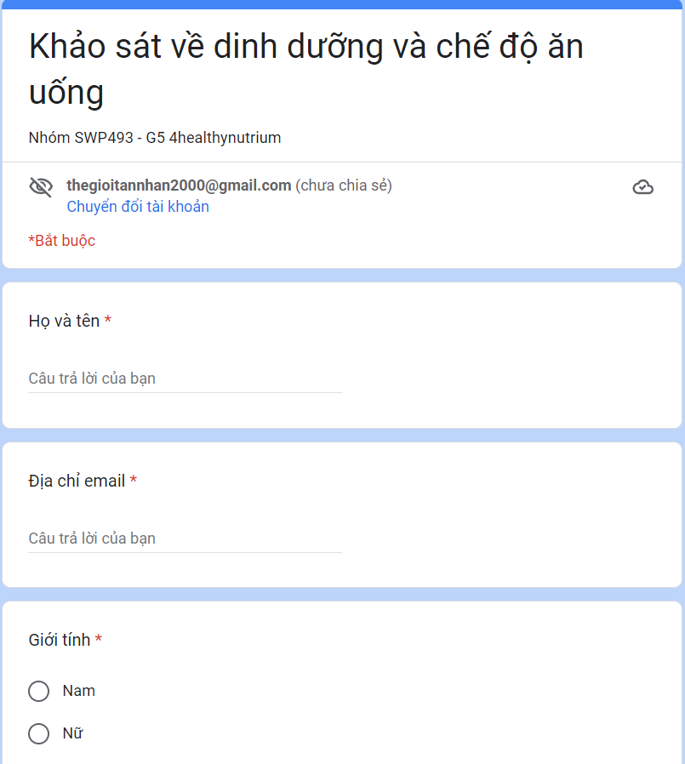

*Figure 2:1. Our survey form*

With 74 different responses from 74 people of different professions, gender and ages, we gathered a lot of information about each person's nutritional needs and habits:

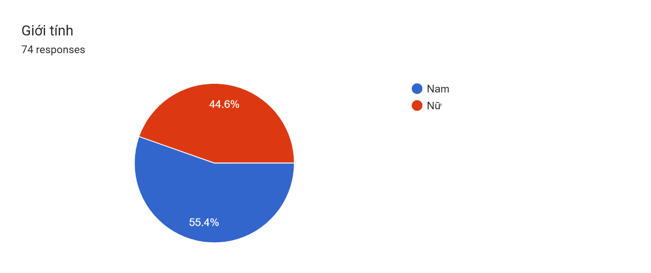  
*Figure 2:2. Statistics of survey participant's gender*

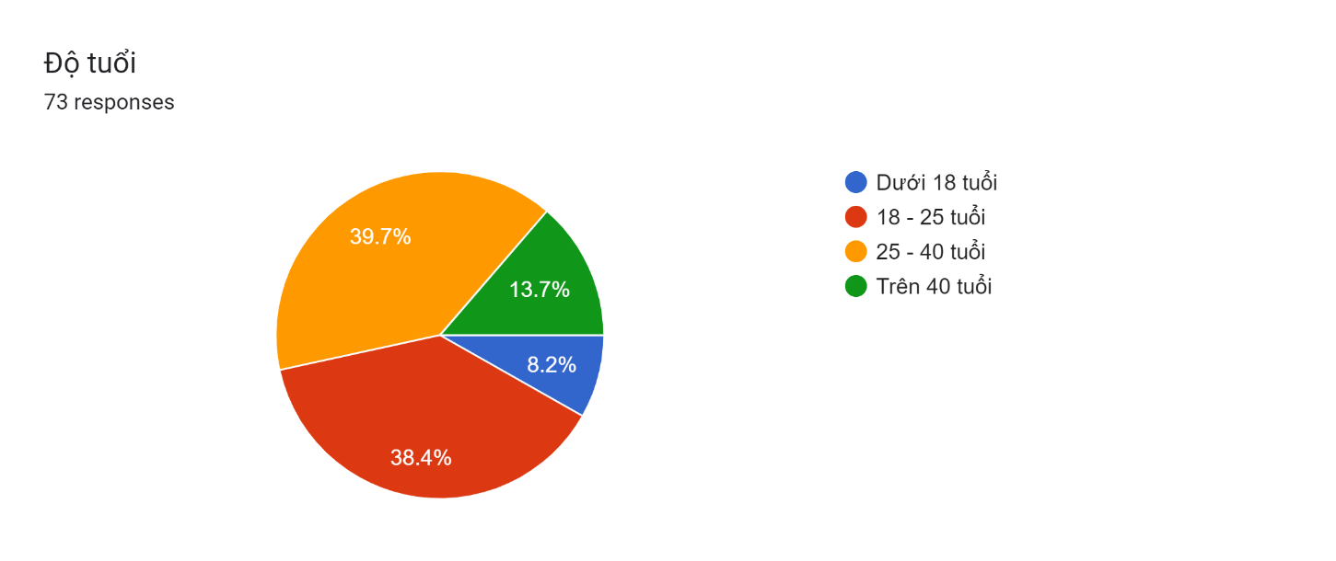

Figure 2:3. Statistics of survey participant's age

First, we can see that most of the survey participants are extremely health conscious and are willing to invest money and effort for their health needs.

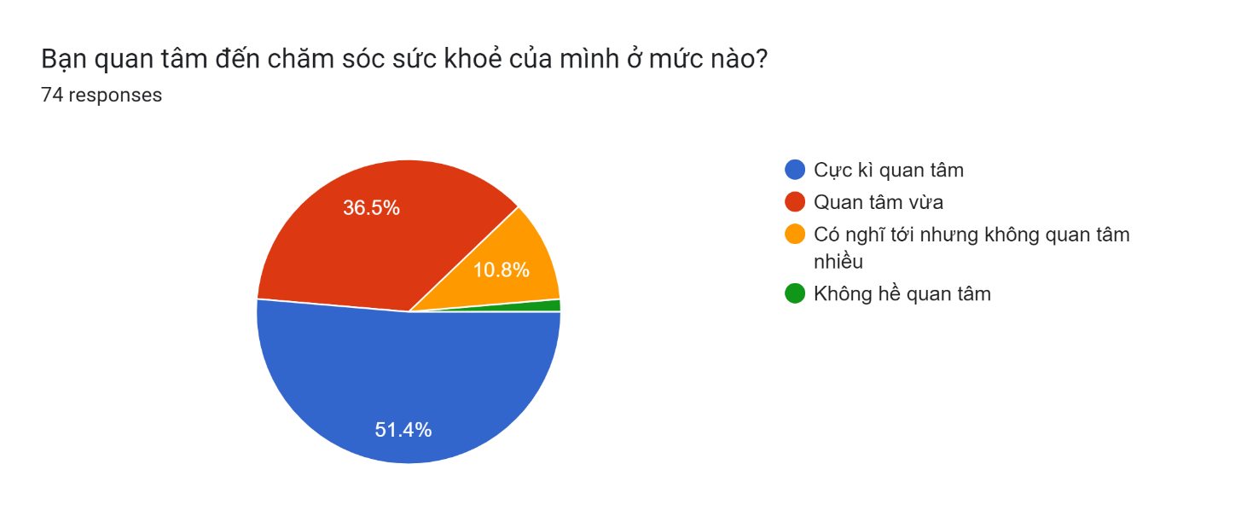

*Figure 2:6. Statistics of survey participant's level of concern for health*

Next, we conducted a survey on the difficulties that the interviewees encountered when learning about and building a healthy diet and exercise regimen. It can be seen that quite a few interviewees attributed the lack of nutrition knowledge to the lack of knowledge. Besides, the lack of a clear and specific plan also makes it difficult for many people to build a diet and exercise regimen.



*Figure 2:6. Statistics of survey participant's level of concern for health*

That's why our team decided to work together to build a website for nutrition and exercise advice to help satisfy everyone's needs.

In order to be able to create a website to help advise on diet, we have prepared the basic nutritional knowledge required, aimed at Vietnamese people who need to maintain and improve health. Our website will help users calculate the energy they need for the whole day based on the information provided by the user. From there, suggesting to user suitable menus to help them maintain and improve their personal health.

First, we learn about the basis for building energy recommendations for Vietnamese people. Based on the formula[[trang 29 sách Nhu cầu dinh dưỡng khuyến nghị cho người Việt Nam XB2016 ]](https://drive.google.com/drive/folders/1EsUWzp1ufCXleiTTQSDOBzx7jxfK1--3):

**A = B x C**

A: Recommended all-day energy needs (kcal).

B: Basal metabolic energy for the day (kcal).

C: Physical activity coefficient (PAL).

From the above basis, we learned about the basic metabolic energy in a day and the physical activity coefficient of Vietnamese people.

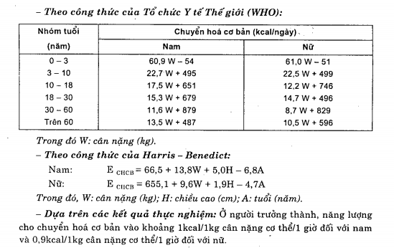

*Figure 2:7.1. Statistics of basic metabolic energy of Vietnamese people*

[[trang 18 sách Dinh dưỡng và an toàn thực phẩm Bộ Y Tế]](https://drive.google.com/file/d/1WTg9GA-RXxcPPfJ1JojHX7fDRRZTa0GW/view?fbclid=IwAR0My0Ap6B-ZtjAJSDE5IYdCPgQ1eVPtqrp1oVNPHtRG03wNHaXeX7Bxu3g)

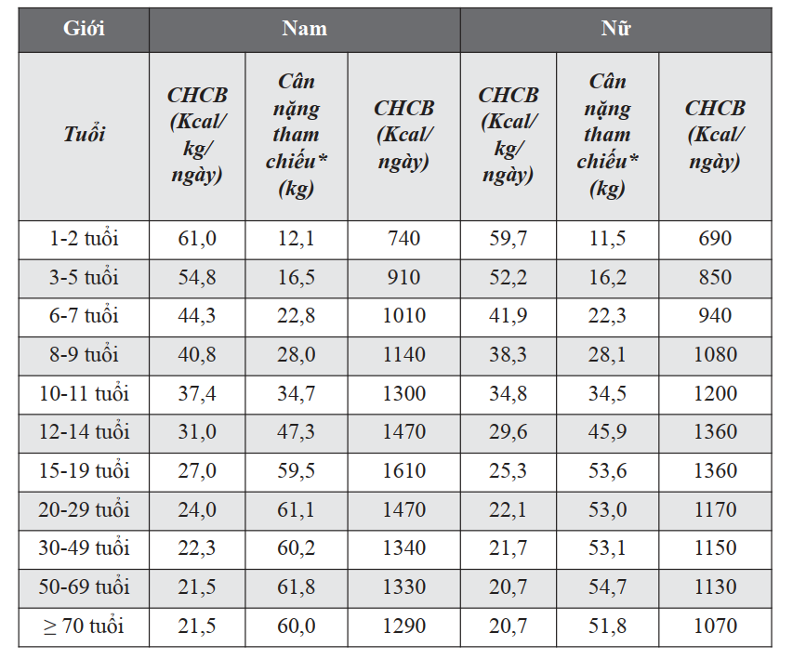

*Figure 2:7.2. Statistics of basic metabolic energy of Vietnamese people*

[[trang 30 sách Nhu cầu dinh dưỡng khuyến nghị cho người Việt Nam XB2016 ]](https://drive.google.com/drive/folders/1EsUWzp1ufCXleiTTQSDOBzx7jxfK1--3)

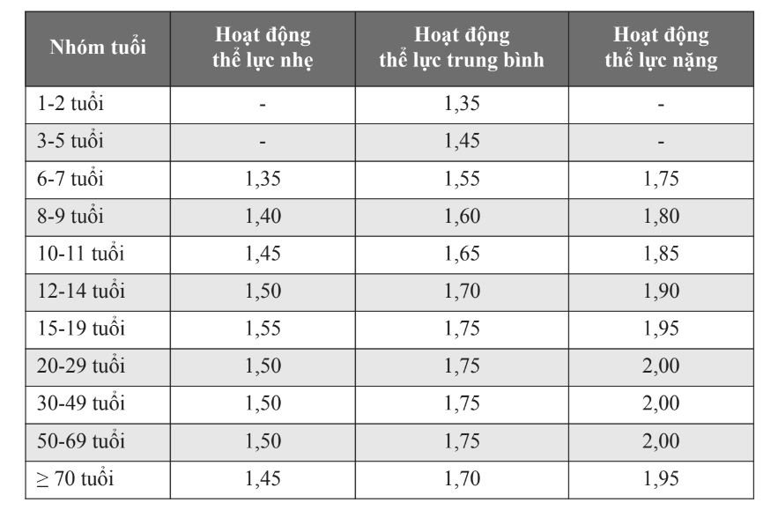

*Figure 2:8. Statistics of the physical activity coefficient* *of Vietnamese people*

[[trang 31 sách Nhu cầu dinh dưỡng khuyến nghị cho người Việt Nam XB2016 ]](https://drive.google.com/drive/folders/1EsUWzp1ufCXleiTTQSDOBzx7jxfK1--3)

We also learned more about the classification of physical activity levels by type of work so that it is easier to categorize the physical activity coefficients by different occupations.

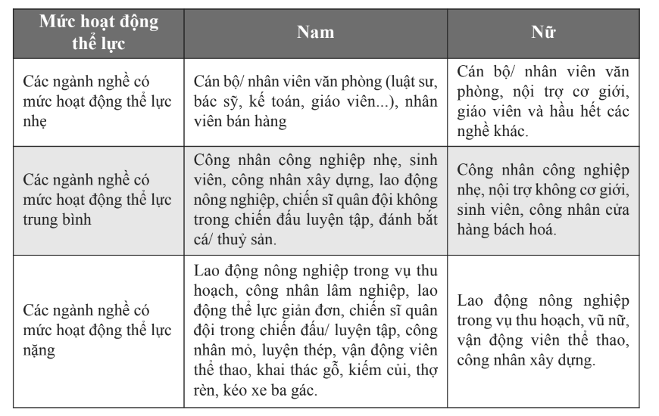

*Figure 2:9 Statistics of classification of physical activity levels by type of work of Vietnamese people*

[[trang 32 sách Nhu cầu dinh dưỡng khuyến nghị cho người Việt Nam XB2016 ]](https://drive.google.com/drive/folders/1EsUWzp1ufCXleiTTQSDOBzx7jxfK1--3)

From the above parameters, we have continued to collect data on recommended energy needs for Vietnamese people.

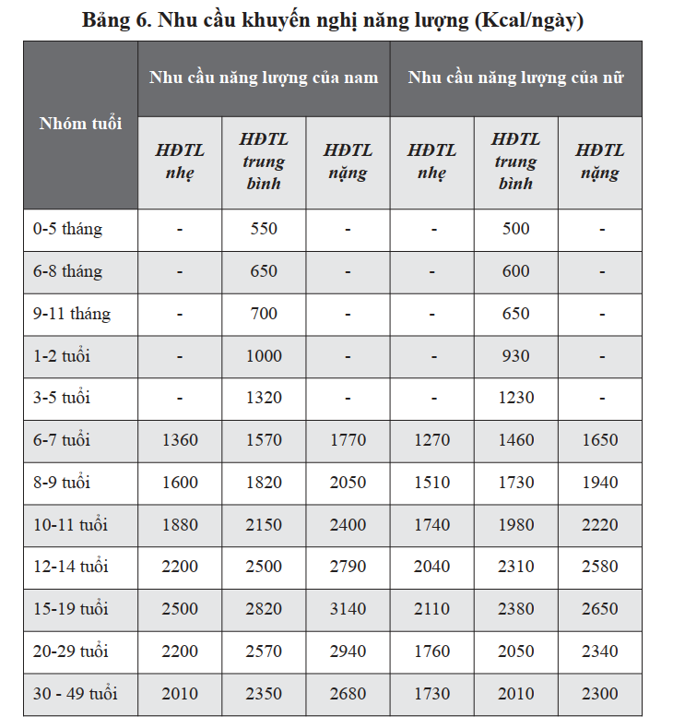

*Figure 2:10 Statistics of recommended energy needs* *of Vietnamese people*

[[trang 33 sách Nhu cầu dinh dưỡng khuyến nghị cho người Việt Nam XB2016 ]](https://drive.google.com/drive/folders/1EsUWzp1ufCXleiTTQSDOBzx7jxfK1--3)

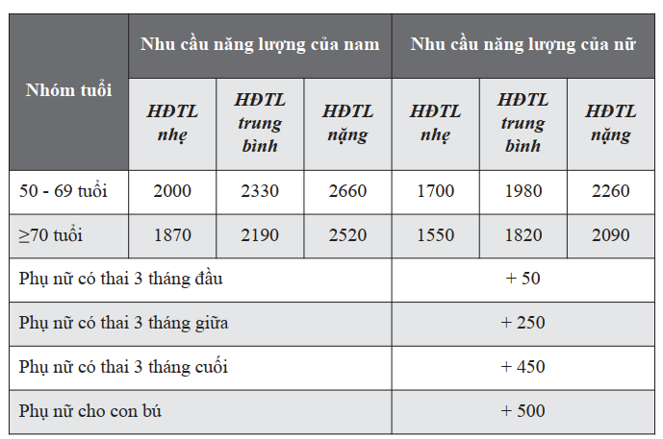

*Figure 2:11 Statistics of* recommended energy needs *of Vietnamese people*

[[trang 34 sách Nhu cầu dinh dưỡng khuyến nghị cho người Việt Nam XB2016 ]](https://drive.google.com/drive/folders/1EsUWzp1ufCXleiTTQSDOBzx7jxfK1--3)

In addition to ensuring energy needs, balancing the ratio of energy-producing substances (protein, glucide, lipid) is also very important:

* The energy provided by protein ranges from 13-20% of the total amount of dietary energy.
* The energy provided by lipids ranges from 20-25% of total amount of dietary energy. Should not exceed 25% of total energy.
* The energy provided by glucide ranges from 55-65% of the total amount of dietary energy.

[[trang 27 sách Nhu cầu dinh dưỡng khuyến nghị cho người Việt Nam XB2016]](https://drive.google.com/drive/folders/1EsUWzp1ufCXleiTTQSDOBzx7jxfK1--3)

[[trang 17 sách Dinh dưỡng và an toàn thực phẩm Bộ Y Tế]](https://drive.google.com/file/d/1WTg9GA-RXxcPPfJ1JojHX7fDRRZTa0GW/view?fbclid=IwAR0My0Ap6B-ZtjAJSDE5IYdCPgQ1eVPtqrp1oVNPHtRG03wNHaXeX7Bxu3g)

Besides, our team has also studied documents on how to divide meals in a reasonable way during the day.

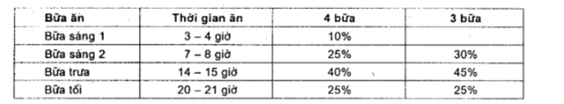

*Figure 2:12 Statistics of dividing the meals of the day of Vietnamese people*

[[trang 18 sách Dinh dưỡng và an toàn thực phẩm Bộ Y Tế]](https://drive.google.com/file/d/1WTg9GA-RXxcPPfJ1JojHX7fDRRZTa0GW/view?fbclid=IwAR0My0Ap6B-ZtjAJSDE5IYdCPgQ1eVPtqrp1oVNPHtRG03wNHaXeX7Bxu3g)

With the above knowledge, 4healthyNutrium wishes to be able to help advise Vietnamese users on how to maintain a healthy diet and exercise.

## 3. Existing Systems （既存のシステム）

### 3.1. Eat this much

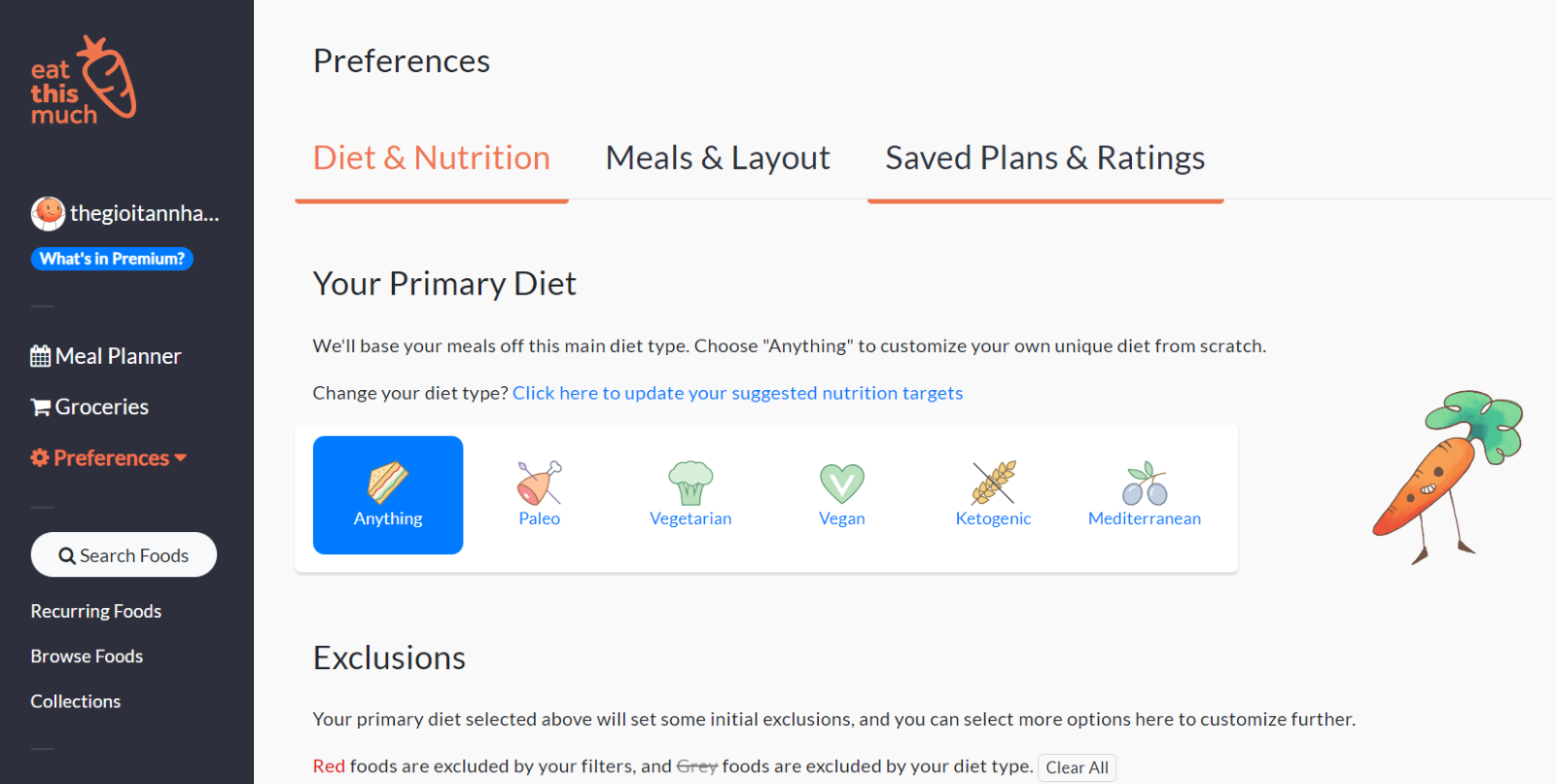

|  |  |
| --- | --- |
| **Advantages** | **Disadvantages** |
| * Easy to use, beginner-friendly. * Good classification about ingredient and food. * Automatically looking for diets. * Users can easily change their diets. | * Generated diets that are too high in fat. * Do not classify food and ingredients by season. |

Table 3.1. Advantages and disadvantages of Eatthismuch

### 3.2. Fatsecret

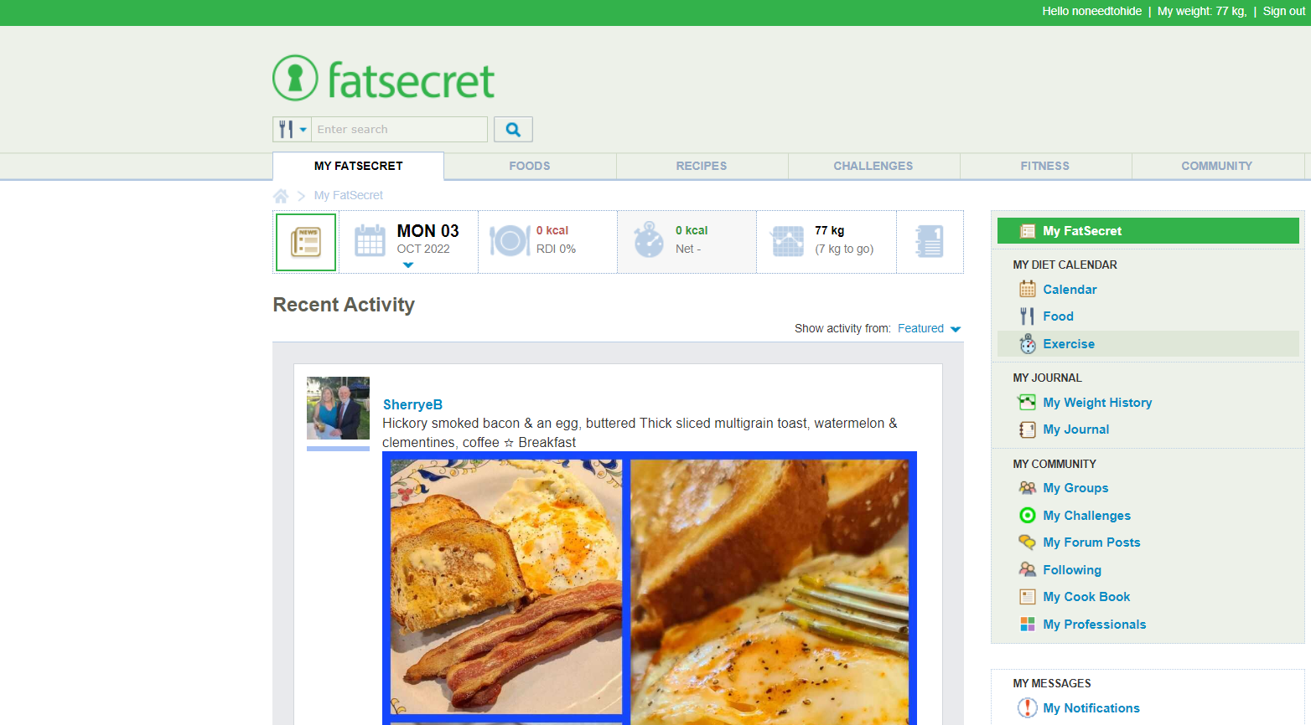

|  |  |
| --- | --- |
| **Advantages** | **Disadvantages** |
| * Easy to use. * Good calorie calculator. * Rich and varied nutritional information. * Having a social networking function that helps users easily connect with others. | * Significantly underestimates sodium and protein levels. * Do not classify food and ingredients by season. * Does not automatically generate dishes according to the calories entered. |

Table 3.2. Advantages and disadvantages of Fatsecret

### 3.3. Myfitnesspal

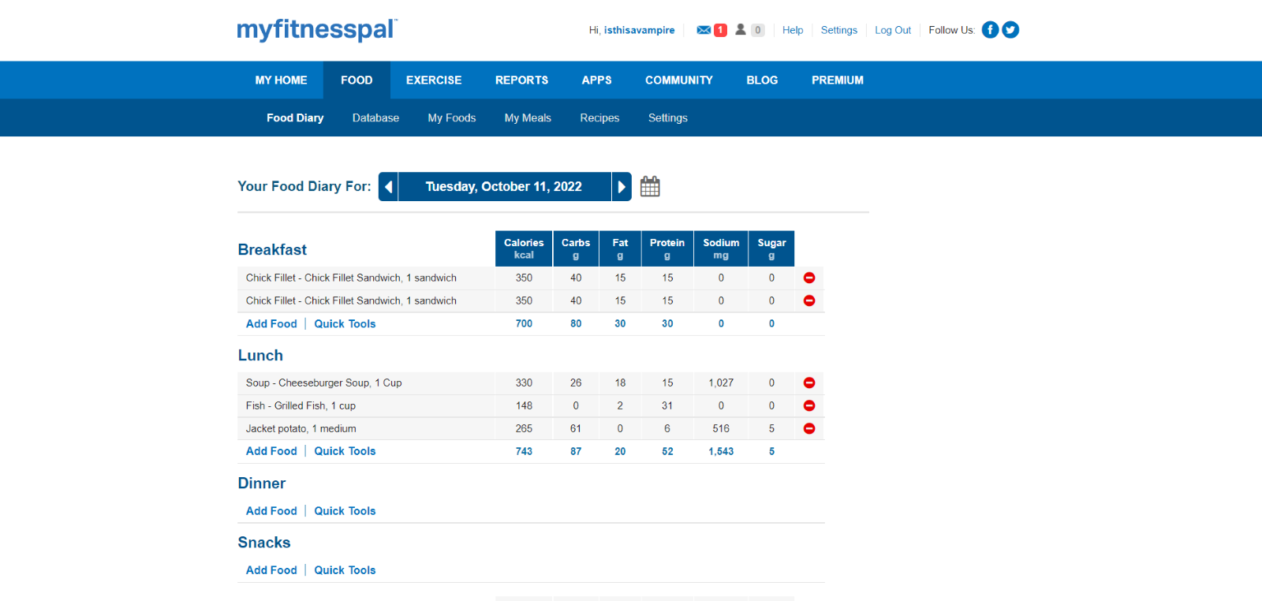

|  |  |
| --- | --- |
| **Advantages** | **Disadvantages** |
| * Users can track their water intake and macronutrients. * Extensive nutrient databases. * Recommended by dietitians. | * Underestimate micronutrients like calcium, iron, and vitamin C. * Quite complex to use. * Do not classify food and ingredients by season. |

Table 3.3. Advantages and disadvantages of Myfitnesspaypal

## 4. Business Opportunity（ビジネスチャンス）

Through the survey, we found that most of the survey participants wanted a website that could help them advise them to adjust their diet and exercise properly:

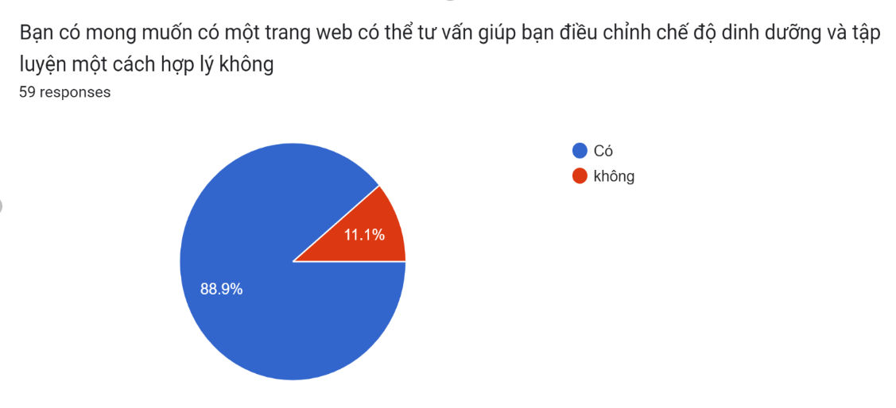

*Figure 4:1. Statistics of survey participants wanted a nutritional diet advice website*

Besides, the surveyed people also have the desire to be consulted on a diet suitable for each age, each season of the year:

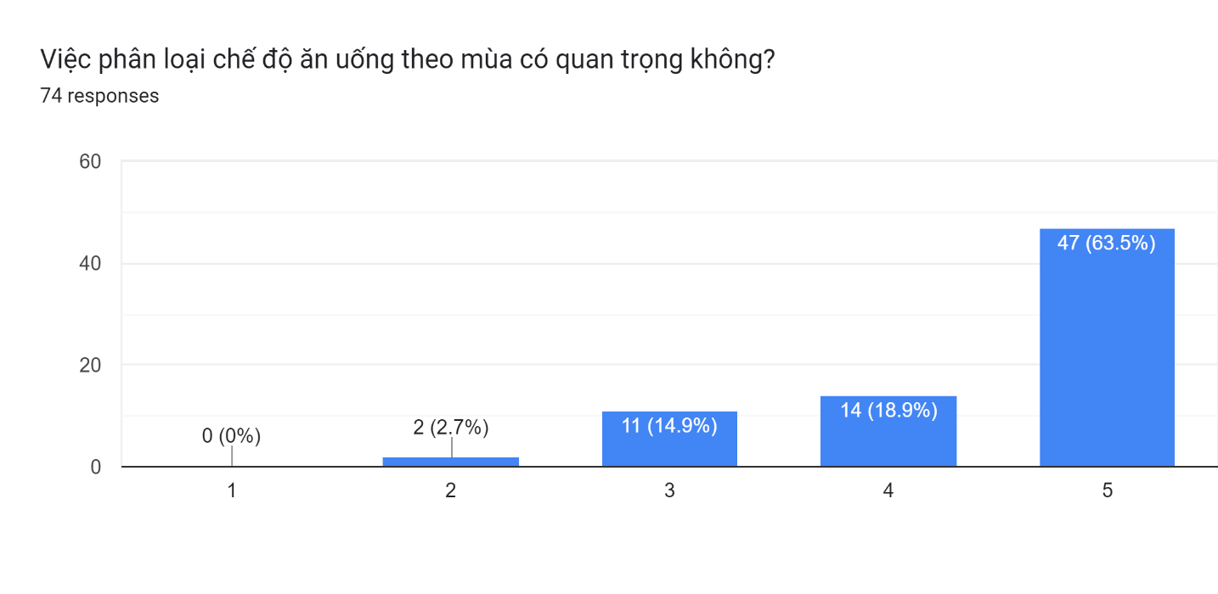

*Figure 4:2 Statistics about the importance of categorizing nutrition from seasonal food*

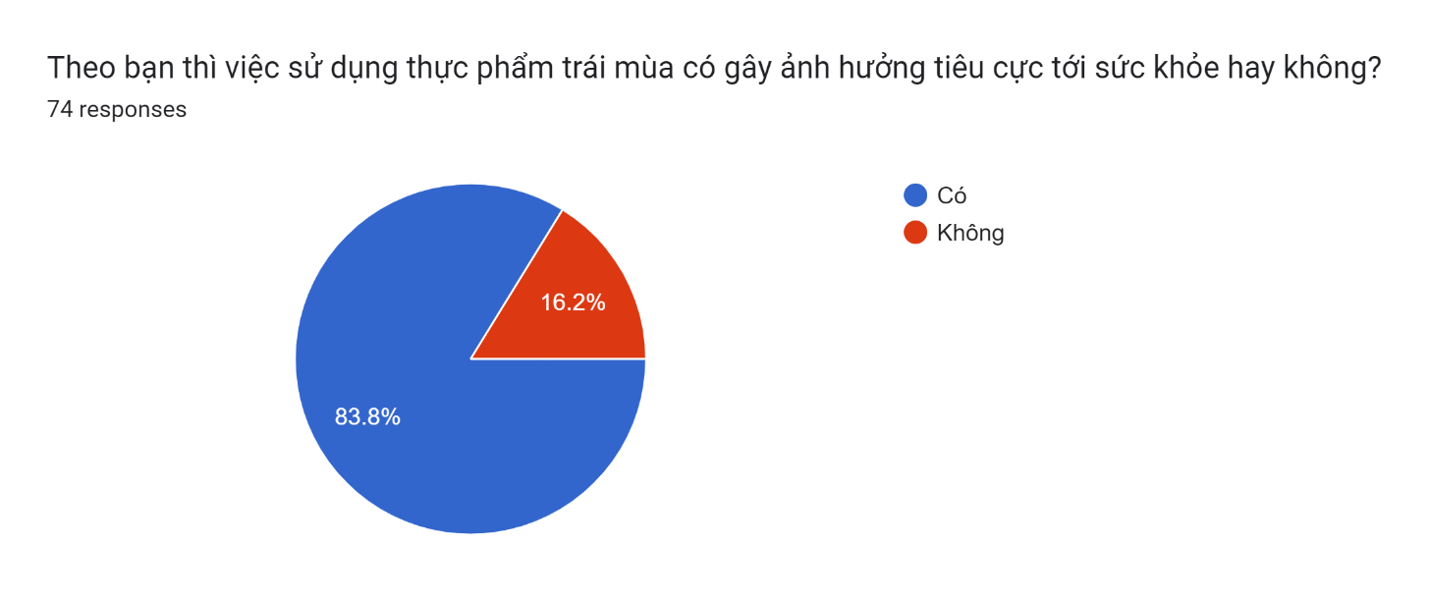

*Figure 4:3. Statistics about the flip side of out-of-season food*

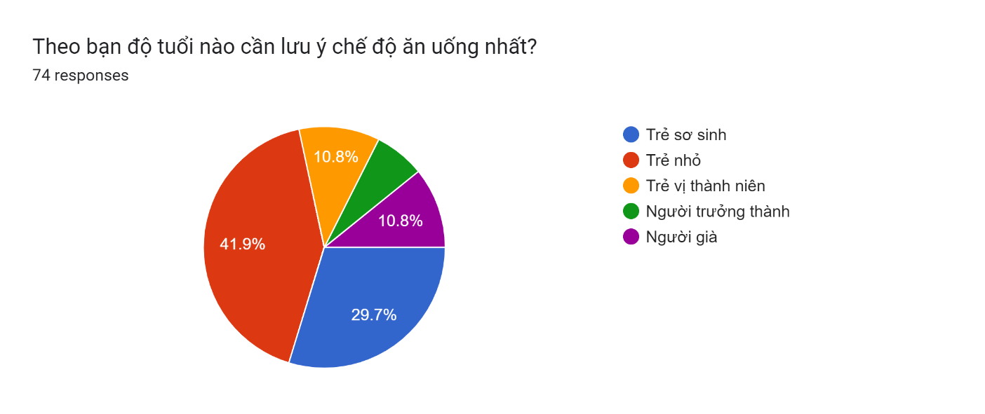

*Figure 4:4. Statistics about the importance of categorizing nutrition by age*

Through the information gathered from the survey, we have realized that it is very important to classify the diet by age and by season.

However, most of the energy-required dietary advice websites that exist today do not categorize these factors. Besides, the suggested dishes are all Western dishes and have a ratio of energy-producing substances that are not suitable for Eastern people in general and Vietnamese people in particular.

Therefore, we are confident that our products are suitable for the healthy nutritional needs of Vietnamese people, namely those who are healthy and want to maintain their health.

## 5. Software Product Vision (ソフトウェアプロダクトのビジョン)

In addition, through the above surveys, we also realized the importance of nutrition for young children. Therefore, we initially aimed to develop nutrition for primary and secondary schools. However, in the process of product development, we found that building school nutrition is still relevant to various ministries. So, we changed our orientation from targeting school nutrition to targeting personal nutrition. In the future, we hope to expand further to target audiences such as senior athletes and household.

## 6. Project Scope & Limitation（プロジェクト範囲と制限事項）

### 6.1 Major Features（主な特長）

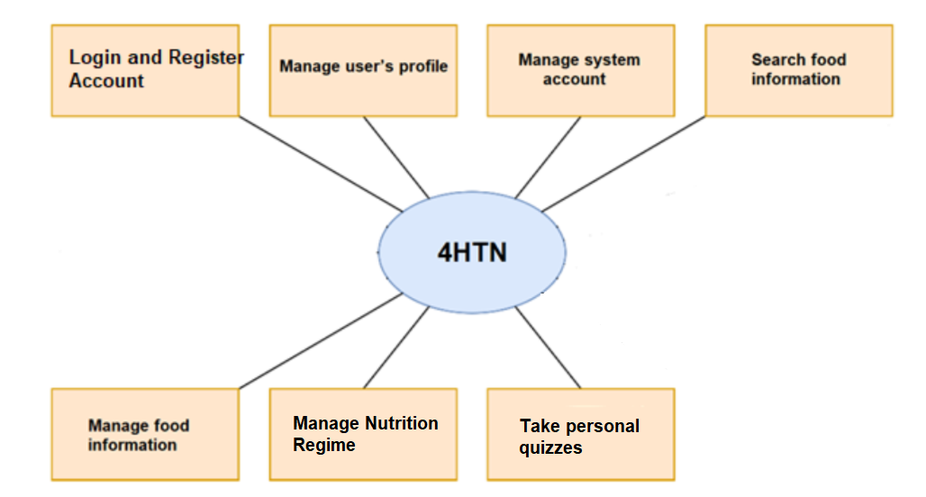

Figure 6.1.1 4HTN’s major features

|  |  |
| --- | --- |
| **ID** | **Feature & Description** |
| FE-01 | Login and register account: Users must have an account to access other features in the system. |
| FE-02 | Manage profile: Users can manage their personal information. |
| FE-03 | Manage system account: Admin can manage accounts in the system to activate or deactivate a user. |
| FE-04 | Search food’s information: Users can search for nutrient value of food to get more information about diet. |
| FE-05 | Manage food’s information: Nutrition experts can edit food information, change the nutrient value of food and edit the food recipes. |
| FE-06 | Manage Nutrition Regime: Users can see their nutrition need, receive their personal nutrition regime and change their nutrition regime. |
| FE-07 | Take personal quizzes: Users can take their personal quiz, then system will analyze their information to give them suitable nutrition regimes. |

Table 6.1. List of major features.

**Algorithmic process explanation:**

- First, we collect information about the user's job and height and weight through a quiz. Combined with the age and gender information that was available when the user signed up, we calculate their nutritional needs in a day. Then it will be divided into energy needs corresponding to each meal.



Figure 6.1.2 List of food categories.

- Second, after the user chooses the type of food they want, we will base on the current date to combine the classification with the season to filter out the foods that match the above criteria.

- Next, after the user selects the number of dishes for each meal, we will base on that to divide the combination of eligible dishes. Each split case will correspond to a system of equations with the variables being the food coefficient. Combinations with dishes with ingredients in the taboo food table will also be disqualified.

- Finally, we will use matrices to solve each system of equations. Equations with negative solutions will be eliminated. Equations with satisfactory solutions will be selected and stored in the solution set.

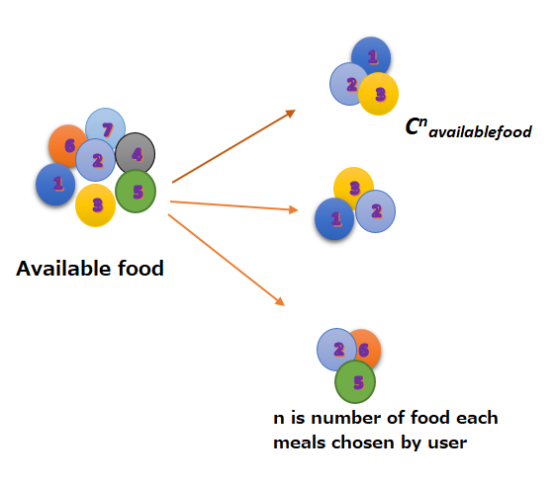

Figure 6.1.3 Divide Combination Step.

- After that, we will use matrices to solve each system of equations. Equations with negative solutions will be eliminated. Equations with satisfactory solutions will be selected and stored in the solution set.

- Finally, we will give suggestions to the user that the dishes in the combination have solutions in the solution set.

### 6.2 Limitations & Exclusions（制限事項と除外）

|  |  |
| --- | --- |
| **ID** | **Feature & Description** |
| LI-01 | Users cannot see other people's profiles. |
| LI-02 | Users cannot receive push notifications when not using the web. |
| LI-03 | The web only supports the Vietnamese language. |
| LI-04 | The web is not absolutely accurate, for reference only. |
| LI-05 | The food coefficient may have the coefficients of 0.5, 1.5, 2.5, 3.5, ... will make the user a little difficult to process. |

Table 6.2:1. Limitations

|  |  |
| --- | --- |
| **ID** | **Feature & Description** |
| EX-01 | The web does not support uncommon dishes and ingredients. |
| EX-02 | The web does not support live streaming. |
| EX-03 | The web does not support dish leaderboards. |
| EX-04 | The web is not a social network or forum. |
| EX-05 | This website is for personal nutrition only |

Table 6.2:2. Exclusions

# II. Project Management Plan (プロジェクト管理計画 ）

## 1. Overview（概要）

### 1.1. WBS & Estimation 作業分解図と見積もり

|  |  |  |  |
| --- | --- | --- | --- |
| **#** | **WBS Item** | **Complexity** | **Est. Effort** **(Man-days)** |
| ***1*** | ***Pre-Initiating Phase*** |  | ***20*** |
| 1.1 | Select project manager | Simple | 2 |
| 1.2 | Determine the role of team members | Simple | 2 |
| 1.3 | Choose topic | Complex | 15 |
| 1.4 | Register Capstone Project | Simple | 1 |
| ***2*** | ***Initiating Phase*** |  | ***32*** |
| 2.1 | Kick-off meeting | Simple | 4 |
| 2.2 | Develop project introduction document | Complex | 28 |
| ***3*** | ***Planning Phase*** |  | ***50*** |
| **3.1** | **Project Planning** |  | ***20*** |
| 3.1.1 | Define scope | Medium | 3 |
| 3.1.2 | Choose working model process | Simple | 1 |
| 3.1.3 | Choose software process model | Simple | 1 |
| 3.1.4 | Select tools and techniques | Simple | 1 |
| 3.1.5 | Develop WBS | Medium | 4 |
| 3.1.6 | Develop project schedule | Medium | 3 |
| 3.1.7 | Develop risk management plan | Medium | 1 |
| 3.1.8 | Develop project communication plan | Simple | 1 |
| 3.1.9 | Organize project resources | Simple | 1 |
| 3.1.10 | Develop software project management plan | Medium | 4 |
| **3.2** | **Project Preparing** |  | ***5*** |
| 3.2.1 | Create software mockup | Complex | 3 |
| 3.2.2 | Technical Training/Self study | Simple | 2 |
| **3.3** | **Analyzing & Requirement** |  | ***25*** |
| 3.3.1 | User Requirements | Medium | 3 |
| 3.3.2 | Functional Requirements | Medium | 3 |
| 3.3.3 | Create Entity Relationship Diagram | Complex | 5 |
| 3.3.4 | Non-Functional Requirements | Simple | 2 |
| 3.3.5 | Create test cases for system test | Medium | 3 |
| 3.3.6 | Develop Software Requirement Specification | Complex | 9 |
| ***4*** | ***Executing*** |  | ***112*** |
| **4.1** | **Designing** |  | ***40*** |
| 4.1.1 | Basic architecture design | Medium | 3 |
| 4.1.2 | Create test cases for integration test | Medium | 5 |
| 4.1.3 | Detail design | Medium | 6 |
| 4.1.4 | Data & Database Design | Medium | 6 |
| 4.1.5 | Create test cases for unit test | Medium | 5 |
| 4.1.6 | Develop Software Design Document | Medium | 15 |
| **4.2** | **Implementation - Iteration 1: Develop user features** |  | ***72*** |
| 4.2.1 | *Requirements* |  | **3** |
| 4.2.1.1 | Update Software Requirement Specification | Medium | 3 |
| 4.2.2 | *Design* |  | ***4*** |
| 4.2.2.1 | Update Software Design Document | Medium | 4 |
| 4.2.3 | *Coding* |  | **56** |
| 4.2.3.1 | Feature 1: Authentication user |  | *5* |
| 4.2.3.1.1 | Code front-end | Medium | 3 |
| 4.2.3.1.2 | Code back-end | Complex | 2 |
| 4.2.3.2 | Feature 2: Manage personal profile |  | *5* |
| 4.2.3.2.1 | Code front-end | Medium | 3 |
| 4.2.3.2.2 | Code back-end | Medium | 2 |
| 4.2.3.2 | Feature 3: Receive diet |  | *24* |
| 4.2.3.2.1 | Code front-end | Medium | 6 |
| 4.2.3.2.2 | Code back-end | Complex | 18 |
| 4.2.3.3 | Feature 4: Search food |  | *5* |
| 4.2.3.3.1 | Code front-end | Medium | 3 |
| 4.2.3.3.2 | Code back-end | Medium | 2 |
| 4.2.3.4 | Feature 5: Change personal diet |  | *12* |
| 4.2.3.4.1 | Code front-end | Medium | 3 |
| 4.2.3.4.2 | Code back-end | Complex | 9 |
| 4.2.3.5 | Feature 6: Manage food |  | *5* |
| 4.2.3.5.1 | Code front-end | Medium | 3 |
| 4.2.3.5.2 | Code back-end | Medium | 2 |
| 4.2.4 | *Testing* |  | **15** |
| 4.2.4.1 | Unit test | Medium | 10 |
| 4.2.4.2 | Integration test | Medium | 5 |
| 4.2.5 | *Evaluation* | Simple | **5** |
| **4.3** | **Implementation - Iteration 2: Develop admin features** |  | ***35*** |
| 4.3.1 | *Requirements* |  | **4** |
| 4.3.1.1 | Update Software Requirement Specification | Medium | 4 |
| 4.3.2 | *Design* |  | **4** |
| 4.3.2.1 | Update Software Design Document | Medium | 4 |
| 4.3.3 | *Coding* |  | **6** |
| 4.3.3.1 | Feature 1: Manage system account |  | 6 |
| 4.3.3.1.1 | Code front-end | Medium | 3 |
| 4.3.3.1.2 | Code back-end | Medium | 3 |
| 4.3.4 | *Testing* |  | **10** |
| 4.3.4.1 | Unit test | Medium | 5 |
| 4.3.4.2 | Integration test | Medium | 5 |
| 4.3.5 | *Evaluation* | Simple | **5** |
| 4.4 | **Full System testing** |  | **30** |
| 4.4.1 | Execute Full System Test & Fix Bugs | Medium | 25 |
| 4.4.2 | Update Software Test Report Document | Medium | 5 |
| 4.5 | **Transitioning** |  | **45** |
| 4.5.1 | *Software Optimization* |  | *30* |
| 4.5.1.1 | Optimize/Refactor Codes | Medium | 5 |
| 4.5.1.2 | Execute Full System Test Round 2 & Fix Bugs | Simple | 15 |
| 4.5.2 | *User Guides* |  | *5* |
| 4.5.2.1 | Develop Software User Guides | Medium | 5 |
| 4.5.2.2 | Develop Final Project Report | Medium | 10 |
| ***5*** | ***Monitoring and Controlling*** |  | ***5*** |
| 5.1 | Meet instructor | Medium | 2 |
| 5.2 | Progress Report | Complex | 3 |
| ***6*** | ***Closing*** |  | ***25*** |
| 6.1 | Prepare for final project presentation | Medium | 15 |
| 6.2 | Present final project | Medium | 5 |
| 6.3 | Project completed | Simple | 5 |
| **Total Estimated Effort (man-days)** | | | **244** |

Table 2.1.1. WBS & Estimation

### 1.2. Project Objectives プロジェクトの目的

#### 1.2.1. Project Objectives プロジェクトの目的

* This product is a website, suitable for the person want to maintain their health.
* This product has the main features:
* Provide information about nutrition.
* Manage personal nutrition information.

#### 1.2.2. Team Objectives チームの目的

* The team finishes the project before 17th December, 2022.
* Team members improve their skills in working in a group.
* Each member improves both technical skills and soft skills.
* Team successfully applied a software development process.

### 1.3. Project Risks プロジェクトのリスク

|  |  |  |  |  |
| --- | --- | --- | --- | --- |
| **#** | **Risk Description** | **Impact** | **Possibility** | **Response Plans** |
| 1 | Member illness | High | Medium | Other members should join forces to fulfill the work of the absent members. |
| 2 | Conflict among members | Medium | Medium | All members should discuss ways to resolve the conflict. |
| 3 | Lack of skill | High | Medium | Members should be given time to train in their field before coding. |
| 4 | Ambiguous business requirement | High | High | Study about other existing systems.  Study about the needs of end-users.  State the requirements clearly in documents.  Analyze each requirement carefully. |
| 5 | Facing hard problems | High | High | All members should discuss the problems and find out the best solution.  Ask the supervisor and people who have experience and knowledge about the problems. |
| 6 | Requirement changes | High | Medium | All members should discuss carefully at the beginning of each iteration to define scope and requirement. |

Table 1.3. Project Risks

## 2. Management Approach（マネジメントアプローチ）

### 2.1 Project Process（プロジェクトのプロセス）

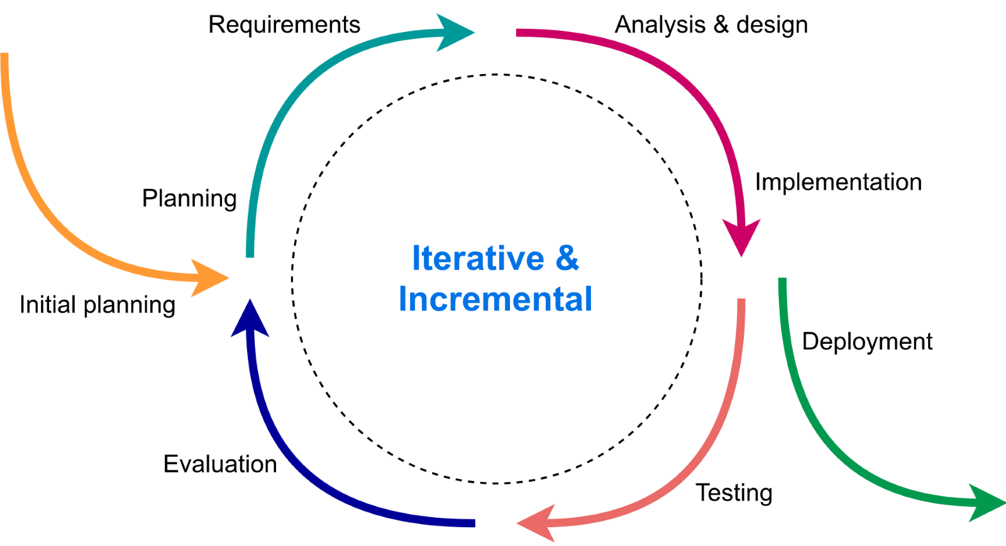

Figure 2.2.1. Iterative and Incremental software process model

In my project will be divided into two iterative & incremental: develop user & nutrition expert features and develop admin feature.

In each iteration, we are going to finish and deliver a code package of essential features

### 2.2. Meeting Minutes 議事録

All meeting minutes will follow this template:

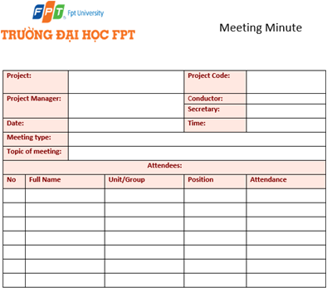

Figure 2.2.2. Meeting minute template

### 2.3 Training Plan （訓練計画）

|  |  |  |  |
| --- | --- | --- | --- |
| **Training Area** | **Participants** | **When, Duration** | **Waiver Criteria** |
| Java Spring Boot | Nguyen Hoang Viet  Nguyen Viet Long | 27/9/2022, 1 week | Mandatory |
| ReactJS | Nguyen Duc Son  Le Manh Cuong | 27/9/2022, 1 week | Mandatory |
| GitLab, GitHub | Nguyen Hoang Viet  Nguyen Viet Long  Nguyen Duc Son  Le Manh Cuong | 27/9/2022, 1 week | Mandatory |
| Figma | Nguyen Duc Son  Le Manh Cuong | 22/09/2022, 1 week | Mandatory |

Table 2.2.3. Training Plan

## 3. Master Plan マスタープラン

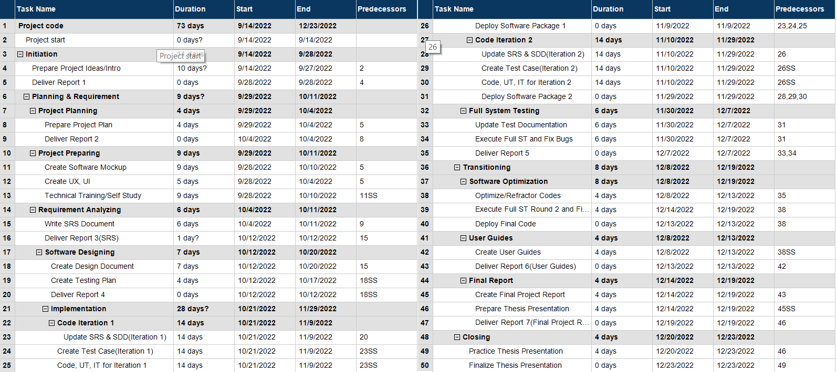

Figure 3.1 Master Schedule

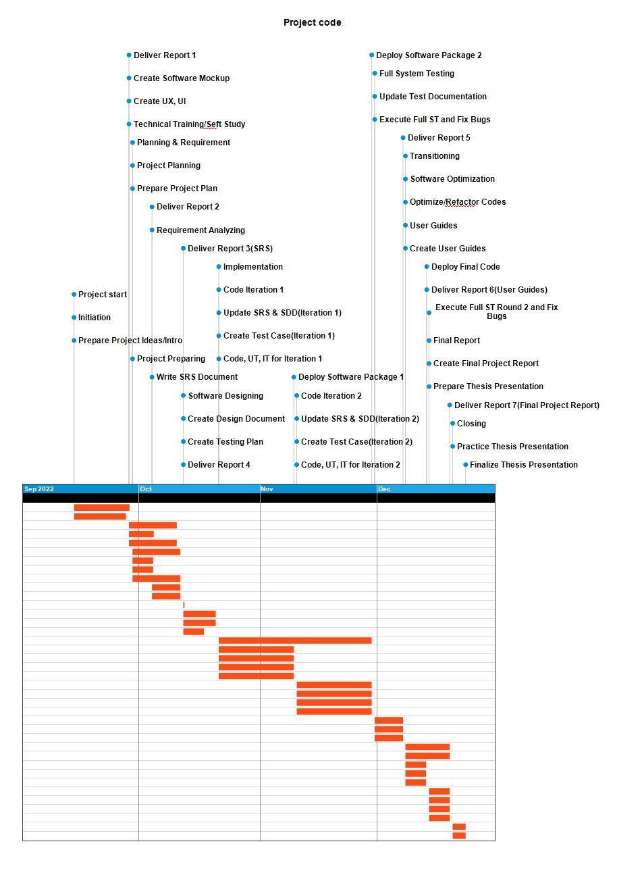

Figure 3.2 Master Schedule (Gantt Chart Timeline)

## 4. Project Organization（プロジェクト組織）

#### 4.1. Team & Structure（チームと構造）

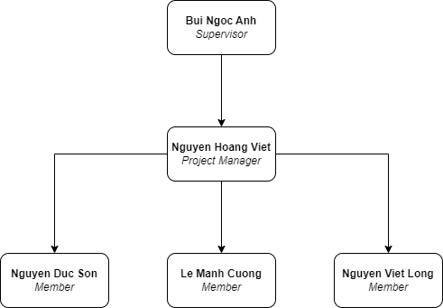

Figure 4.1. Team & Structures Diagram

#### 4.2. Roles & Responsibilities（役割と責任）

|  |  |  |
| --- | --- | --- |
| **Role** | **Member** | **Responsibility** |
| Project Manager | Nguyen Hoang Viet | Responsible for planning, creating schedules, coordinating communication.  Keeping track of the progress of the project.  Take responsibility with all requirement and schedule of school.  Keep project in direct goals. |
| Analysis Leader | Nguyen Hoang Viet | Analyze project requirement  Define project scope, create SRS document  Review SRS created by analysis members  Study and research about nutrition information |
| Analysis Member | Nguyen Viet Long  Nguyen Duc Son  Le Manh Cuong | Define requirements: functional and non-functional requirements  Keep track and contribute to SRS document  Define detail flow of features  Review other members and comment  Study and research about information |
| Designer | Nguyen Hoang Viet  Nguyen Duc Son | Define screens, flow between screens  Design UI, UX for application |
| Technical Leader | Nguyen Viet Long | Responsible for choosing technologies for the whole system and overseeing the work done by other programmers |
| Frontend Developer | Nguyen Duc Son  Le Manh Cuong | Initial and develop frontend  Study technical requirement to apply into  project  Review code for each other  Fix bugs |
| Backend Developer | Nguyen Hoang Viet  Nguyen Viet Long | Design database  Study technical requirement to apply into  project  Initial and develop backend server  Review code for each other  Fix bugs  Deploy code to server |
| Test Leader | Nguyen Hoang Viet | Define test plan  Assign tasks for other member  Study and research testing tools  Create test template  Take responsibility about coverage of test |
| Test Member | Le Manh Cuong | Create test cases  Implement tests follow test plan  Create test reports and inform development teams about bugs |

Table 4.2. Roles & Responsibilities

## 5. Project Communications（プロジェクトコミュニケーション）

#### 5.1. Communication Plan（コミュニケーション計画）

|  |  |  |  |  |
| --- | --- | --- | --- | --- |
| **Communication Item** | **Who/ Target** | **Purpose** | **When, Frequency** | **Type, Tool, Method(s)** |
| Weekly meeting | Team members, supervisor | Review member’s work achievements.  Report the project's progress and status of each member’s work. | Every Tuesday | Google Meet |
| Daily meeting | Team members | Report the project's progress and status of each member’s work each day. | Every weekday | Google Meet |
| Unscheduled meeting | Team members | Resolve unpredicted problems | When any problems arise | Google Meet, Messenger |
| Supervisor daily communication | Team member, supervisor | Report project status, Q&A | Every weekday | Messenger |
| Team daily communication | Team members | Discuss project, sharing files, sharing source code | Every weekday | Discord, Messenger |

Table 5.1. Communication Plan

#### 5.2. External Interface（外部インターフェース）

|  |  |  |  |
| --- | --- | --- | --- |
| **Function** | **Contact Person**  **(name, position)** | **Contact address**  **(email, telephone)** | **Responsibility** |
| Supervisor | Bui Ngoc Anh | [anhbn5@fe.edu.vn](mailto:anhbn5@fe.edu.vn) | * Provide document template * Give instruction to project team * Review deliverables * Supervise project status |

Table 5.2. External Interface

## 6. Configuration Management（構成管理）

#### 6.1. Tools & Infrastructures（ツールとインフラ）

|  |  |
| --- | --- |
| **Programming languages** | **Tools & Technical** |
| Framework | Java SpringBoot, React |
| Library | ReactJS, |
| API | REST API |
| DBMS | MySQL Workbench |
| IDEs/Editors | Visual Studio Code, IntelliJ |
| Testing tools & Framework | IntelliJ, Postman |
| Design | Figma, Proto.io |
| UML tools | Draw.io |
| Version Control | GitLab |
| Deployment Server | localhost3000 and localhost8080 |
| Project Management Tools | Jira, MindView |

Table 6.1. Tools & Infrastructures

#### 6.2. Document Management（ドキュメント管理）

**6.2.1. Convention 規約**

|  |  |  |
| --- | --- | --- |
| **Identifiers Type** | **Naming Rules** | **Examples** |
| Class | It should start with the uppercase letter. It should be a noun such as Color, Button, System, Thread, etc. Use appropriate words, instead of acronyms. | Public class **DietaryInfoService**  **{** **//code snippet** **}** |
| Interface | It should start with the uppercase letter. It should be an adjective such as Runnable, Remote, ActionListener. Use appropriate words, instead of acronyms. | Interface **DietaryInfoRepo** extends JpaRepository<DietaryInfo, Long> **{** **//code snippet** **}** |
| Method | It should start with lowercase letter. It should be a verb such as main(), print(), println(). If the name contains multiple words, start it with a lowercase letter followed by an uppercase letter such as actionPerformed(). | Class **DietaryInfoService** { // method void **saveDiet()** **{** **//code snippet** **}** **}** |
| Variable | It should start with a lowercase letter such as id, name. It should not start with the special characters like & (ampersand), $ (dollar), _ (underscore). If the name contains multiple words, start it with the lowercase letter followed by an uppercase letter such as firstName, lastName. Avoid using one-character variables such as x, y, z. | Class **DietaryInfoService** { // variable double **bmi**; //code snippet } |
| Package | It should be a lowercase letter such as java, lang. If the name contains multiple words, it should be separated by dots (.) such as java.util, java.lang. | //package package **com.javatpoint;** **class DietaryInfoService** **{** **//code snippet** **}** |
| Constant | It should be in uppercase letters such as RED, YELLOW. If the name contains multiple words, it should be separated by an underscore(_) such as MAX_PRIORITY. It may contain digits but not as the first letter. | class **DietaryInfoService** { //constant static final int **MIN_AGE** = 18; //code snippet } |

**6.2.2. Management 管理**

* All documents will be stored on Google Drive and Microsoft OneDrive.
* All reports will be delivered to the supervisor through Gmail.

**6.3. Source Code Management ソースコード管理**

**6.3.1. Convention 規約**

* All coding branches must be reviewed by team developers before merging to the default branch.
* All developers must implement unit tests and review code before creating a merge request.

**6.3.2. Management 管理**

* All source code will be stored on GitLab.
* Only team members can access the repository on GitLab.

## 7. Responsibility Assignments（責任の割り当て）

|  |  |  |  |  |  |
| --- | --- | --- | --- | --- | --- |
|  |  |  |  |  |  |
| Project Planning & Tracking | D | I | I | I | S |
| Prepare Project Introduction Document | R | R | R | R | D |
| Prepare SRS Document | D | D | D | D | D |
| Prepare SDD Document | D | D | D | D | D |
| Code Backend | D, R | D | I | R | I |
| Code Frontend | R | R | S | D | S |
| Deployment | D, R | R | I | D | I |
| Prepare Test Document and Report | R, S | S | D | S | S |
| Prepare User Guides | D, R | D | D | D | D |
| Prepare Final Report (all document and presentation slide) | D, R | D | D | D | D |

***Note:***

|  |  |
| --- | --- |
| D | Do |
| R | Review |
| S | Support |
| I | Informed |

# III. Software Requirement Specification（システム要求仕様）

## 1. Product Overview（製品の概要）

The 4HeathyNutrium aims to provide suggestions and advice on reasonable nutrition for users. The system packs feature up into a website, where the users can easily access to. The diagram below illustrates the external entities and system interfaces for first-time release.

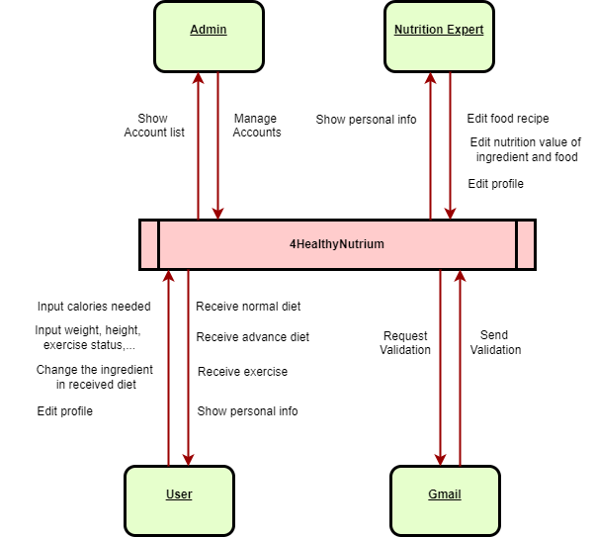

Figure 1. Context Diagram

## 2. User Requirements（ユーザー要件）

### 2.1 Actors（アクター）

|  |  |  |
| --- | --- | --- |
| **#** | **Actor** | **Description** |
| 1 | User | An user is the person who can receice and change personal diets, and search for foods and ingredients. |
| 2 | Nutrition Expert | An nutrition expert is the person who can edit foods, recipes and ingredients. |
| 3 | Administrator | An admin is the person who has the permission to administer user accounts in the system |

Table 2.1. Actors

### 2.2 Use Cases ユースケース

#### 2.2.1. Overview （概要）

- We have three actors in our system: Admin, User and Nutrition Expert.

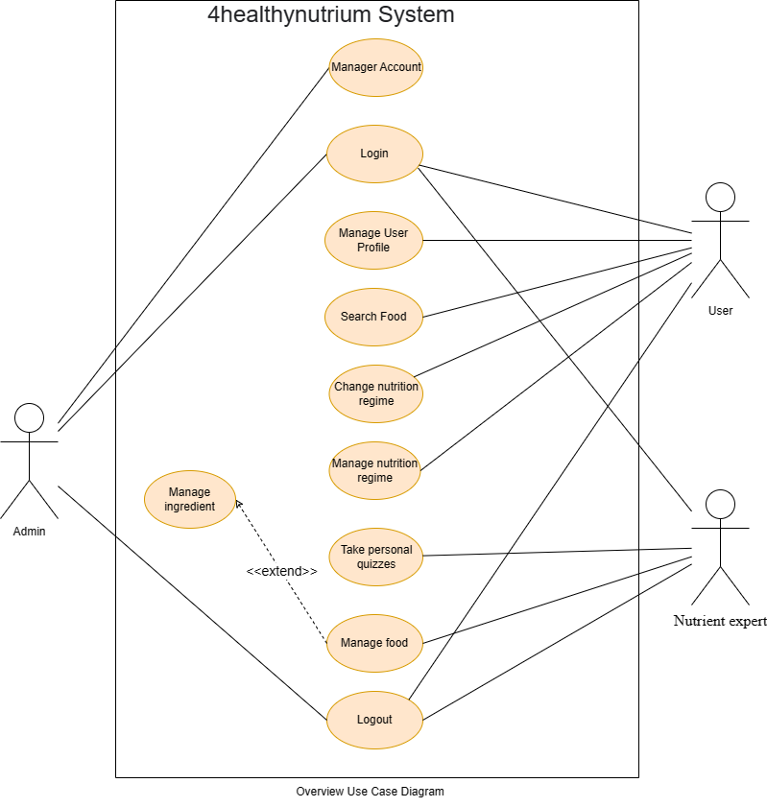

Figure 2.2.1. Overall use case diagram

#### 2.2.2. Feature “Login and Register”

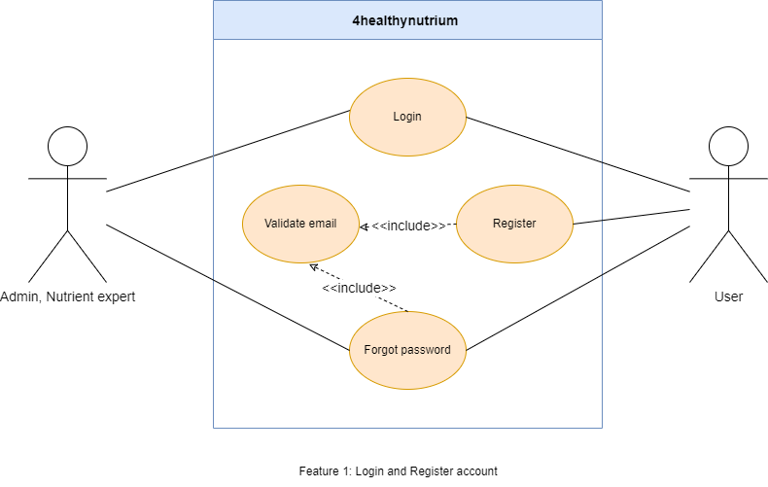

Figure 2.2.2. “Login and Register” use cases

##### 2.2.2.1. Login ログイン

|  |  |  |  |
| --- | --- | --- | --- |
| **UC ID and Name:** | **UC-01. Login** | | |
| **Created By:** | VietNH | **Date Created:** | 10/02/2022 |
| **Primary Actor:** | User, Nutrition Expert, Admin | **Secondary Actors:** | N/A |
| **Trigger:** | N/A | | |
| **Description:** | This use case allows the user to login into the system. | | |
| **Preconditions:** | **PRE-01.** The user has registered an account in the system.  **PRE-02.** The user’s phone number has not been banned in the system. | | |
| **Post-conditions:** | **POST-01.** The system saves the user’s login session token. | | |
| **Normal Flow:** | **1.0. Login to the system**   1. The user access to the system. 2. The system displays the Login screen.   A required text field to input the username.  A required text field to input the user’s password.   1. The user inputs his/her username and password, then presses on the “Login” button to login. 2. The system validates and the user logged in successfully. | | |
| **Alternative Flows:** | N/A | | |
| **Exceptions:** | **1.0.E1. Wrong username or password**  1. In step 3, if the user inputs the wrong username or password.  2. The system rejects the user’s login attempt and displays an error message (MSG01).  **1.0.E2. Leave required fields blank**  1. In step 3, if the user logs in without providing a username or password.  2. The system rejects the user’s login attempt and displays error messages (MSG02).  **1.0.E3.** **The user inputs the wrong password format**  1. The user inputs a password less than 8 characters.  2. The system rejects the user’s attempt and displays an error message (MSG03). | | |
| **Priority:** | High | | |
| **Frequency of Use:** | High | | |
| **Business Rules:** | BR-01, BR-02 | | |
| **Other Information:** | 1. If the user logs out from the system, the system returns to the Login Screen as default. | | |
| **Assumptions:** | N/A | | |

Table 2.2.2.1. Login

##### 2.2.2.2. Register 登録

|  |  |  |  |
| --- | --- | --- | --- |
| **UC ID and Name:** | **UC-02. Register** | | |
| **Created By:** | VietNH | **Date Created:** | 10/02/2022 |
| **Primary Actor:** | User | **Secondary Actors:** | N/A |
| **Trigger:** | **TRIG-01.** The user presses on the “Register” underlining text in the Login Screen. | | |
| **Description:** | This use case allows the user to register a new account to login to the system. | | |
| **Preconditions:** | **PRE-01.** The user must have a username.  **PRE-01.** The user is in the Login Screen. | | |
| **Post-conditions:** | **POST-01.** The system creates an account for the user in the database. | | |
| **Normal Flow:** | **2.0. Register a new account**   1. The user presses on the “Register” underlining text in the Login Screen. 2. The system redirects to the Register Screen and displays the following:    1. A required number field to input the username.    2. Two required text fields to input password and password confirmation.    3. A required combo box field to input gender.    4. A required text field to input the email.    5. A text field to input the address. 3. The user inputs required fields; presses “Next” to continue the process. 4. The system sends the validation code to the user’s email and redirects the user to the Email Validation Screen, displays the following (See other information 1):    1. 6 number cells to input validation code.    2. A countdown timer indicates the next email validation code send request availability.    3. The “Next” button. 5. The user inputs the email validation code and presses the “Next” button to continue the process. 6. The user inputs required fields, any non-required fields and presses the “Register” button. 7. The system registers the user, displays a message (MSG06) and redirects the user back to the Login Screen. | | |
| **Alternative Flows:** | N/A | | |
| **Exceptions:** | **2.0.E1. Leave required fields blank**  1. In step 3, the user registers without filling in the required fields  2. The system rejects the user’s register attempt and displays error messages (MSG02).  **2.0.E2. The user inputs an invalid username**  1. The user inputs an invalid username.  2. The system rejects the user’s register attempt and displays an error message (MSG04).  **2.0.E3. The user inputs wrong password format**  1. The user inputs a password less than 8 characters.  2. The system displays an error message (MSG10).  **2.0.E4. The user inputs unmatched password re-confirmation**  1. In step 3, the user inputs unmatched password re-confirmation, the system displays an error message (MSG06).  **2.0.E5. Use existing username or banned username to register**  1. In step 3, the user inputs existed username or banned username.  2. The system rejects the user’s register attempt and displays an error message (MSG05).  **2.0.E6. The user inputs invalid validation code.**  1. In step 3, the user inputs the invalid validation code.  2. The system rejects the user’s attempt and displays an error message (MSG03). | | |
| **Priority:** | High | | |
| **Frequency of Use:** | High | | |
| **Business Rules:** | BR-03, BR-06, BR-07 | | |
| **Other Information:** | 1. When a validation session is over, the system asks if the user wants to re-send a validation code. The system repeats steps 4 and 5 if the user chooses to resend. | | |
| **Assumptions:** | N/A | | |

Table 2.2.2.2. Register

##### 2.2.2.3. Forgot password パスワードをお忘れた

|  |  |  |  |
| --- | --- | --- | --- |
| **UC ID and Name:** | **UC-03. Forgot password** | | |
| **Created By:** | VietNH | **Date Created:** | 10/02/2022 |
| **Primary Actor:** | User, Nutrition Expert | **Secondary Actors:** | N/A |
| **Trigger:** | **TRIG-01.** The user presses on the “Forgot Password?” underline text in the Login Screen. | | |
| **Description:** | The function allows the user to reset the password. | | |
| **Preconditions:** | **PRE-01.** The user is in the Login Screen. | | |
| **Post-conditions:** | **POST-01**. The new password is updated in the system. | | |
| **Normal Flow:** | **3.0. Reset the password in the Forgot Password Screen**   1. The user presses on the “Forgot Password?” underline text in the Login Screen. 2. The system redirects the user to the Forgot Password Screen, displays a required number field for phone number. 3. The user inputs his/her email and presses the “Next” button to continue the process. (See 3.0.E1, 3.0.E2) 4. The system sends the validation code to the user’s email and redirects the user the Validation Email Screen, displays the following field (See other information 1):    1. 6 number cells to input validation code.    2. A countdown timer indicates the next validation send request availability.    3. The “Next” button. 5. The user inputs the validation code and presses on the “validation” button to continue the process (see 3.0.E4). 6. The system validates the validation code and successfully redirects the user to the Change Password Screen, displays two required password and password confirmation fields. 7. The user inputs required fields and press the “Next” button (see 3.0.E1, 3.0.E3, 3.0.E4, 3.0.E5). 8. The system updates a new password, displays a message and navigates the user backs to the Login Screen. | | |
| **Alternative Flows:** | **3.0.E1. Leave required fields blank**  1. The user not filling required fields and press the “Next” button.  2. The system rejects the user’s attempt and displays error messages (MSG01).  **3.0.E2. The user input invalid email**  1. In step 3, The user inputs invalid email.  2. The system rejects the user’s attempt and displays an error message (MSG04).  **3.0.E3. The user inputs wrong password format**  1. In step 7, the user inputs a password less than 8 characters.  2. The system rejects the user’s attempt and displays an error message (MSG01).  **3.0.E4. The user inputs incorrect email validation code**  1. In step 7, the user inputs incorrect email validation code.  2. The system rejects the user’s attempt and displays an error message (MSG03).  **3.0.E5. Password confirmation does not match**  1. In step 7, the user inputs a different password confirmation.  2. The system rejects the user’s attempt, display an error message (MSG06). | | |
| **Exceptions:** | N/A | | |
| **Priority:** | High | | |
| **Frequency of Use:** | Low | | |
| **Business Rules:** | BR-06 | | |
| **Other Information:** | 1. When an Email Validation session is over, the system asks if the user wants to re-send an email validation code. The system repeats steps 4, 5 if the user chooses to resend. | | |
| **Assumptions:** | N/A | | |

Table 2.2.2.3. Forgot password

#### 2.2.3. Feature “Manage personal profile” プロフィール管理機能

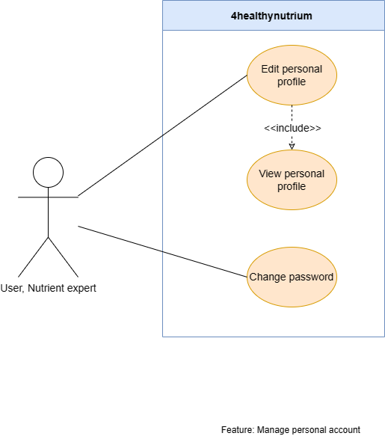

Figure 2.2.3. “Manage personal profile” use cases

##### 2.2.3.1. View personal profile プロフィール表示

|  |  |  |  |
| --- | --- | --- | --- |
| **UC ID and Name:** | **UC-04. View personal profile** | | |
| **Created By:** | VietNH | **Date Created:** | 10/02/2022 |
| **Primary Actor:** | Users | **Secondary Actors:** | N/A |
| **Trigger:** | **TRIG-01.** The user presses on the “Edit Personal Information” option in the Personal Setting Screen. | | |
| **Description:** | This use case allows the user to view his/her profile information. | | |
| **Preconditions:** | **PRE-01.** The user has logged in.  **PRE-02.** The user is in the Personal Profile Setting Screen. | | |
| **Post-conditions:** | N/A | | |
| **Normal Flow:** | **4.0. View the user profile**   1. After PRE-01, PRE-02 are confirmed, the user presses on the “Edit Personal Information” option. 2. The system redirects to the Edit Personal Profile Screen, displays fields containing information of the user:    1. Required text field for name    2. Required date selector for birthdate   Non-required fields are: Gender, Address, Province, District, Ward. | | |
| **Alternative Flows:** | N/A | | |
| **Exceptions:** | N/A | | |
| **Priority:** | High | | |
| **Frequency of Use:** | High | | |
| **Business Rules:** | N/A | | |
| **Other Information:** | 1. If the user has not input any non-required field (Gender, Address, Age, Height, Weight) when registering in the Register Information Screen, fields will display as empty. | | |
| **Assumptions:** | N/A | | |

Table 2.2.3.1. View personal profile

##### 2.2.3.2. Edit personal profile 個人プロフィールを編集する

|  |  |  |  |
| --- | --- | --- | --- |
| **UC ID and Name:** | **UC-05. Edit personal profile** | | |
| **Created By:** | VietNH | **Date Created:** | 10/02/2022 |
| **Primary Actor:** | Users | **Secondary Actors:** | N/A |
| **Trigger:** | **TRIG-01.** The user presses on the “Save changes” button. | | |
| **Description:** | The function allows the user to edit his/her profile information | | |
| **Preconditions:** | **PRE-01.** The user has logged in.  **PRE-02.** The user is in the Edit Personal Profile Screen. | | |
| **Post-conditions:** | **POST-01**. The system updates the user’s profile changes. | | |
| **Normal Flow:** | **5.0. The user edits personal profile**   1. The user makes any changes to any field in the Edit Personal Profile Screen and presses the “Save changes” button to save new changes (see 6.0.E1).   The system updates new changes. | | |
| **Alternative Flows:** | N/A | | |
| **Exceptions:** | **5.0.E1. The user leaves the required fields empty**  1. The user deletes data in required fields and presses the “Save changes” button.  2. The system rejects the user’s attempt, and displays error messages (MSG02). | | |
| **Priority:** | High | | |
| **Frequency of Use:** | Low | | |
| **Business Rules:** | BR-03 | | |
| **Other Information:** | N/A | | |
| **Assumptions:** | N/A | | |

Table 2.2.3.2. Edit personal profile

##### 2.2.3.3. Change password パスワード変更

|  |  |  |  |
| --- | --- | --- | --- |
| **UC ID and Name:** | **UC-06. Change password** | | |
| **Created By:** | VietNH | **Date Created:** | 10/02/2022 |
| **Primary Actor:** | User, Nutrition Expert | **Secondary Actors:** | N/A |
| **Trigger:** | **TRIG-01.** The user presses on the “Change Password” option in the Personal Setting Screen. | | |
| **Description:** | This use case allows the user to change his/her password. | | |
| **Preconditions:** | **PRE-01.** The user has logged in.  **PRE-02.** The user is in the Personal Setting Screen. | | |
| **Post-conditions:** | **POST-01.** The system updates the user’s new password. | | |
| **Normal Flow:** | **6.0 The user changes the password**   1. The system redirects the user to the Change Password Screen, display the following fields:    1. Required text field to input old password.    2. Required text field to input new password.    3. Required text field to input new password confirmation. 2. The user inputs required fields and presses the “Save change” button (see 6.0.E1, 6.0.E2, 6.0.E3, 6.0.E4).   The system updates the new password, displays a message (MSG12) and logs out the user. | | |
| **Alternative Flows:** | N/A | | |
| **Exceptions:** | **6.0.E1. Leave required fields blank.**  1. In step 2, the user does not input the required fields before saving.  2. The system rejects the user’s attempt, display error messages (MSG02).  **6.0.E2 The user inputs wrong password format**  1. The user inputs password less than 8 characters and presses the “Change Password” button.  2. The system rejects the user’s attempt, and displays an error message (MSG01).  **6.0.E3 The user inputs the new password matched with the old password**  1. In step 2, the user inputs the new password matched with the old password and presses the “Change Password” button.  2. The system rejects the user’s attempt, displays an error message (MSG07).  **6.0.E4** **Password confirmation does not match**  1. The user inputs a different password confirmation and the “Change Password” button.  2. The system rejects the user’s attempt, displays an error message (MSG06). | | |
| **Priority:** | High | | |
| **Frequency of Use:** | Low | | |
| **Business Rules:** | BR-07 | | |
| **Other Information:** | N/A | | |
| **Assumptions:** | N/A | | |

Table 2.2.3.3. Change password

#### 2.2.4. Feature “Manage system accounts” システム アカウントの管理

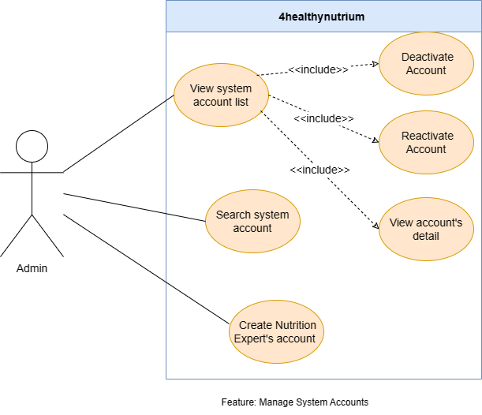

Figure 2.2.4. “Manage system accounts” use cases

##### 2.2.4.1. View system account list システム アカウント リストの表示

|  |  |  |  |
| --- | --- | --- | --- |
| **UC ID and Name:** | **UC-08. View system account list** | | |
| **Created By:** | VietNH | **Date Created:** | 10/02/2022 |
| **Primary Actor:** | Admin | **Secondary Actors:** | N/A |
| **Trigger:** | **TRIG-01.** The admin presses on “Accounts Management” option in the Admin Setting Screen. | | |
| **Description:** | The function allows the admin to view all user’s accounts registered in the system. | | |
| **Preconditions:** | **PRE-01.** The user must login with an admin account.  **PRE-02.** The admin is in the Admin Setting Screen. | | |
| **Post-conditions:** | N/A | | |
| **Normal Flow:** | **8.0. View list of accounts in the system**   1. The admin presses on the “Accounts Management” option in the Admin Setting Screen. 2. The system redirects the admin to the System Account Management Screen, display the following:    1. A search bar to search by email.    2. A combo box includes 2 role Users and Nutrition Expert.   List of all accounts in the system, each item in the list displays the summary of the account, includes avatar, name, email and account status. | | |
| **Alternative Flows:** | N/A | | |
| **Exceptions:** | N/A | | |
| **Priority:** | High | | |
| **Frequency of Use:** | High | | |
| **Business Rules:** | N/A | | |
| **Other Information:** | N/A | | |
| **Assumptions:** | N/A | | |

Table 2.2.4.1. View system account list

##### 2.2.4.2. View account detail アカウントの詳細を表示

|  |  |  |  |
| --- | --- | --- | --- |
| **UC ID and Name:** | **UC-09. View account detail** | | |
| **Created By:** | VietNH | **Date Created:** | 02/10/22 |
| **Primary Actor:** | Admin | **Secondary Actors:** | N/A |
| **Trigger:** | **TRIG-01:** The admin presses on a list item in the System Account List Screen. | | |
| **Description:** | The function allows the admin to view all user’s account details. | | |
| **Preconditions:** | **PRE-01.** The user must login with an admin account.  **PRE-02.** The admin is in the System Account Management Screen. | | |
| **Post-conditions:** | N/A | | |
| **Normal Flow:** | **9.0 View details of the account**   1. The admin presses on a specific list item in the System Account List Screen. 2. The system redirects the admin to the Account Detail Screen, displays the following:    1. Account detail section, displays all information of the account includes: avatar, name, age, email, gender, address and status to describe the locked or unlocked state of the account.    2. A button with label: “Delete Account” to delete account. | | |
| **Alternative Flows:** | N/A | | |
| **Exceptions:** | N/A | | |
| **Priority:** | High | | |
| **Frequency of Use:** | High | | |
| **Business Rules:** | N/A | | |
| **Other Information:** | N/A | | |
| **Assumptions:** | N/A | | |

Table 2.2.4.2. View account detail

##### 2.2.4.3. Search system account 検索システム アカウント

|  |  |  |  |
| --- | --- | --- | --- |
| **UC ID and Name:** | **UC-10. Search system account** | | |
| **Created By:** | VietNH | **Date Created:** | 02/10/22 |
| **Primary Actor:** | Admin | **Secondary Actors:** | N/A |
| **Trigger:** | **TRIG-01.** The admin presses enter on the keyboard after filling in the search bar in the System Account List Screen. | | |
| **Description:** | The function allows the admin to search the system account by phone number or by username. | | |
| **Preconditions:** | **PRE-01.** The user must login with an admin account.  **PRE-02.** The admin is in the System Account List Screen. | | |
| **Post-conditions:** | N/A | | |
| **Normal Flow:** | **10.0.1 Search an account by username in the system**   1. The admin presses to focus on the search bar. 2. The system pops up a keyboard allowing the admin to type in. 3. The user inputs the account's username and presses enter on the keyboard. 4. The system finds matched accounts and displays them in the list of results (See other information 1).   **10.0.2 Search an account by email in the system**   1. The admin presses to focus on the search bar. 2. The system pops up a keyboard allowing the admin to type in. 3. The user inputs the account's email and presses search icon on the screen.   The system finds matched accounts and displays them in the list of results.  **10.0.2 Sort an account by role in the system**   1. The admin presses to focus on the combo box and change between 2 role Users and Nutrition Experts.   The system finds matched accounts and displays them in the list of results. | | |
| **Alternative Flows:** | N/A | | |
| **Exceptions:** | N/A | | |
| **Priority:** | Medium | | |
| **Frequency of Use:** | High | | |
| **Business Rules:** | N/A | | |
| **Other Information:** | 1. The account list returns empty if no records match the username or email. | | |
| **Assumptions:** | N/A | | |

Table 2.2.4.3. Search system account

##### 2.2.4.4. Create Nutritional Expert Account 栄養専門家アカウントを作成

|  |  |  |  |
| --- | --- | --- | --- |
| **UC ID and Name:** | **UC-11. Create Nutritional Expert Account** | | |
| **Created By:** | VietNH | **Date Created:** | 10/02/2022 |
| **Primary Actor:** | Admin | **Secondary Actors:** | N/A |
| **Trigger:** | **TRIG-01.** The user presses on the “Adding” icon with label “Add new nutrition expert”. | | |
| **Description:** | This use case allows the admin to create a new account for nutritional expert to login to the system. | | |
| **Preconditions:** | **PRE-01.** The admin is in System Account List Screen. | | |
| **Post-conditions:** | **POST-01.** The system creates an account for the nutrition expert in the database. | | |
| **Normal Flow:** | **11.0. Create a new account for nutrition expert**  The admin presses on the “Adding” icon with label “Add new nutrition expert” in the System Account List Screen.   1. The system redirects to the “Nutrition Expert Adding” Screen and displays the following:    1. A required number field to input the username.    2. Two required text fields to input password and password confirmation.    3. A required combo box field to input gender.    4. A required text field to input the email.    5. A text field to input the address.    6. A "Choose Image" button to upload a certification. 2. The user inputs required fields; presses “Next” to continue the process. 3. The system registers the nutrition expert’s account, displays a message (MSG06) and redirects the admin back to the System Account List Screen. | | |
| **Alternative Flows:** | N/A | | |
| **Exceptions:** | **11.0.E1. Leave required fields blank**  1. In step 3, the admin’s creating without filling in the required fields  2. The system rejects the admin’s creating attempt and displays error messages (MSG02).  **11.0.E2. The user inputs an invalid username**  1. The admin inputs an invalid username.  2. The system rejects the admin’s creating attempt and displays an error message (MSG04).  **11.0.E3. The user inputs wrong password format**  1. The user inputs a password less than 8 characters.  2. The system displays an error message (MSG10).  **11.0.E4. The user inputs unmatched password re-confirmation**  1. In step 3, the admin inputs unmatched password re-confirmation, the system displays an error message (MSG06).  **11.0.E5. Use existing username or banned username to register**  1. In step 3, the admin inputs existed username or banned username.  2. The system rejects the admin’s creating attempt and displays an error message (MSG05). | | |
| **Priority:** | High | | |
| **Frequency of Use:** | High | | |
| **Business Rules:** | BR-03, BR-06, BR-07 | | |
| **Other Information:** |  | | |
| **Assumptions:** | N/A | | |

Table 2.2.4.4. Register

#### 2.2.5. Feature “Search fiFood” 食べ物を探す

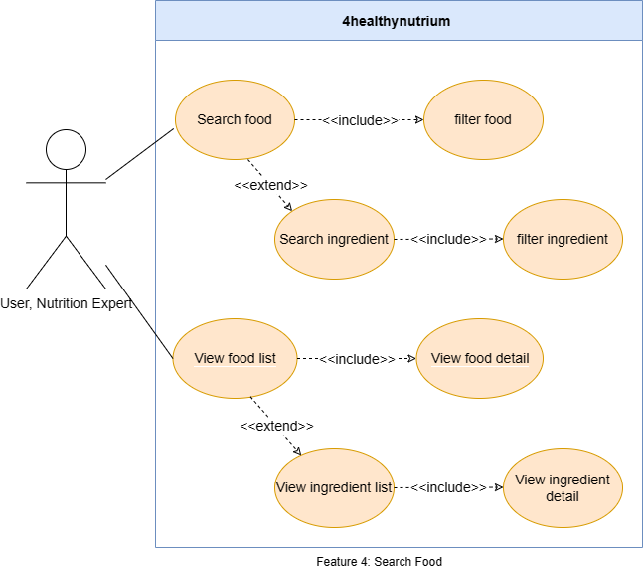

Figure 2.2.5. “Search Food” use cases

##### 2.2.5.1. Search Food 食べ物を探す

|  |  |  |  |
| --- | --- | --- | --- |
| **UC ID and Name:** | **UC-11. Search Food by Food Name** | | |
| **Created By:** | VietNH | **Date Created:** | 10/02/2022 |
| **Primary Actor:** | Nutrition Expert, Users | **Secondary Actors:** | N/A |
| **Trigger:** | **TRIG-01:** The user or nutrition expert presses on the “Library” icon in the navigation bar.  **TRIG-02:** The user nutrition expert presses on the “Recipe” in the Search Recipe and Ingredient Screen. | | |
| **Description:** | This use case allows the user to search food information which they want to know.  This use case allows the nutrition expert for easier searching food to edit. | | |
| **Preconditions:** | **PRE-01.** The user or the nutrition expert has logged in.  **PRE-02.** The user or the nutrition expert is in the Search Recipe and Ingredient Screen. | | |
| **Post-conditions:** | N/A | | |
| **Normal Flow:** | **12.0 Go to Recipe and Ingredient List Screen**   1. After PRE-01, PRE-02 is confirmed, the user presses on the “Recipe” button in the double button. 2. The system redirects the user to the Recipe List Screen. (See other information 1, 2, 3). 3. The system displays list of food in the database.   **12.0.1 Search a food by its name**   1. The user or nutrition expert presses to focus on the search bar. 2. The system pops up a keyboard allowing the user or nutrition expert to type in. 3. The user and the nutrition expert input the food name and presses search icon on the screen. 4. The system finds matched accounts and displays them in the list of results.   **12.0.2 Filter a food by category in the system**   1. The user or nutrition expert presses to focus on the combo box and choose which category they want to filter.   The system finds matched category and displays them in the list of results.  **12.0.3 Filter a food by season in the system**   1. The user or nutrition expert presses to focus on the combo box and choose which season they want to filter.   The system finds matched season and displays them in the list of results. | | |
| **Alternative Flows:** | N/A | | |
| **Exceptions:** | N/A | | |
| **Priority:** | High | | |
| **Frequency of Use:** | High | | |
| **Business Rules:** | N/A | | |
| **Other Information:** | 1. The food list returns empty if no records match the food name. | | |
| **Assumptions:** | N/A | | |

Table 2.5.5.1. Search Food

##### 2.2.5.2. Search Ingredient 材料を探す

|  |  |  |  |
| --- | --- | --- | --- |
|  | **UC-12. Search Ingredient** | | |
| **Created By:** | VietNH | **Date Created:** | 10/02/2022 |
| **Primary Actor:** | Nutrition Expert, Users | **Secondary Actors:** | N/A |
| **Trigger:** | **TRIG-01:** The user or the nutrition expert presses on the “Library” in the navigation bar.  **TRIG-02:** The user or the nutrition expert presses on the “Ingredient” in the Search Recipe and Ingredient Screen. | | |
| **Description:** | This use case allows the user to search ingredient information which they want to know.  This use case allows the nutrition expert for easier searching ingredient to edit. | | |
| **Preconditions:** | **PRE-01.** The user has logged in.  **PRE-02.** The user is in the Search Result Screen. | | |
| **Post-conditions:** | N/A | | |
| **Normal Flow:** | **13.0 Go to Recipe and Ingredient List Screen**   1. After PRE-01, PRE-02 is confirmed, the user presses on the “Recipe” button in the double button. 2. The system redirects the user to the Recipe List Screen. 3. The system displays list of food in the database.   **12.0.1 Search an ingredient by its name**   1. The user or nutrition expert presses to focus on the search bar. 2. The system pops up a keyboard allowing the user or nutrition expert to type in. 3. The user and the nutrition expert input the ingredient name and presses search icon on the screen. 4. The system finds matched ingredient name and displays them in the list of results.   **13.0.2 Filter a food by category in the system**   1. The user or nutrition expert presses to focus on the combo box and choose which category they want to filter.   The system finds matched category and displays them in the list of results.  **13.0.3 Filter a food by season in the system**   1. The user or nutrition expert presses to focus on the combo box and choose which season they want to filter.   The system finds matched season and displays them in the list of results. | | |
| **Alternative Flows:** | N/A | | |
| **Exceptions:** | N/A | | |
| **Priority:** | High | | |
| **Frequency of Use:** | High | | |
| **Business Rules:** | N/A | | |
| **Other Information:** | 1. The ingredient list returns empty if no records match the ingredient name. | | |
| **Assumptions:** | N/A | | |

Table 2.2.5.2. Search ingredient

#### 2.2.6. Feature “Manage Personal Nutrition” 個人の栄養を管理

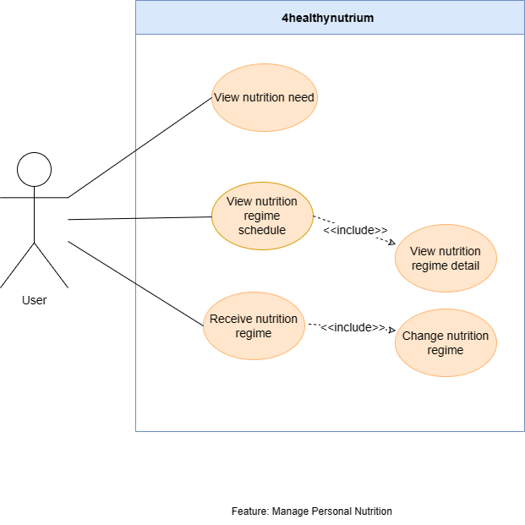

Figure 2.2.6. “Manage Personal Nutrition” use cases

##### 2.2.6.1. View nutrition regime 個人の栄養管理をビュー

|  |  |  |  |
| --- | --- | --- | --- |
| **UC ID and Name:** | **UC-013. View Nutrition Regime** | | |
| **Created By:** | VietNH | **Date Created:** | 10/02/2022 |
| **Primary Actor:** | User | **Secondary Actors:** | N/A |
| **Trigger:** | **TRIG-01.** The user presses on the “Nutrition Regime Plan” button in the navigation bar. | | |
| **Description:** | This use case allows the user to view the nutrition regime. | | |
| **Preconditions:** | **PRE-01.** The user has logged in.  **PRE-02.** The user is in the “View Nutrition Regime” Screen. | | |
| **Post-conditions:** | N/A | | |
| **Normal Flow:** | **15.0. Go to “My Profile” screen.**  1. After PRE-01 is confirmed, the user presses on “My Profile” screen.  2. The system will send user to “Personal Schedule Screen”, which display diet information in current day. | | |
| **Alternative Flows:** | **15.1. Go to “My diet” screen.**   1. After PRE-01, PRE-02 is confirmed, the system display the Detail Diet.    1. If the user have their diet in database, the system will display user’s diet information in current day.    2. If the user don’t have their diet in database, the system will display nothing. 2. If the user clicks onto the button “I want eat this”, then back to screen “My diet”. | | |
| **Exceptions:** | N/A | | |
| **Priority:** | High | | |
| **Frequency of Use:** | High | | |
| **Business Rules:** | N/A | | |
| **Other Information:** |  | | |
| **Assumptions:** | N/A | | |

##### 2.2.6.2. Receive nutrition regime 栄養管理を受ける

|  |  |  |  |
| --- | --- | --- | --- |
| **UC ID and Name:** | **UC-14. Receive nutrition regime** | | |
| **Created By:** | VietNH | **Date Created:** | 10/02/2022 |
| **Primary Actor:** | User | **Secondary Actors:** | N/A |
| **Trigger:** | **TRIG-01.** The user presses on the “My diet” button in the navigation bar.  **TRIG-02.1.** If user’s data about weight, height, job, frequency exercise haven’t existed in database. User have to fill this information in “Input height and weight” screen, “Input frequency exercise” screen, “Input job” screen.  **TRIG-02.2** If user’s data about weight, height, job, frequency exercise haven’t existed in database, redirect to “Diet Detail Screen”. | | |
| **Description:** | This use case allows the user to view the nutrition regime detail. | | |
| **Preconditions:** | **PRE-01.** The user has logged in.  **PRE-02.** The user is in the My Diet Screen.  **PRE-03.** If user’s data about weight, height, job, frequency exercise haven’t existed in database, they have to fill it in required screens. | | |
| **Post-conditions:** | N/A | | |
| **Normal Flow:** | **14.0.1 Go to My diet screen (have already had necessary information)**   1. After PRE-01 is confirmed, the user presses on the “My diet” button in the navigation bar. 2. The system redirects the user to the My diet Screen. 3. The system displays user’s information in “Summary Profile Screen”. 4. If user press “Receive my diet” button, display an alert message (MSG15). If user choose “Yes”, they will go to screen “Diet Detail” which show their diet for a day.   **14.0.2 Go to My diet screen (haven’t had necessary information)**   1. After PRE-01 is confirmed, the user presses on the “My diet” button in the navigation bar. 2. The system redirects the user to the My diet Screen. 3. The system will display “Input height and weight” screen, “Input frequency exercise” screen, “Input job” screen. User have to fill all of these screens to receive their diet. 4. The system displays user’s information in “Summary Profile Screen”. 5. If user press “Receive my diet” button, display an alert message (MSG15). If user choose “Yes”, they will go to screen “Diet Detail” which show their diet for a day. | | |
| **Alternative Flows:** |  | | |
| **Exceptions:** | N/A | | |
| **Priority:** | High | | |
| **Frequency of Use:** | High | | |
| **Business Rules:** | N/A | | |
| **Other Information:** | 1. By pressing “Yes” button when alert message (MSG15) exists, the current information of the user is in will be saved and can be later viewed in the My Profile Screen. | | |
| **Assumptions:** | N/A | | |

Table 2.2.5.4. Receive diet

##### 2.2.6.3. Change nutrition regime 栄養体制を変える

|  |  |  |  |
| --- | --- | --- | --- |
| **UC ID and Name:** | **UC-15. Change nutrition regime** | | |
| **Created By:** | VietNH | **Date Created:** | 10/02/2022 |
| **Primary Actor:** | User | **Secondary Actors:** | N/A |
| **Trigger:** | **TRIG-01.** The user presses on the “My diet” button in the navigation bar.  **TRIG-02:** The user nutrition expert presses on the “Recipe” in the Search Recipe and Ingredient Screen. | | |
| **Description:** | This use case allows the user to change food in diet. | | |
| **Preconditions:** | **PRE-01.** The user has logged in.  **PRE-02.** The user is in the “Receive diet detail” Screen. | | |
| **Post-conditions:** | N/A | | |
| **Normal Flow:** | **15.0. When user have already received their daily personal diet.**   1. After PRE-01, PRE-02 is confirmed, the system display the Detail Diet. 2. If the user wants to change foods in their diet, click onto “Swap” icon in the right of food displayed. 3. The system displays another food which still meet the requirements. 4. If the user clicks onto the button “I want eat this”, then back to screen “My diet”. | | |
| **Alternative Flows:** |  | | |
| **Exceptions:** | N/A | | |
| **Priority:** | High | | |
| **Frequency of Use:** | High | | |
| **Business Rules:** | N/A | | |
| **Other Information:** | 1. By pressing “I want eat this” button, the current information of the user’s diet is in will be saved and can be later viewed in the My Diet. | | |
| **Assumptions:** | N/A | | |

Table 2.2.5.4. Receive diet

#### 2.2.7. Feature “Manage Food” 食べ物を管理する

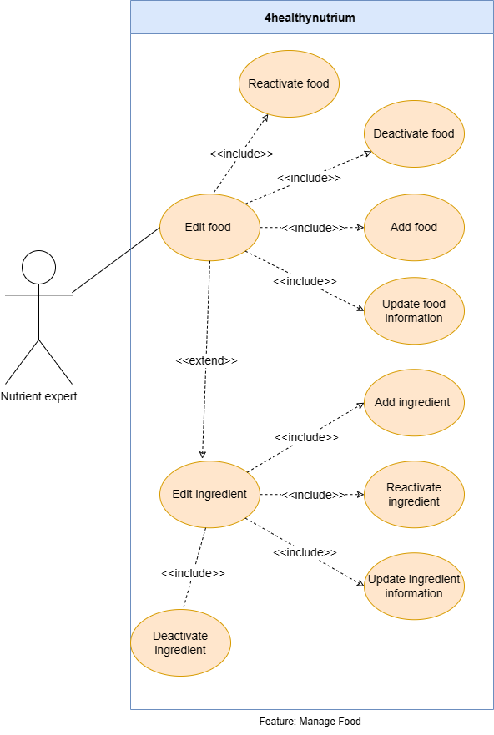

Figure 2.2.7. “Receive diet” use cases

##### 2.2.7.1. Add Food 食べ物を追加

|  |  |  |  |
| --- | --- | --- | --- |
| **UC ID and Name:** | **UC-17. Add Food** | | |
| **Created By:** | VietNH | **Date Created:** | 10/13/2021 |
| **Primary Actor:** | Nutritional Expert | **Secondary Actors:** | N/A |
| **Description:** | This allows the nutrition expert to add a new food to the system. | | |
| **Trigger:** | **TRIG-01.** The user presses on the “Add Food” button in the Food List Screen. | | |
| **Preconditions:** | **PRE-01.** The nutrition is logged in.  **PRE-02.** The user is in the Food List Screen. | | |
| **Post-conditions:** | **POST-01**. The Food’s information is created in a database.  **POST**-**02.** The Food’s information created will be displayed as a product card in the Food List Screen. | | |
| **Normal Flow:** | **17.0.1. Add new food**   1. After PRE-01, PRE-02 are confirmed, the user presses on the “Add food” button on the screen. 2. The system redirects the user to the Adding Food Screen, displays the following:    1. A required section to upload images of the food.    2. A required text field to input the food name.    3. A required combo box to input meal type.    4. A required combo box to input seasonal type.    5. A required text area labelled “Recipe” to input how to cook this food.    6. A required “adding” icon with list box to add the ingredients.    7. A required text area to input food description.    8. A required text field to input food’s calories value.    9. A required text field to input food’s fat value.    10. A required text field to input food’s carb value.    11. A required text field to input food’s protein value. 3. The user fills in required fields and presses the “Save” button to save the information. 4. The system redirects the nutrition expert back to the Food List Screen, accepts new information in the form, creates a new food, and displays pop-up message (MSG16).   The user presses on the “Confirm” button in the pop-up message to be redirected back to the Food List Screen. | | |
| **Alternative Flows:** | N/A | | |
| **Exceptions:** | **17.0.E1. Leaving the required field blank**  1. In step 4, the nutrition expert leaves required fields blank.  2. The system rejects the nutrition expert’s attempt, displays error messages (MSG02).  **17.0.E2. The nutrition expert does not select the value in combo box**  1. The nutrition expert does not select the meal type and season before pressing the “Save” button.  2. The system rejects the nutrition expert’s attempt, displays an error pop-up message (MSG17).  **17.0.E3. The system failed to create new food information**  1. The system displays an error pop-up message. (MSG17) | | |
| **Priority:** | High | | |
| **Frequency of Use:** | Low | | |
| **Business Rules:** | N/A | | |
| **Other Information:** | 1. If the Food List Screen does not have any food values, the system shows the “Add Food” button in the middle of the screen.  2. The maximum number of images the user can upload within the food profile is 1 image. | | |
| **Assumptions:** | N/A | | |

Table 2.2.9.1. Add Food

##### 2.2.7.2. Add Ingredient 材料を加える

|  |  |  |  |
| --- | --- | --- | --- |
| **UC ID and Name:** | **UC-18. Add Ingredient** | | |
| **Created By:** | VietNH | **Date Created:** | 10/13/2021 |
| **Primary Actor:** | Nutritional Expert | **Secondary Actors:** | N/A |
| **Description:** | This allows the nutrition expert to add a new ingredient to the system. | | |
| **Trigger:** | **TRIG-01.** The user presses on the “Add Ingredient” button in the Ingredient List Screen. | | |
| **Preconditions:** | **PRE-01.** The nutrition is logged in.  **PRE-02.** The user is in the Ingredient List Screen. | | |
| **Post-conditions:** | **POST-01**. The ingredient’s information is created in a database.  **POST**-**02.** The ingredient’s information created will be displayed as a product card in the ingredient List Screen. | | |
| **Normal Flow:** | **18.0.1. Add new food**   1. After PRE-01, PRE-02 are confirmed, the user presses on the “Add ingredient” button on the screen. 2. The system redirects the user to the Adding Ingredient Screen, displays the following:    1. A required section to upload images of the ingredient.    2. A required text field to input the ingredient name.    3. A required text area to input ingredient description.    4. A required text field to input ingredient’s calories value.    5. A required text field to input ingredient’s fat value.    6. A required text field to input ingredient’s carb value.    7. A required text field to input ingredient’s protein value.    8. Required text fields to input ingredient’s vitamin values.    9. Required text fields to input ingredient’s mineral values. 3. The user fills in required fields and presses the “Save” button to save the information. 4. The system redirects the nutrition expert back to the Ingredient List Screen, accepts new information in the form, creates a new food, and displays pop-up message (MSG18).   The user presses on the “Confirm” button in the pop-up message to be redirected back to the Ingredient List Screen. | | |
| **Alternative Flows:** | N/A | | |
| **Exceptions:** | **18.0.E1. Leaving the required field blank**  1. In step 4, the nutrition expert leaves required fields blank.  2. The system rejects the nutrition expert’s attempt, displays error messages (MSG02).  **18.0.E2. The system failed to create new food information**  1. The system displays an error pop-up message. (MSG19) | | |
| **Priority:** | High | | |
| **Frequency of Use:** | Low | | |
| **Business Rules:** | N/A | | |
| **Other Information:** | 1. If the Ingredient List Screen does not have any food values, the system shows the “Add Ingredient” button in the middle of the screen.  2. The maximum number of images the user can upload within the ingredient profile is 1 image. | | |
| **Assumptions:** | N/A | | |

Table 2.2.9.1. Add Ingredient

##### 2.2.7.3. Update Food Information 食品情報を更新する

|  |  |  |  |
| --- | --- | --- | --- |
| **UC ID and Name:** | **UC-21 Update Food Information** | | |
| **Created By:** | VietNH | **Date Created:** | 10/20/2022 |
| **Primary Actor:** | Nutrition Expert | **Secondary Actors:** | N/A |
| **Description:** | This allows the Nutrition Expert to edit an existing food profile in the database. | | |
| **Trigger:** | **TRIG-01.** The Nutrition Expert pressed on the "Edit” icon in the Food List Screen. | | |
| **Preconditions:** | **PRE-01.** The nutrition expert is logged in.  **PRE-03.** The nutrition expert is in the Food List Screen. | | |
| **Post-conditions:** | **POST-01.** The food’s profile is updated in the database. | | |
| **Normal Flow:** | **21.0. Edit food’s profile**   1. After PRE-01, PRE-02 are confirmed, the user presses on the “Edit” icon in the right of food card. 2. The system redirects the owner to the Food Screen to edit the current food’s information, displays the following:    1. A required image section to upload an image of Food.    2. A required text field to input the food name.    3. A required combo box to input meal type.    4. A required combo box to input seasonal type.    5. A required text area labelled “Recipe” to input how to cook this food.    6. A required “adding” icon with list box to add the ingredients.    7. A required text area to input food description.    8. A required text field to input food’s calories value.    9. A required text field to input food’s fat value.    10. A required text field to input food’s carb value.    11. A required text field to input food’s protein value. 3. The user fills in required fields and presses the “Save” button to save the information. 4. The system redirects the nutrition expert back to the Food List Screen, accepts new information in the form, creates a new food, and displays pop-up message (MSG16).   The user presses on the “Confirm” button in the pop-up message to be redirected back to the Food List Screen. | | |
| **Alternative Flows:** | N/A | | |
| **Exceptions:** | **21.0.E1. Leaving the required field blank**  1. In step 4, the nutrition expert leaves required fields blank.  2. The system rejects the nutrition expert’s attempt, displays error messages (MSG02).  **21.0.E2. The nutrition expert does not select the value in combo box**  1. The nutrition expert does not select the meal type and season before pressing the “Save” button.  2. The system rejects the nutrition expert’s attempt, displays an error pop-up message (MSG17).  **21.0.E3. The system failed to create new food information**  1. The system displays an error pop-up message. (MSG17) | | |
| **Priority:** | High | | |
| **Frequency of Use:** | High | | |
| **Business Rules:** | BR-11 | | |
| **Other Information:** |  | | |
| **Assumptions:** | N/A | | |

Table 2.2.9.6. Edit Food

##### 2.2.7.4. Update Ingredient Information 材料情報を更新する

|  |  |  |  |
| --- | --- | --- | --- |
| **UC ID and Name:** | **UC-22 Update Food Information** | | |
| **Created By:** | VietNH | **Date Created:** | 10/20/2022 |
| **Primary Actor:** | Nutrition Expert | **Secondary Actors:** | N/A |
| **Description:** | This allows the Nutrition Expert to edit an existing food profile in the database. | | |
| **Trigger:** | **TRIG-01.** The Nutrition Expert pressed on the "Edit” icon in the Ingredient List Screen. | | |
| **Preconditions:** | **PRE-01.** The nutrition expert is logged in.  **PRE-03.** The nutrition expert is in the Ingredient List Screen. | | |
| **Post-conditions:** | **POST-01.** The food’s profile is updated in the database. | | |
| **Normal Flow:** | **22.0. Edit food’s profile**   1. After PRE-01, PRE-02 are confirmed, the user presses on the “Edit” icon in the right of food card. 2. The system redirects the owner to the Ingredient Screen to edit the current food’s information, displays the following:    1. A required image section to upload an image of ingredient.    2. A required text field to input the ingredient name.    3. A required text area to input ingredient description.    4. A required text field to input ingredient’s calories value.    5. A required text field to input ingredient’s fat value.    6. A required text field to input ingredient’s carb value.    7. A required text field to input ingredient’s protein value.    8. Required text fields to input ingredient’s vitamin values.    9. Required text fields to input ingredient’s mineral values. 3. The user fills in required fields and presses the “Save” button to save the information. 4. The system redirects the nutrition expert back to the Ingredient List Screen, accepts new information in the form, creates a new food, and displays pop-up message (MSG18). | | |
| **Alternative Flows:** | N/A | | |
| **Exceptions:** | **22.0.E1. Leaving the required field blank**  1. In step 4, the nutrition expert leaves required fields blank.  2. The system rejects the nutrition expert’s attempt, displays error messages (MSG02).  **22.0.E2. The system failed to update new food information**  1. The system displays an error pop-up message. (MSG17) | | |
| **Priority:** | High | | |
| **Frequency of Use:** | High | | |
| **Business Rules:** | BR-11 | | |
| **Other Information:** |  | | |
| **Assumptions:** | N/A | | |

Table 2.2.9.6. Edit Ingredient

## 3. Functional Requirements（機能要件）

### 3.1 System Functional Overview（システム機能の概要）

#### 3.1.1 Screen Flow スクリーンフロー

##### 3.1.1.1. User ユーザー

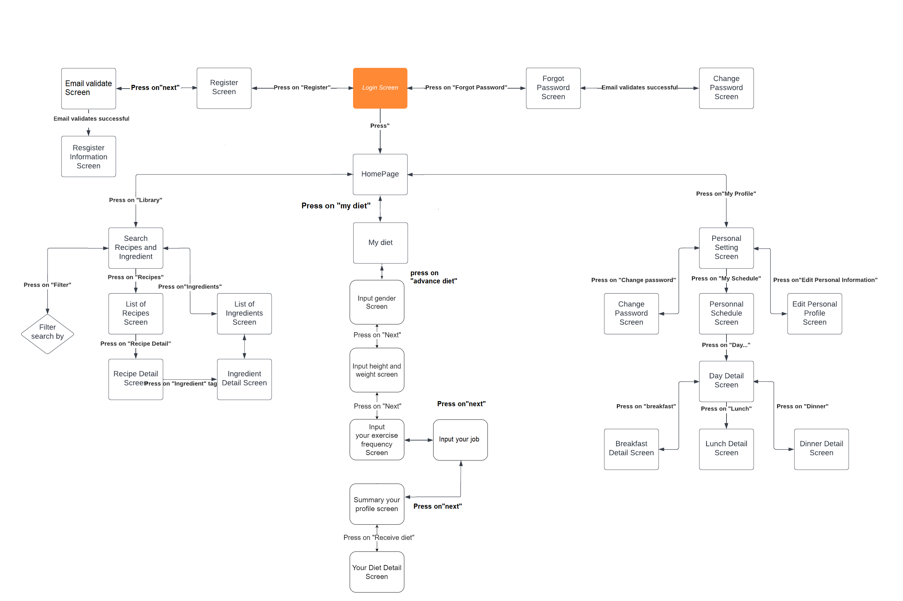

Figure 3.1.1.1. User Screen Flow

##### 3.1.1.2. Admin 管理者

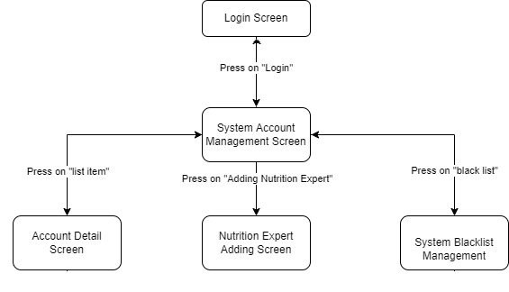

Figure 3.1.1.2. Admin Screen Flow

##### 3.1.1.3. Nutrition Expert 栄養士

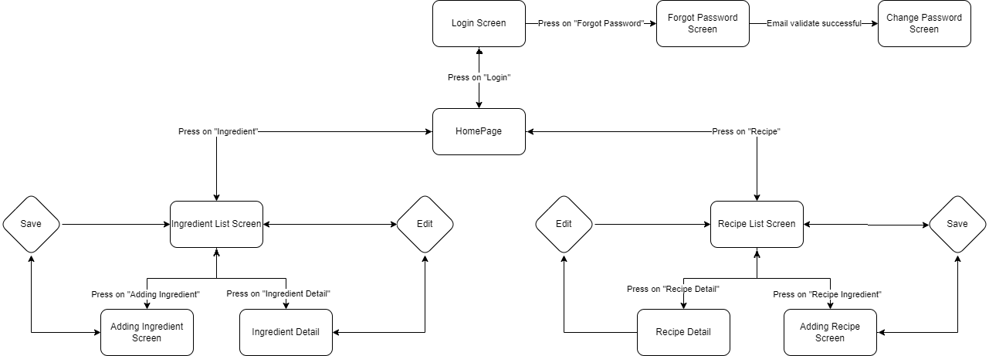

Figure 3.1.1.3. Nutrition Expert Screen Flow

**3.1.2. Screen Descriptions 画面説明**

##### 3.1.2.1. User ユーザー

|  |  |  |  |
| --- | --- | --- | --- |
| **#** | **Feature** | **Screen** | **Description** |
|  | Login and Register | Login | Log in to the system. |
|  | Forgot password | Request change password. |
|  | Register | Register a new account. |
|  | Email Validation | Request email validation. |
|  | Register information | Register personal information for a new account. |
|  | Manage personal profile | Personal setting | View profile management menu. |
|  | Edit personal profile | View and edit personal profile. |
|  | Personal schedule | View personal schedule diets. |
|  | Day Detail | View diet in a day. |
|  | Breakfast Detail | View breakfast diet. |
|  | Lunch Detail | View lunch diet. |
|  | Dinner Detail | View dinner diet. |
|  | Change password | Change old password to new password. |
|  | Search food | Search Food | Searches for all foods information in 4HealthyNutrium library. |
|  | Search Ingredient | Searches for all ingredients information in 4HealthyNutrium library. |
|  | Receive diet | My diet | Show user’s personal diet in a day. |
|  | Input gender | Require the user to enter information. |
|  | Input weight and height | Require the user to enter information. |
|  | Input job | Require the user to enter information |
|  | Input exercise frequency | Require the user to enter information |
|  | Summary profile | View personal recently input information (gender, weight, height, job, exercise frequency, etc.) |
|  | Diet Detail | Show detail diet for user. |
|  | Search food | Search Foods and Ingredients | Show food or ingredient list. |
|  | List of Foods | Show food list. |
|  | List of Ingredient | Show ingredient list. |
|  | Food Detail | Show selected food detail. |
|  | Ingredient Detail | Show selected ingredient detail. |

Table 3.1.2.1. User’s screen descriptions

##### 3.1.2.2. Nutrition Expert 栄養士

|  |  |  |  |
| --- | --- | --- | --- |
| **#** | **Feature** | **Screen** | **Description** |
|  | Manage food | Add food | Add foods to library. |
|  | Add ingredient | Add ingredients to library. |
|  | Update food | Update food to library. |
|  | Update ingredient | Update ingredient to library. |
|  | Login | Login | Log in to the system. |
|  | Forgot password | Request change password. |
|  | Email Validation | Request email validation. |

Table 3.1.2.2. Nutrition Expert’s screen descriptions

##### 3.1.2.3. Admin 管理者

|  |  |  |  |
| --- | --- | --- | --- |
| **#** | **Feature** | **Screen** | **Description** |
|  | Manage system accounts | System account management | Show list of user account in the system, comes with management functions. |
|  | Account detail screen | Show detail of user account. |
|  | Add Nutrition Expert | Add nutrition expert. |

Table 3.1.2.3. Admin’s screen descriptions

##### 3.1.3. Screen Authorization 画面認可

|  |  |  |  |
| --- | --- | --- | --- |
| **Screen** | **User** | **Nutrition Expert** | **Admin** |
| Login | X | X | X |
| Forgot password | X | X | X |
| Register | X |  |  |
| Register information | X |  |  |
| Personal setting | X |  |  |
| Edit personal profile | X |  |  |
| Change password | X | X | X |
| List of Foods | X | X |  |
| Filter search | X | X |  |
| List of Ingredients | X | X |  |
| Food Detail | X | X |  |
| Ingredient Detail | X | X |  |
| Input gender | X |  |  |
| Input height and weight | X |  |  |
| Input exercise frequency | X |  |  |
| Input job | X |  |  |
| Summary profile | X |  |  |
| My diet | X |  |  |
| Personal Schedule | X |  |  |
| Day Detail | X |  |  |
| Breakfast Detail | X |  |  |
| Lunch Detail | X |  |  |
| Dinner Detail | X |  |  |
| System Account |  |  | X |
| Account Detail |  |  | X |
| Add Nutrition Expert |  |  | X |
| Add Ingredients |  | X |  |
| Edit Ingredients |  | X |  |
| Email verification | X | X |  |

Table 3.1.3. Screen authorization

##### 3.1.4. Entity Relationship Diagram 実体関連図

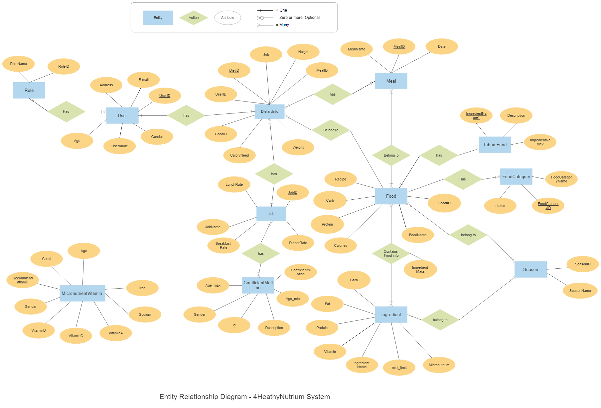

Figure 3.1.4. 4HealthyNutrium Entity Relationship Diagram

|  |  |  |
| --- | --- | --- |
| **ID** | **Entity** | **Description** |
| 1 | User | An actor who uses the system. |
| 2 | Role | A user can have one role only, either normal user or admin. |
| 3 | Dietary Info | User’s diet information. |
| 4 | Meal | Include suggested foods which divided by meal. |
| 5 | Food | Editable by nutrition expert only. |
| 6 | Ingredient | Editable by nutrition expert only. |
| 7 | Taboo Food | Includes ingredients that should not be eaten together. |
| 8 | Season | Include foods and ingredient which divided by season. |
| 9 | Exercise | Contain information about personal exercise. |

Table 3.1.4. Entities Description

### 3.2. Feature “Login and register” 特徴「ログインして登録」

#### 3.2.1. Login ログイン

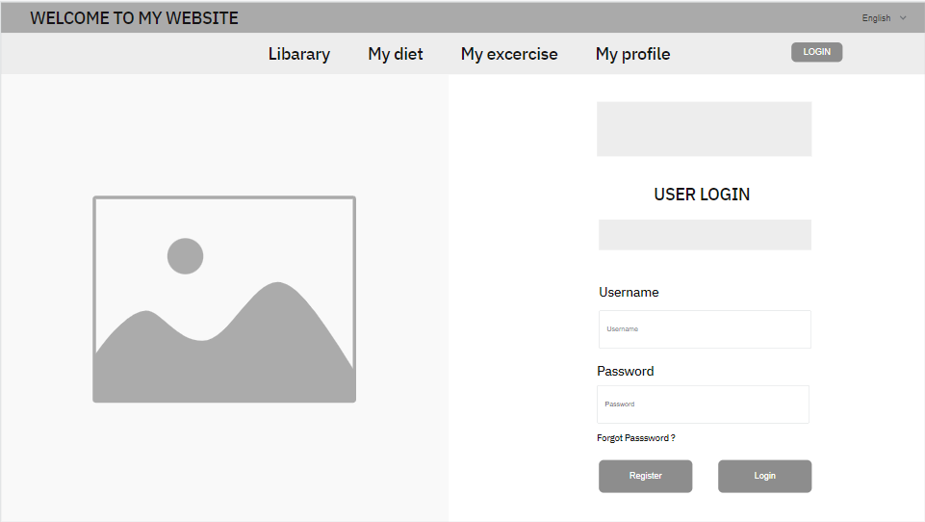

Figure 3.2.2. “Login” Mockup

|  |  |
| --- | --- |
| **Description** | The screen will appear if the user has not logged in for the first time or has logged out. |
| **Functional requirement** | * Password must be at least 8 characters. * The logo is small in size, appearing at the top of the form. * Forgot password and Register navigation buttons must be underlined. |

#### 3.2.2. Register 登録

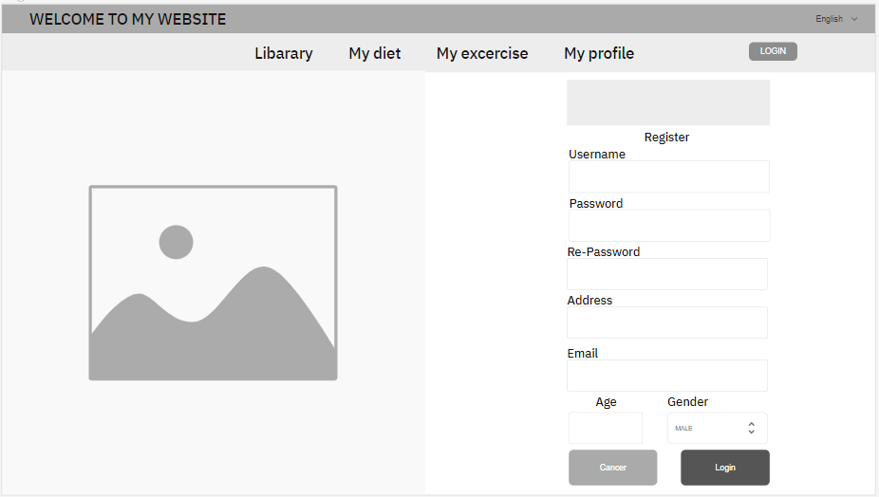

Figure 3.2.3. “Register” Mockup

|  |  |
| --- | --- |
| **Description** | This screen allows users to register with a new phone number to gain access to the system. |
| **Functional requirement** | * Phone numbers are limited to Vietnam region. * Password, re-enter password must be 8 characters long. * Provinces, districts and wards are limited to the Vietnam region. |

#### 3.2.3. Forgot password パスワードをお忘れた

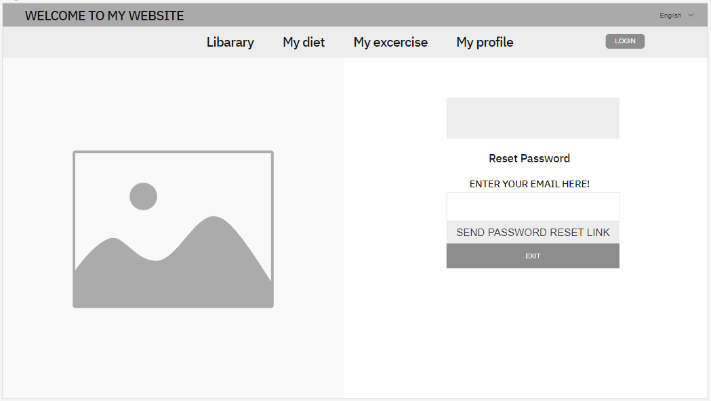

Figure 3.2.4. “Forgot password” Mockup

|  |  |
| --- | --- |
| **Description** | This screen allows users to reset their password when they forget the original password. |
| **Functional requirement** | * Password, re-enter password must be 8 characters long. |

#### 3.2.4. Email Validation 電子メールの検証

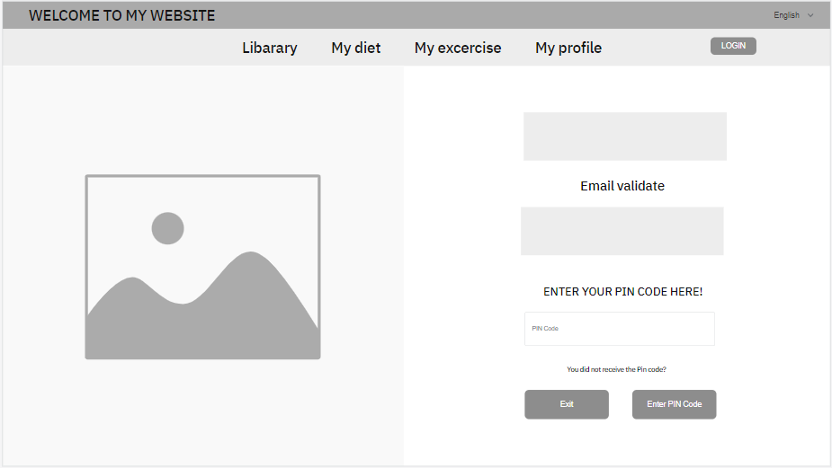

Figure 3.2.5. “Email Validation” Mockup

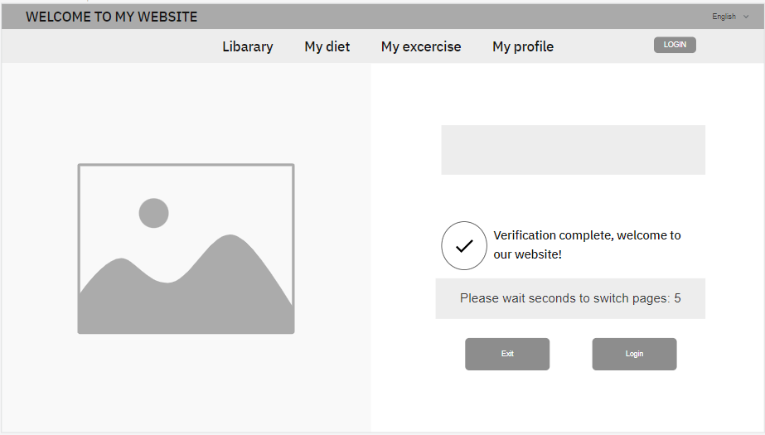

Figure 3.2.6. “Email successful Validation” Mockup

|  |  |
| --- | --- |
| **Description** | This screen is displayed in cases such as registration, forgetting password, changing phone number to be authenticated via email validation message. |
| **Functional requirement** | * Displays the email sending the email validation code. * The timeout for the resend button to show up is 1 minute. * The continue button will enable when the user enters all 6 numeric characters. |

### 3.3. Feature “Manage personal profile” 特徴「個人プロフィールの管理」

#### 3.3.1. View Personal profile 個人プロフィールを見る

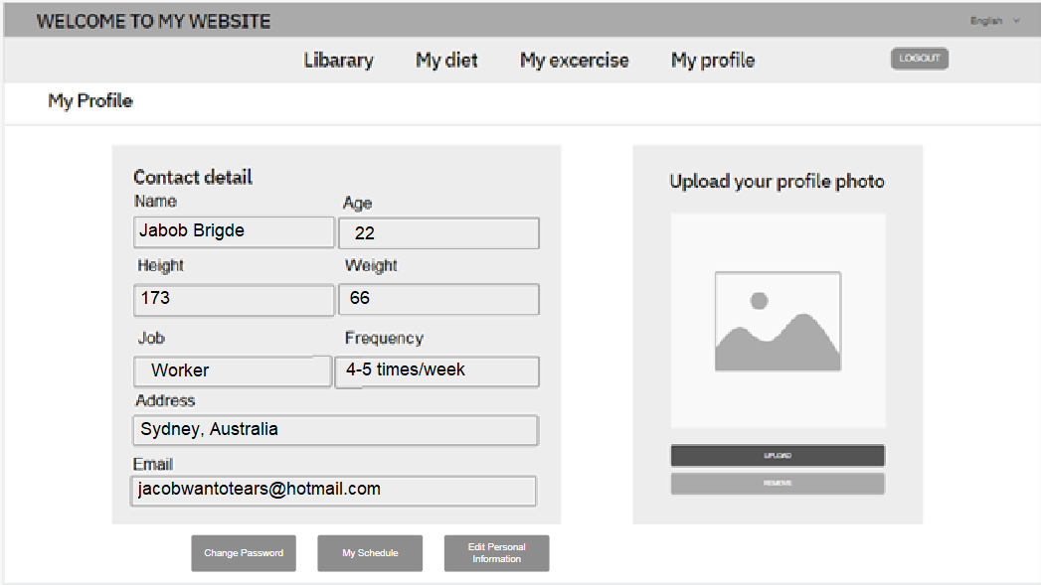

Figure 3.3.1. “Personal options” Mockup

|  |  |
| --- | --- |
| **Description** | This screen is displayed when the user clicks to view personal information on the navigation bar. |
| **Functional requirement** | * Show avatar, full name, number of catches. * The logout button should be colored red. |

#### 3.2.2. Edit personal profile 個人プロフィールを編集

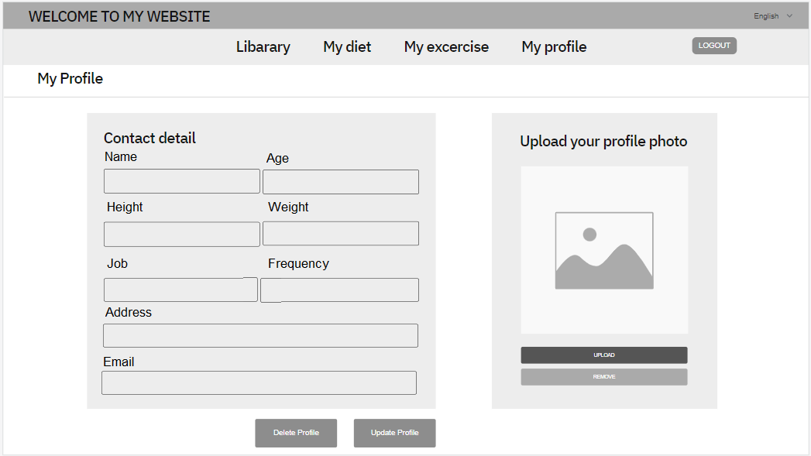

Figure 3.2.2. “Edit personal profile” Mockup

|  |  |
| --- | --- |
| **Description** | The screen displays full personal information of the user, and can be edited and updated. |
| **Functional requirement** |  |

#### 3.2.3. Change password パスワードを変更する

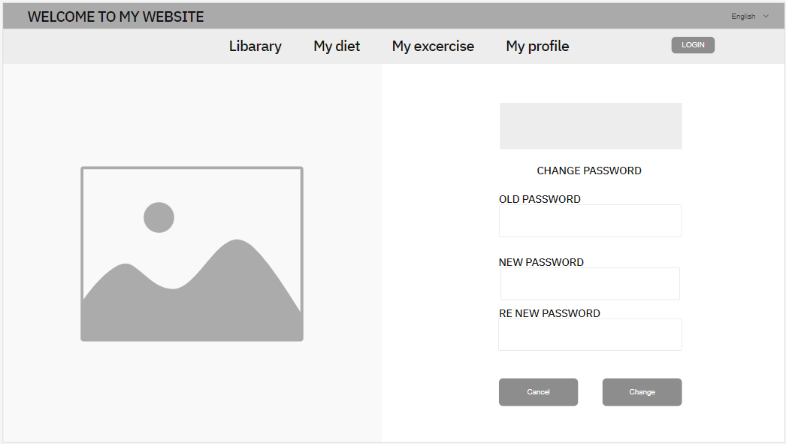

Figure 3.2.4. “Change password” Mockup

|  |  |
| --- | --- |
| **Description** | This screen allows the user to change to a new password. |
| **Functional requirement** | * Old password, new password, and re-enter new password must be 8 characters long. |

#### 3.2.4. Personal Schedule 個人スケジュール

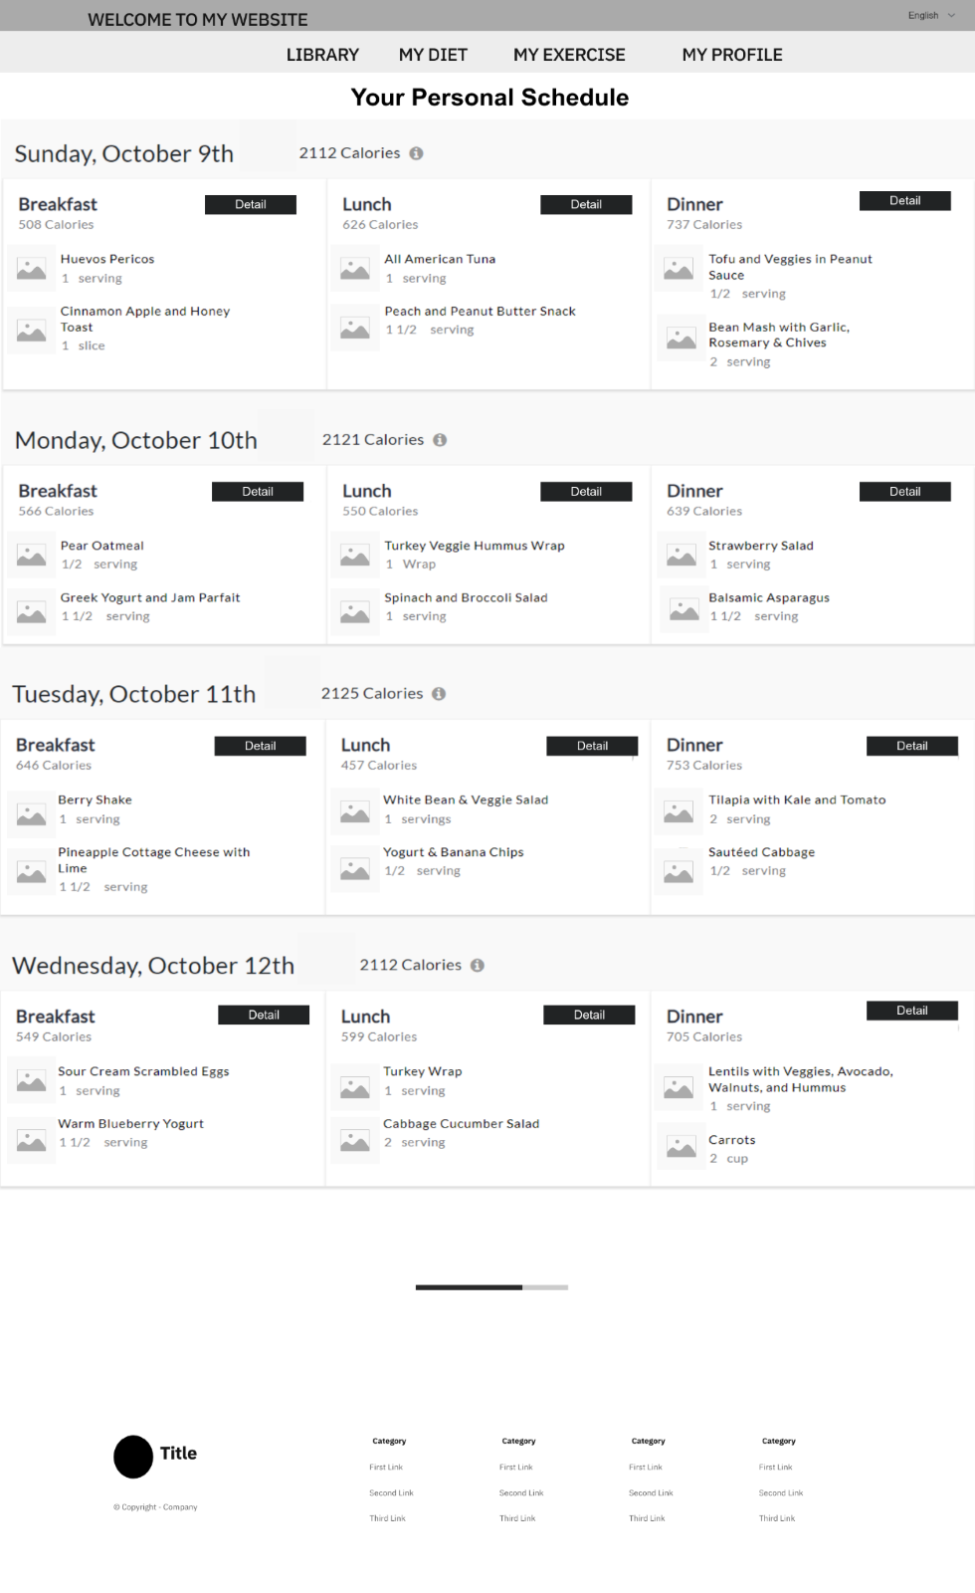

Figure 3.4.1. “System account management” Mockup

|  |  |
| --- | --- |
| **Description** | This screen allows the user to see their dietary schedule. |
| **Functional requirement** | * Each day has 3 meals. It also display food information of each meals, calories values of each day. * User can click “Detail” to go to “Diet Detail” screen. |

### 3.4. Feature “Manage system accounts” 特徴「システム アカウントの管理」

#### 3.4.1. System account management システム アカウント管理

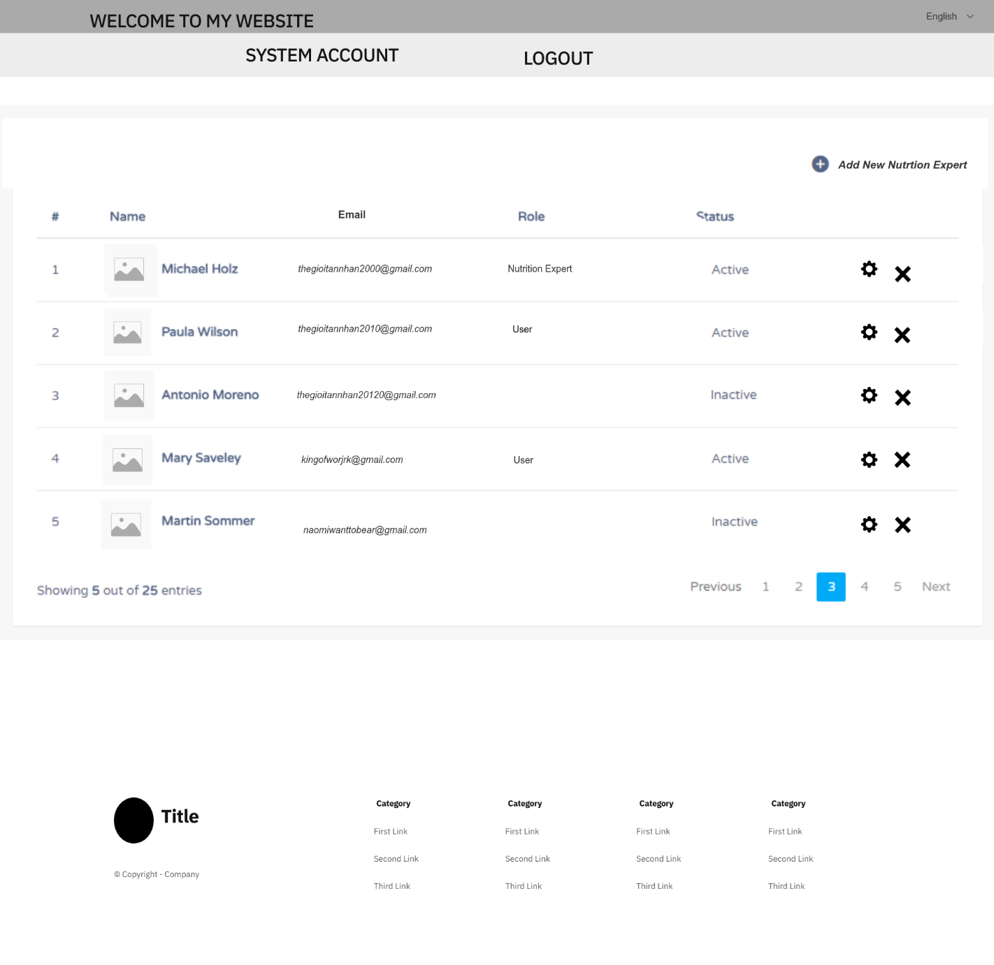

Figure 3.4.1. “System account management” Mockup

|  |  |
| --- | --- |
| **Description** | This screen allows the user to change to a new password. |
| **Functional requirement** | * Each card has an avatar, full name, email and status. * Administrators can search by name or by email. * If admin click onto “delete” icon, the system will display an alert message box to confirm the action. If admin click “Yes”, the account will be deleted. |

#### 3.4.2. View Account details アカウントの詳細を表示

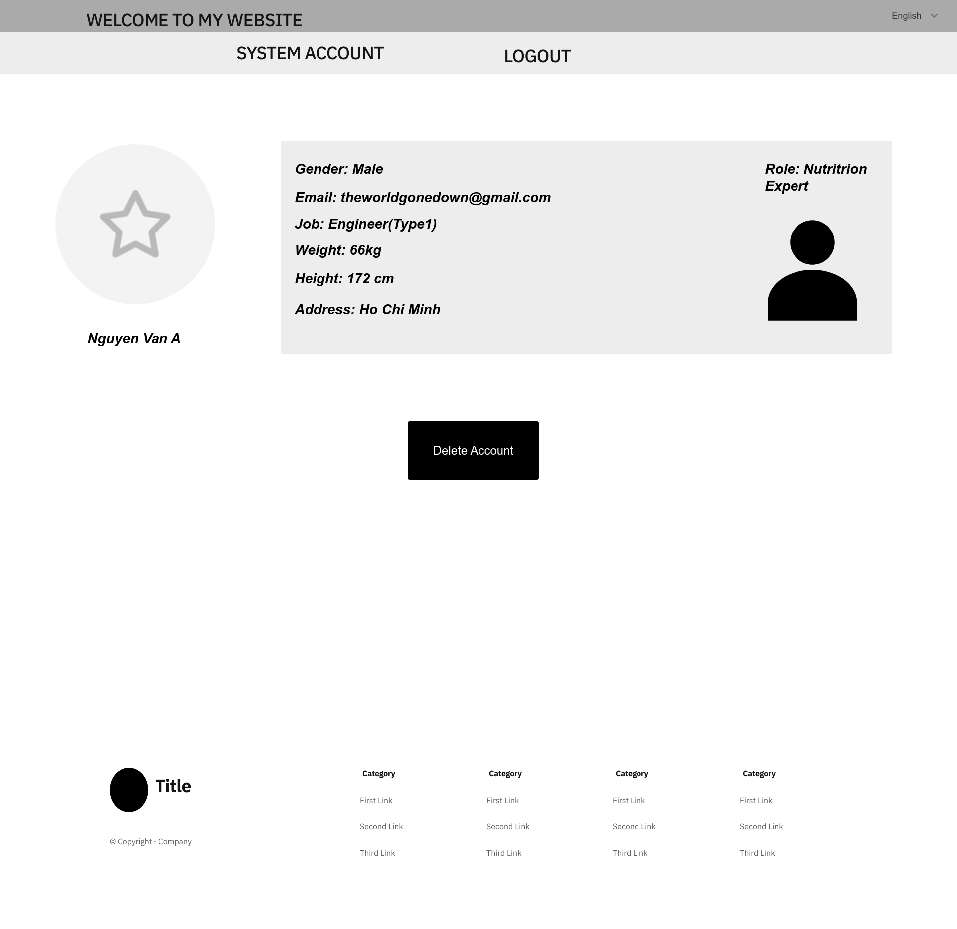

Figure 3.4.2. “Account details” Mockup

|  |  |
| --- | --- |
| **Description** | The screen displays full user information that only admins can access. |
| **Functional requirement** | * Show full avatar, full name, phone number, gender, date of birth, address and status. * The admin can’t edit user information. * The admin can click onto “Delete Account” to delete user’s account. |

### 3.5. Feature “Search foods”

#### 3.5.1. Search Food 食べ物を探す

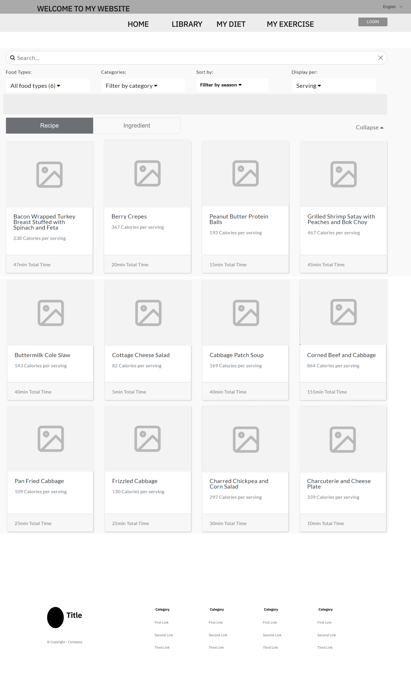

Figure 3.5.1. “Search Foods” Mockup

|  |  |
| --- | --- |
| **Description** | The screen shows the list of the foods that exist in database. |
| **Functional requirement** | * Show full avatar, full name, calories of foods. * Can filter by season and categories. |

#### 3.5.2. Search Ingredient 検索材料

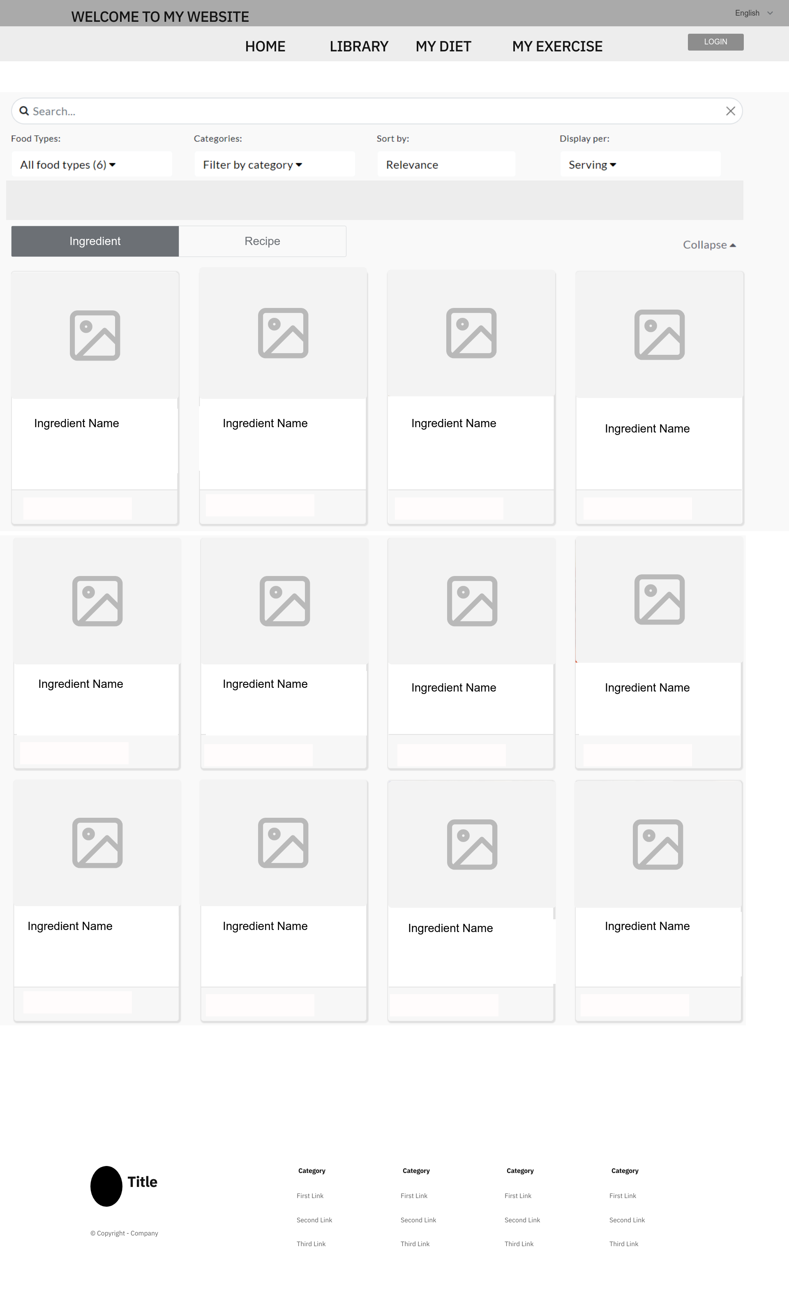

Figure 3.5.2. “Search Ingredient” Mockup

|  |  |
| --- | --- |
| **Description** | The screen shows the list of the ingredients that exist in database. |
| **Functional requirement** | * Show full avatar, full name, calories of ingredients. * Can filter by season and categories |

### 3.6. Feature “Manage food” 特集「食事管理」

#### 3.6.1. Add and Delete foods 食品の追加と削除

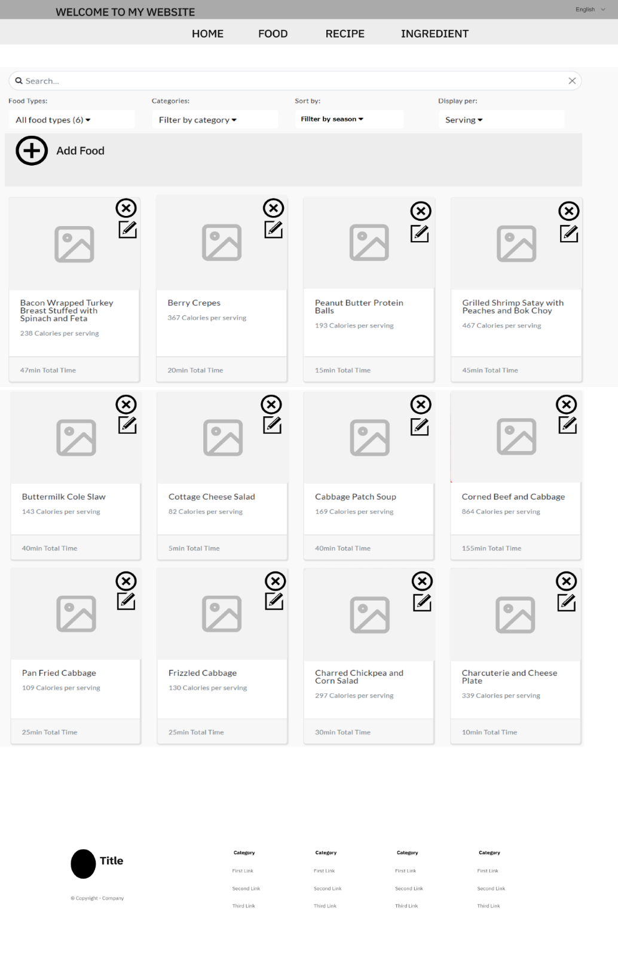

Figure 3.6.1. “Food List” Mockup

|  |  |
| --- | --- |
| **Description** | The screen shows the list of the foods that exist in database for nutrition expert to add and delete. |
| **Functional requirement** | * Show full avatar, full name, calories of foods. * Can filter by season and categories. * Nutrition Expert can add or delete foods. |

#### 3.6.2. Edit Food 食べ物を編集する

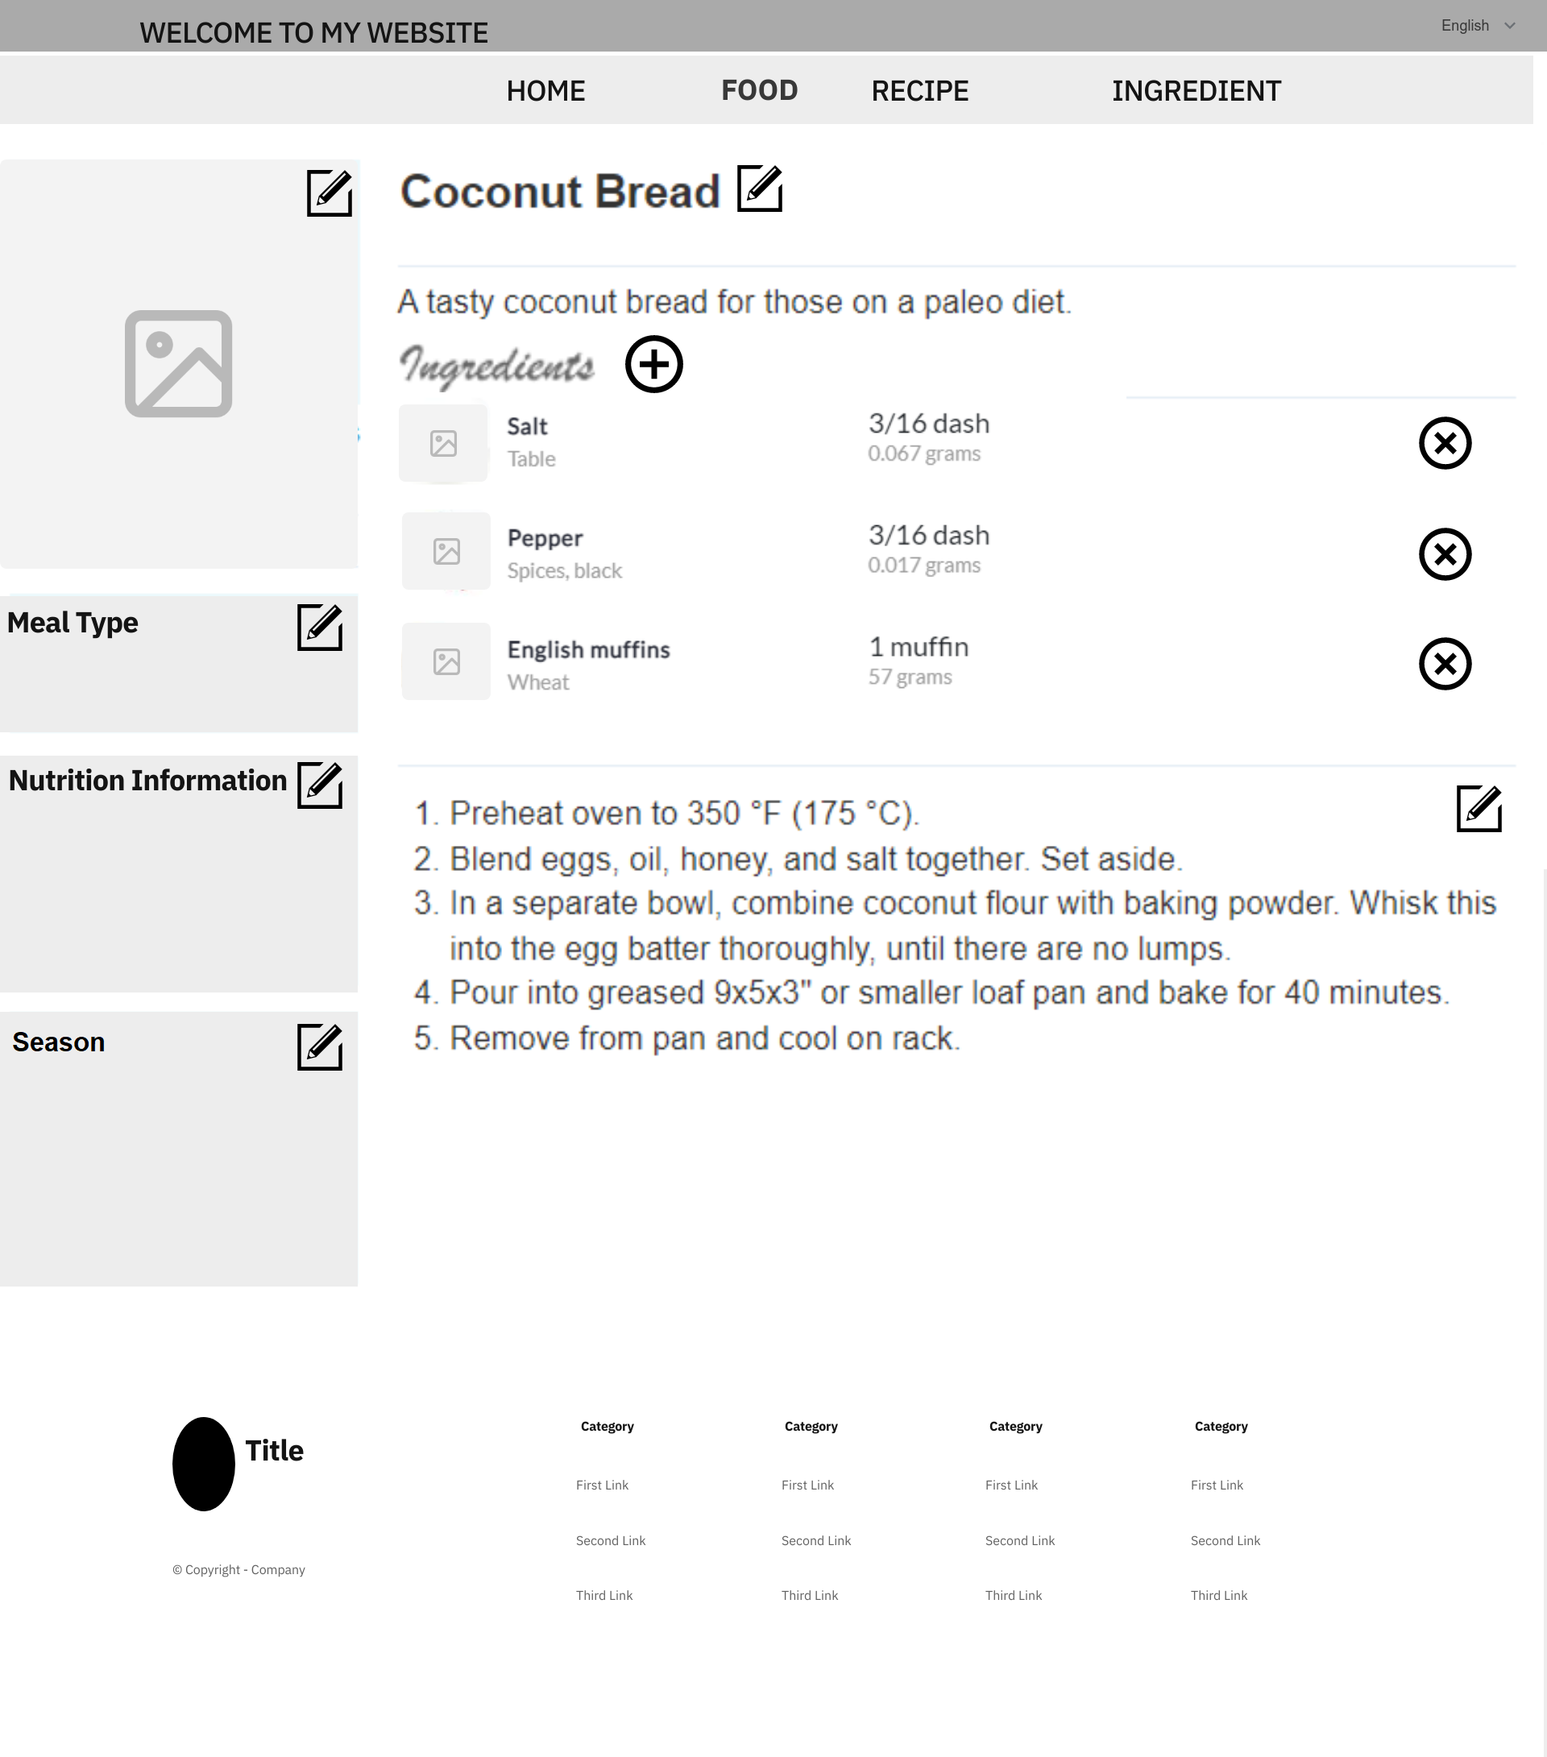

Figure 3.5.4. “Edit Food Detail” Mockup

|  |  |
| --- | --- |
| **Description** | The screen shows selected food detail for nutrition expert to edit. |
| **Functional requirement** | * Show full information of selected food. * Nutrition expert can delete or add ingredients into foods. |

#### 3.6.3. Add and delete ingredient 材料の追加と削除

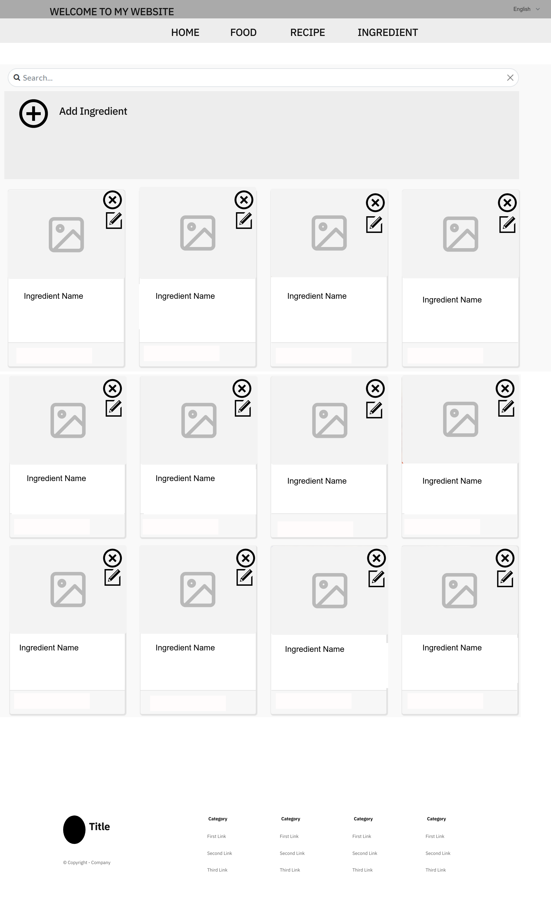

Figure 3.5.5. “Ingredient List” Mockup

|  |  |
| --- | --- |
| **Description** | The screen displays the full information of the ingredients in database. |
| **Functional requirement** | * Show full avatar, full name, calories of ingredients. * Can filter by season and categories. * Nutrition Expert can add or delete ingredients. |

#### 3.6.2. Edit Ingredient 材料を編集する

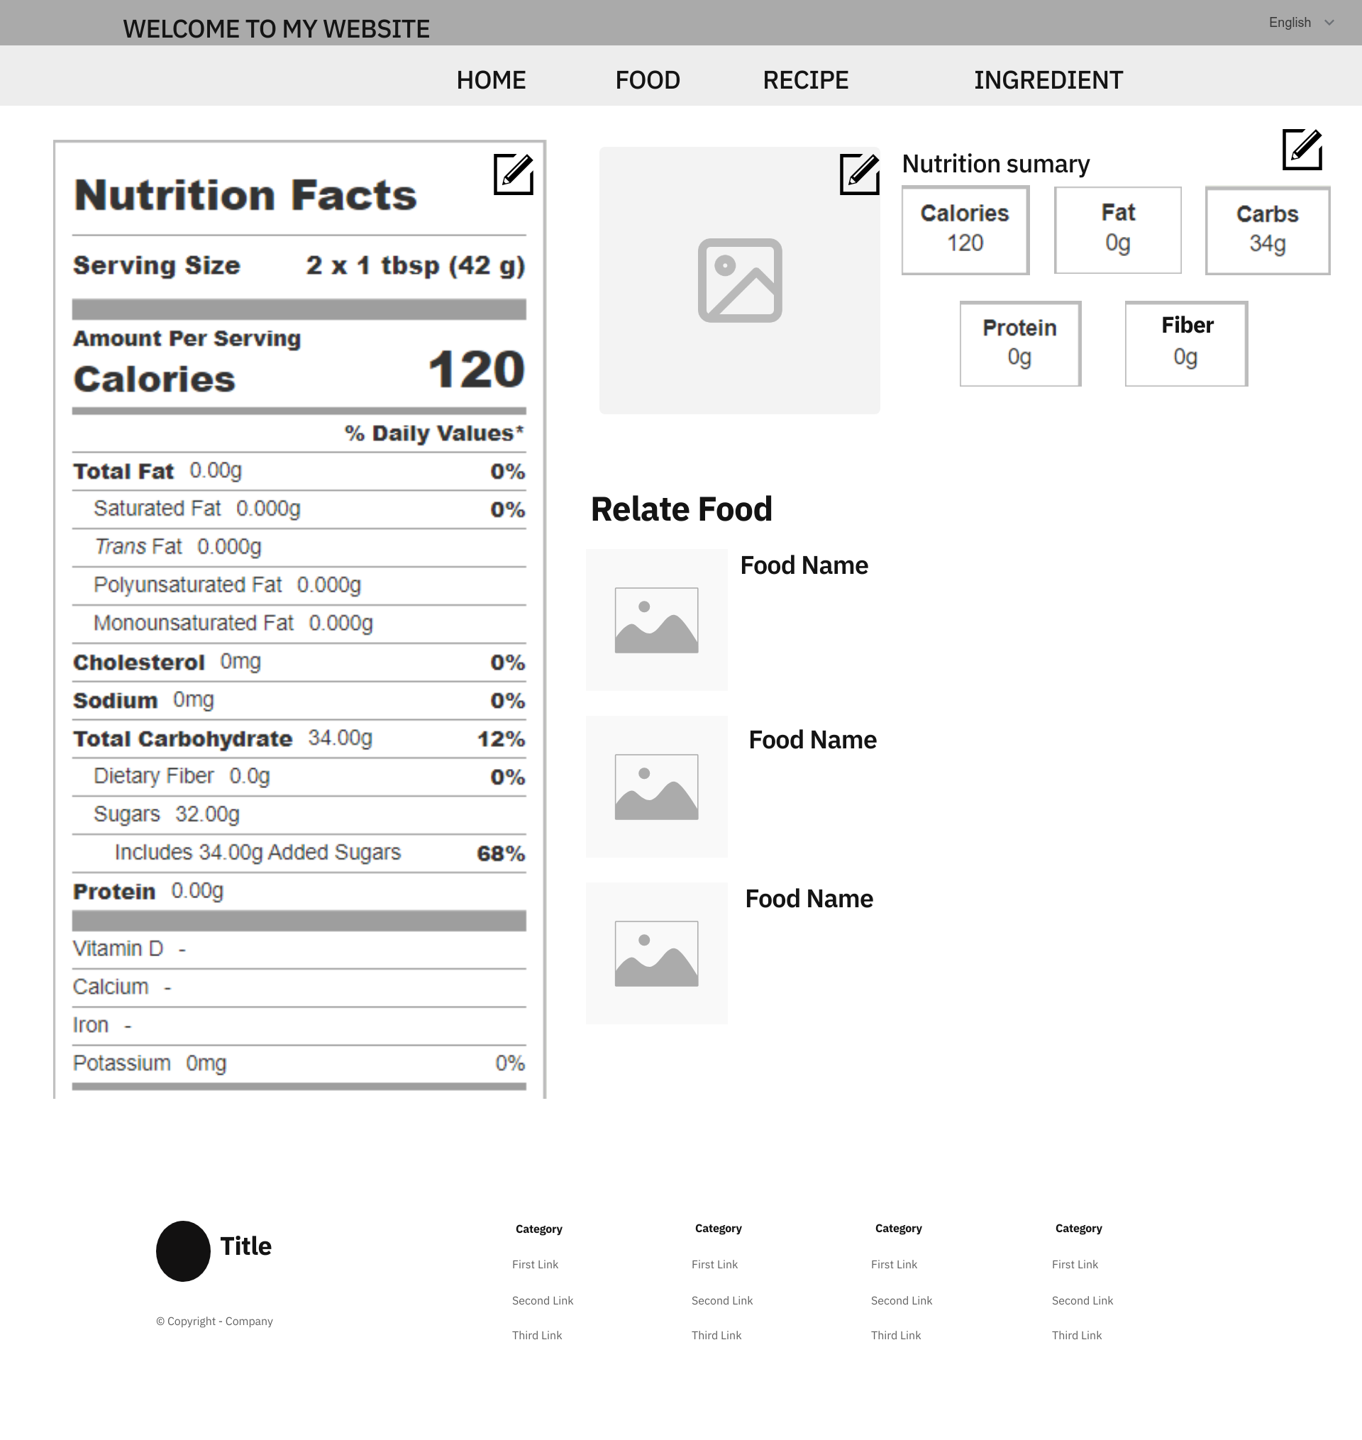

Figure 3.5.4. “Edit Ingredient Detail” Mockup

|  |  |
| --- | --- |
| **Description** | The screen shows selected ingredient detail for nutrition expert to edit. |
| **Functional requirement** | * Show full information of selected ingredient. |

### 3.7. Feature “Receive nutritional regime” 特集「栄養療法を受ける」

#### 3.7.1. View personal diet 個人的な食事を見る

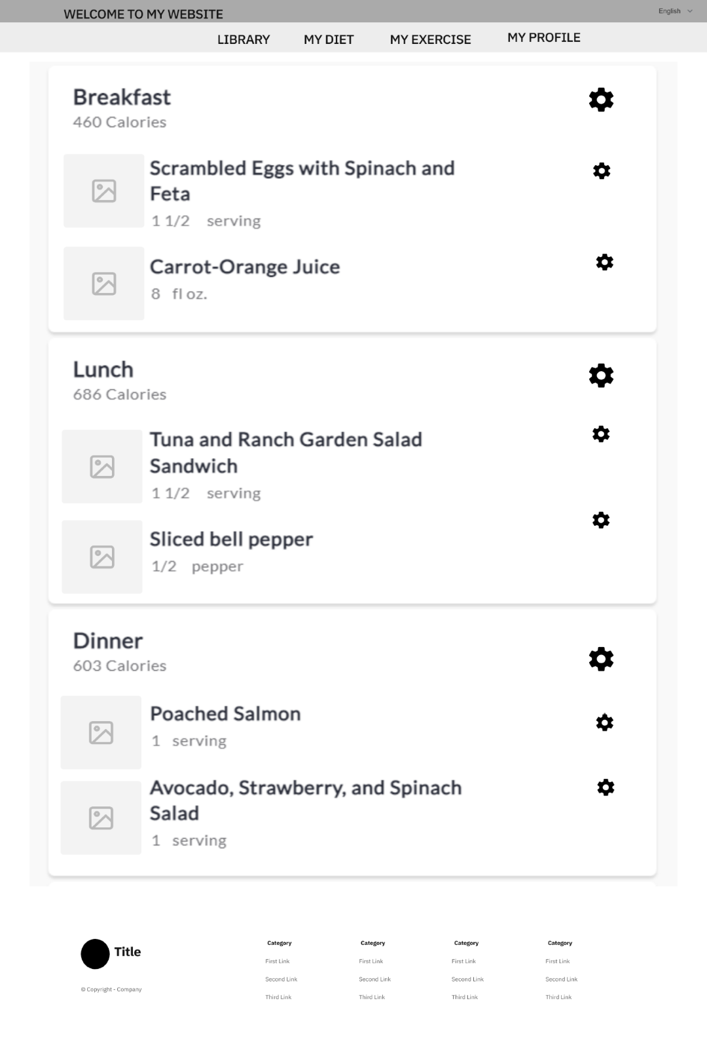

Figure 3.7.1. “View personal diet” Mockup

|  |  |
| --- | --- |
| **Description** | The screen shows the received diet of user in a day. |
| **Functional requirement** | * Daily diet has 3 meals: breakfast, lunch, dinner. * User can change foods in personal diet. |

#### 3.7.2. Input lacked information 不足している情報を入力

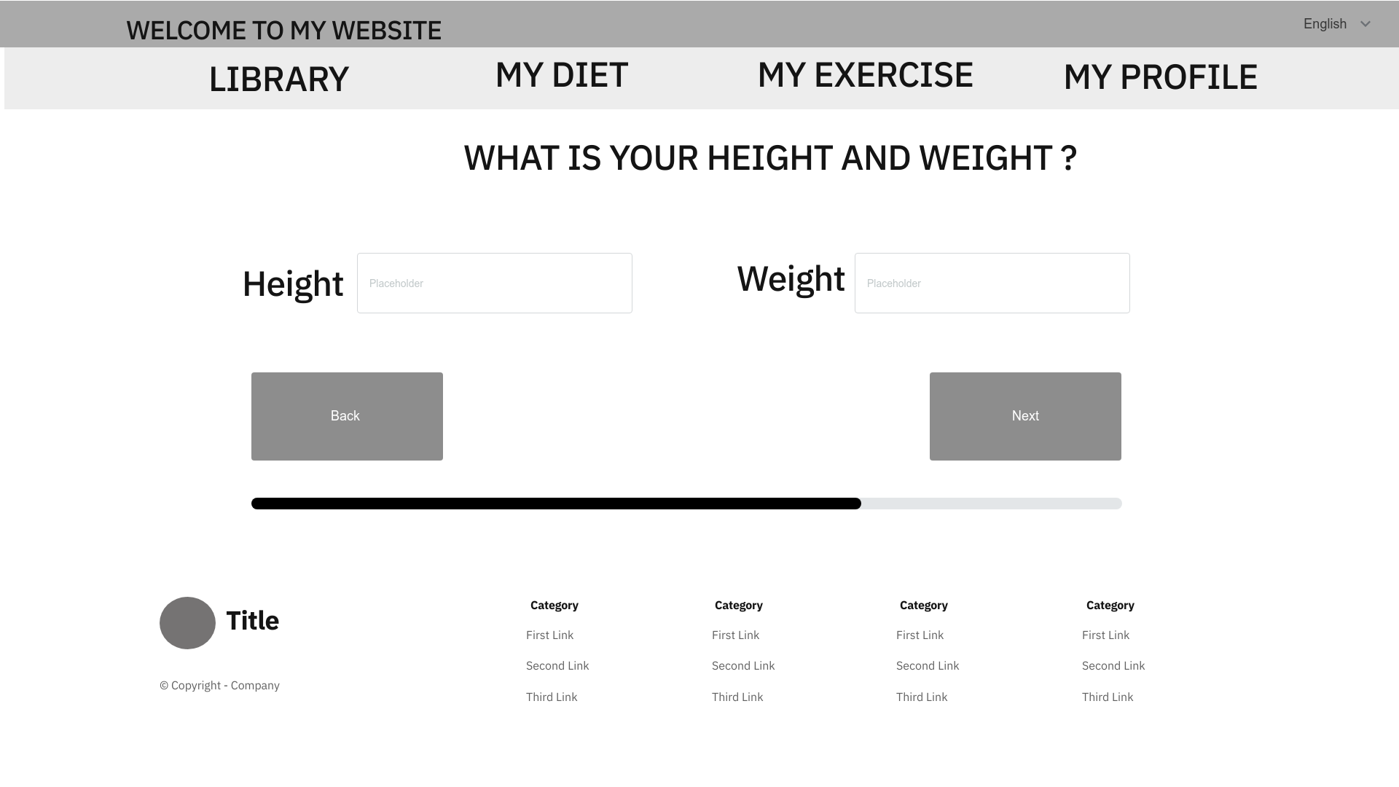

Figure 3.7.2.1 “Input weight, height” Mockup

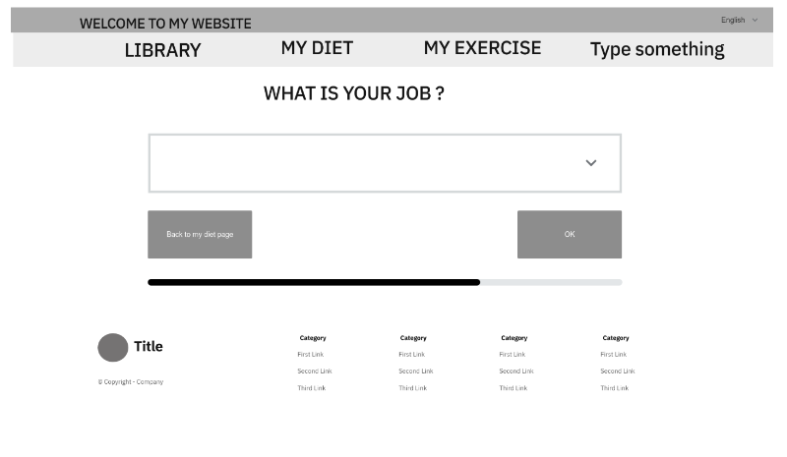

Figure 3.7.2.2 “Input job” Mockup

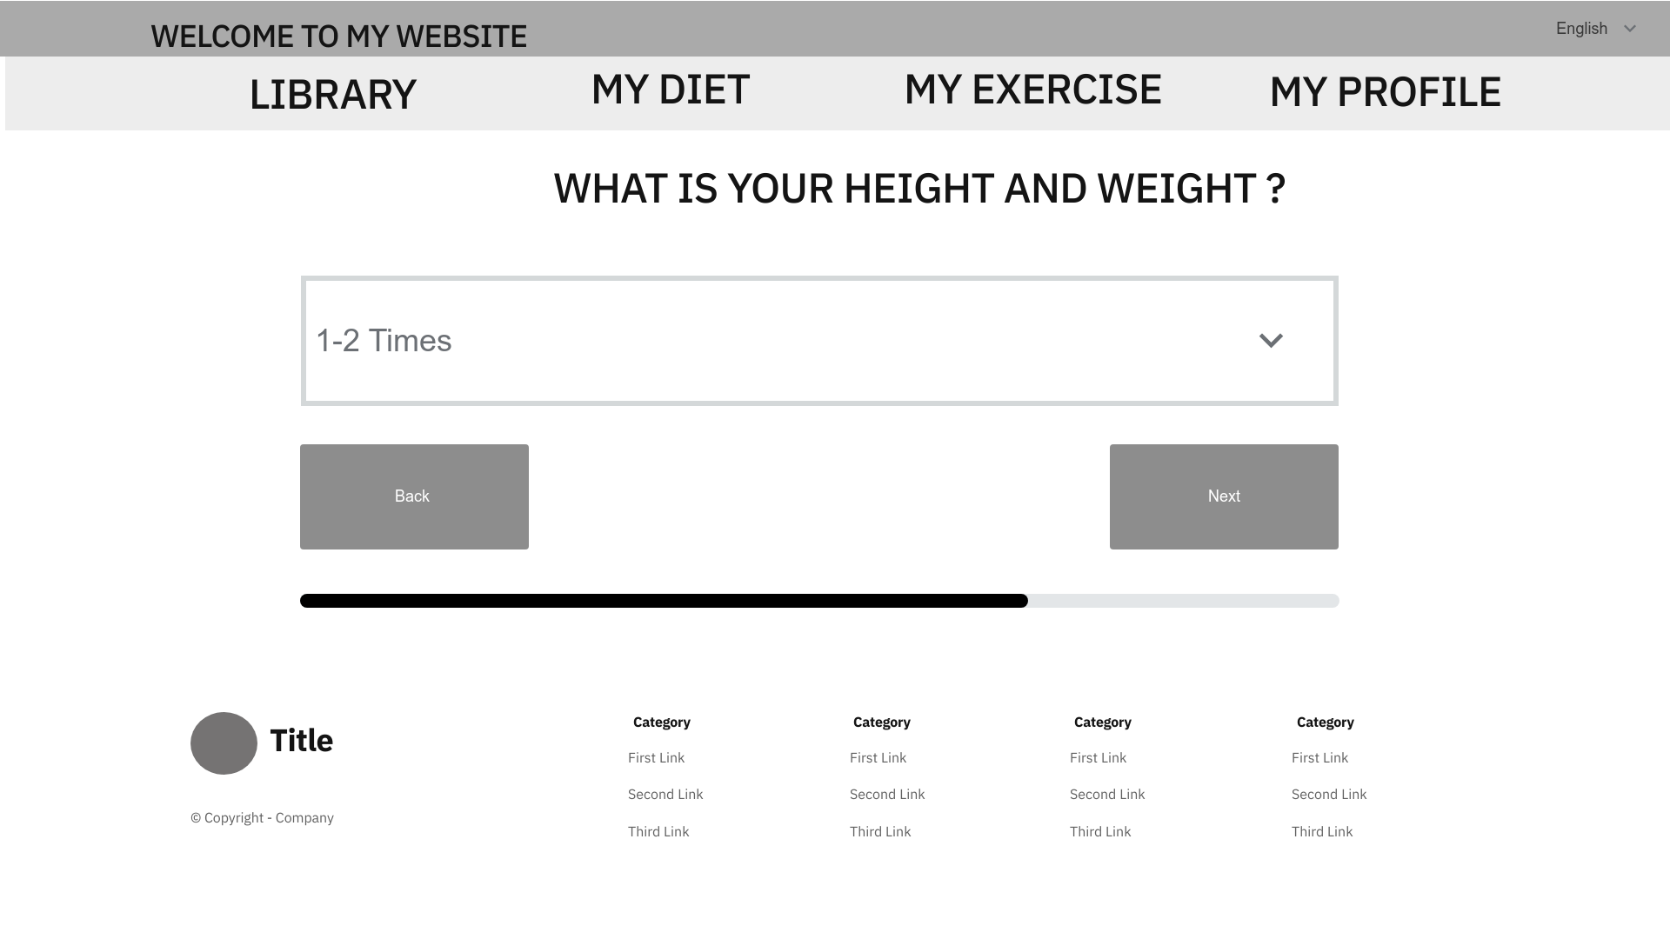

Figure 3.7.2.3 “Input frequency exercise” Mockup

|  |  |
| --- | --- |
| **Description** | The screen allows the user to fill lacked information before receive diet. |
| **Functional requirement** | * User have to fill all lacked information to continue. |

#### 3.7.3. Summary personal information 要約個人情報

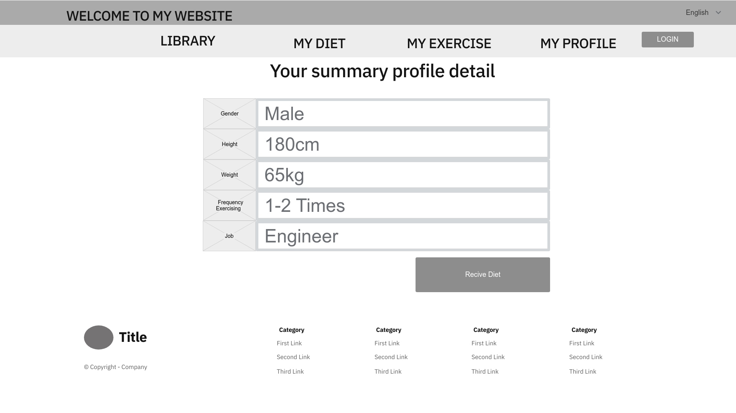

*Figure 3.7.3.“Summary personal information” Mockup*

|  |  |
| --- | --- |
| **Description** | The screen allows the user to fill lacked information before receive diet. |
| **Functional requirement** | * User have to fill all lacked information to continue. |

#### 3.7.4. Diet Detail ダイエットの詳細

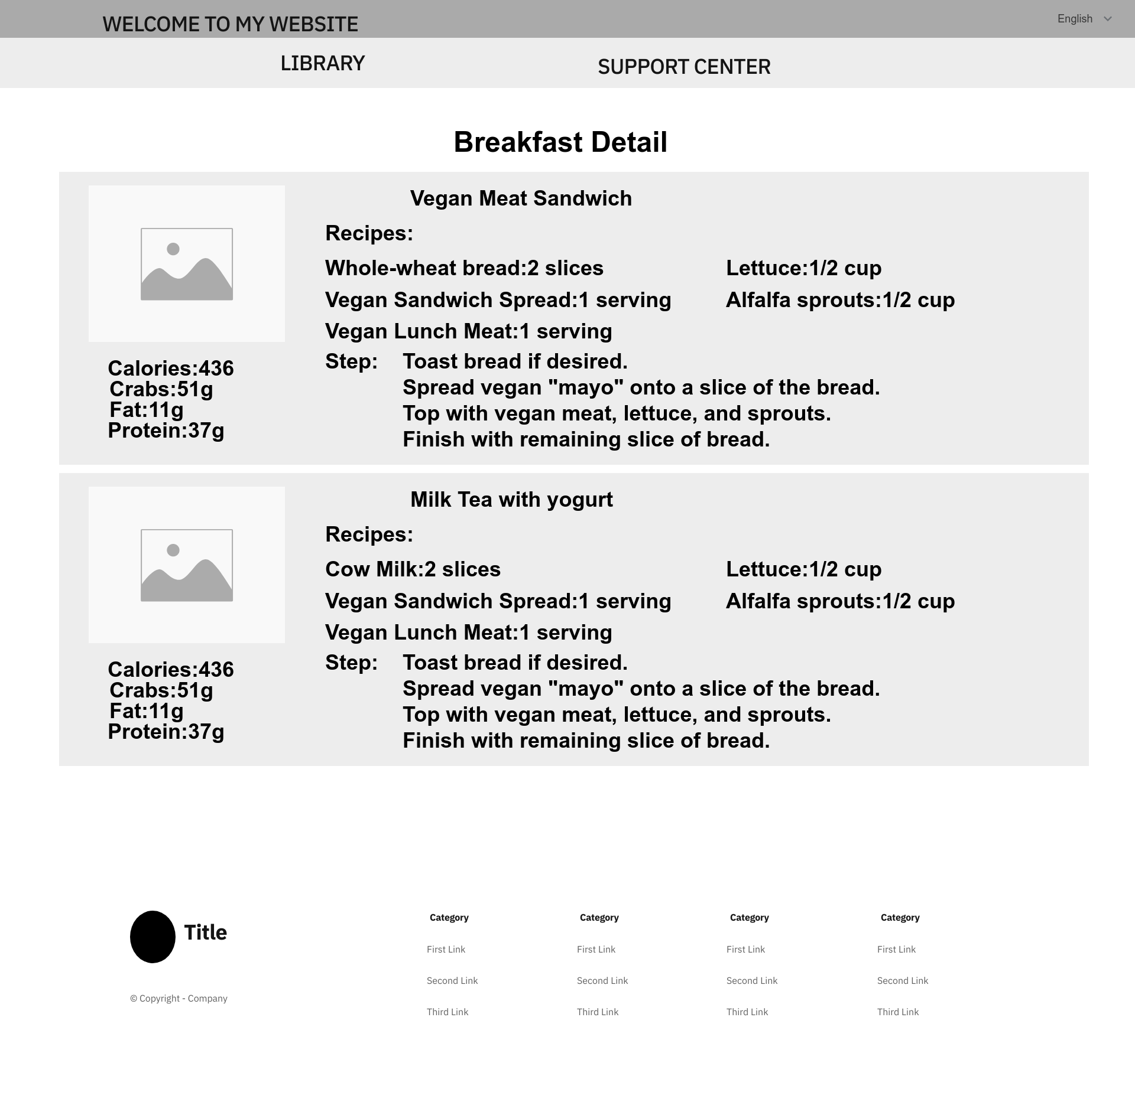

*Figure 3.7.4.1 “Breakfast Detail” Mockup*

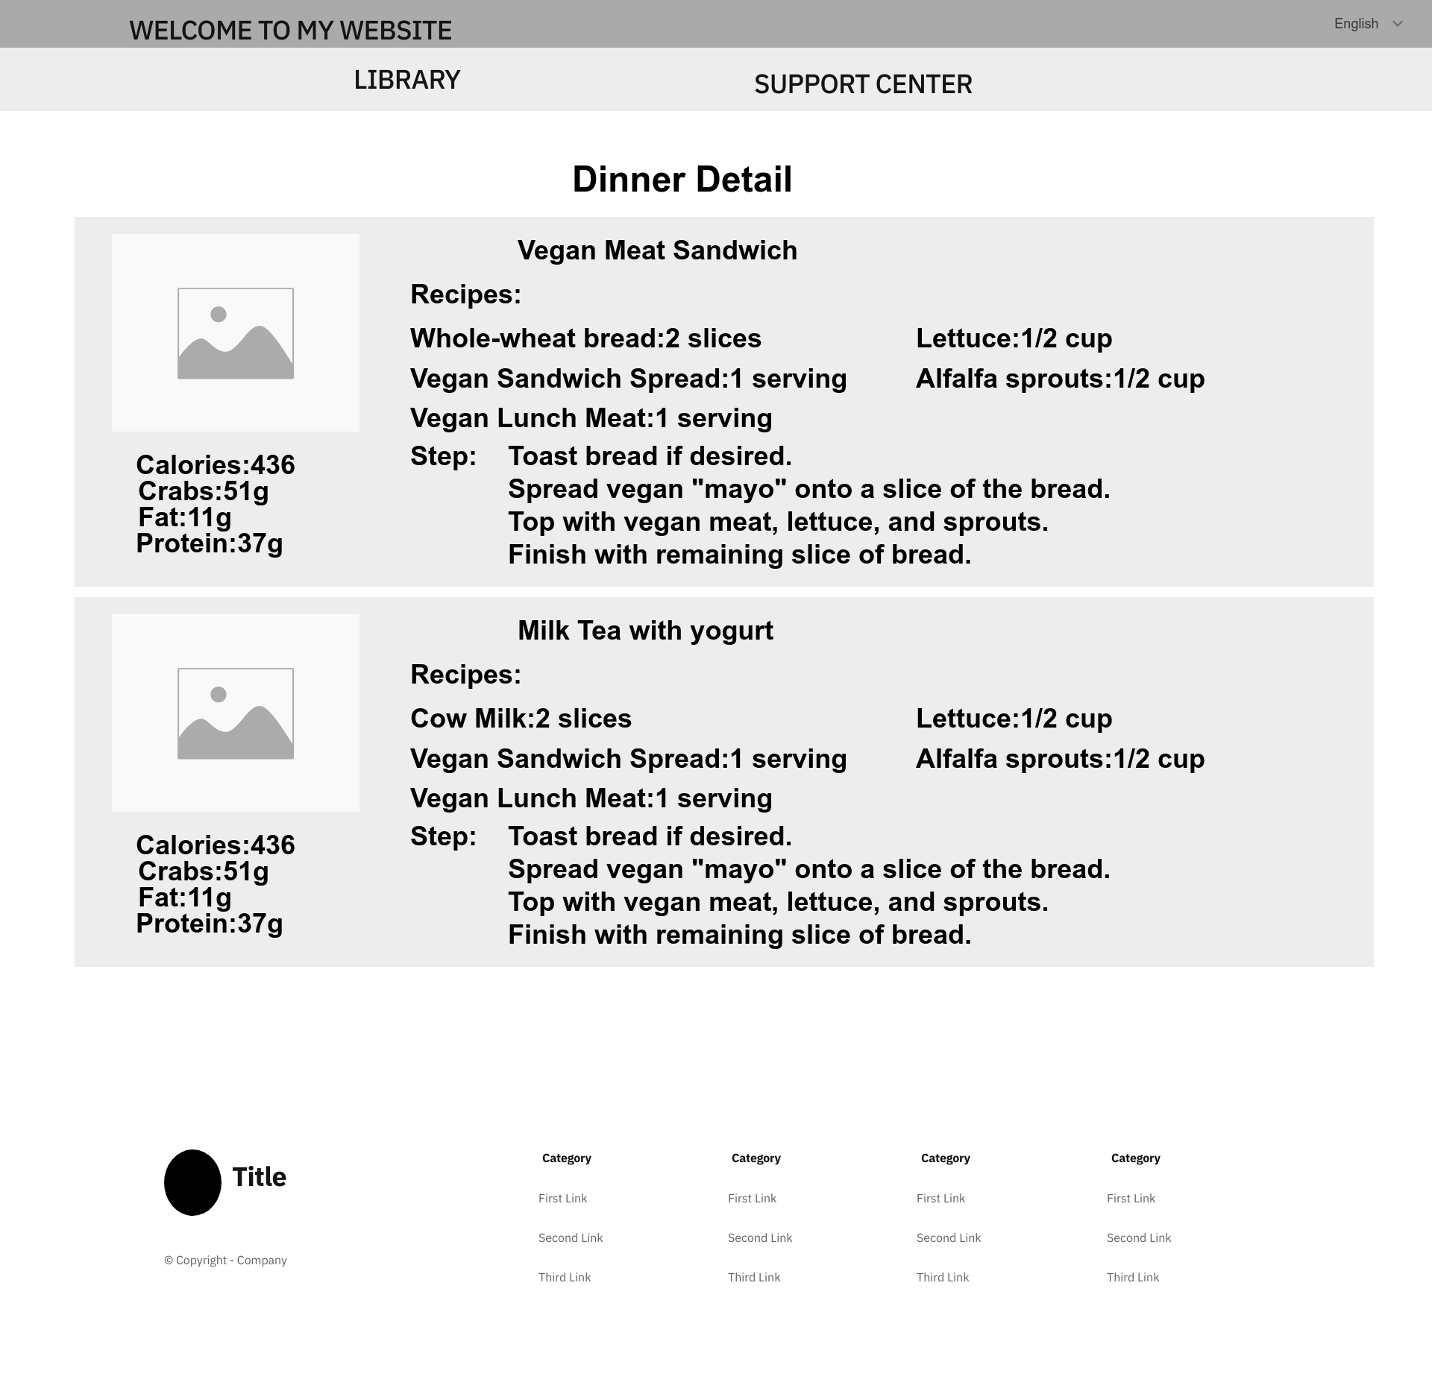

*Figure 3.7.4.2 “Lunch Detail” Mockup*

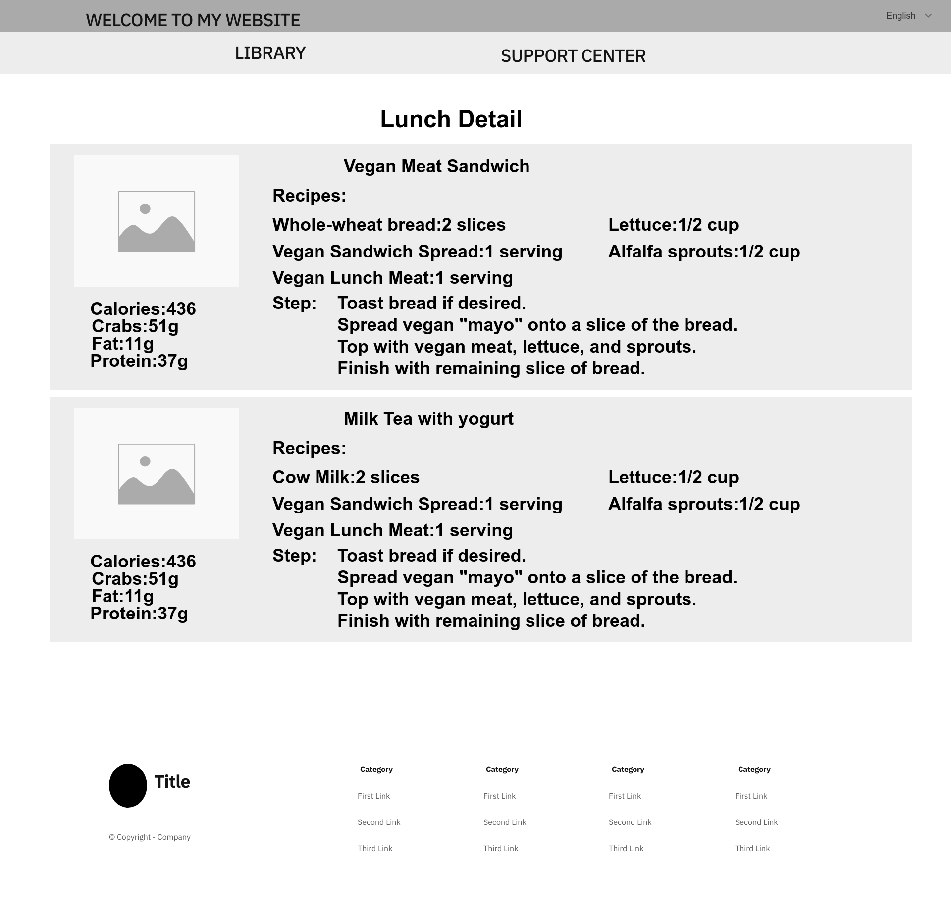

*Figure 3.7.4.3 “Dinner detail” Mockup*

|  |  |
| --- | --- |
| **Description** | The screen allows the user to see diet detail. |
| **Functional requirement** | * Diet detail must include 3 meals in a day. |

## 4. Non-Functional Requirements（非機能要件）

### 4.1 External Interfaces（外部インターフェース）

* Links, buttons, and checkboxes are easily clickable.
* User interface should be clear and easy to use.
* The system must be designed so that users can easily familiarize themselves with and use competently functions in a short time. Main functions are organized into tabs for easier access.
* The maximum steps to complete 1 activity from seeing the screen is 3.

### 4.2 Security セキュリティ

* Using authentication and authorization to access protected resources.
* Password must be protected and encrypt before store in database.
* Only send the latest email validation to the user's email.

### 4.3 Performance パフォーマンス

* In the best condition, the slowest response is not exceed 10 seconds.
* The loading pages time must not exceed 5 seconds.

### 4.4 Maintaining & Scalability 保守性と拡張性

* System logs error reporting to track errors whenever the application happens to crash.
* Source code must follow the coding convention to help developers to read, understand, and find it easy to maintain or modify the code.

### 4.5 Compatibility 互換性

* The device must be Window 7 or higher.

## 5. Requirement Appendix（要件の付録）

### 5.1 Business Rules（ビジネスルール）

|  |  |
| --- | --- |
| **ID** | **Rule definition** |
| BR-01 | The user must provide phone number and password to login. |
| BR-02 | The date will be display in the format: dd/mm/yyyy. |
| BR-03 | The time will be display in 24-hour time. |
| BR-04 | The password must have at least 8 characters and alphanumeric. |
| BR-25 | Registering an account requires an email, password. |

Table 5.1. Business rules

### 5.2 Application Messages List（アプリケーションメッセージリスト）

|  |  |  |  |  |
| --- | --- | --- | --- | --- |
| **#** | **ID** | **Message Type** | **Context** | **Content** |
|  | MSG01 | In red, under text field | Login with wrong email or password | Email hoặc mật khẩu không hợp lệ |
|  | MSG02 | In red, under text field | Input required fields are empty | ${Tên_trường} không được bỏ trống |
|  | MSG03 | In red, under text field | Invalid Email Validation Code | Mã xác nhận email không hợp lệ |
|  | MSG04 | In red, under text field | Wrong email format | Email không hợp lệ |
|  | MSG05 | Toast message | Phone number is existed in the system | Email này đã tồn tại trong hệ thống |
|  | MSG06 | Toast message | Unmatched password | Mật khẩu không khớp |
|  | MSG07 | In red, under text field | New password must differ than old password | Mật khẩu mới không được trùng với mật khẩu cũ |
|  | MSG08 | Toast message | Confirm that verify information success | Xác nhận thông tin thành công |
|  | MSG09 | In grey, center of the screen | When the user or nutrition expert does not enter the search information, or there are no results returned | Không tìm thấy kết quả |
|  | MSG10 | In red, under text field | The user inputs wrong password format | Mật khẩu phải chứa ít nhất 8 ký tự |
|  | MSG11 | Toast message | Register successfully | Đăng ký thành công |
|  | MSG12 | Toast message | Change password successfully | Đổi mật khẩu thành công |
|  | MSG13 | In Grey, center of the screen | When search return empty | Kết quả tìm kiếm đang trống |
|  | MSG14 | In Red, under text field | There already a name like this exists in the system | Đã tồn tại ${STRING} với tên này |
|  | MSG15 | Alert message box, center of the screen. | Do you want to submit this information to get your diet? | Bạn có muốn gửi những thông tin này để nhận được chế độ ăn của mình chứ? |
|  | MSG16 | Toast message | Add new food successfully | Thêm thức ăn thành công |
|  | MSG17 | Toast message | Add new food fail | Thêm thức ăn thất bại. |
|  | MSG18 | Toast message | Add new ingredient successfully | Thêm nguyên liệu thành công |
|  | MSG19 | Toast message | Add new ingredient fail | Thêm nguyên liệu thất bại |

Table 5.2. Application Message List

# IV. Software Design Document（ソフトウェア設計書）

## 1. System Design（システム設計）

### 1.1 System Architecture（システムアーキテクチャー）

#### 1.1.1 System Overview （システム概要）

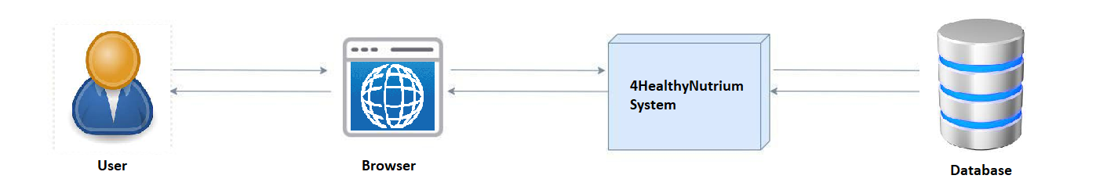

*Figure 1.1.1: System Overview*

This is the system overview of 4HealthyNutrium System (4HTN). Users use the Browser to access the internet, input the domain name of the 4HTN in the URL bar. 4HTN will access the database to get data to provide to the User.

#### 1.1.2 Overall Architecture（全体的なアーキテクチャー）

*Figure 1.2.2: System Overall*

|  |  |  |
| --- | --- | --- |
| **No** | **Element** | **Description** |
| 1 | User | The people who communicate with inventory management software |
| 2 | Mail | The user can link between the user and the system when there is a notification or the user wants to change the password |
| 3 | Brower | This part of the interface displayed for users to interact with the software. |
| 4 | Front-End | This is the place used to upload the system's interface and call API display data to the user. |
| 5 | Back-End | The is a place to manipulate data used to send data to Front-End |
| 6 | Database | This is where the system data is stored |

*Table 1.2.2. Overall Architecture Description*

##### 1.1.2.1 Front-end Architecture Designフロントエンドのアーキテクチャ設計

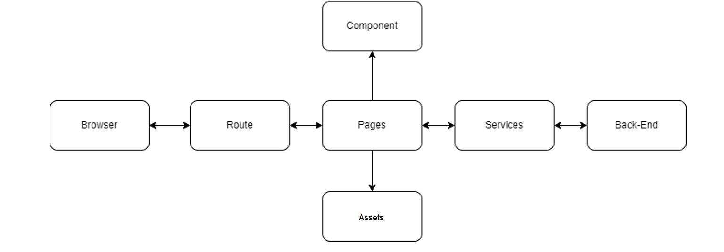

*Figure 1.2.3: Front-End Architecture Design*

|  |  |  |
| --- | --- | --- |
| **No** | **Element** | **Description** |
| 1 | Route | This element routes and connects paths to Page components |
| 2 | Pages | This element is responsible for rendering the interface for each view. It handles user operations on the interface and passes requests to the Slice element then gets a loading state in the Store element. After that, it receives and displays the results that were returned. |
| 3 | Service | Include files called API from the Back-end side. |
| 4 | Component | This element contains common components that can be used in Page |
| 5 | Assets | The assets element contains the assets of the project such as images |

*Table 1.2.3. Front-End Architecture Design Description*

##### 1.1.2.2 Back-end Architecture Design　バックエンドのアーキテクチャ設計

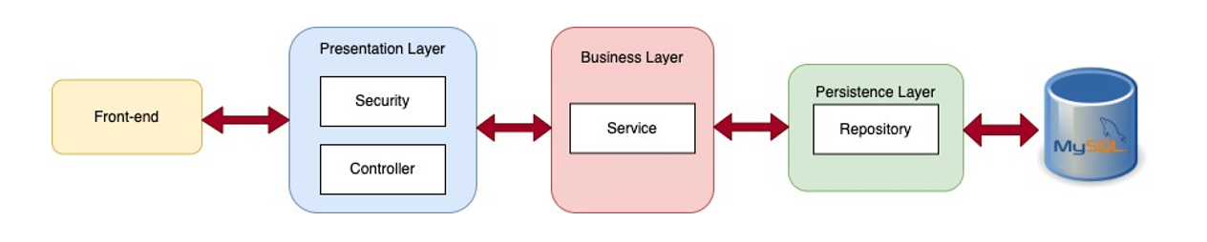

*Figure 1.2.4: Back-End Architecture Design*

|  |  |  |
| --- | --- | --- |
| **No** | **Element** | **Description** |
| 1 | Model | This receives objects passed down from front end |
| 2 | Controller | Connection between Model and View, receive requests and handle data flow |
| 3 | Security | This a place to filter requests sent to the server |
| 4 | Service | This is the place to handle the business of the function |
| 5 | Repository | This is responsible for communicating with the DBs, storage devices, query processing, and returning the data types requested by the Service layer. responsible for communicating with the DBs, storage devices, query processing, and returning the data types requested by the Service layer. |
| 6 | Entity | This entity is a Java class corresponding to a table in the database, each entity object corresponds to a row in the table. JPA requires an entity class to provide full metadata to map between entity class and table such as column name, data type, primary key, foreign key, etc. |

*Table 1.2.4. Back-End Architecture Design Description*

### 1.2 System Components (システムコンポーネント)

#### 1.2.1. Back-end Components (バックエンド コンポーネント)

##### 1.2.1.1. Spring Boot1



Figure 1.2.2.1. “Spring Boot” Logo

Spring Boot is an open-source Java-based framework used to create a micro-service. It is developed by Pivotal Team and is used to build stand-alone and production ready spring applications.

##### 1.2.1.2. Json Web Tokens2



Figure 1.2.2.2. “JWT” Logo

JSON Web Token is a proposed Internet standard for creating data with optional signature and/or optional encryption whose payload holds JSON that asserts some number of claims. The tokens are signed either using a private secret or a public/private key.

##### 1.2.1.3. JUnit



Figure 1.2.2.3.

JUnit is a unit testing open-source framework for the Java programming language. Java Developers use this framework to write and execute [automated tests](https://www.simplilearn.com/what-is-automation-testing-article). In Java, there are test cases that have to be re-executed every time a new code is added. This is done to make sure that nothing in the code is broken.

##### 1.2.1.4. Postman



Figure 1.2.2.4.

Postman is an API platform for building and using APIs. Postman simplifies each step of the API lifecycle and streamlines collaboration so you can create better APIs—faster.

#### 1.2.2. Front-end Components (フロントエンド コンポーネント)

##### 1.2.2.1. ReactJS

**

*Figure 1.2.1.1. “ReactJS” Logo*

The React.js framework is an open-source JavaScript framework and library developed by Facebook. It's used for building interactive user interfaces and web applications quickly and efficiently with significantly less code than you would with vanilla JavaScript.

##### 1.2.2.2. Ant Design

**

*Figure 1.2.1.3. “Ant Design” Logo*

Ant Design is a React UI library that contains easy-to-use components that are useful for building interactive user interfaces. It is very easy to use as well as integrate. It is one of the smart options to design web applications using react. It provides us with high-quality components which can be used with ease.

##### 1.2.2.3. BootStrap

**

*Figure 1.2.1.4. “Bootstrap” Logo*

#### 1.2.3. Database



Figure 1.2.3. MySQL Workbench

MySQL Workbench is a unified visual tool for database architects, developers, and DBAs. MySQL Workbench provides data modeling, SQL development, and comprehensive administration tools for server configuration, user administration, backup, and much more. MySQL Workbench is available on Windows, Linux and Mac OS X.

#### 1.2.4. Deployment & Hosting

##### 1.2.4.1. GitLab



Figure 1.2.4.1. “GitLab” Logo

GitLab is one of America's fastest-growing private software companies, posting[huge gains in 2021](https://www.reuters.com/technology/coding-platform-gitlab-valued-1348-bln-shares-climb-debut-2021-10-14/). The company provides a central server that manages Git repositories and is used to simplify the administration tasks of many corporations worldwide. According to Wikipedia, GitLab has over 100,000 users and is used by large, well-known organizations such as IBM, Sony, Goldman Sachs, and NASA.

##### 1.2.4.2. Github 3



Figure 1.2.4.2. “Github” Logo

GitHub is a for-profit company that offers a cloud-based Git repository hosting service. Essentially, it makes it a lot easier for individuals and teams to use Git for version control and collaboration.

### 1.3 Package Diagram（パッケージ図）

#### 1.3.1. Frontend フロントエンド

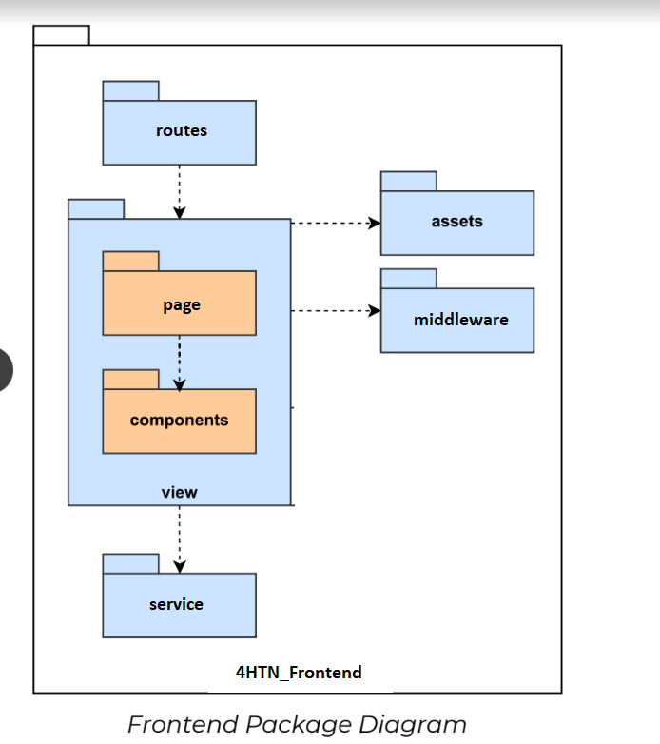

*Figure 1.3.1: Front-end package diagram*

|  |  |  |
| --- | --- | --- |
| **No** | **Package** | **Description** |
| 1 | routes | House navigation stacks and navigation functions to move between multiple screens. |
| 2 | pages | House screens of the application |
| 3 | components | House reusable components for the screens. |
| 4 | assets | House images and logos of the application. |
| 5 | service | House helper functions for lightweight logic and creates HTTP requests and stores. |
| 6 | middleware | House theme configuration. |

Table 1.3.1. Frontend package details

#### 1.3.2. Backend バックエンド

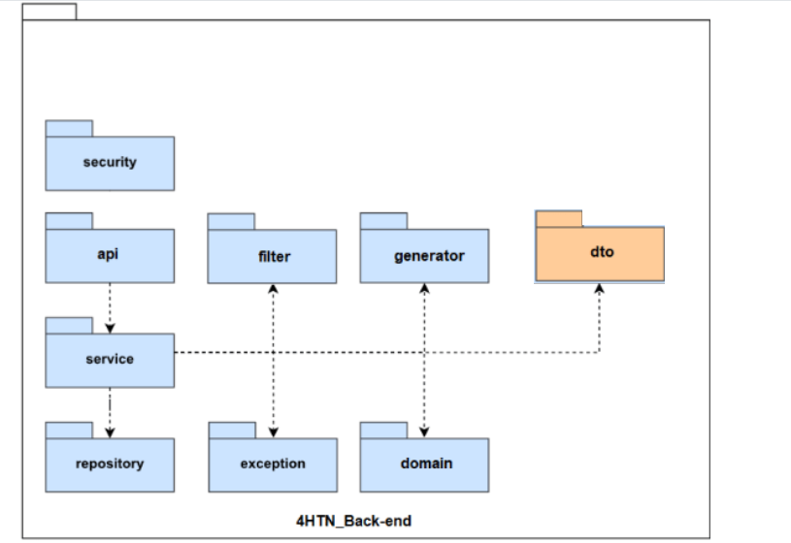

Figure 1.3.2. Backend Package Diagram

|  |  |  |
| --- | --- | --- |
| **No** | **Package** | **Description** |
| 1 | security | Contains classes used for configuration |
| 2 | API | Contains classes which handle incoming requests |
| 3 | service | Contains classes which are used to perform business logic. These classes communicate with data tier, process data then return to controller classes |
| 4 | repository | Contains interfaces which communicate with the database and return them to service classes |
| 5 | filter | Used for authentication and authorization |
| 6 | DTO | Contains objects used to transfer data between controller and service |
| 7 | exception | Contains custom exceptions and exceptions handler |
| 8 | domain | Contains classes represent real entities which can be persisted in database and some additional helper classes |
| 9 | generator | Contains objects used to handling combinatorial division algorithm |

Table 1.3.2. Backend package details

## 2. Database Design（データベース設計）

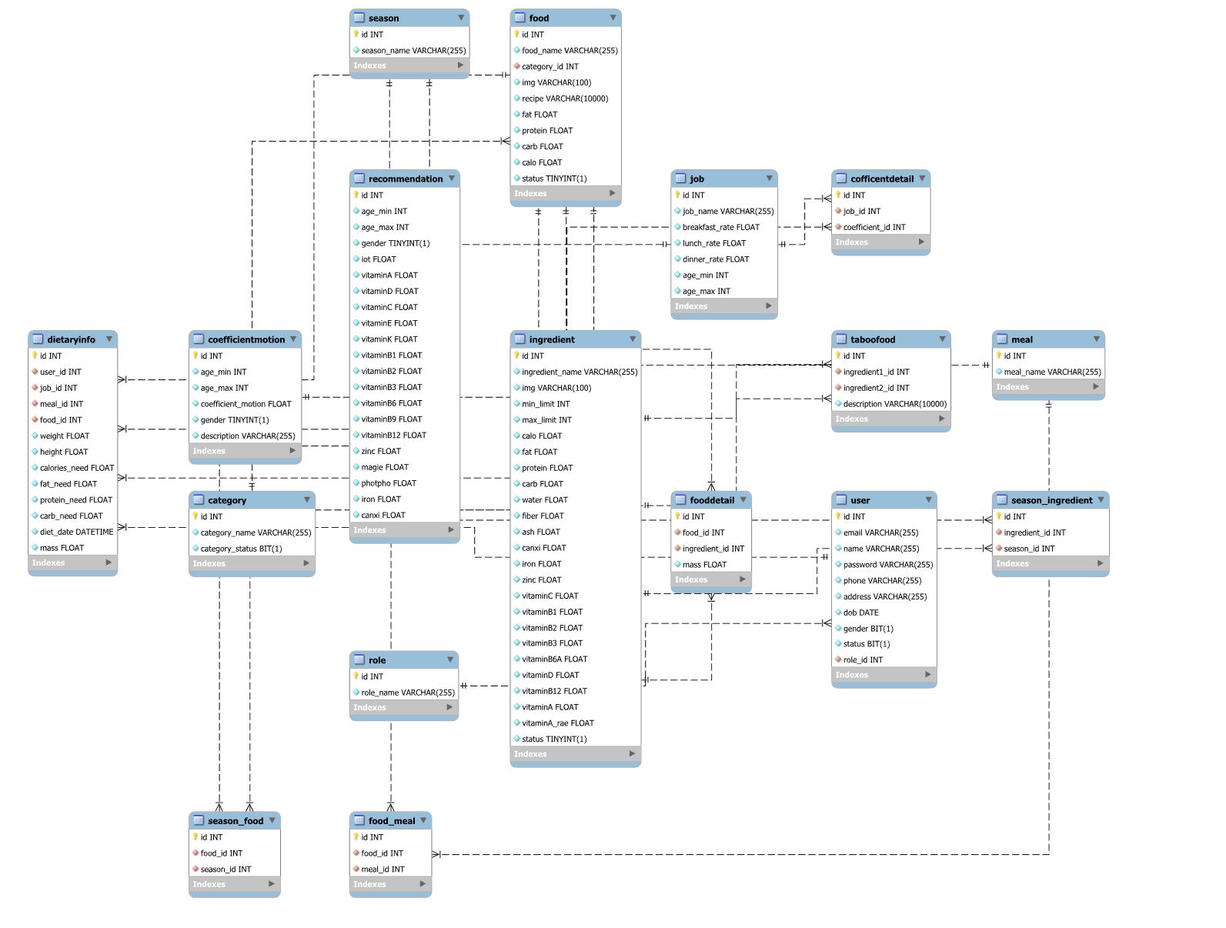

Figure 2. 4HTN Database design

### 2.1. Table “user” 表「ユーザー」

|  |  |  |  |  |  |  |  |
| --- | --- | --- | --- | --- | --- | --- | --- |
| **#** | **Field name** | **Type** | **Size** | **Unique** | **Not Null** | **PK/FK** | **Notes** |
| 1 | id | int |  | x | x | PK |  |
| 2 | email | varchar | 255 |  | x |  |  |
| 3 | name | varchar | 255 |  | x |  |  |
| 4 | password | varchar | 255 |  | x |  |  |
| 5 | phone | varchar | 255 |  | x |  |  |
| 6 | address | date |  |  | x |  |  |
| 7 | gender | bit | 1 |  | x |  |  |
| 8 | status | status | 1 |  | x |  |  |
| 9 | role_id | int |  |  | x |  |  |

Table 2.1. Table”user”

### 2.2. Table “dietaryinfo” 表「食事情報」

|  |  |  |  |  |  |  |  |
| --- | --- | --- | --- | --- | --- | --- | --- |
| **#** | **Field name** | **Type** | **Size** | **Unique** | **Not Null** | **PK/FK** | **Notes** |
| 1 | id | int |  | x | x | PK |  |
| 2 | user_id | int |  |  | x | FK |  |
| 3 | job_id | int |  |  | x | FK |  |
| 4 | meal_id | int |  |  | x | FK |  |
| 5 | food_id | int |  |  | x | FK |  |
| 6 | weight | float |  |  | x |  |  |
| 7 | height | float |  |  | x |  |  |
| 8 | calories_need | float |  |  | x |  |  |
| 9 | fat_need | float |  |  | x |  |  |
| 10 | protein_need | float |  |  | x |  |  |
| 11 | carb_need | float |  |  | x |  |  |
| 12 | diet_date | datetime |  |  | x |  |  |
| 13 | mass | float |  |  | x |  |  |

Table 2.2. Table”dietaryinfo”

### 2.3. Table “Job” 表「ジョブ」

|  |  |  |  |  |  |  |  |
| --- | --- | --- | --- | --- | --- | --- | --- |
| **#** | **Field name** | **Type** | **Size** | **Unique** | **Not Null** | **PK/FK** | **Notes** |
| 1 | id | int |  | x | x | PK |  |
| 2 | job_name | varchar | 255 |  | x |  |  |
| 3 | breakfast_rate | float |  |  | x |  |  |
| 4 | lunch_rate | float |  |  | x |  |  |
| 5 | dinner_rate | float |  |  | x |  |  |
| 6 | age_min | int |  |  | x |  |  |
| 7 | age_max | int |  |  | x |  |  |

Table 2.3. Table_Job

### 2.4. Table “Food” 表「食」

|  |  |  |  |  |  |  |  |
| --- | --- | --- | --- | --- | --- | --- | --- |
| **#** | **Field name** | **Type** | **Size** | **Unique** | **Not Null** | **PK/FK** | **Notes** |
| 1 | id | int |  | x | x | PK |  |
| 2 | food_name | varchar | 255 |  | x |  |  |
| 3 | img | varchar | 100 |  | x |  |  |
| 4 | category_id | int |  |  | x | FK |  |
| 5 | recipe | varchar | 10000 |  | x |  |  |
| 6 | fat | float |  |  | x |  |  |
| 7 | protein | float |  |  | x |  |  |
| 8 | carb | float |  |  | x |  |  |
| 9 | calo | float |  |  | x |  |  |

Table 2.4. Table_Food

### 2.5. Table “Category” 表「カテゴリ」

|  |  |  |  |  |  |  |  |
| --- | --- | --- | --- | --- | --- | --- | --- |
| **#** | **Field name** | **Type** | **Size** | **Unique** | **Not Null** | **PK/FK** | **Notes** |
| 1 | id | int |  | x | x | PK |  |
| 2 | category_name | varchar | 255 |  | x |  |  |
| 3 | category_status | bit | 1 |  | x |  |  |

Table 2.5. Table Category

### 2.6. Table “Season” 表「季節」

|  |  |  |  |  |  |  |  |
| --- | --- | --- | --- | --- | --- | --- | --- |
| **#** | **Field name** | **Type** | **Size** | **Unique** | **Not Null** | **PK/FK** | **Notes** |
| 1 | id | int |  | x | x | PK |  |
| 2 | season_name | varchar | 255 |  | x |  |  |

Table 2.6. Table Season

### 2.7. Table “CoefficentMotion” 表「運動係数」

|  |  |  |  |  |  |  |  |
| --- | --- | --- | --- | --- | --- | --- | --- |
| **#** | **Field name** | **Type** | **Size** | **Unique** | **Not Null** | **PK/FK** | **Notes** |
| 1 | id | int |  | x | x | PK |  |
| 2 | age_min | int |  |  | x |  |  |
| 3 | age_max | int |  |  | x |  |  |
| 4 | coefficient_motion | float |  |  | x |  |  |
| 5 | gender | tinyint | 1 |  | x |  |  |
| 6 | description | varchar | 255 |  | x |  |  |

Table 2.7. Table “CoefficentMotion”

### 2.8. Table “Recommendation” 表「おすすめ」

|  |  |  |  |  |  |  |  |
| --- | --- | --- | --- | --- | --- | --- | --- |
| **#** | **Field name** | **Type** | **Size** | **Unique** | **Not Null** | **PK/FK** | **Notes** |
| 1 | id |  |  | x | x | PK |  |
| 2 | min_age | int |  |  | x |  |  |
| 3 | max_age | int |  |  | x |  |  |
| 4 | gender | tinyint |  |  | x |  |  |
| 5 | iot | float |  |  | x |  |  |
| 6 | maggie | float |  |  | x |  |  |
| 7 | photpho | float |  |  | x |  |  |
| 8 | vitaminB9 | float |  |  | x |  |  |
| 9 | vitaminE | float |  |  | x |  |  |
| 10 | fiber | float |  |  | x |  |  |
| 11 | ash | float |  |  | x |  |  |
| 12 | canxi | float |  |  | x |  |  |
| 13 | iron | float |  |  | x |  |  |
| 14 | zinc | float |  |  | x |  |  |
| 15 | vitaminC | float |  |  | x |  |  |
| 16 | vitaminB1 | float |  |  | x |  |  |
| 17 | vitaminB2 | float |  |  | x |  |  |
| 18 | vitaminB3 | float |  |  | x |  |  |
| 19 | vitaminB6A | float |  |  | x |  |  |
| 20 | vitaminB12 | float |  |  | x |  |  |
| 21 | vitaminD | float |  |  | x |  |  |
| 22 | vitaminA | float |  |  | x |  |  |

Table 2.8. Table”Remommendation”

### 2.9. Table “Ingredient” 表「材料」

|  |  |  |  |  |  |  |  |
| --- | --- | --- | --- | --- | --- | --- | --- |
| **#** | **Field name** | **Type** | **Size** | **Unique** | **Not Null** | **PK/FK** | **Notes** |
| 1 | id | bigserial |  | x | x | PK |  |
| 2 | ingredient_name | varchar | 255 |  | x |  |  |
| 3 | img | varchar | 100 |  | x |  |  |
| 4 | min_limit | int |  |  | x |  |  |
| 5 | max_limit | int |  |  | x |  |  |
| 6 | calo | float |  |  | x |  |  |
| 7 | carb | float |  |  | x |  |  |
| 8 | protein | float |  |  | x |  |  |
| 9 | fat | float |  |  | x |  |  |
| 10 | water | float |  |  | x |  |  |
| 11 | fiber | float |  |  | x |  |  |
| 12 | ash | float |  |  | x |  |  |
| 13 | canxi | float |  |  | x |  |  |
| 14 | iron | float |  |  | x |  |  |
| 15 | zinc | float |  |  | x |  |  |
| 16 | vitaminC | float |  |  |  |  |  |
| 17 | vitaminB1 | float |  |  | x | FK |  |
| 18 | vitaminB2 | float |  |  | x | FK |  |
| 19 | vitaminB3 | float |  |  | x |  |  |
| 20 | vitaminB6A | float |  |  | x |  |  |
| 21 | vitaminB12 | float |  |  | x |  |  |
| 22 | vitaminD | float |  |  |  |  |  |
| 23 | vitaminA | float |  |  |  |  |  |
| 24 | vitaminArae | float |  |  |  |  |  |

Table 2.9. Table “Ingredient”

### 2.10. Table “Season_Ingredient” 表「季節_材料」

|  |  |  |  |  |  |  |  |
| --- | --- | --- | --- | --- | --- | --- | --- |
| **#** | **Field name** | **Type** | **Size** | **Unique** | **Not Null** | **PK/FK** | **Notes** |
| 1 | id |  |  | x | x | PK |  |
| 2 | season_id | int |  |  | x |  |  |
| 3 | ingredient_id | int |  |  | x |  |  |

Table 2.10. Season_Ingredient

### 2.11. Table “FoodDetail” 表「料理内容」

|  |  |  |  |  |  |  |  |
| --- | --- | --- | --- | --- | --- | --- | --- |
| **#** | **Field name** | **Type** | **Size** | **Unique** | **Not Null** | **PK/FK** | **Notes** |
| 1 | id | int |  | x | x | PK |  |
| 2 | food_id | int |  |  | x | FK |  |
| 3 | ingredient_id | int |  |  | x | FK |  |
| 4 | mass | int |  |  | x |  |  |

Table 2.11. Table “Food_Detail”

### 2.12. Table “Meal” 表「食事」

|  |  |  |  |  |  |  |  |
| --- | --- | --- | --- | --- | --- | --- | --- |
| **#** | **Field name** | **Type** | **Size** | **Unique** | **Not Null** | **PK/FK** | **Notes** |
| 1 | meal_id | int |  |  | x | PK |  |
| 2 | meal_name | varchar | 255 |  | x |  |  |

Table 2.12. Table “Meal”

### 2.13. Table “Food_meal” 表「食_食事」

|  |  |  |  |  |  |  |  |
| --- | --- | --- | --- | --- | --- | --- | --- |
| **#** | **Field name** | **Type** | **Size** | **Unique** | **Not Null** | **PK/FK** | **Notes** |
| 1 | id | int |  | x | x | PK |  |
| 2 | food_id | int |  |  | x | FK |  |
| 3 | meal_id | int |  |  | x | FK |  |

Table 2.13. Table “Food_Meal”

### 2.14. Table “Taboo_Food” 表「タブーフード」

|  |  |  |  |  |  |  |  |
| --- | --- | --- | --- | --- | --- | --- | --- |
| **#** | **Field name** | **Type** | **Size** | **Unique** | **Not Null** | **PK/FK** | **Notes** |
| 1 | id | int |  | x | x | PK |  |
| 2 | Ingredient1_id | int |  |  | x |  |  |
| 3 | Ingredient2_id | int |  |  | x |  |  |
| 4 | description | varchar | 255 |  | x |  |  |

Table 2.14. Table”Tabbo_Food”

### 2.15. Table “Role” 表「役割」

|  |  |  |  |  |  |  |  |
| --- | --- | --- | --- | --- | --- | --- | --- |
| **#** | **Field name** | **Type** | **Size** | **Unique** | **Not Null** | **PK/FK** | **Notes** |
| 1 | id | int | 8 | x | x | PK |  |
| 2 | role_name | varchar | 255 |  | x |  |  |

Table 2.15. tbl_province

### 2.16. Table “Season_Food” 表「季節_食べ物」

|  |  |  |  |  |  |  |  |
| --- | --- | --- | --- | --- | --- | --- | --- |
| **#** | **Field name** | **Type** | **Size** | **Unique** | **Not Null** | **PK/FK** | **Notes** |
| 1 | id |  |  | x | x | PK |  |
| 2 | food_id | int |  |  | x | FK |  |
| 3 | Season_id | int |  |  | x | FK |  |

Table 2.16. Season_Food

## 3. Detailed Design（詳細設計）

### 3.1. Feature “Login and Register” 特徴「ログインして登録」

#### 3.1.1. Class Diagram クラスダイアグラム

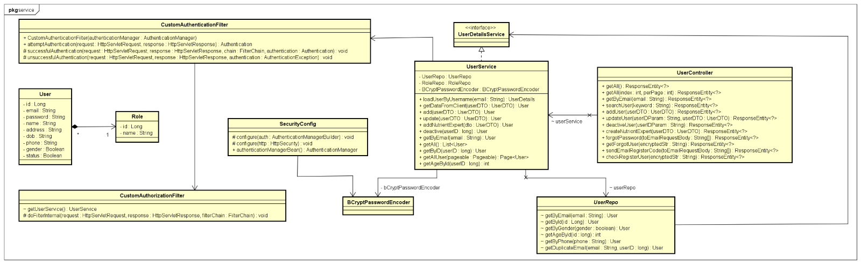

Figure 3.1. “Login and Register” Class Diagram

#### 3.1.2. Sequence Diagram(s)

##### 3.1.2.2. Register 登録

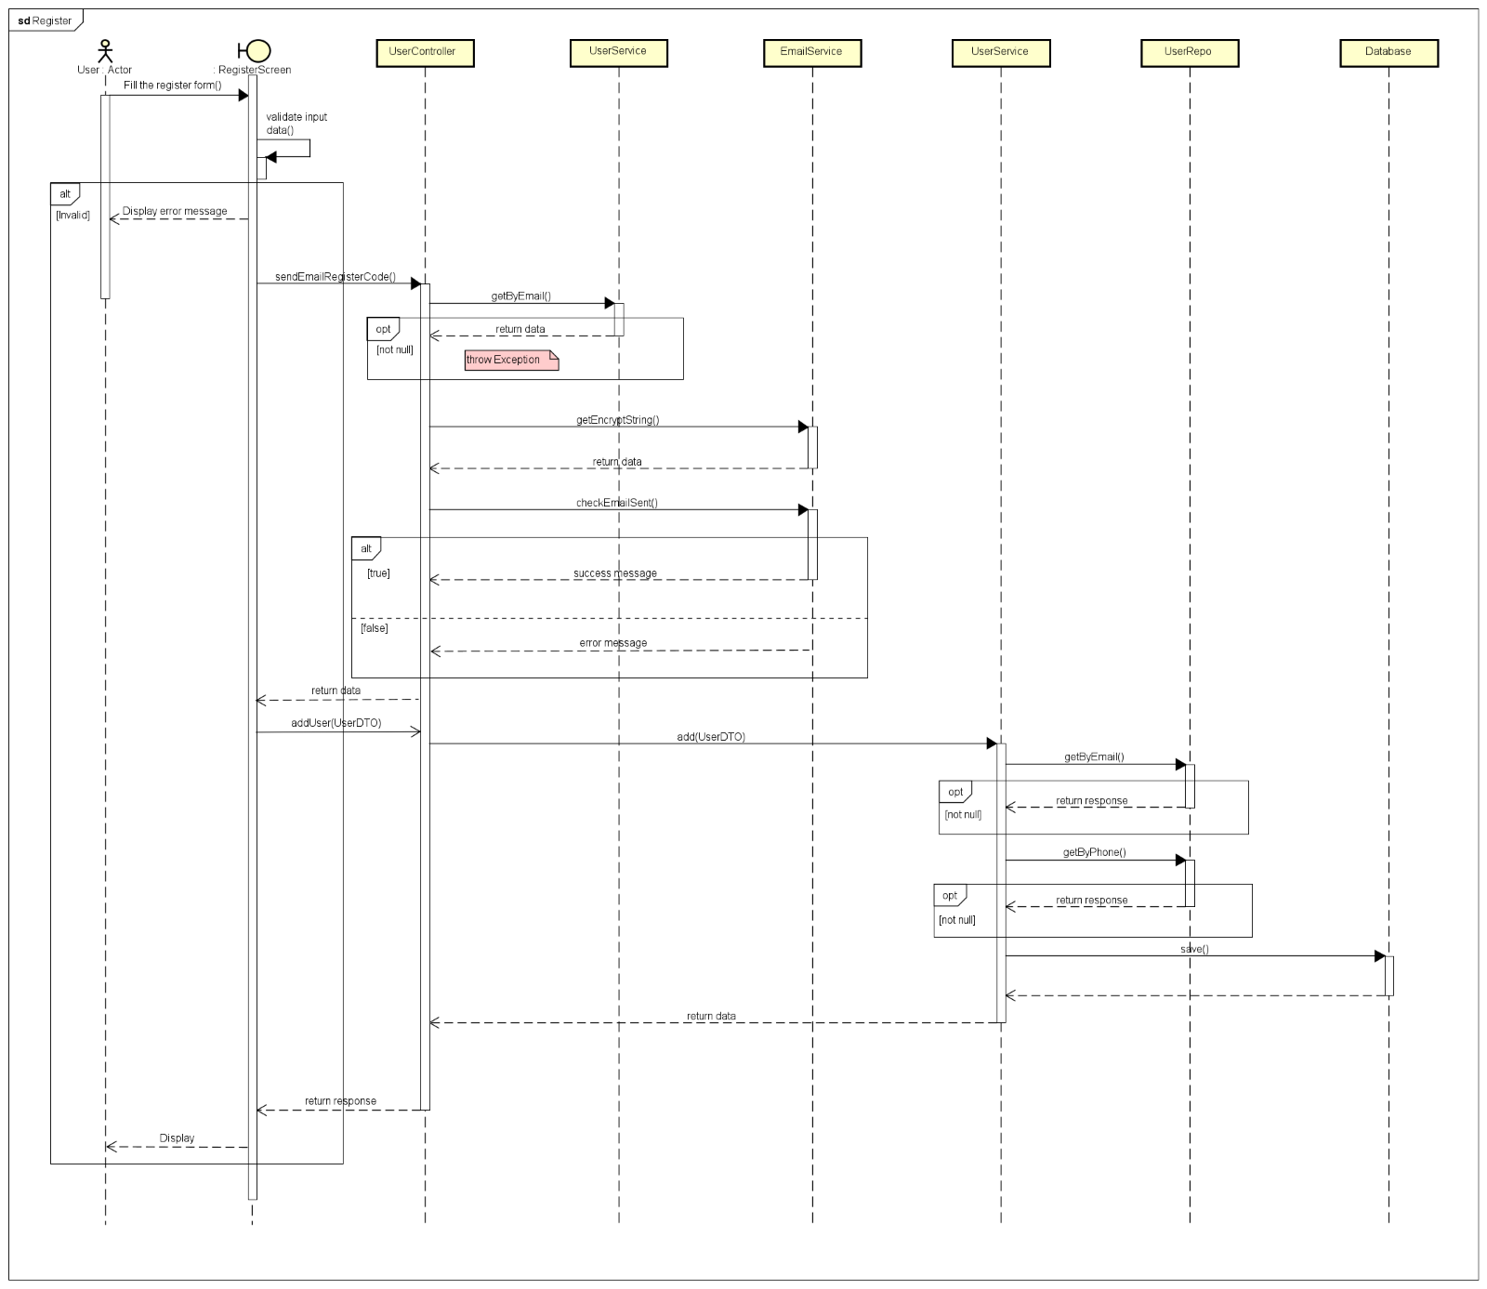

Figure 3.1.2.2. “Register” Sequence Diagram

##### 3.1.2.3. Forgot password パスワードをお忘れた

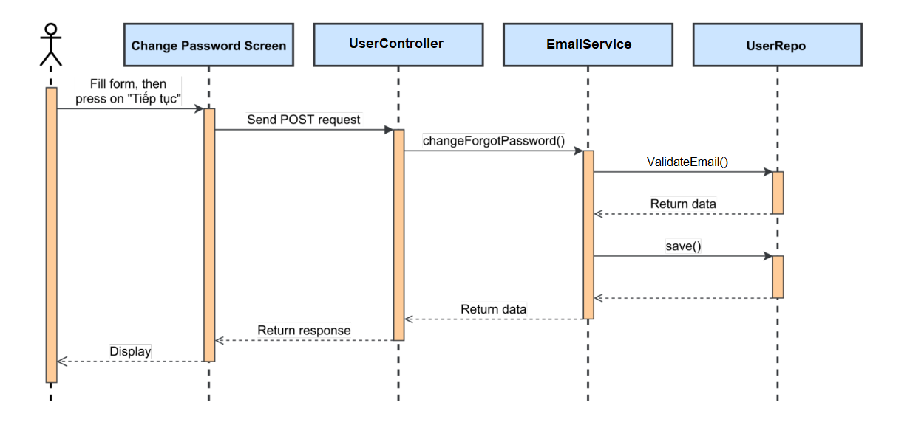

Figure 3.1.2.3. “Forgot password” Sequence Diagram

### 3.2. Feature “Manage personal profile” 特徴「個人プロフィールの管理」

#### 3.2.1. Class Diagram クラスダイアグラム

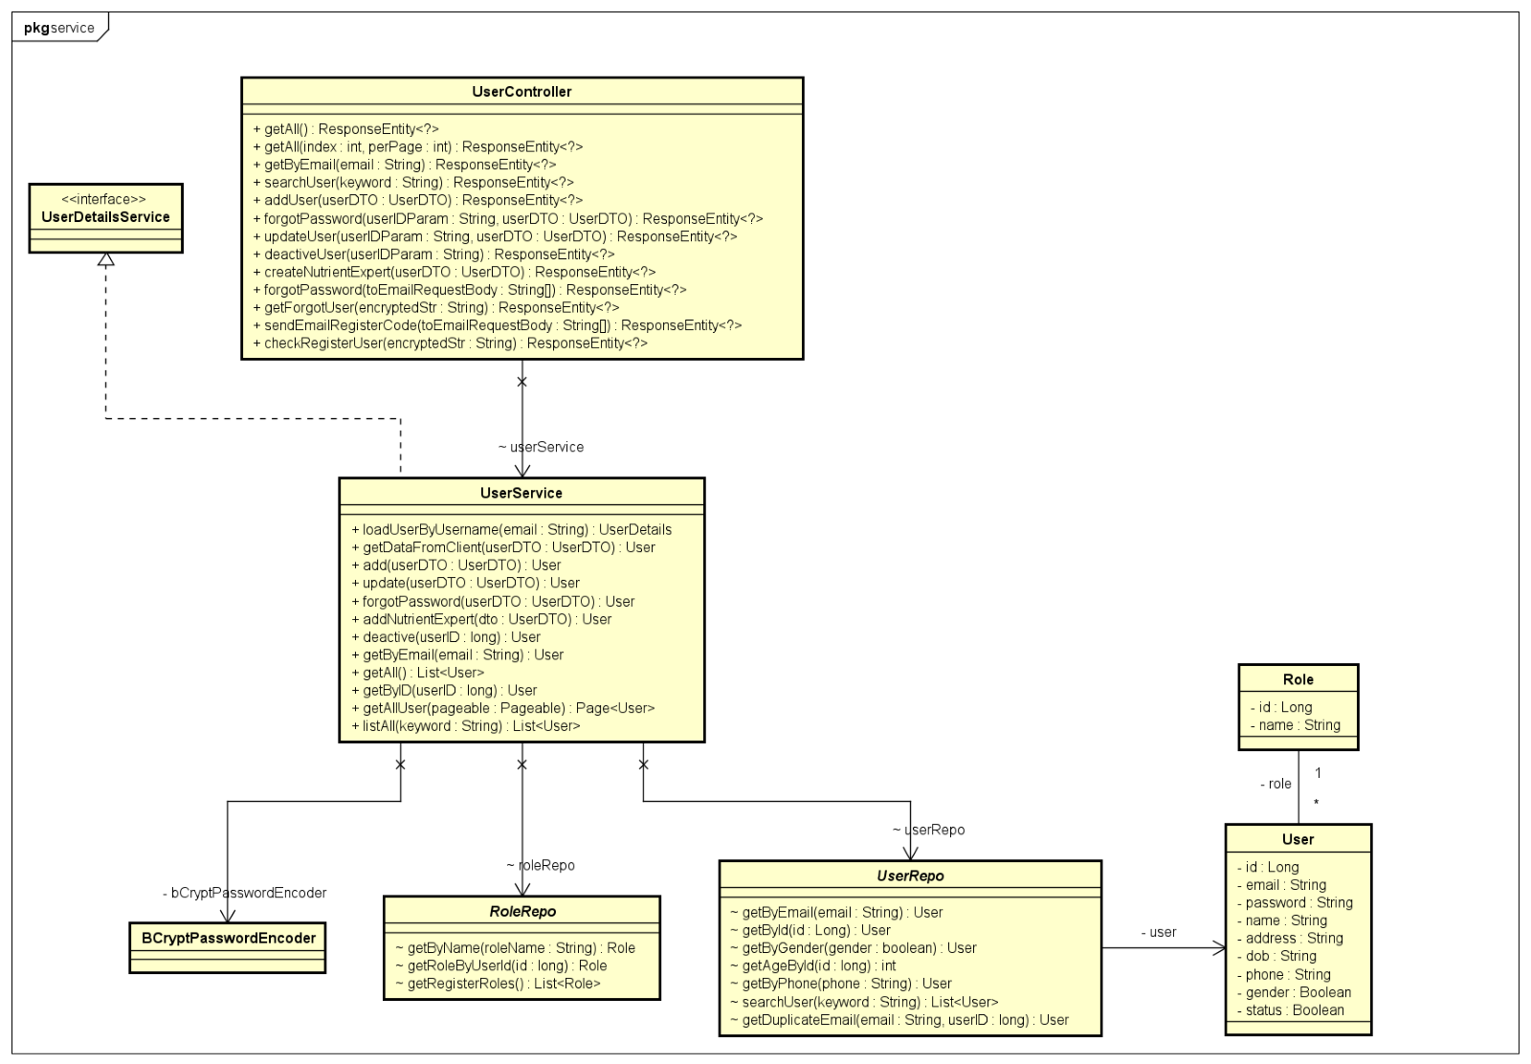

Figure 3.2. “Manage personal profile” Class Diagram

#### 3.2.2. Sequence Diagram(s) シーケンスダイアグラム

##### 3.2.2.1. View personal profile 個人プロフィールを見る

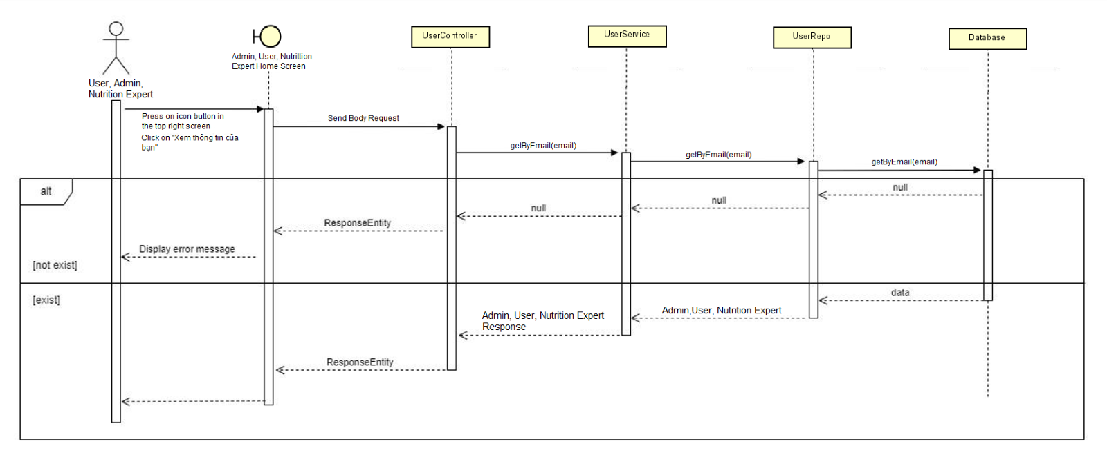

Figure 3.2.2.1. “View personal profile” Sequence Diagram

##### 3.2.2.2. Edit personal profile 個人プロフィールの編集

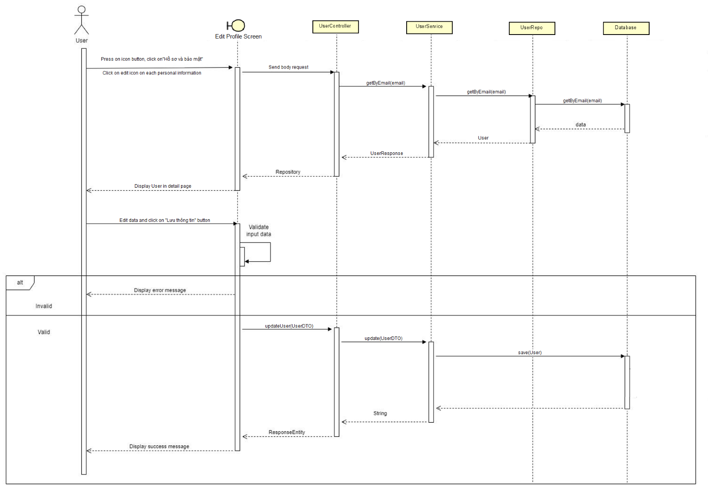

Figure 3.2.2.2. “Edit personal profile” Sequence Diagram

##### 3.2.2.3. Change password パスワードを変更する

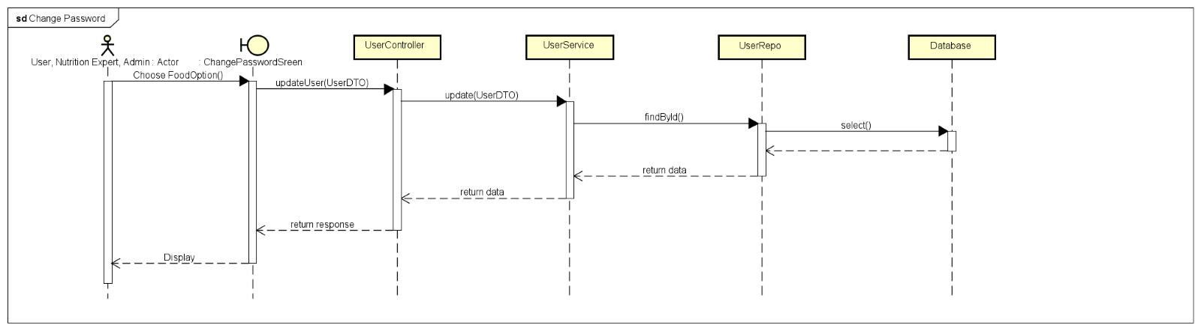

Figure 3.2.2.3. “Change password” Sequence Diagram

##### 3.2.2.4. Validate email メールを検証

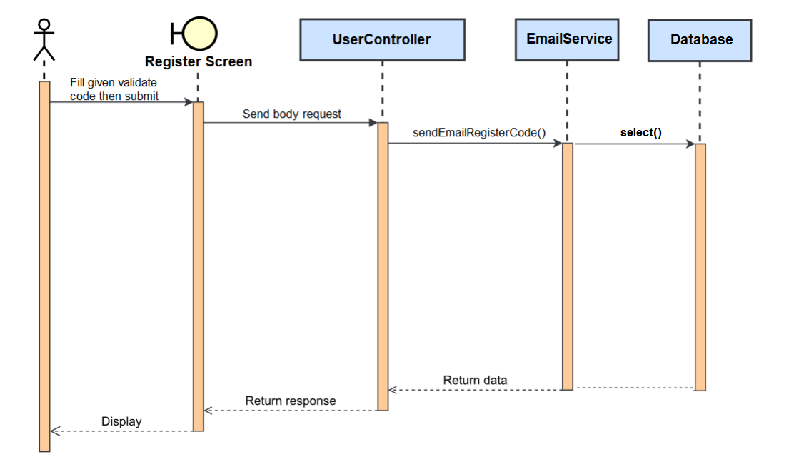

Figure 3.2.2.5. “Validate email” Sequence Diagram

### 3.3. Feature “Manage system accounts” 特徴「システム アカウントの管理」

#### 3.3.1. Class Diagram クラスダイアグラム



Figure 3.3.1. “Manage system accounts” Class Diagram

#### 3.3.2. Sequence Diagram(s) シーケンスダイアグラム

##### 3.3.2.1. View system account list システム アカウント リストの表示

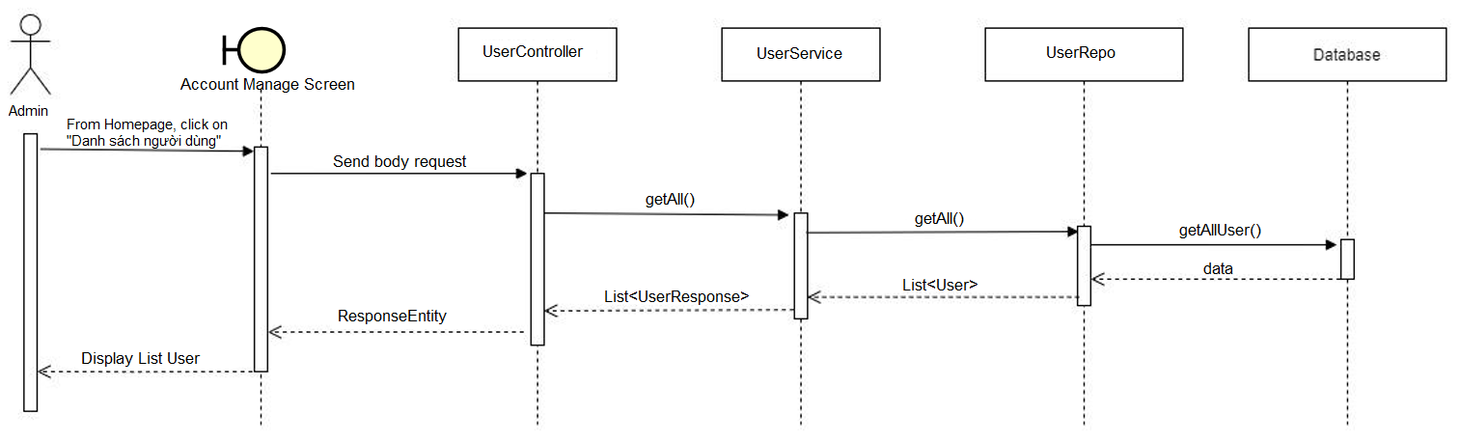

Figure 3.3.2.1. “View system account list” Sequence Diagram

##### 3.3.2.2. Deactivate account アカウントを無効化し

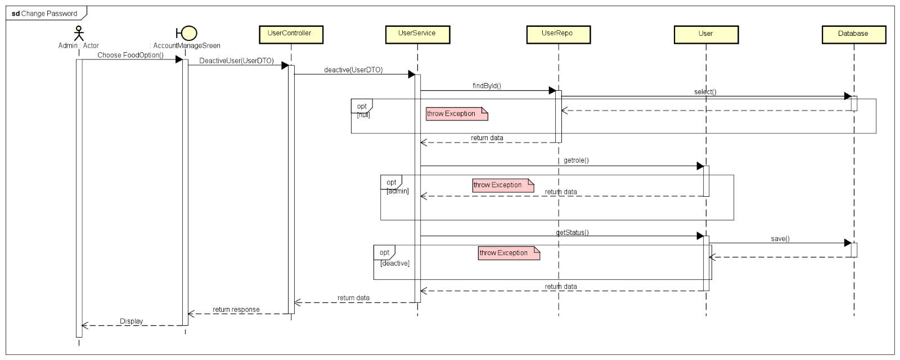

Figure 3.3.2.2. “Deactivate account” Sequence Diagram

##### 3.3.2.3. Reactivate account アカウントを再開する

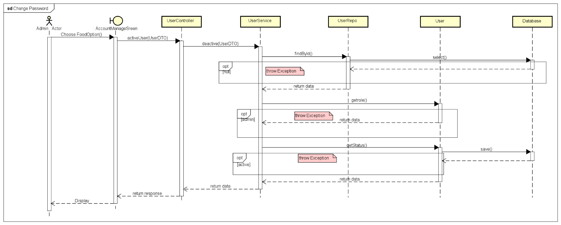

Figure 3.3.2.3. “Deactivate account” Sequence Diagram

### 3.4. Feature “Manage Food” 特集「食事管理」

#### 3.4.1. Class Diagram クラスダイアグラム

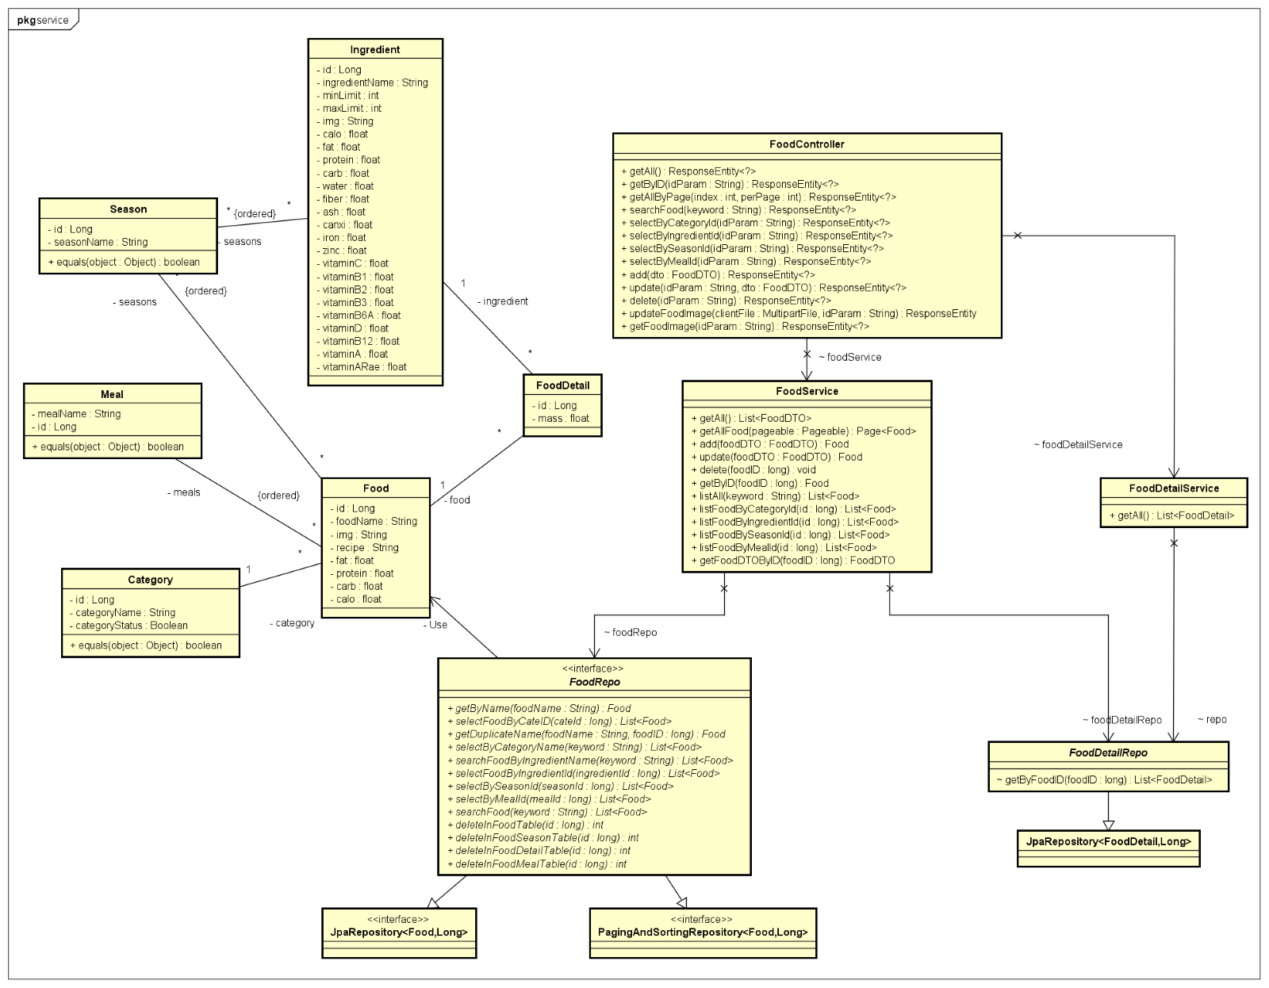

Figure 3.4.1. “Manage Food” Class Diagram

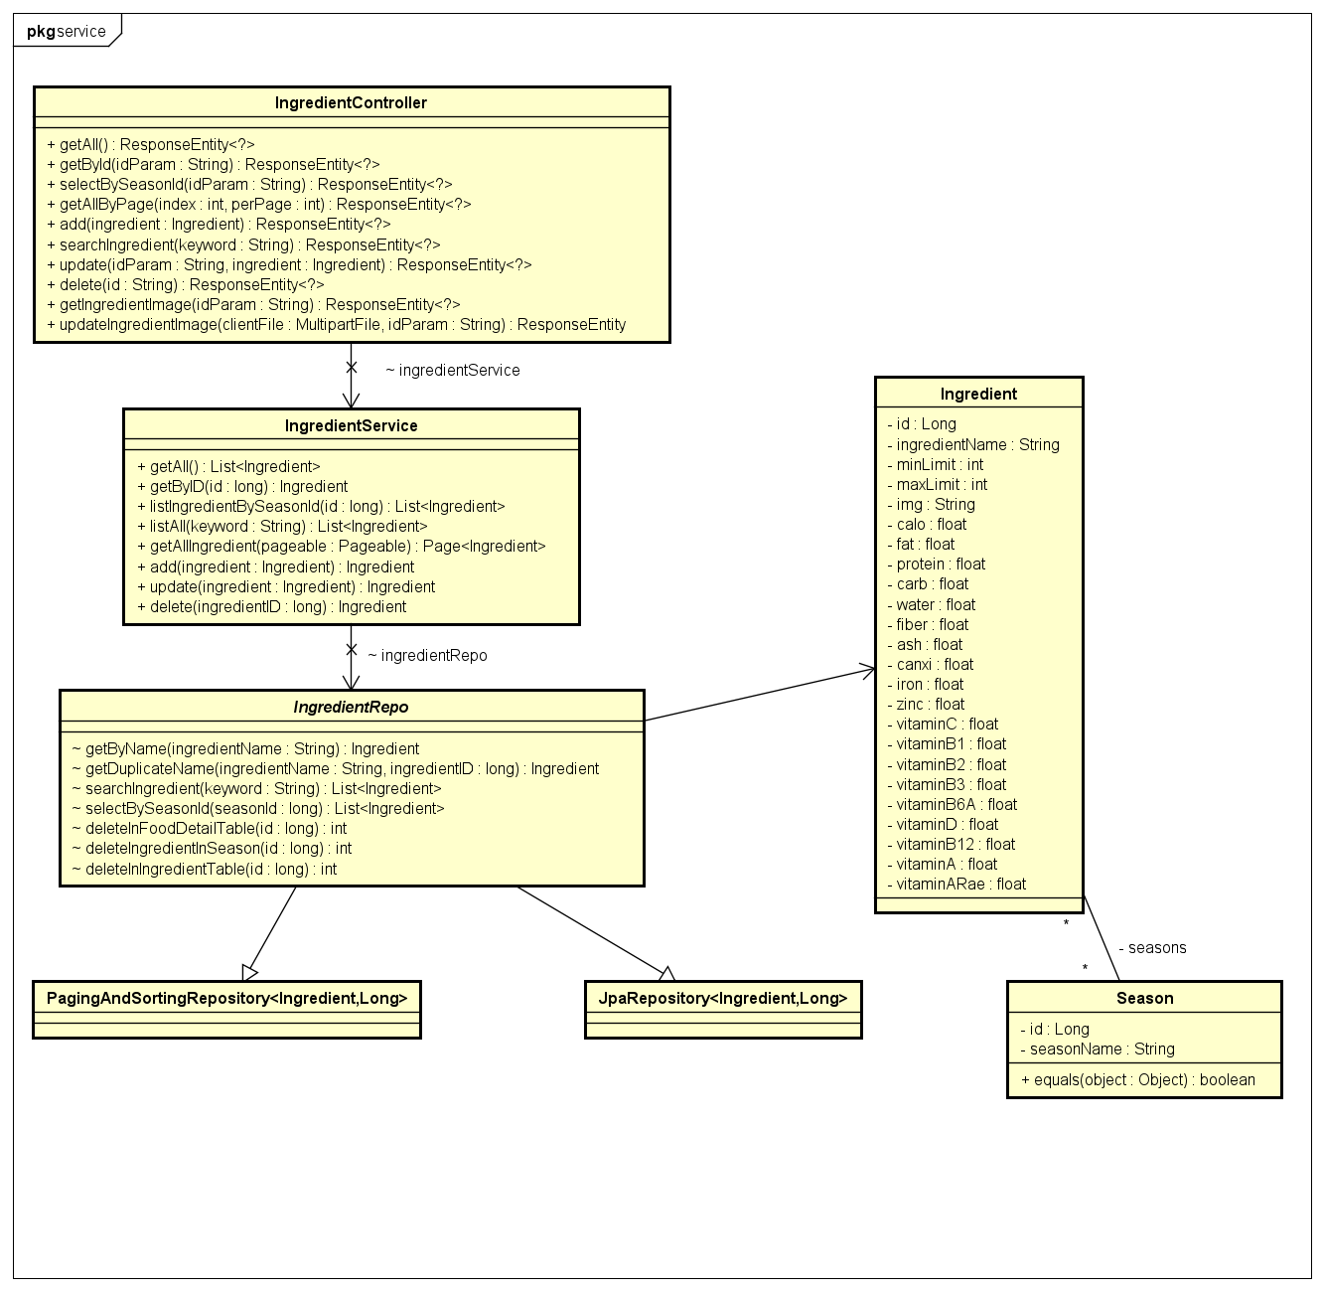

Figure 3.4.2. “Manage Ingredient” Class Diagram

#### 3.4.2. Sequence Diagram(s) シーケンスダイアグラム

##### 3.4.2.1. Add Food 食べ物を追加

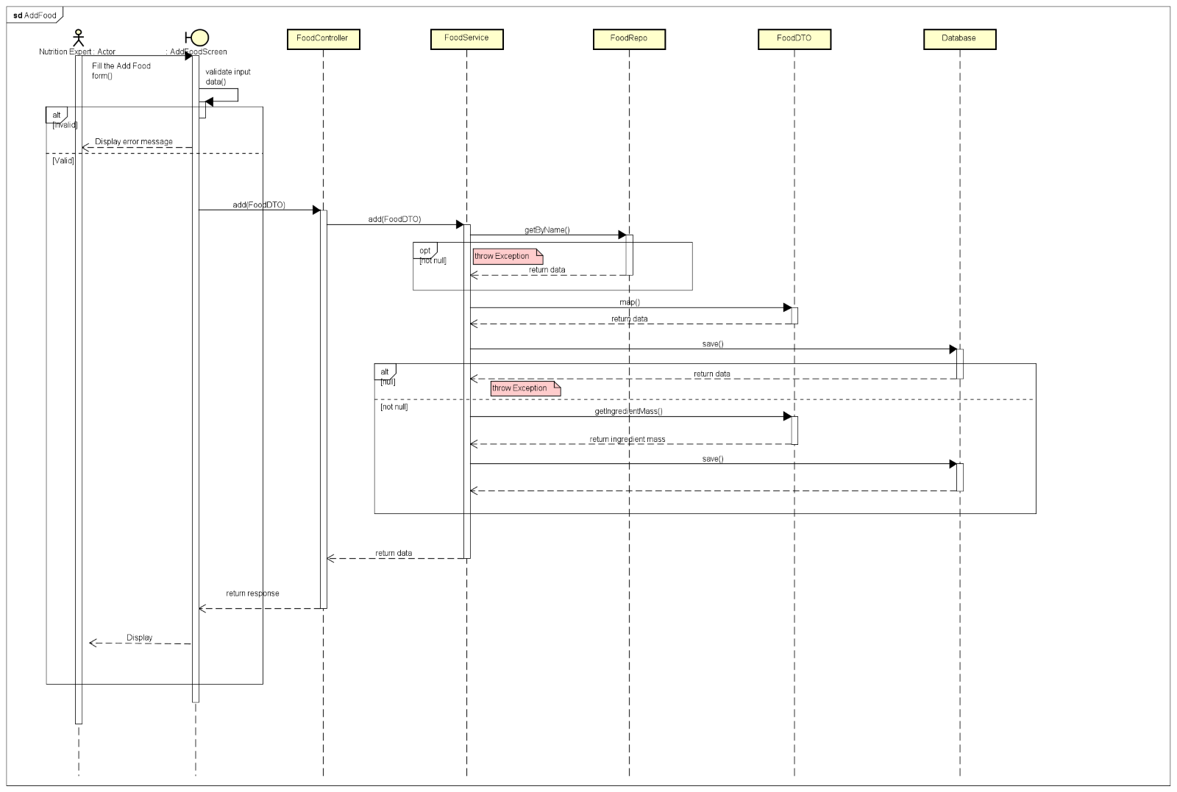

Figure 3.4.2.1. “Add Food” Sequence Diagram

##### 3.4.2.2. Edit Ingredient 特徴を編集

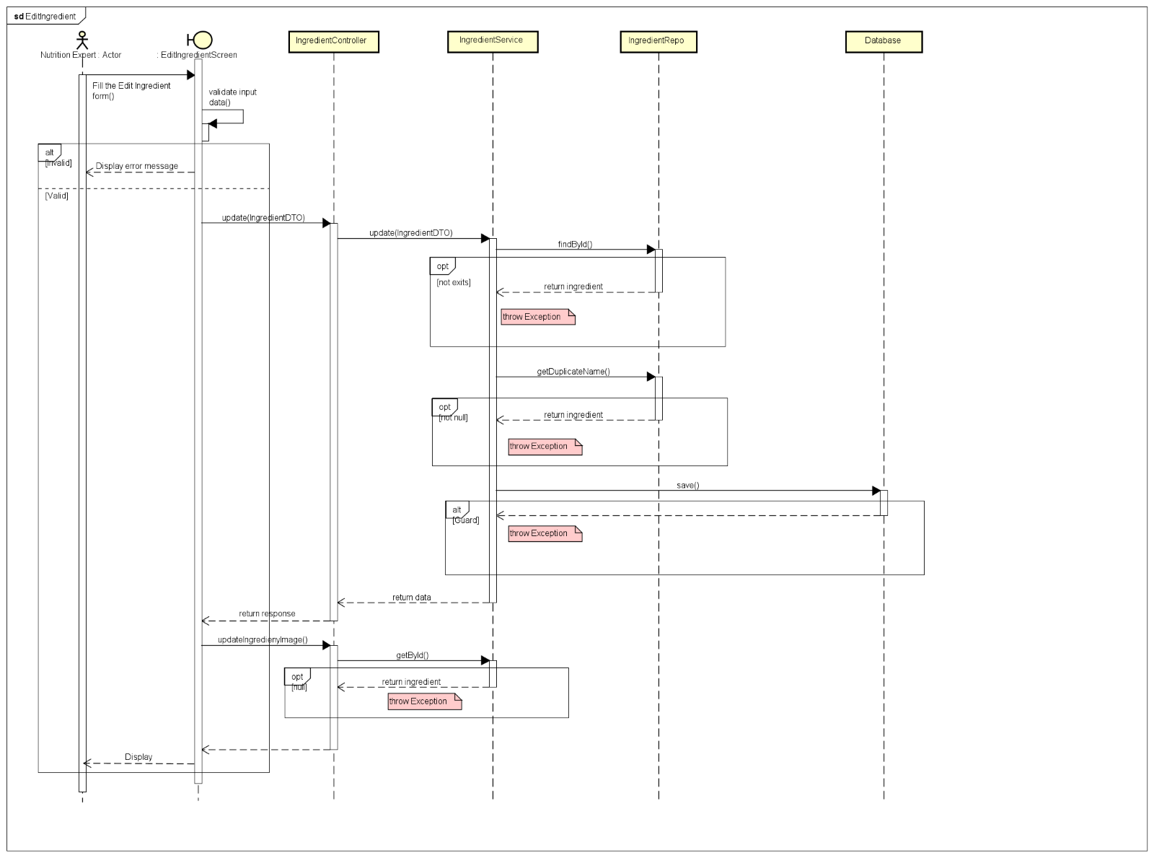

Figure 3.4.2.3. “Edit Ingredient” Sequence Diagram

##### 3.4.2.3. Edit Food 食べ物を編集する

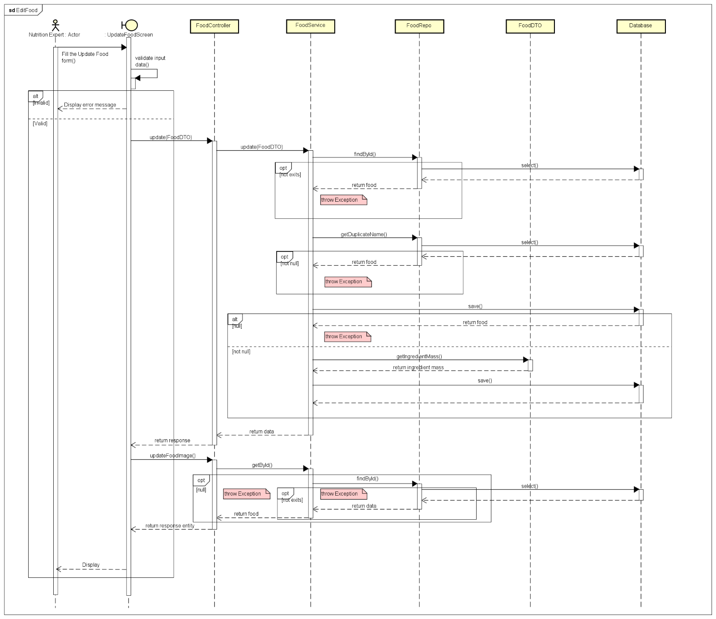

Figure 3.4.2.5. “Edit Food” Sequence Diagram

##### 3.4.2.4. Add Ingredient 材料を加える

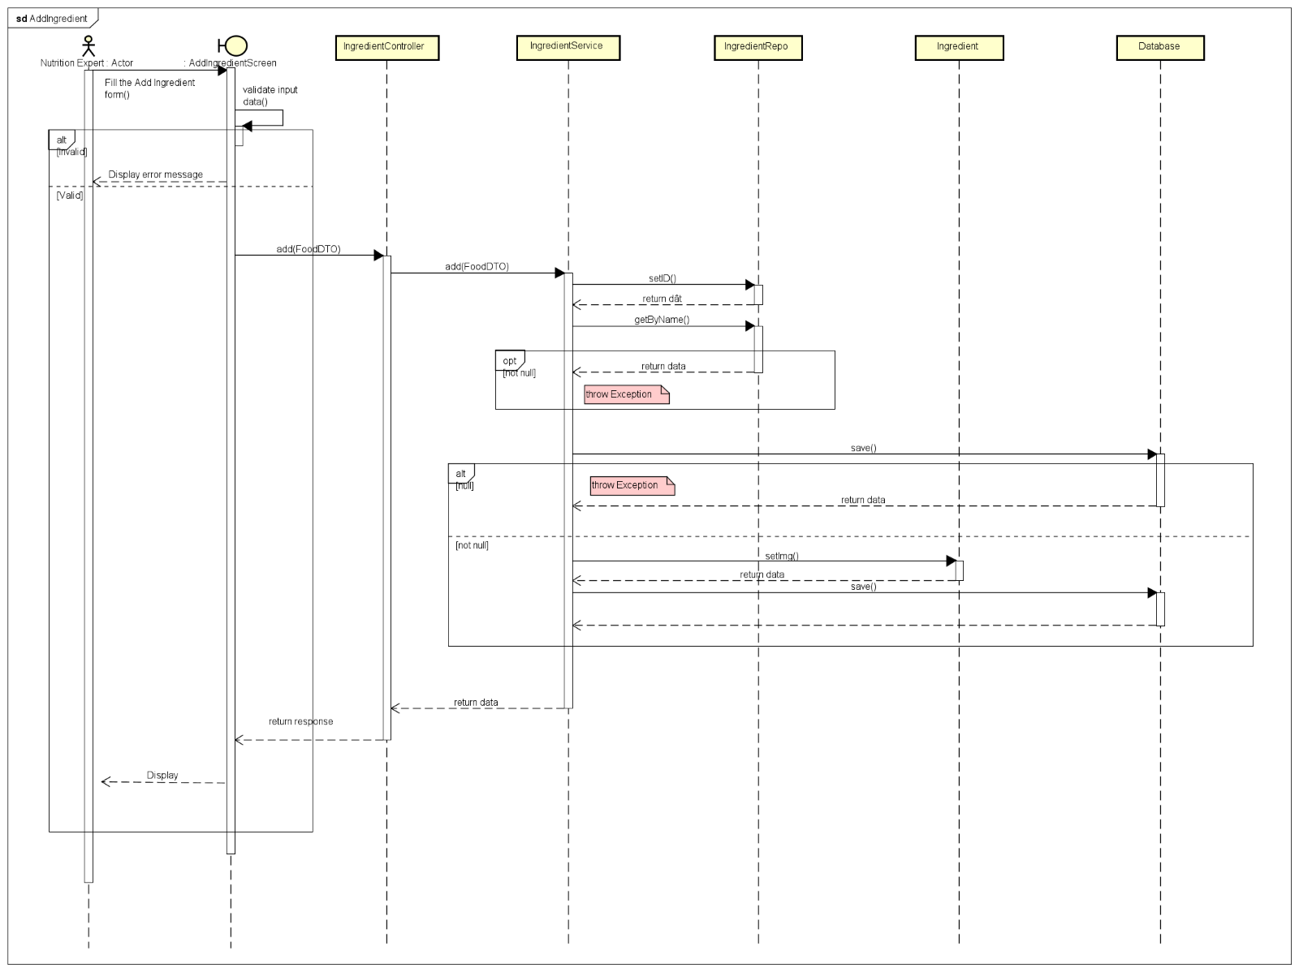

Figure 3.4.2.7. “Add Ingredient” Sequence Diagram

### 3.5. Feature “Search Food and Ingredient”

#### 3.5.1. Sequence Diagram(s) シーケンスダイアグラム

##### 3.5.1.1. Search Food by Name 名前で食を検索

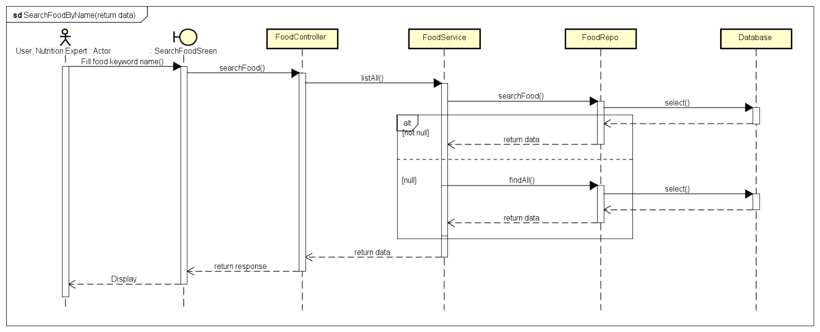

Figure 3.5.2.1. “” Sequence Diagram

##### 3.5.1.2. Search Ingredient by Name 材料名から探す

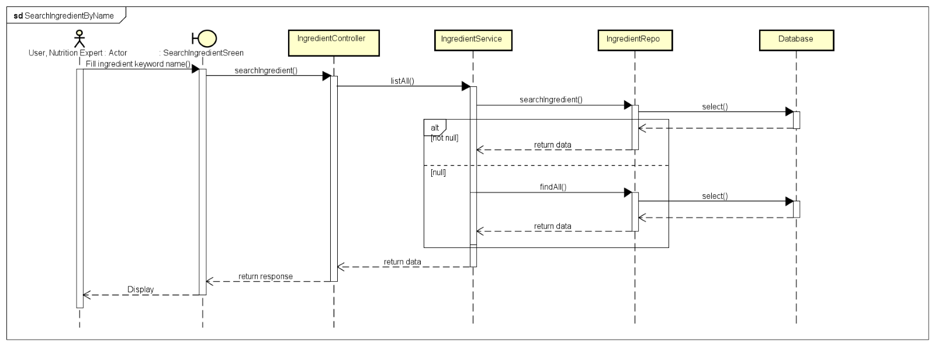

Figure 3.5.2.2. “” Sequence Diagram

##### 3.5.1.3. Filter Food 食品をろ過する

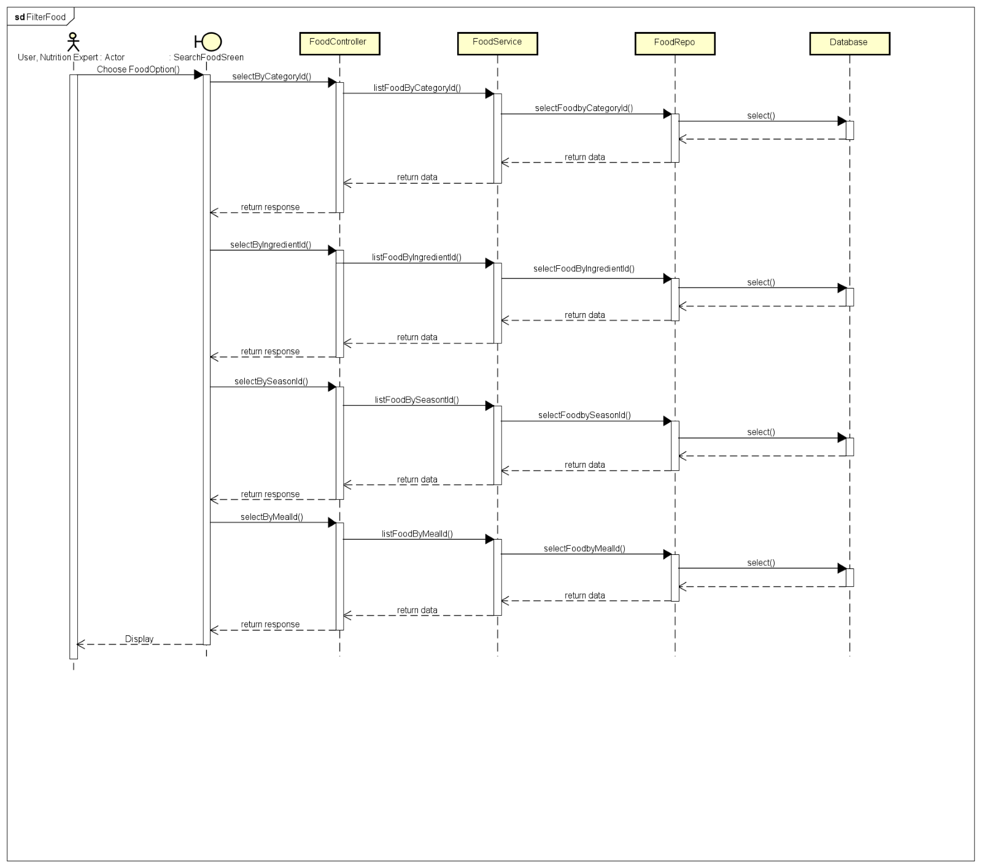

Figure 3.5.2.3. “” Sequence Diagram

##### 3.5.1.4. Filter Ingredient フィルタ材料

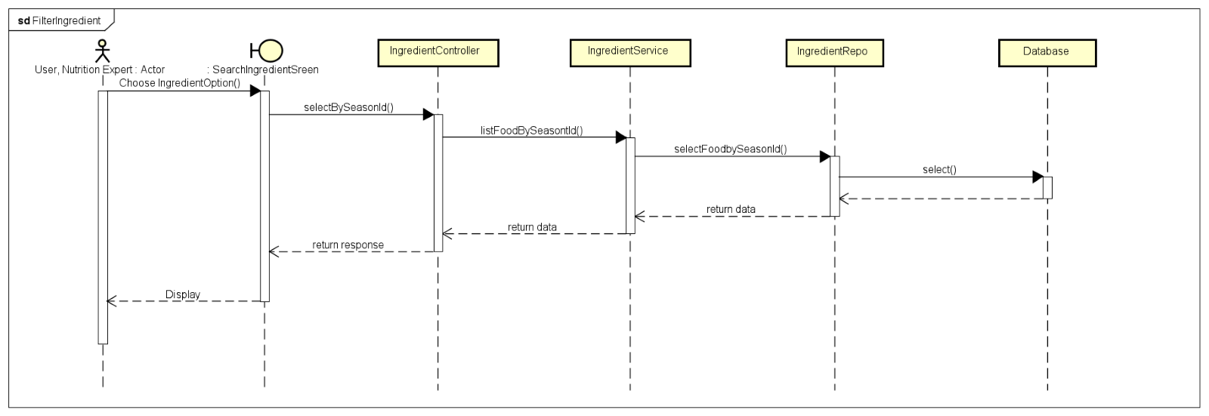

Figure 3.5.2.4. “Delete personal review” Sequence Diagram

##### 3.5.1.5. View Food Detail

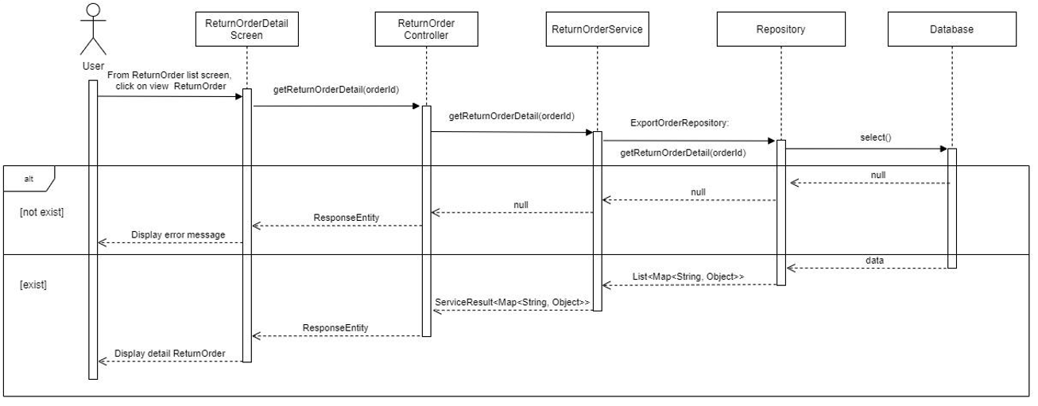

Figure 3.5.2.5. “View Food Detail” Sequence Diagram

### 3.6. Feature “Manage Diet” 特集「食事管理」

#### 3.6.1. Class Diagram クラスダイアグラム

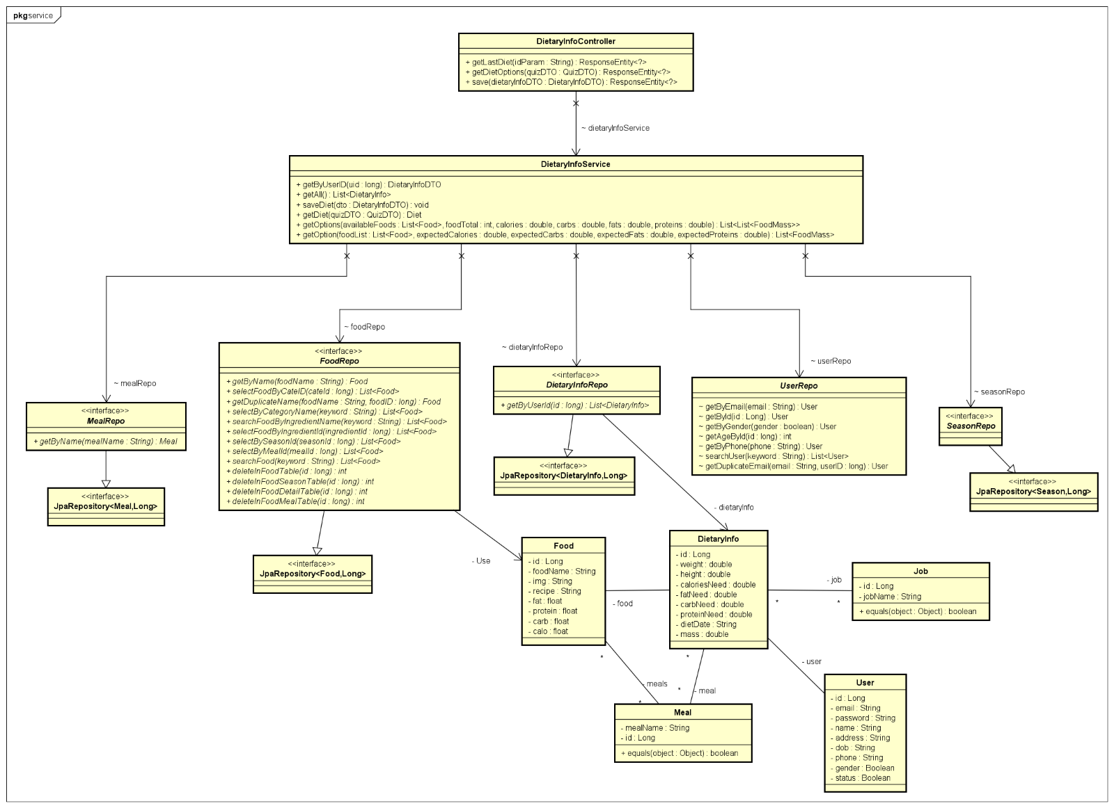

Figure 3.6.1. “Manage check-in” Class Diagram

#### 3.6.2. Sequence Diagram(s) シーケンスダイアグラム

##### 3.6.2.1. Receive Nutrition Regime 栄養管理を受ける

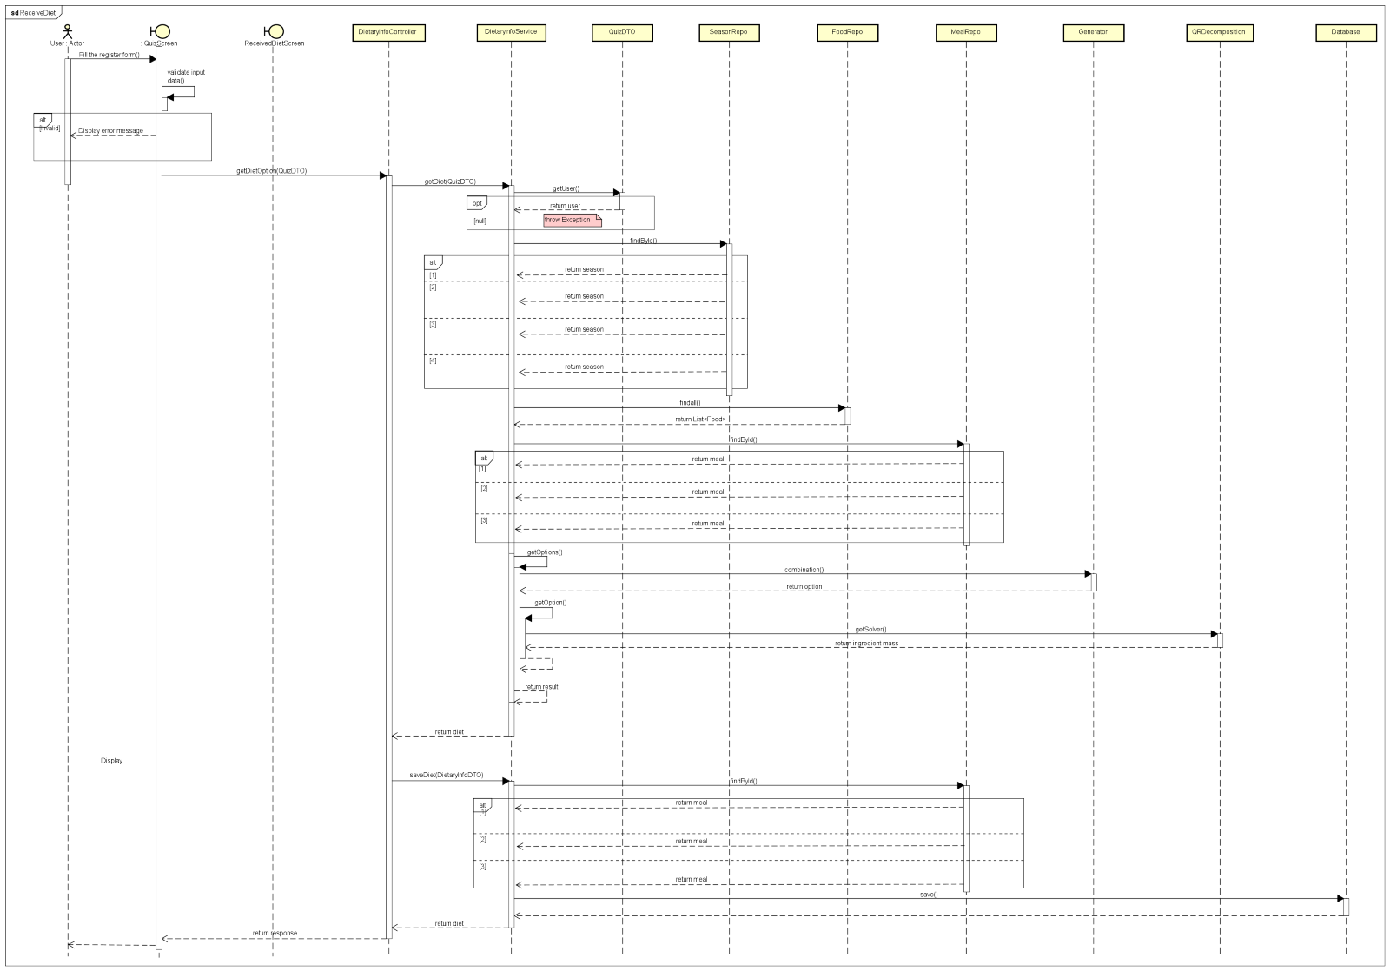

Figure 3.6.2.1. “Receive Nutrition Regime” Sequence Diagram

##### 3.6.2.2. View Nutrition Regime Schedule 栄養管理スケジュール

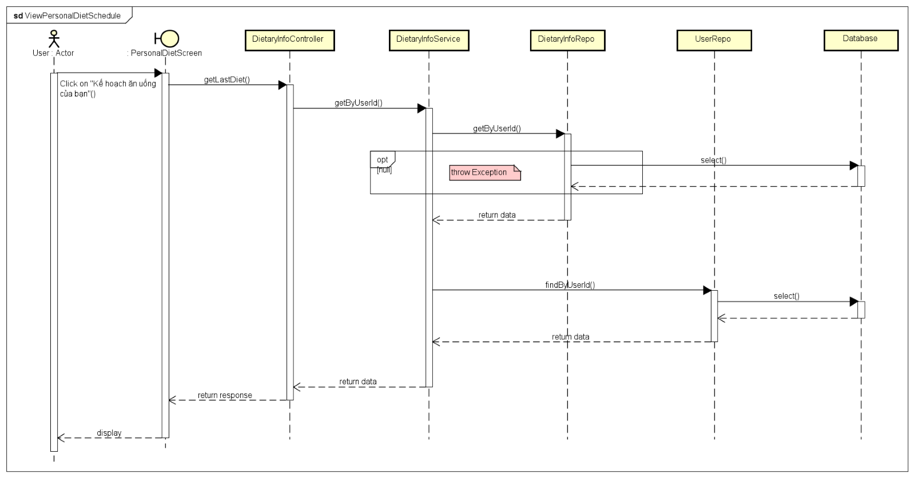

Figure 3.6.2.2. “View nutrition regime schedule” Sequence Diagram

# V. Software Testing Documentation ソフトウェア テスト ドキュメント

## 1. Scope of Testing（テストの範囲）

* The team will focus mainly on functions that actor “Angler” will be executed.
* There are 4 phases in the testing process: Unit testing, Integration testing, System testing, and Acceptance testing.

|  |  |  |
| --- | --- | --- |
| **Test stages** | **Description** | **Purpose** |
| Unit testing | It is used to test function in backend code, created, and performed in source code by backend developers. | Re-check all requirements and cases that might be happened to a function and check if it can adapt them or not. |
| Integration testing | Group all individual modules and test as a group. It is created and performed by tester team. | To expose defects in the interfaces or defects in the interaction between integrated modules. |
| System testing | It is used to test a complete integrated system. It is created and performed by tester team. | To test overall system and verify all logic and data stream of system. |
| Acceptance testing | It conducted to determine if the requirements of a specification or are met. | Including alpha testing. Supervisor, team members and people who want to use the app can test builded app to detect bug and strange behavior. |

Table 1. Stages of testing

## 2. Test Strategy（テスト戦略）

### 2.1 Testing Model（テストのモデル）

Our test type is an Interative Model. According to the model of the development process in Agile Model (an interative software development process framework). The Interative Model interates the requirement, design, implementation, testing and deployment phase continuously for each requirement and builds up the system iteratively till it is completely built.

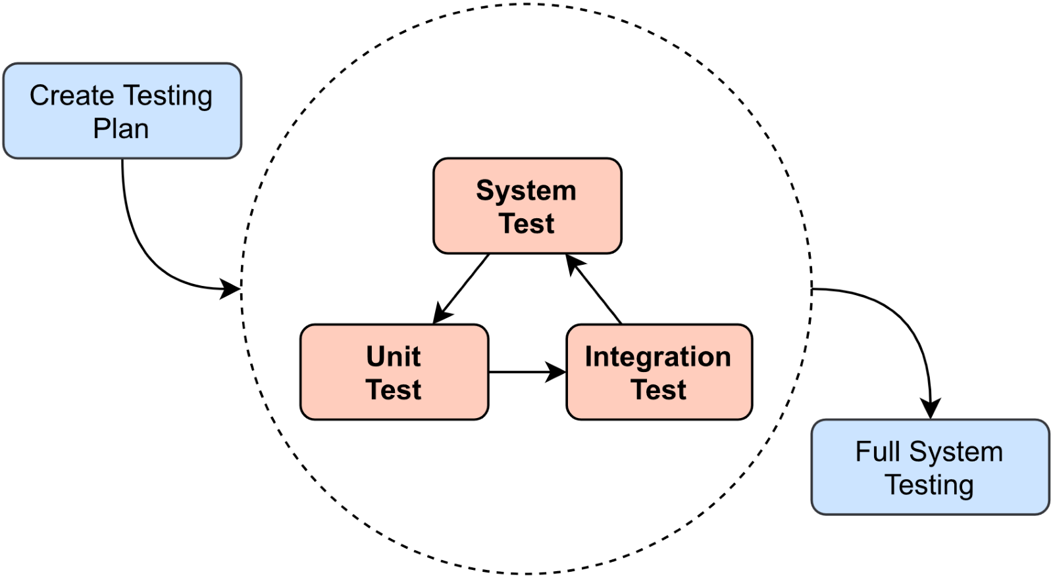

Figure 2.1. Interative Test Model

### 2.2 Testing Types（テストの種類）

|  |  |
| --- | --- |
| **Testing Type** | **Description** |
| Functional Testing | * Testing individual methods, functions, model class and library class. * Test case will have to cover all logic branch that function or method could execute with difference data input. Another alternative logic branch should be covered if not, that logic branch should be detected at API testing level. * Implemented function’s error message and database error message will be included in this test. |
| GUI Testing | * GUI testing verifies a user’s interaction with the software. The goal of GUI testing is to ensure that the GUI provides the user with an appropriate access and navigation through the functions of the target-of-test. In addition, GUI testing ensures that the objects within the GUI function as expected and conform to requirement * GUI test will be performed fully on all screens. * This test targets to cover the verification of the overall look and feel of the system including initial position, font, text size, color, focus, initial button, tab order, label, etc. |
| API Testing | * Involves testing APIs directly to determine if they meet expectations for functionality, reliability, performance, and security. API testing will test all of individual implemented API of system API Service. |
| Regression Testing | * The testing is to confirm that the bug was removed including the extent of the impact, when developers fix bug, developers and testers will confirm with each other what is the impacts of fix bug modification, after that all impact unit or function will be retested by developers then testers after that. |
| Acceptance Testing | * This test type will be executed by tester with designed test cases, acceptance test is a test type conducted to determine if the requirements of a specification or contract are met. * It also includes alpha testing; alpha testing takes place at close relation user’s site and are free test to detect bug and strange behavior. By that, development team will improve UX and UI of system. |

Table 2.2. Testing Types

### 2.3 Test Levels（テストレベル）

|  |  |  |  |  |
| --- | --- | --- | --- | --- |
| **Type of Tests** | **Test level** | | | |
| **Unit test** | **Integration Test** | **System Test** | **Acceptance Test** |
| Functional Testing | x | x | x |  |
| GUI Testing |  | x | x | x |
| API Testing | x |  | x |  |
| Regression Testing | x | x | x | x |
| Acceptance Testing |  |  |  | x |

Table 2.3. Test Levels

### 2.4 Supporting Tools（サポートツール）

|  |  |  |  |  |
| --- | --- | --- | --- | --- |
| **Purpose** | **Type** | **Tool** | **Provider** | **Version** |
| Manage test cases | Software | Microsoft Excel | Microsoft | Professional Plus 2019 |
| Test APIs | Software | Postman1 | Postman, Inc | Latest |
| Test function | Software | IntelliJ, Visual Studio Code | JetBrains, Microsoft | Latest |
| Execute integration and system test | Hardware | LENOVO Thinkpad, Razer, Dell G7 |  | Window 10 |
| Database management | Software | MySQL Workbench |  | Latest |

Table 2.4. Supporting Tools

## 3. Test Plan（テスト計画）

### 3.1. Human Resources 人事

|  |  |  |
| --- | --- | --- |
| **Member** | **Role** | **Specific Responsibility** |
| VietNH | Test leader  Tester | * Create test plan, test process, test case. * Create and execute unit test. * Execute test. * Log bug. * Create reports. |
| CuongLM | Tester  Frontend developer | * Execute test. * Fix bug of frontend features. * Log bug. |
| LongNV | Backend developer | * Fix bug of back-end features. * Log bug. |
| SonND | Frontend developer | * Fix bug of front-end features. * Log bug. |

Table 3.1. Human Resources

### 3.2 Test Milestones（テストのマイルストーン）

|  |  |  |
| --- | --- | --- |
| **Milestone Tasks** | **Start Date** | **End Date** |
| Create test cases (Iteration 1) | 11/18/2022 | 12/05/2022 |
| Execute Unit test and Integration test (Iteration 1) | 11/18/2022 | 12/05/2022 |
| Create test cases (Iteration 2) | 11/18/2022 | 12/05/2022 |
| Execute Unit test and Integration test (Iteration 2) | 11/18/2022 | 12/05/2022 |
| Update testing document | 11/29/2022 | 12/05/2022 |
| Execute System testing | 11/29/2022 | 12/05/2022 |
| Execute Acceptance testing with fixing bugs | 11/29/2022 | 12/05/2022 |
| Create test reports | 12/06/2022 | 12/14/2022 |

Table 3.2. Test Milestones

## 4. Test Cases テストケース

### 4.1. Unit Test 単体テスト

Functional testing will be done on server development side by backend developer, we use Junit libraries, which have been integrated in Spring Boot. These help to reduce test environment installation and can create function test in the most optimal way. For API testing, we use Postman, one of the most popular API testing platforms today, with a simple, easy-to-use interface, clear, and effective results for each test link.

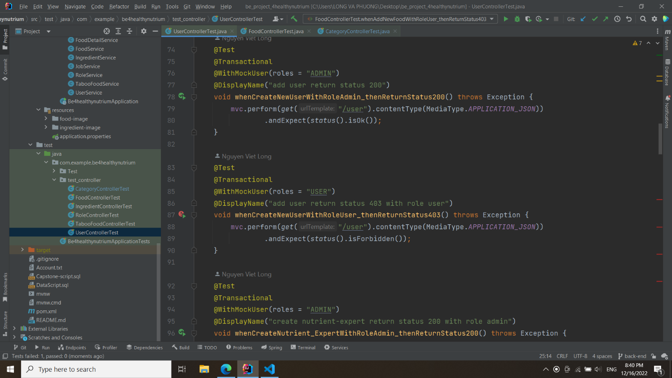

Figure 4.1:1. samples of testing function.

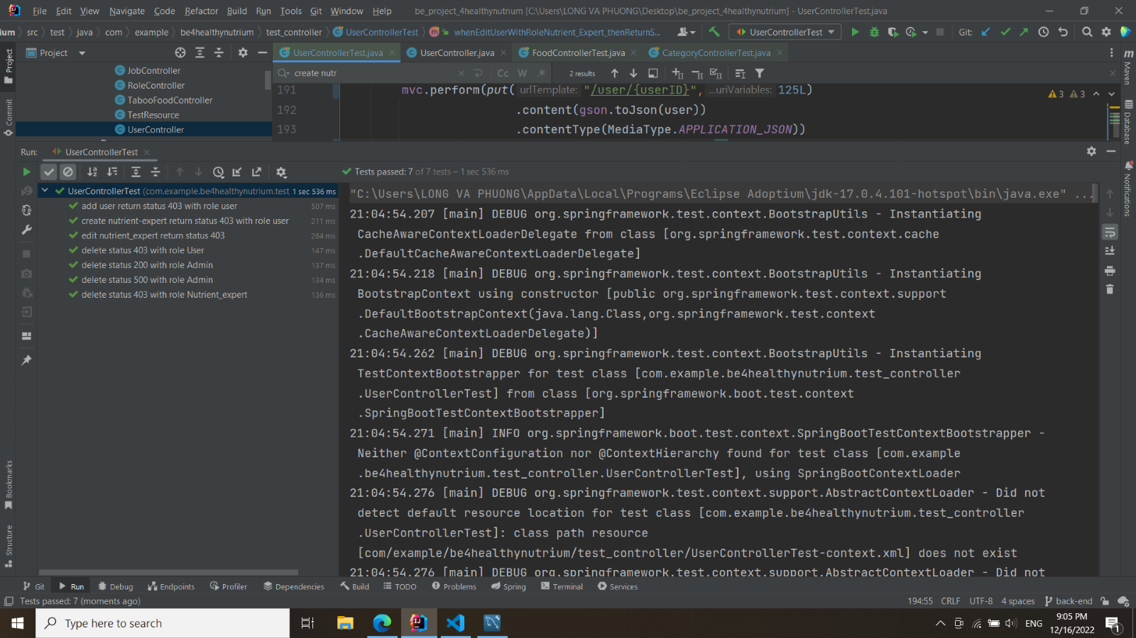

Figure 4.1:2. Running unit test functions

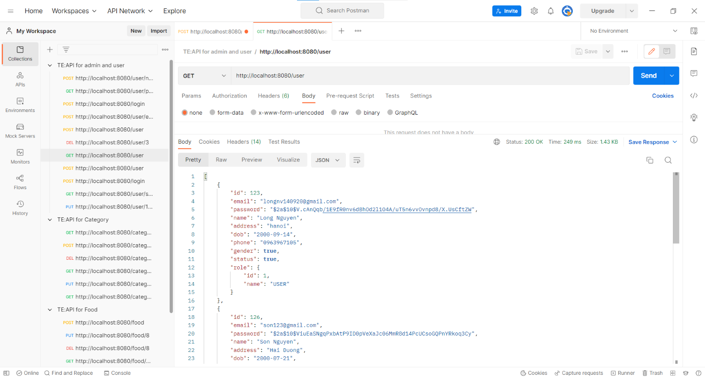

Figure 4.1:3. API testing with Postman Platform

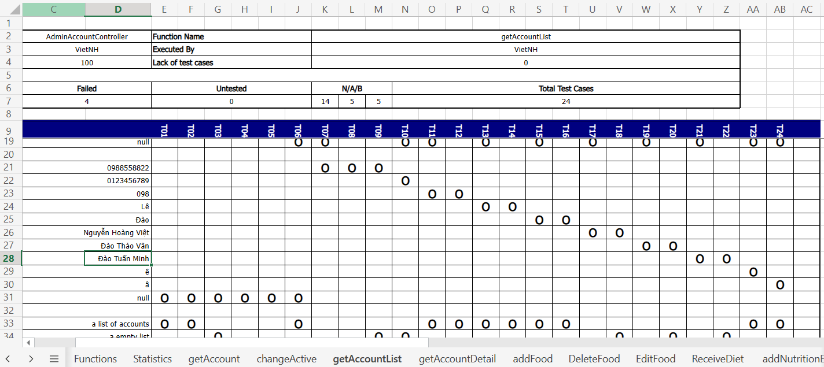

[*Figure 4.1:4 Functional test tracking*](https://fptuniversity-my.sharepoint.com/personal/vietnhhe140789_fpt_edu_vn/_layouts/15/Doc.aspx?sourcedoc=%7B8B462DBE-EEEF-456C-AA47-B1584E529951%7D&file=SWP493_4HTN_UnitTest.xlsx&action=default&mobileredirect=true&DefaultItemOpen=1)

### 4.2. Integration Test 結合テスト

This stage of testing will incorporate the API into the app's interface to test what the data represents to the user. Each test case will clearly record the steps to execute a test case so that bugs or defects can be detected. During testing, if any errors related to UX/UI are discovered, the data representation is incorrect (both user and server side), or maybe the API returns data that is not as expected. Testers will log defect or bug on Jira Issues, and track that test case is failed until it will be fixed by developers.

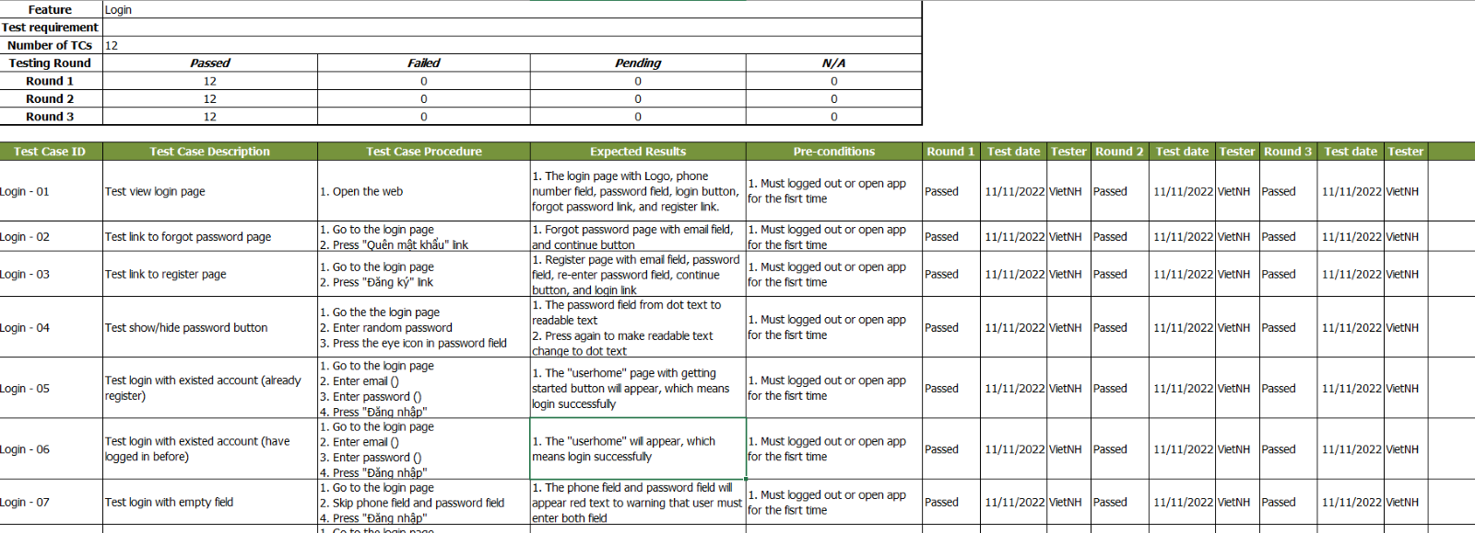

[*Figure 4.2. Integration test tracking*](https://fptuniversity-my.sharepoint.com/personal/vietnhhe140789_fpt_edu_vn/_layouts/15/Doc.aspx?sourcedoc=%7B7231847B-789B-4814-8B5F-6764CE89D116%7D&file=SWP493_4HTN_IntegrationTest.xlsx&action=default&mobileredirect=true&DefaultItemOpen=1)

### 4.3. System Test システムテスト

This stage of testing is performed after the functions outlined in the requirement are fully implemented. We will practice on a physical phone with Window 10 and 11 operating systems. The goal of this test phase is to test the performance that can be run on the device, and assuming the cases that the user will operate on application. Unlike unit testing and integration testing, if any defect or bug is found, the tester needs to notify the developer to fix it immediately or in the shortest time possible.

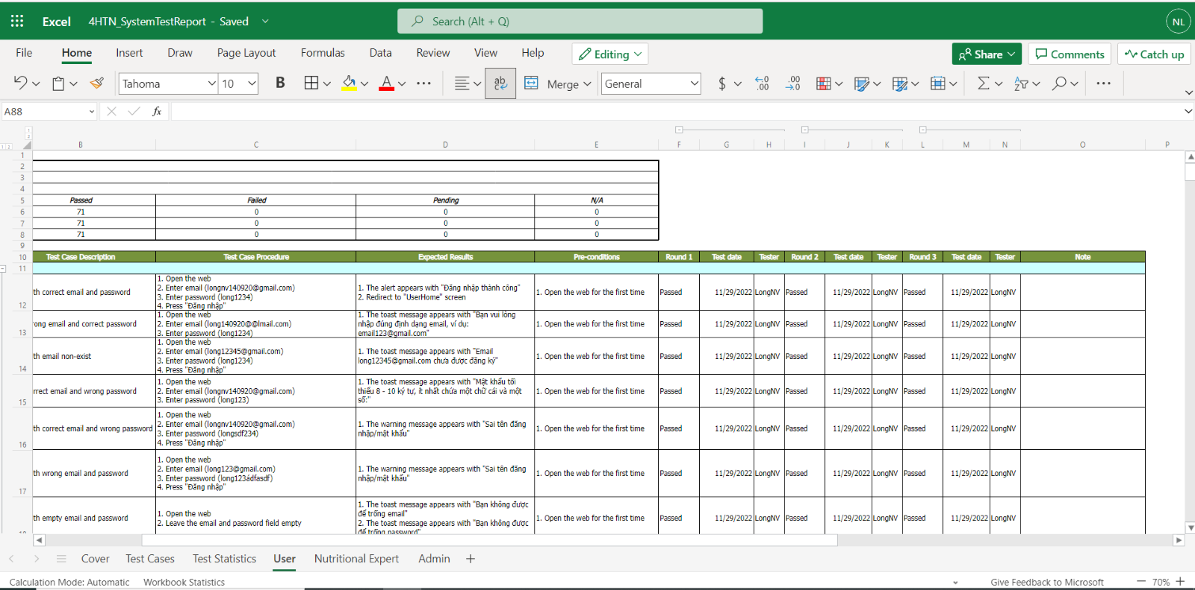

[*Figure 4.3. System test tracking*](https://fptuniversity-my.sharepoint.com/personal/vietnhhe140789_fpt_edu_vn/_layouts/15/Doc.aspx?sourcedoc=%7BBD695506-AF4D-432E-84F5-9E2CE0E0D7D7%7D&file=SWP493_4HTN_SystemTest.xlsx&action=default&mobileredirect=true&DefaultItemOpen=1)

### 4.4. Acceptance Test 受け入れテスト

Our project will use the checklist as a substitute for acceptance testing including items from non-functional requirement specified in Software Requirement Specification.

The content of the checklist is shown in the table below:

|  |  |  |  |
| --- | --- | --- | --- |
| **ID** | **Checklists** | **Yes** | **No** |
| **General** | | | |
| CL-01 | Text on all screens is grammatically correct | x |  |
| CL-02 | All mandatory fields are validated | x |  |
| CL-03 | All error messages are displayed in red color | x |  |
| **GUI and Usability** | | | |
| CL-04 | Links, buttons, and checkboxes are easily clickable | x |  |
| CL-05 | User interface should be clear and easy to use | x |  |
| CL-06 | The system must be designed so that users can easily familiarize themselves with and use competently functions in a short time | x |  |
| CL-07 | Main functions are organized into navigator for easier access | x |  |
| CL-08 | The maximum steps to complete 1 activity from seeing the screen is 3 | x |  |
| **Security** | | | |
| CL-09 | Using authentication and authorization to access protected resources. | x |  |
| CL-10 | JWT token is used to authenticate user. | x |  |
| CL-11 | Password must be protected and encrypt before store in database. | x |  |
| CL-12 | User's password must be hashed with bCryptPasswordEncoder. | x |  |
| CL-13 | Only send the latest OTP to the user's phone number. | x |  |
| **Performance** | | | |
| CL-14 | In the best condition, the slowest response is not exceeded 5 seconds. | x |  |
| CL-15 | In the best condition, the loading pages time must not exceed 5 seconds. | x |  |
| **Maintaining & Scalability** | | | |
| CL-16 | System logs error reporting to track errors whenever the application happens to crash. | x |  |
| CL-17 | Source code must follow the coding convention to help developers to read, understand, and find it easy to maintain or modify the code. | x |  |
| **Compatibility** | | | |
| CL-18 | The device must be Window 10 or higher. | x |  |
| **Localization** | | | |
| CL-19 | The language is Vietnamese. | x |  |
| CL-20 | The date format in the application must be: yyyy-MM-dd or yyyy/MM/dd HH:mm:ss. | x |  |

Table 4.5. Acceptance Testing Checklist

## 5. Test Reports テスト報告

### 5.1. Unit Test 単体テスト

|  |  |  |  |  |  |  |  |
| --- | --- | --- | --- | --- | --- | --- | --- |
| **Function code** | **Passed** | **Failed** | **Untested** | **N** | **A** | **B** | **Total Test Cases** |
| getAccountList | 20 | 4 | 0 | 14 | 5 | 5 | 24 |
| getAccount | 6 | 0 | 0 | 2 | 2 | 2 | 6 |
| changeActive | 9 | 0 | 0 | 2 | 3 | 4 | 9 |
| [getAccountDetail](" \l "getAccountDetail!A1) | 7 | 0 | 0 | 2 | 3 | 2 | 7 |
| addFood | 11 | 3 | 0 | 9 | 5 | 0 | 14 |
| deleteFood | 7 | 0 | 0 | 1 | 3 | 3 | 7 |
| editFood | 12 | 2 | 0 | 9 | 5 | 0 | 14 |
| **Sub total** | **86** | **9** | **0** | **41** | **32** | **22** | **95** |

Table 5.1. Unit Test Report

* Test coverage: 100**%**
* Test successfully coverage: 90.53**%**
* Normal case: 43.16**%**
* Abnormal case: 33.68**%**
* Boundary case: 23.16**%**

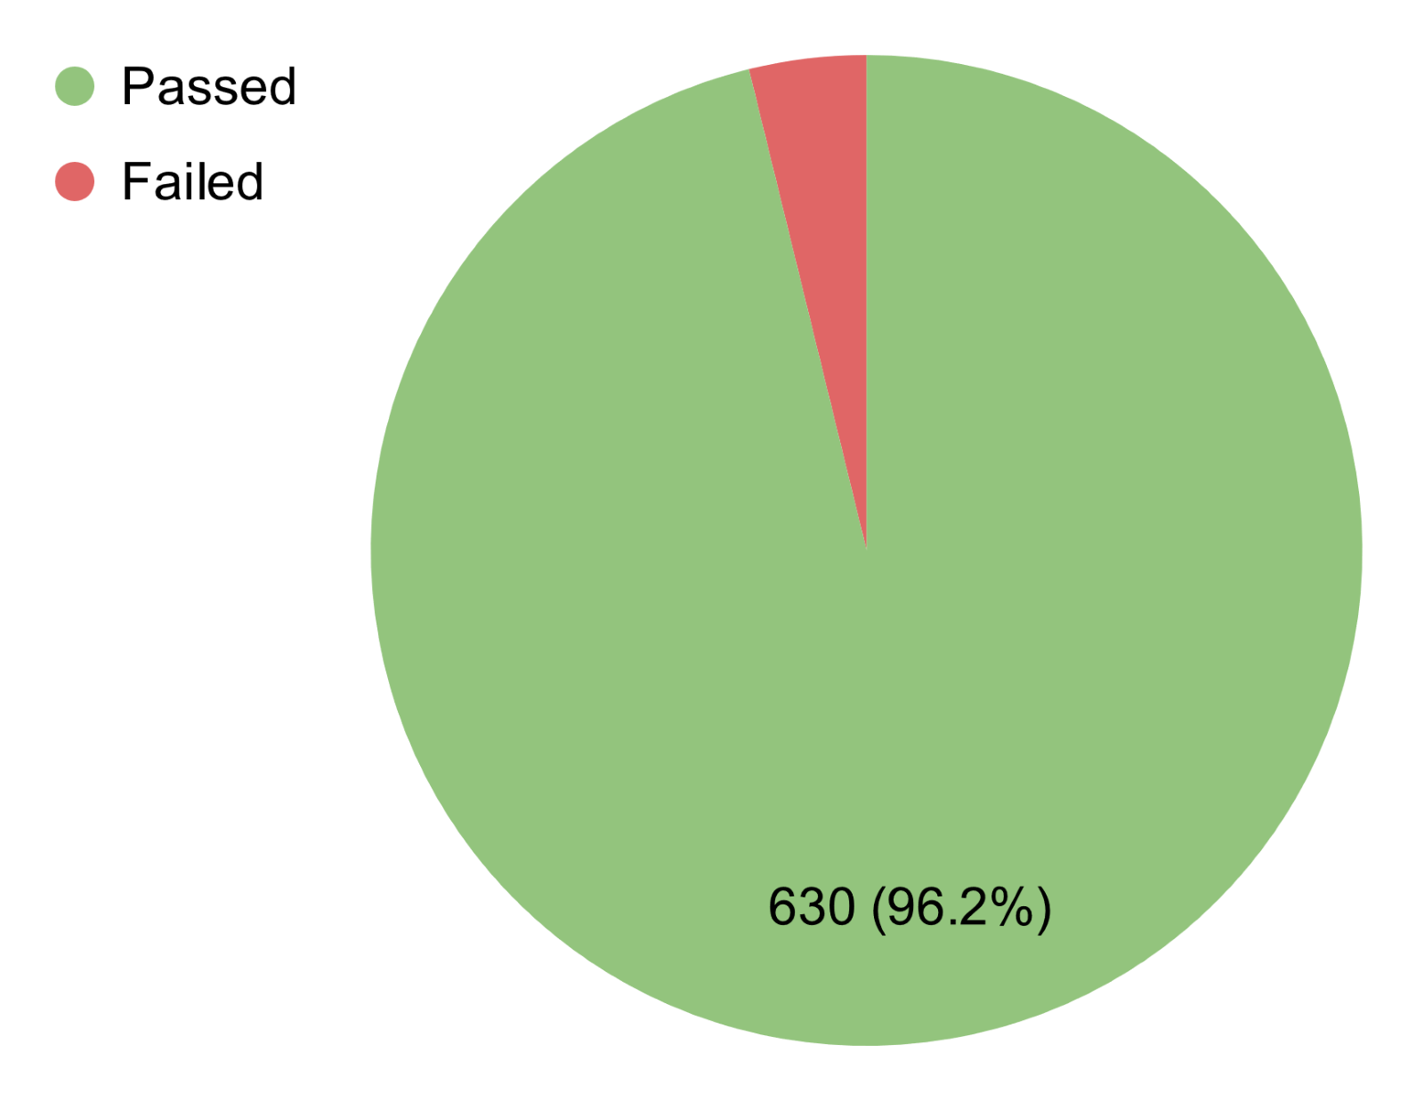 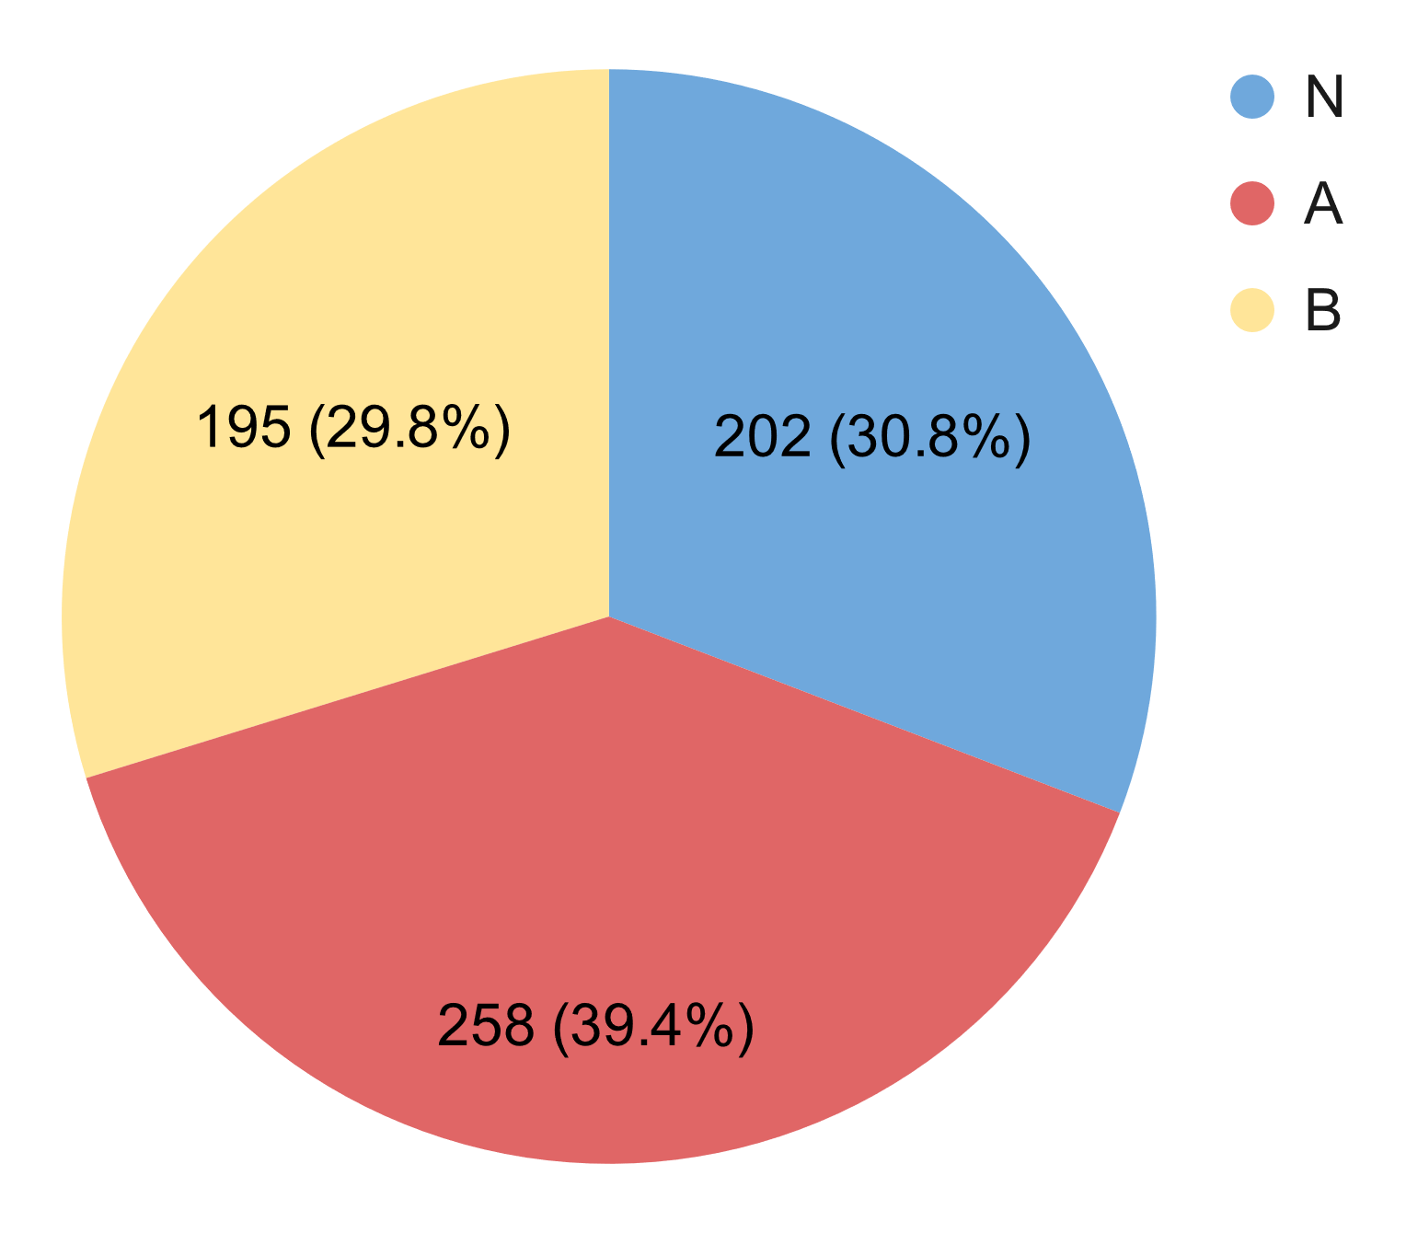

Figure 5.1:1, 5.1:2. Passed Percent & Test Type

### 5.2. Integration Test 結合テスト

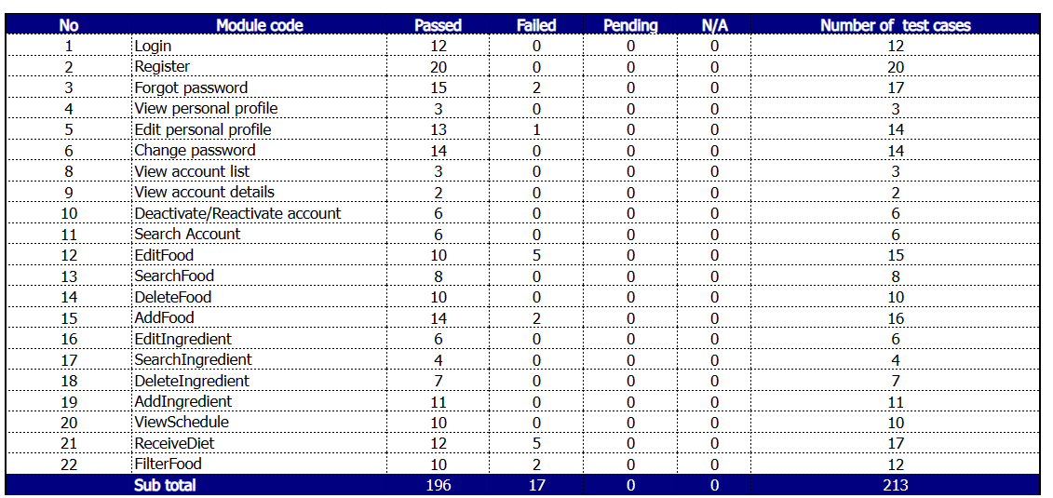

Table 5.2. Integration Test Report

* Test coverage: **100%**
* Test sucessfully coverage: **92.02%**

### 5.3. System Test システムテスト

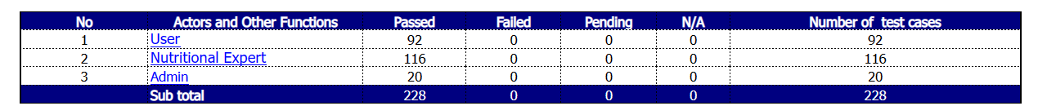

Table 5.3. System Test Report

* Test coverage: **100%**
* Test sucessfully coverage: **100%**

# VI. Release Package & User Guides

## 1. Deliverable Package 成果物パッケージ

*[The section will list all source programs, scripts, documents with version number in this release. You can see the example following table for reference, can customize or delete if not using belong to each project characteristics]*

|  |  |  |
| --- | --- | --- |
| **No.** | **Deliverable Item** | **Description** |
| **Code package** | | |
| 1 | Source Codes Front-end | SWP493_4HTN_Report7_SourceCode_FE.zip |
| 2 | Source Codes Back-end | SWP493_4HTN_Report7_SourceCode_BE.zip |
| 3 | Database Script | SWP493_4HTN_DBScript.sql |
| **Documents** | | |
| 1 | Final Report Document | SWP493_4HTN_Report7_Final Project Report.pdf |
| 2 | Unit Test | SWP439_4HTN_UnitTest.xlsx |
| 3 | Integration Test | SWP439_4HTN_IntegrationTest.xlsx |
| 4 | System Test | SWP439_4HTN_SystemTest.xlsx |
| 5 | Acceptance Test | SWP439_4HTN_AcceptanceTest.xlsx |
| 6 | Slide | SWP493_4HTN_Final_Presentation.pdf |

## 2. Installation Guides インストールガイド

### 2.1 System Requirements システム要件

*[Define any system requirements necessary to support the application, including the software and relevant configurations]*

*For supporting 4HTN, the system requirements are necessary as follows:*

✓ Windows 10, 64-bit, Intel® Core™ i5 or higher, RAM at least 8.00GB

✓ IntelliJ IDEA

✓ Visual Studio Code

✓ MySQL WorkBench

✓ ReactJS (Lastest version)

✓ Java SE Development Kit 17.0.5 (Window x64 installer)

4HTN をサポートするには、次のシステム要件が必要です。

✓ Windows 10, 64-bit, Intel® Core™ i5 or higher, RAM at least 8.00GB

✓ IntelliJ IDEA

✓ Visual Studio Code

✓ MySQL WorkBench

✓ ReactJS (Lastest version)

✓ Java SE Development Kit 17.0.5 (Window x64 installer)

### 2.2 Installation Instruction インストール手順

Session 1: Install IntelliJ IDEA

セッション 1: IntelliJ IDEA のインストール

Step 1.1: Go to IntelliJ IDEA's download homepage.

ステップ 1.1: IntelliJ IDEA のダウンロードホームページ に 移 動 し ま す 。

<https://www.jetbrains.com/idea/download/#section=windows>

Then click Download the version you want to use to develop the application. At this point, the interface will display 2 new categories for you to choose from. Here, we choose the IntelliJ IDEA

Community Edition.

次に、アプリケーションの開発に使用するバージョンをダウンロードをクリックします。 この時点で、 インターフェイスには選択できる 2 つの新しいカテゴリが表示されます。 ここでは、 IntelliJ IDEA Community Edition バージョンを選択します。

Professional: To develop both Database Tools and Web. With HTML, JS, and SQL support. You will have a free trial, if you want to use it, you will have to pay a license fee.

プロフェッショナル：Database Tools と Web の両方を開発すること。 HTML、JS、および SQL をサポート しています。 無料試用版があります。使用したい場合は、ライセンス料を支払う必要があります。

Community: For pure Java Spring development. Free to use.

コミュニティ: 純粋な Java 開発用。 無料で使用できます。

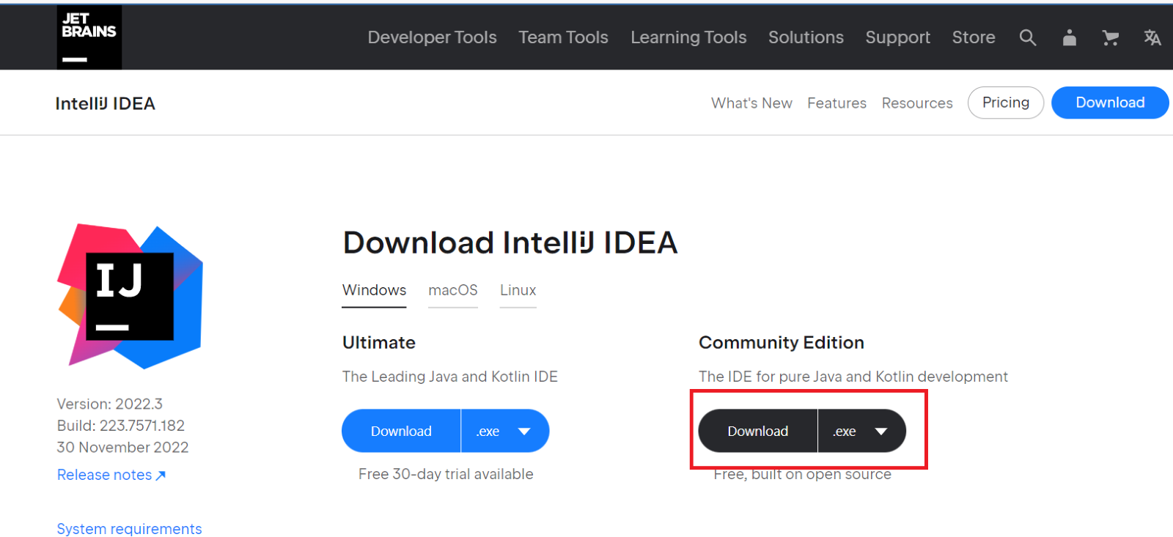

Downloading takes about 3 minutes.

ダウンロードには約 3 分かかります。

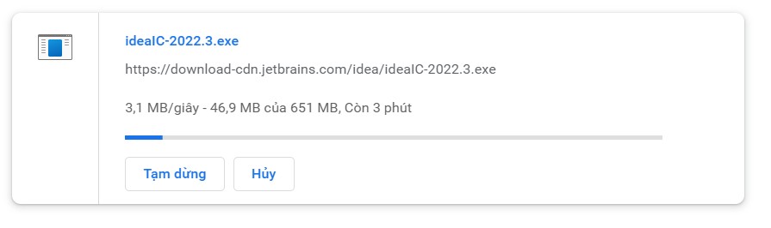

Step 1.2: Complete the download, click on the downloaded file and then click “Run as administrator”.

ステップ 1.２：ダウンロードを完了し、ダウンロードしたファイルをクリックしてから、「管理者とし て実行」をクリックします。

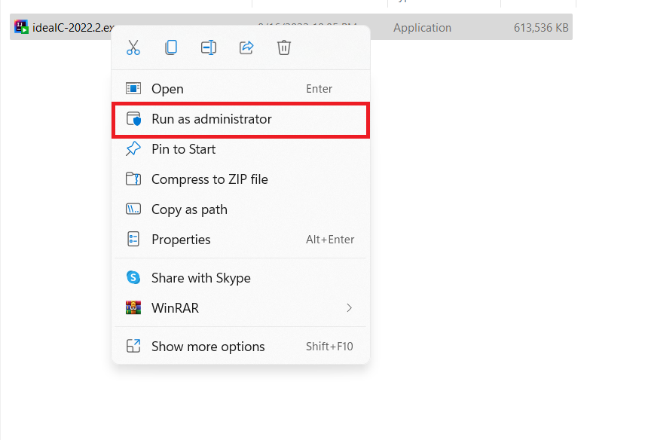

Wait for the software to load 100%.

ソフトウェアが 100% ロードされるまで待ちます。

Step 1.3: After opening the file, click “Next”.

ステップ 1.3：ファイルを開いた後、「次へ」をクリックします。

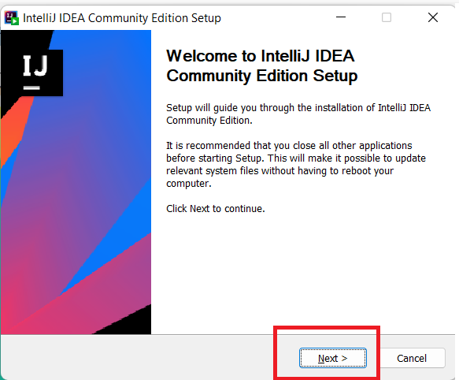

Step 1.4: Click Browse to select another folder and select the destination folder where the installation files are saved. Click "Next" to continue.

ステップ 1.4：「参照」をクリックして別のフォルダーを選択し、インストール ファイルが保存されてい る宛先フォルダーを選択します。 「次へ」をクリックして続行します。

Step 1.5: Click on the items you want to install. Click "Next" to continue.

ステップ 1.5：インストールするアイテムをクリックします。 「次へ」をクリックして続行します。

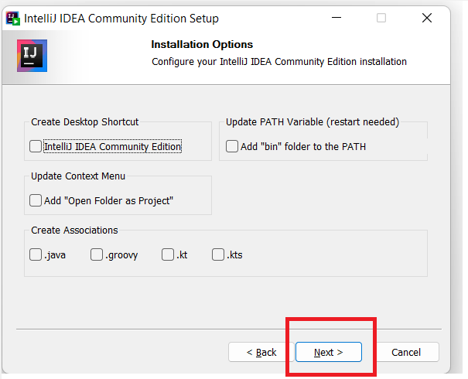

Step 1.6: On the toolbar, customise to the JetBrains section, then click "Install".

ステップ 1.6：ツールバーで、JetBrains セクションに合わせてカスタマイズし、「インストール」をクリ ックします

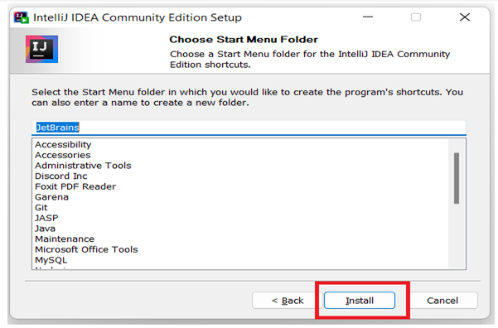

Wait for the installation process to run.

インストール プロセスが実行されるまで待ちます。

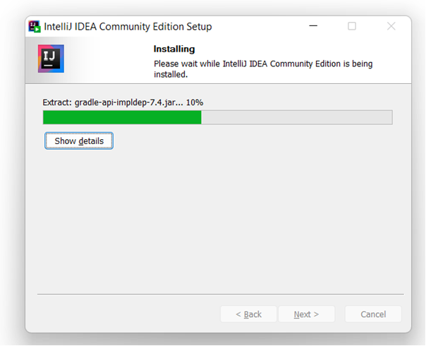

Step 1.7: Click “Finish” to complete the IntelliJ IDEA Community Edition installation.

ステップ 1.7：「完了」をクリックして、IntelliJ IDEA Community Edition のインストールを完了します。

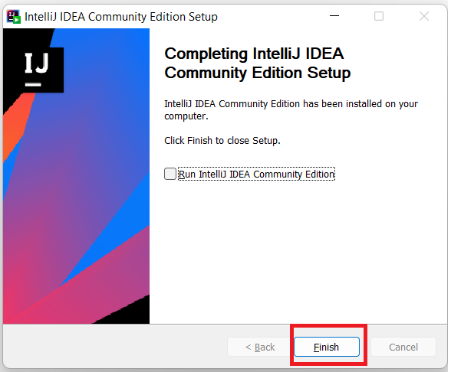

Step 1.8: On the center or left end of the taskbar, select the **Start** icon. Search the name "IntelliJ IDEA Community Edition" then click "Enter" to start using IntelliJ IDEA Community Edition.

ステップ 1.8 : タスク バーの中央または左端にある [**スタート**] アイコンを選択します。「IntelliJ IDEA Community Edition」という名前を検索し、「Enter」をクリックして IntelliJ IDEA Community Edition の使用を開始します。

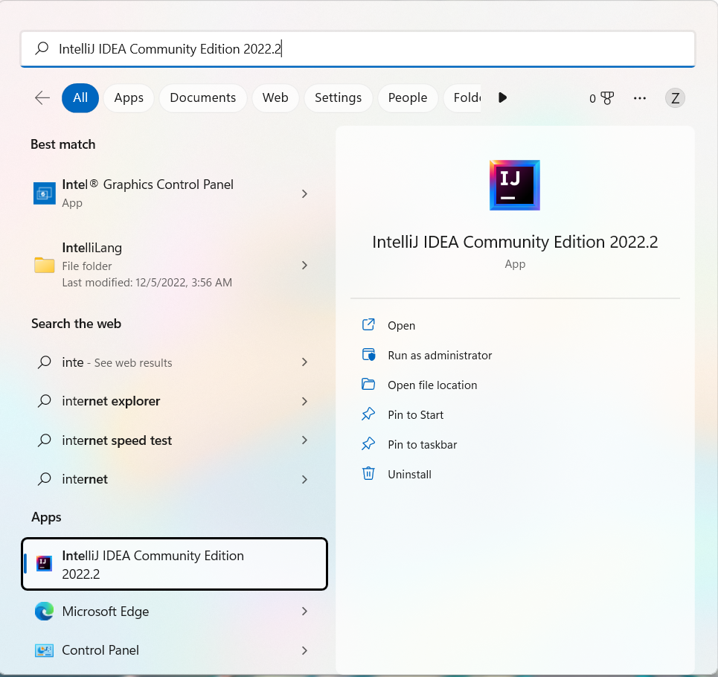



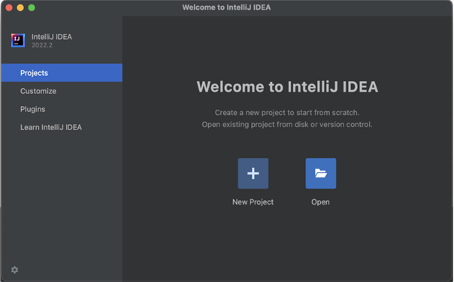

Session 2: Install Visual Studio Code

セッション 2: Visual Studio Code のインストール

Step 2.1: Go to Visual Studio Code's download homepage.

ステップ 2.1: Visual Studio Code のダウンロードホームページ に 移 動 し ま す 。

<https://code.visualstudio.com/>

Then click Download

次に、[ダウンロード] をクリックします

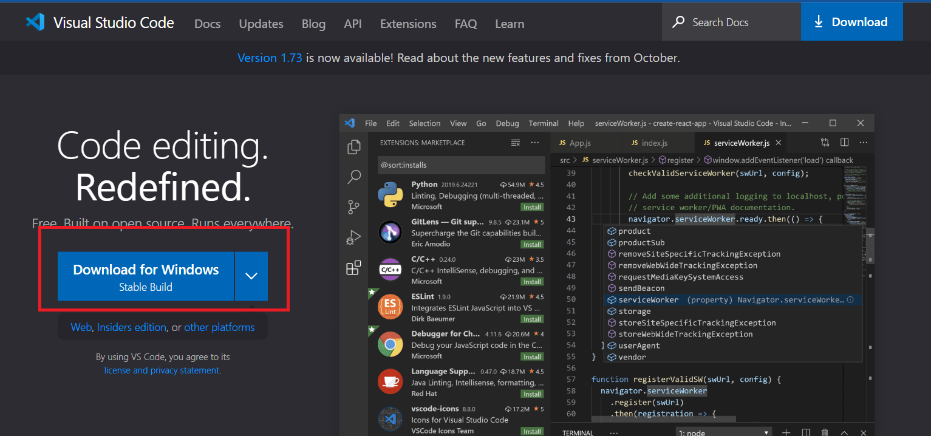

Downloading takes about 1 minute.

ダウンロードには約 1 分かかります。

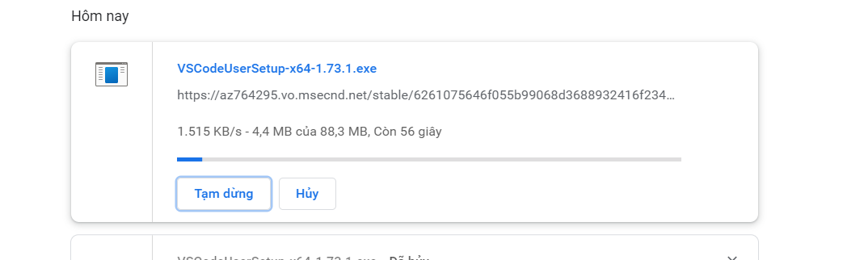

Step 2.2: Complete the download, click on the downloaded file

ステップ 2.2: ダウンロードが完了したら、ダウンロードしたファイルをクリックします。

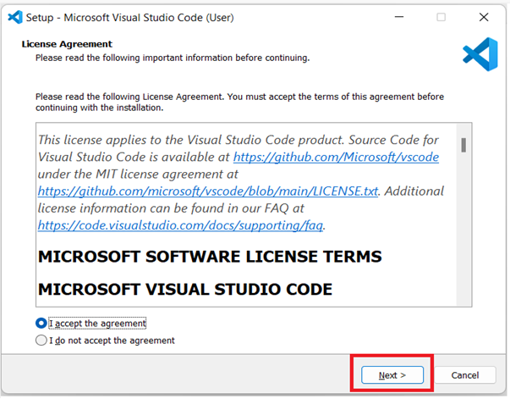

Step 2.3: Select the radio button "I accept the terms" then click "Next".

ステップ 2.3: ラジオボタン「私は契約に同意します」を選択し、「次へ」をクリックします。

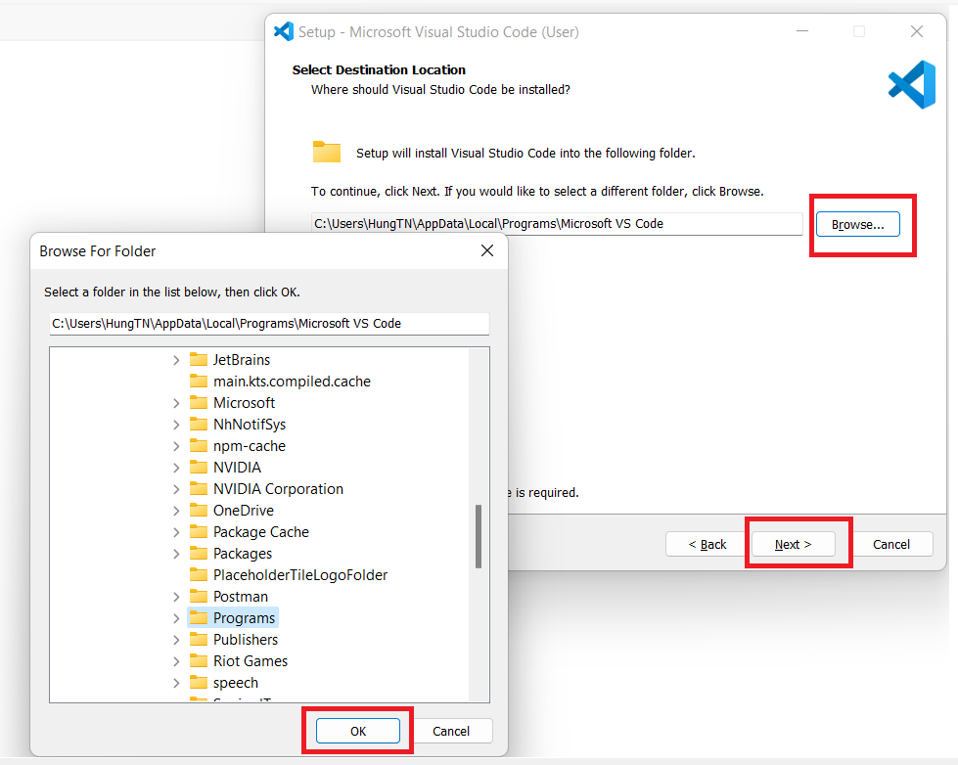

Step 2.4: Click Browse to select another folder and select the destination folder where the installation files are saved. Click "Next" to continue.

ステップ 2.4：「参照」をクリックして別のフォルダーを選択し、インストール ファイルが保存されてい る宛先フォルダーを選択します。 「次へ」をクリックして続行します。

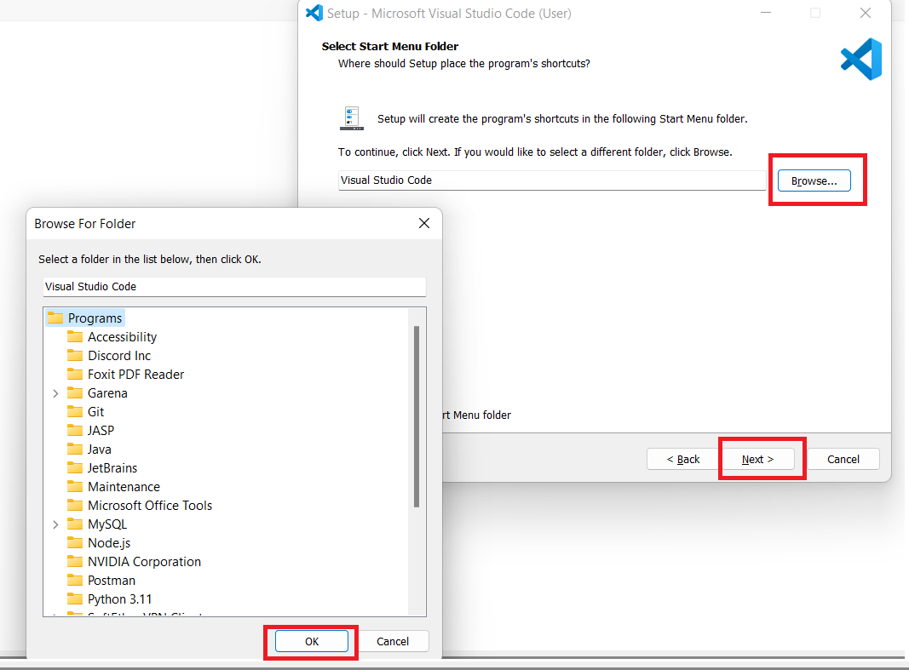

Step 2.5: Click Browse to select another folder and select the start menu folder where the installation files are saved. Click "Next" to continue.

ステップ 2.5：ステップ 2.5: [参照] をクリックして別のフォルダーを選択し、インストール ファイルが保存されているスタート メニュー フォルダーを選択します。 「次へ」をクリックして続行します。

Step 2.6: Click on the items you want to install. Click "Next" to continue.

ステップ 2.6：インストールするアイテムをクリックします。 「次へ」をクリックして続行します。

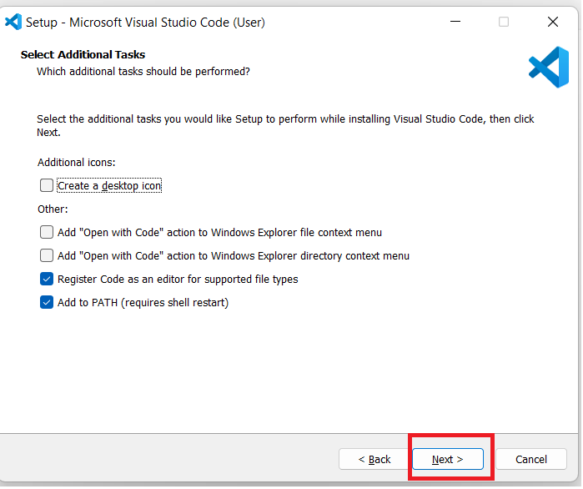

Step 2.7: Then click "Install"

ステップ 2.7：「インストール」をクリ ックします。

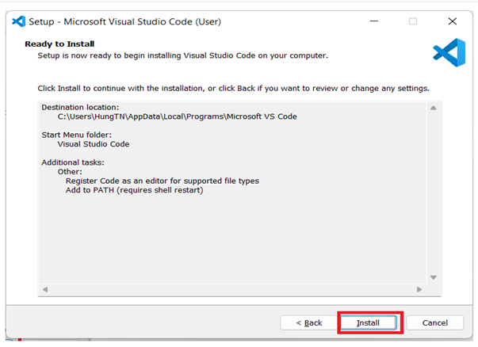

Wait for the installation process to run.

インストール プロセスが実行されるまで待ちます。

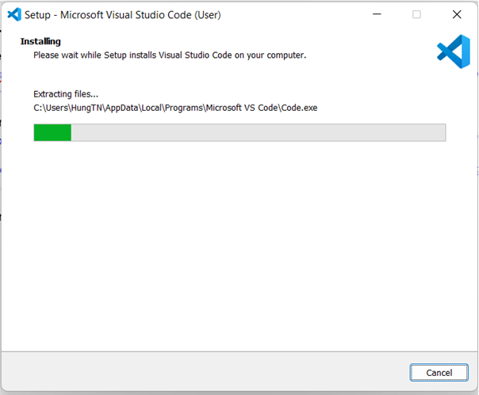

Step 2.8: Click “Finish” to complete the Visual Studio Code installation and use Visual Studio Code.

ステップ 2.8：[完了] をクリックして Visual Studio Code のインストールを完了し、Visual Studio Code を使用します。

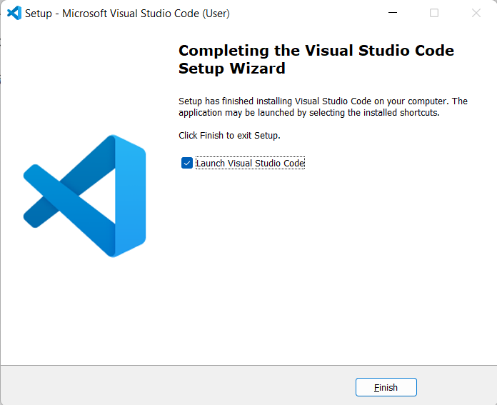  
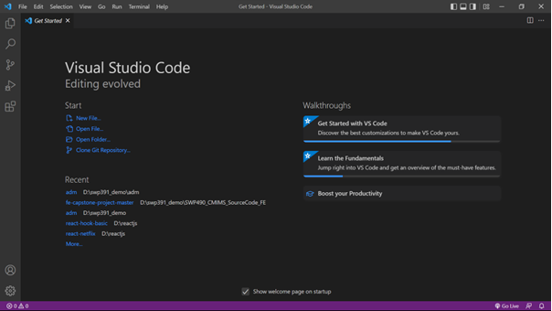

Session 3: Install MySQL WorkBench

セッション 3: IntelliJ MySQL WorkBenchのインストール

Step 3.1: Go to MySQL WorkBench’s download homepage.

ステップ 3.1: MySQL WorkBenchのダウンロードホームページ に 移 動 し ま す 。

<https://dev.mysql.com/downloads/windows/installer/8.0.html>

Then click Download the version you want to use to develop the application. At this point, the interface will display 2 new categories for you to choose from. Here we choose the MySQL Community Download which is 431.7M.

次に、アプリケーションの開発に使用するバージョンをダウンロードをクリックします。 この時点で、インターフェイスには選択できる 2 つの新しいカテゴリが表示されます。 ここでは、431.7M の MySQL Community Download を選択します。

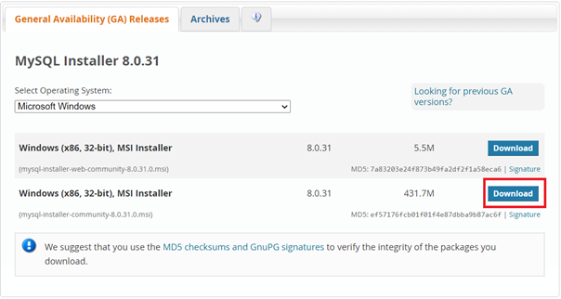

Step 3.2: Then Click “No Thanks, just start my download”

ステップ 3.2：次に、「No Thanks, just start my download」をクリックします

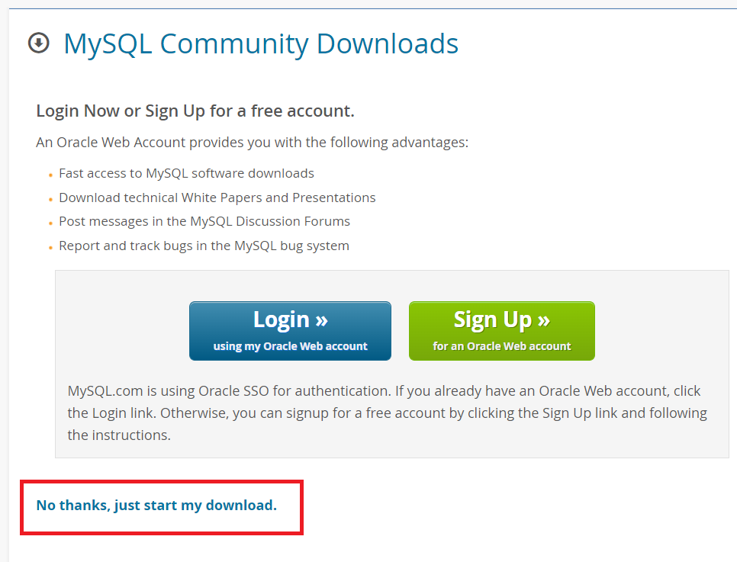

Downloading takes about 1 minute.

ダウンロードには約 1 分かかります。

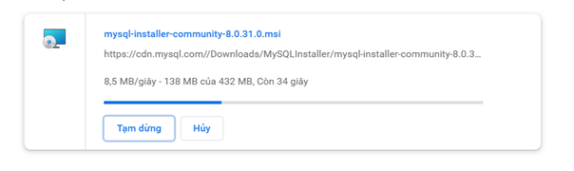

Step 3.3: Complete the download, click on the downloaded file

ステップ 3.3: ダウンロードが完了したら、ダウンロードしたファイルをクリックします。

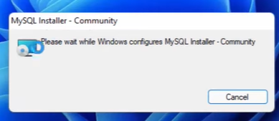

Wait for the configured process to run.

構成されたプロセスが実行されるまで待ちます。

Step 3.4: Choose a setup type you want to install. At this point, I choose "Developer default" .Then Click "Next".

ステップ 3.4:インストールするセットアップの種類を選択します。 この時点で、「開発者のデフォルト」をクリックします。次に、「次へ」をクリックします。

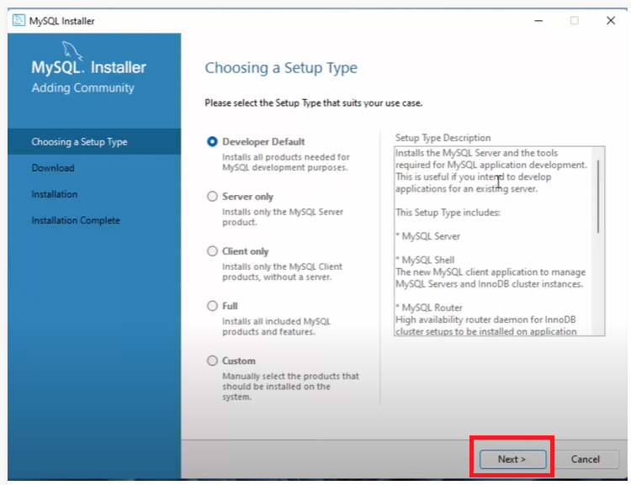

Step 3.5: In the Check Requirement section, you click "Next”. After that, a message will appear, then select "Yes".

ステップ 3.5:要件の確認セクションで、「次へ」をクリックします。その後、メッセージが表示されるので、「はい」を選択します。

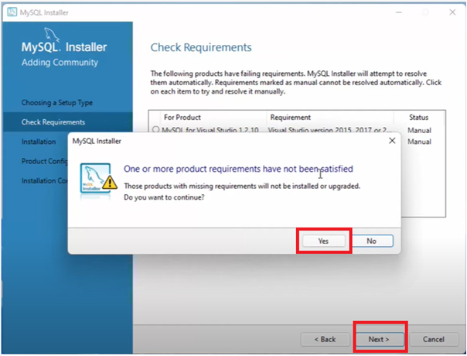

Step 3.6: Click ''Execute" to install the following packages. Wait for the install process to run.

ステップ 3.6: [実行] をクリックして、次のパッケージをインストールします。インストール プロセスが実行されるまで待ちます。

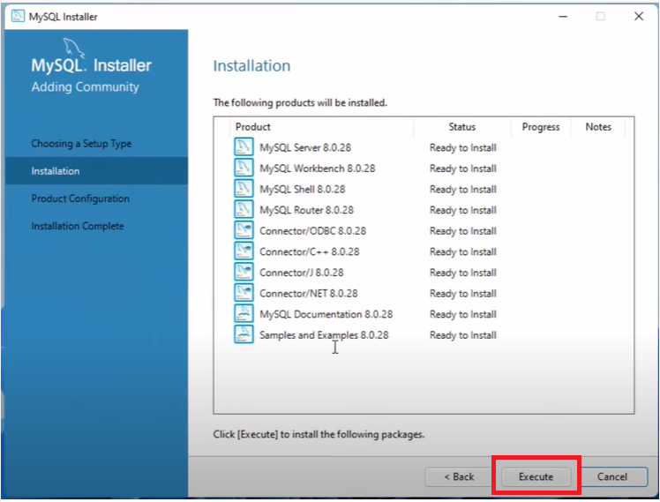

Step 3.7: After packages are completely installed, you click "Next".

ステップ 3.7: パッケージのインストールが完了したら、[次へ] をクリックします。

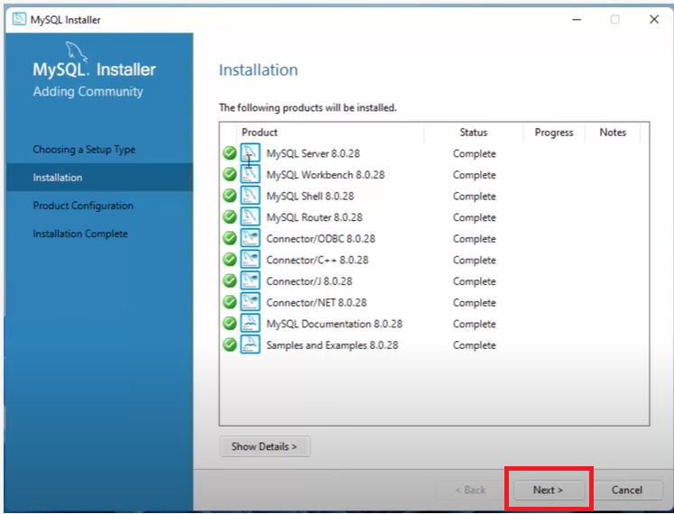

Then Click “Next”

次に、「次へ」をクリックします。

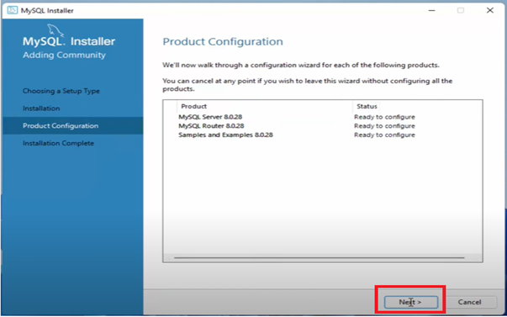

Step 3.8: At tab Type and Networking, you can choose the server configure type you want. At that point, I can choose "Development Computer”. Then you click "Next".

ステップ 3.8:Type と Networking タブで、必要なサーバー構成タイプを選択できます。その時点で、「開発用コンピュータ」を選択できます。次に、「次に」をクリックします。

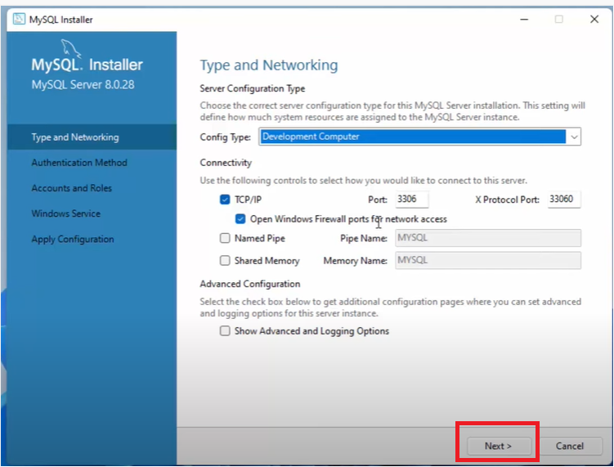

Then Click “Next”

次に、「次へ」をクリックします。

Step 3.9: Enter the password for the root account. Please remember to store this password in a secure place. Then Click “Next”.

ステップ 3.9: root アカウントのパスワードを入力します。このパスワードは安全な場所に保管してください。次に、「次に」をクリックします。

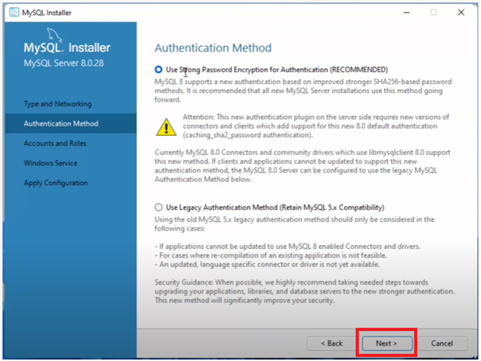

Then Click “Next”.

次に、「次に」をクリックします。

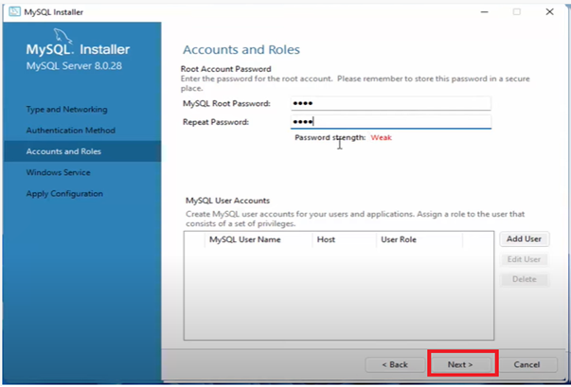

Then click "Execute”. Waiting configuration will apply.

次に、「実行」をクリックします。待機中の構成が適用されます。

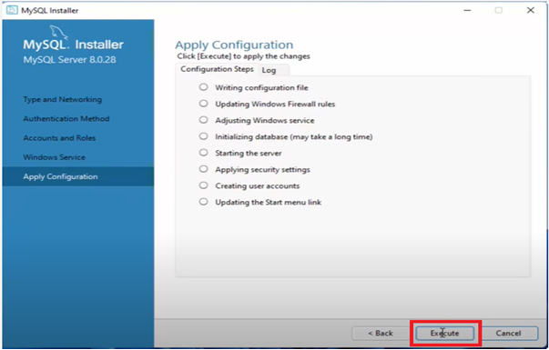

Then Click “Next”.

次に、「次に」をクリックします。

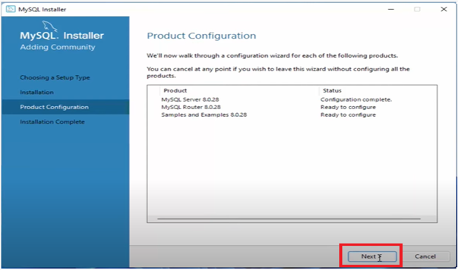

Step 3.10: After MySQL server configuration successfully. Click "Finish”. Then , you click "Next" connect to server.

ステップ 3.10: mysql サーバーの構成が正常に完了したら、[完了] をクリックします。次に、「次へ」をクリックしてサーバーに接続します。

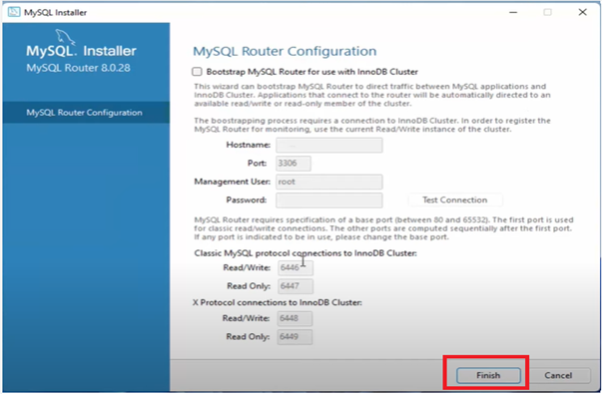

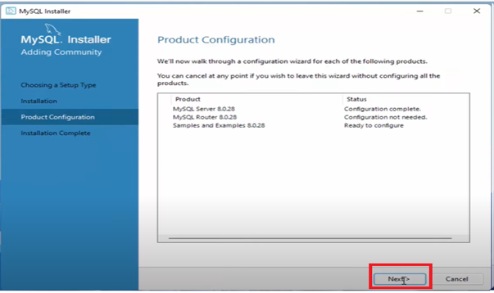

Step 3.11: Fill password you input from step 3.9. After clicking "Check" to ensure they work.

ステップ 3.11: ステップ 3.9 で入力したパスワードを入力します。 「チェック」をクリックして、それらが機能することを確認します。

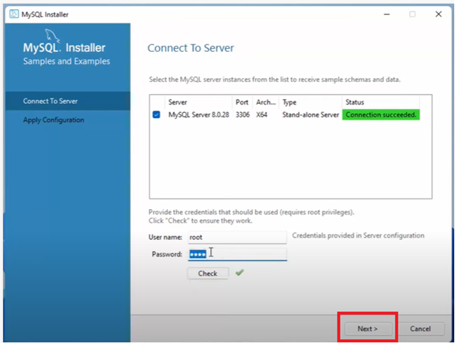

Click "Execute" to apply the changes.

「実行」をクリックして変更を適用します。

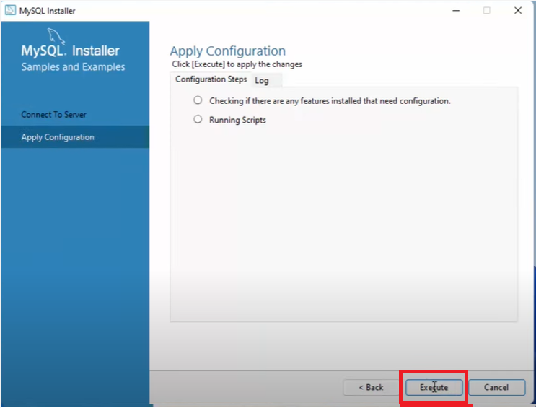

Step 3.12: On the center or left end of the taskbar, select the **Start** icon. Search the name "MySQL WorkBench " then click "Enter" to start using MySQL WorkBench.

ステップ 3.12 : タスク バーの中央または左端にある [**スタート**] アイコンを選択します。「MySQL WorkBench」という名前を検索し、「Enter」をクリックしてMySQL WorkBenchの使用を開始します。

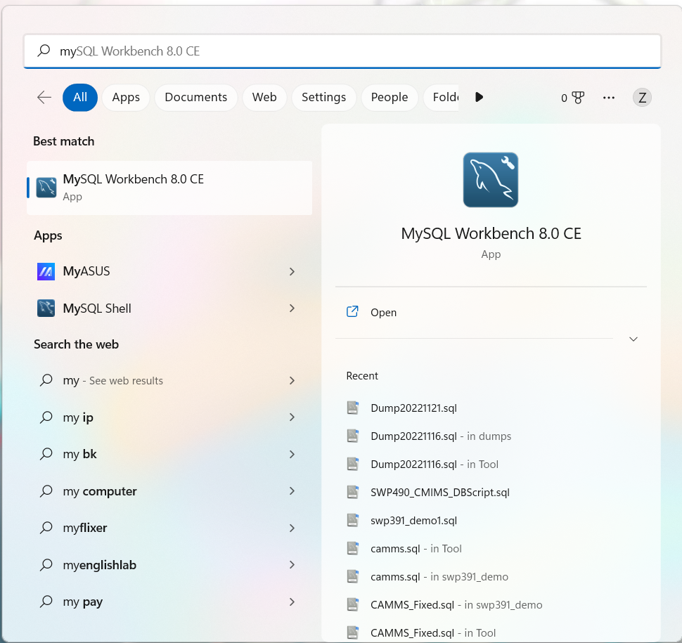

Step 3.13: On the toolbar, select "Connect to Database". Then MySQL shows the settings and select "Store in Vault" and enter the password in step 3.9 and then click "OK"

ステップ 3.13 :ツールバーで、[Connect to Database] を選択します。 次に、MySQL に設定が表示され、[Store in Vault] を選択し、手順 3.9 でパスワードを入力して [OK] をクリックします。

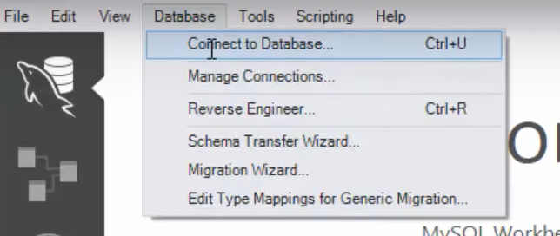  
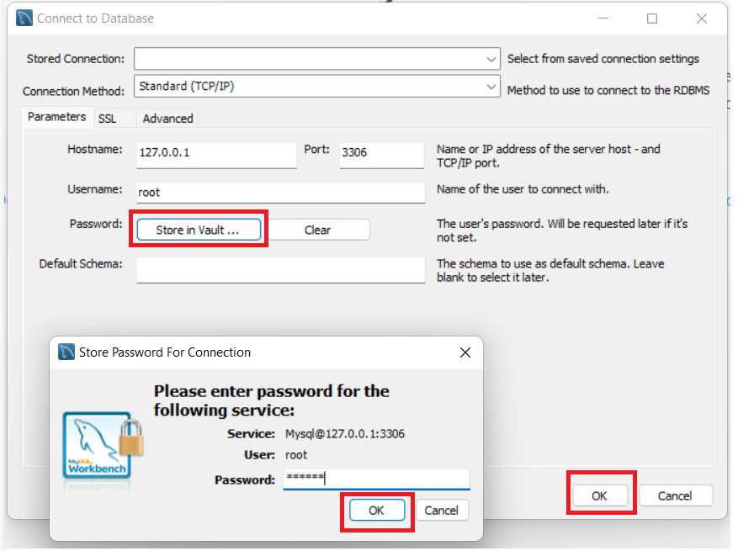  
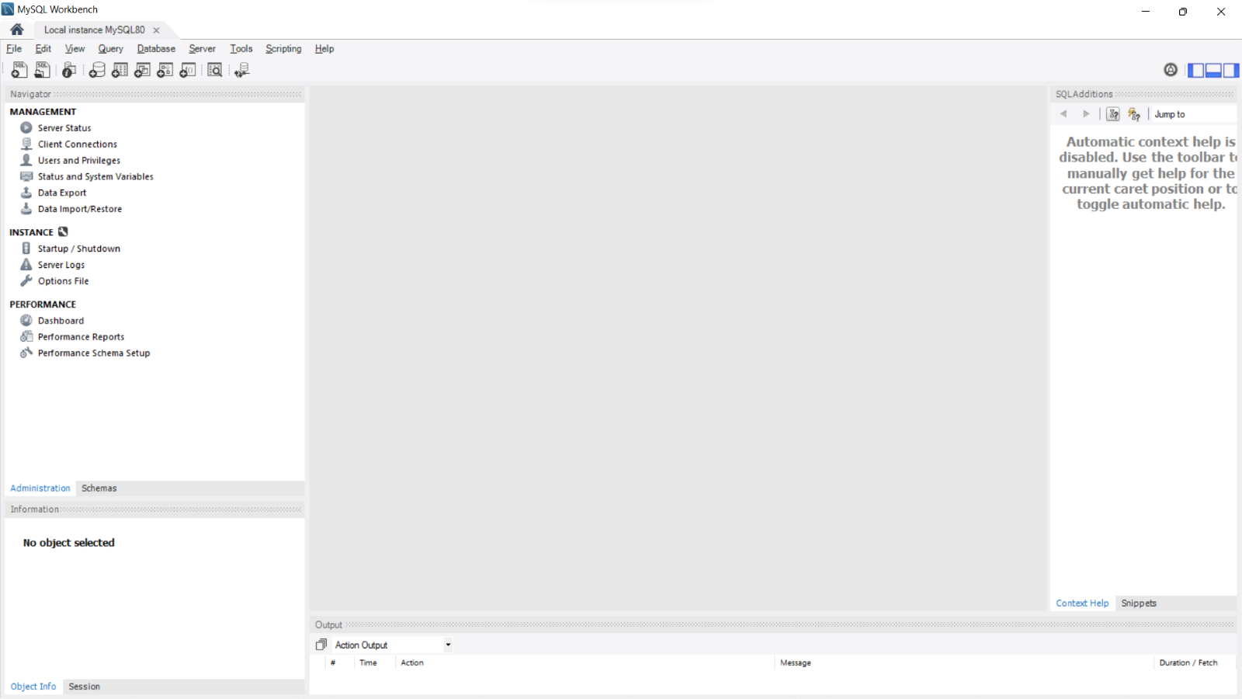

Session 4: Install NodeJS (18.12.1 LTS)

セッション 4: NodeJS (18.12.1 LTS)のインストール

Step 4.1: Go to NodeJS' s download homepage.

ステップ 4.1: NodeJSのダウンロードホームページ に 移 動 し ま す 。

<https://nodejs.org/en/>

Then click Download the version you want to use to develop the application. At this point, the interface will display 2 new categories for you to choose from. Here, we choose the version 18.12.1.LTS.

次に、アプリケーションの開発に使用するバージョンをダウンロードをクリックします。 この時点で、インターフェイスには選択できる 2 つの新しいカテゴリが表示されます。 ここでは、バージョン 18.12.1.LTS を選択します。

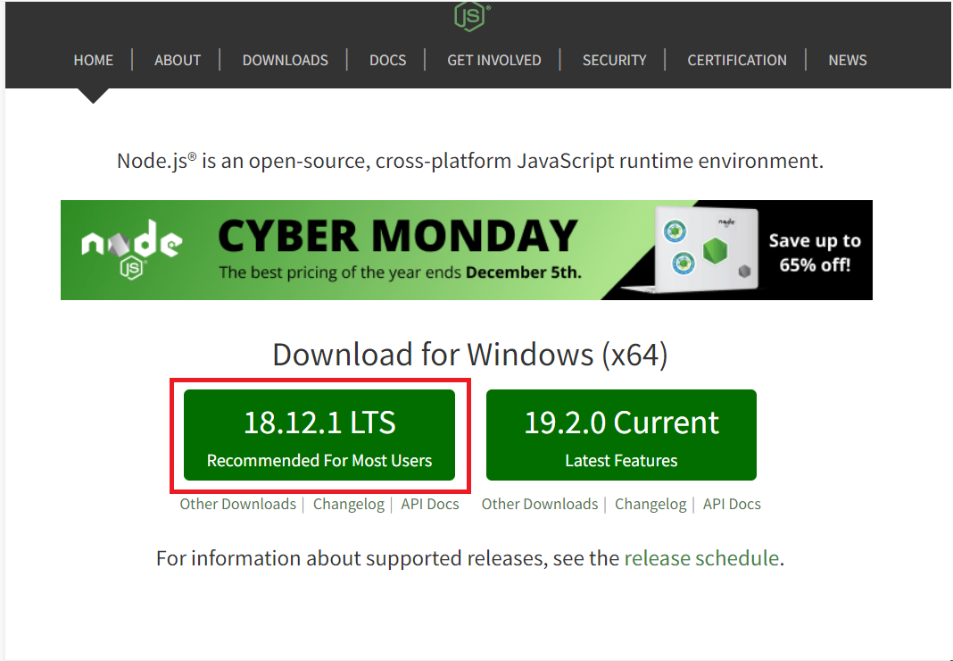

Downloading takes about 1 minute.

ダウンロードには約 1 分かかります。

Step 4.2: Complete the download, click on the downloaded file.

ステップ 4.2: ダウンロードが完了したら、ダウンロードしたファイルをクリックします。

Then Click “Next”.

次に、「次に」をクリックします。

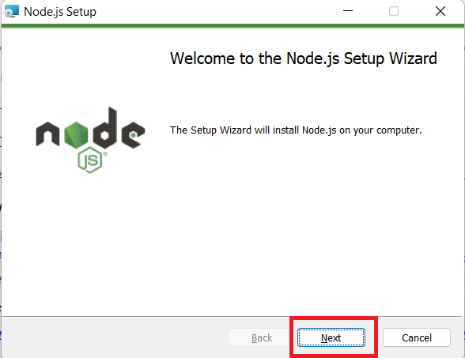

Step 4.3: Select the radio button "I accept the terms" then click "Next".

ステップ 4.3: ラジオボタン「私は契約に同意します」を選択し、「次へ」をクリックします。

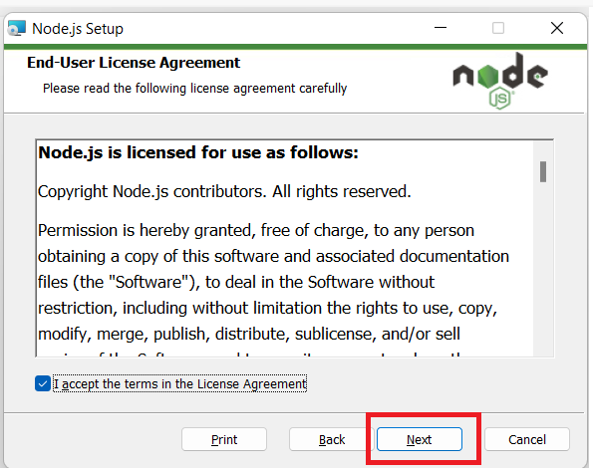

Then Click “Next”.

次に、「次に」をクリックします。

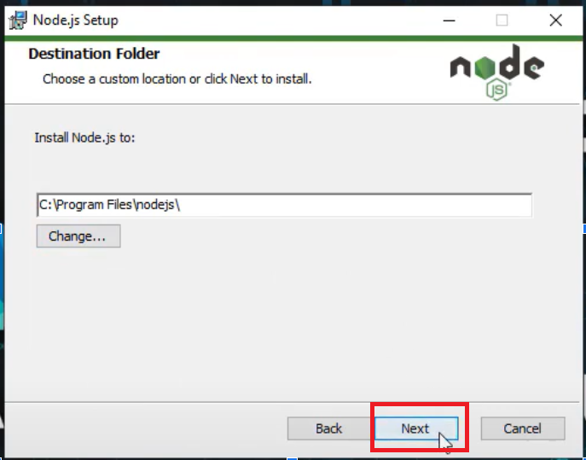

Then Click “Next”.

次に、「次に」をクリックします。



Wait for the installation process to run. Then it will complete. Click "Finish"

インストール プロセスが実行されるまで待ちます。その後、完了します。 「完了」をクリック

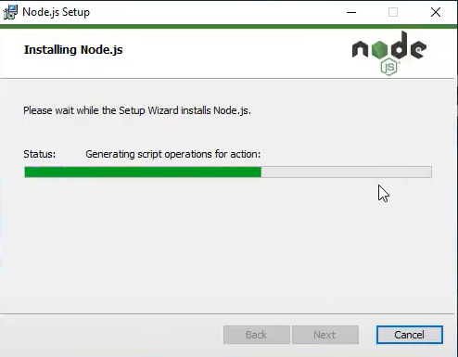  
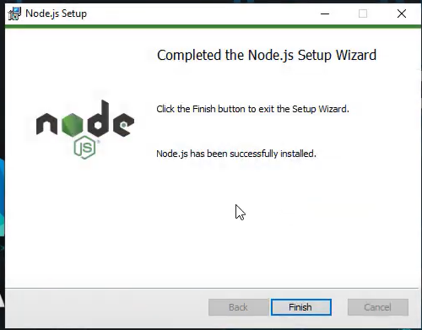

Session 5: Install Java SE Development Kit 17.0.5

セッション 5: Java SE Development Kit 17.0.5のインストール

Step 5.1: Go to Java SE Development Kit 17.0.5' s download homepage.

ステップ 5.1: Java SE Development Kit 17.0.5のダウンロードホームページ に 移 動 し ま す 。

<https://www.oracle.com/java/technologies/javase/jdk17-archive-downloads.html>

Then click Download the version you want to use to develop the application. Currently there are many versions, I will choose the "Windows x64 Installer" version.

次に、アプリケーションの開発に使用するバージョンをダウンロードをクリックします。現在、多くのバージョンがありますが、「Windows x64 Installer」バージョンを選択します。

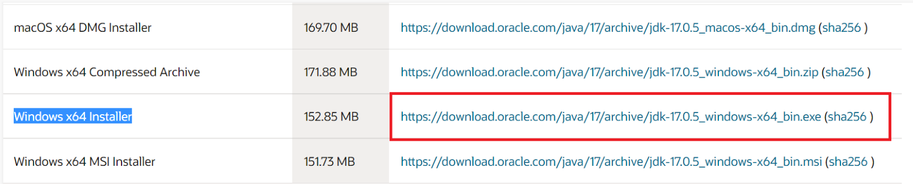

Wait for the configured process to run.

構成されたプロセスが実行されるまで待ちます。

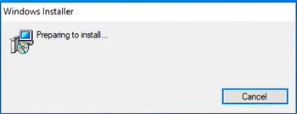

Then Click “Next”.

次に、「次に」をクリックします。

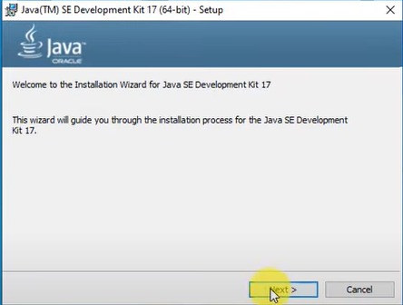

Step 5.2: Select a folder with a size of at least 420MB and then click "Next"

ステップ 5.2: サイズが 420MB 以上のフォルダを選択し、[次へ] をクリックします。

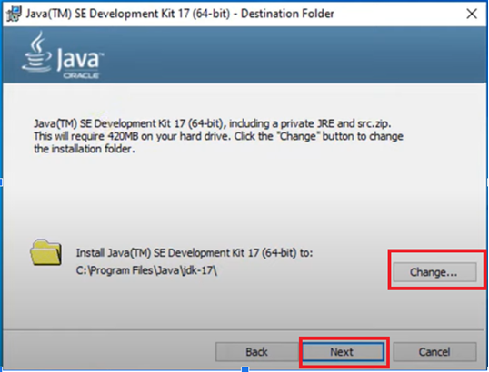

Wait for the installation process to run. Then it will complete. Click "Close".

インストール プロセスが実行されるまで待ちます。 その後、完了します。 「閉じる」をクリック。

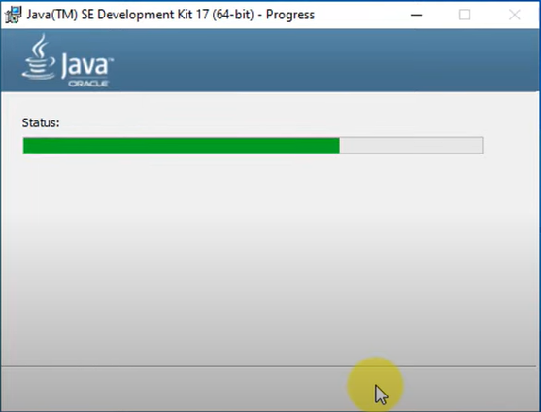

### 2.3 Setup 4HTN Project のセットアップ

**2.3.1 Backend Installation バックエンドのインストール**

Step 1: Go to the GitLab homepage to download or clone the backend project by following the link below. Click "Code" then click "Download ZIP".

ステップ 1: 以下のリンクに従って、GitLab ホームページに移動し、バックエンド プロジェクトをダウンロードまたはクローンします。[Code] をクリックし、 [Download ZIP] をクリックします。

[Files · back-end · Nguyễn Long / be_project_4healthynutrium · GitLab](https://gitlab.com/LongNVHE140051/be_project_4healthynutrium/-/tree/back-end)

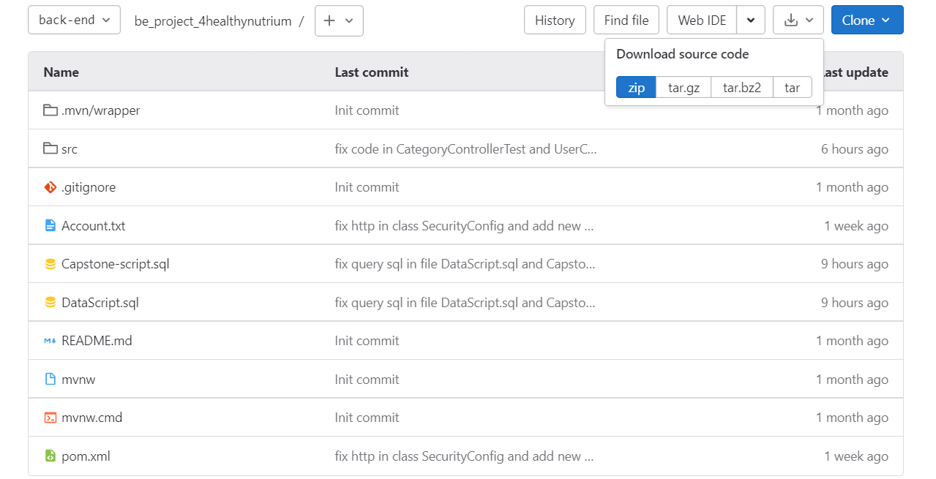

Step 2: Unzip the downloaded zip file. Click “Extract to “SWP493_G5_4HTN_backend”.

ステップ 2: ダウンロードしたzipファイルを解凍します。「SWP493_G5_HTN_backend に抽出」をクリックします。

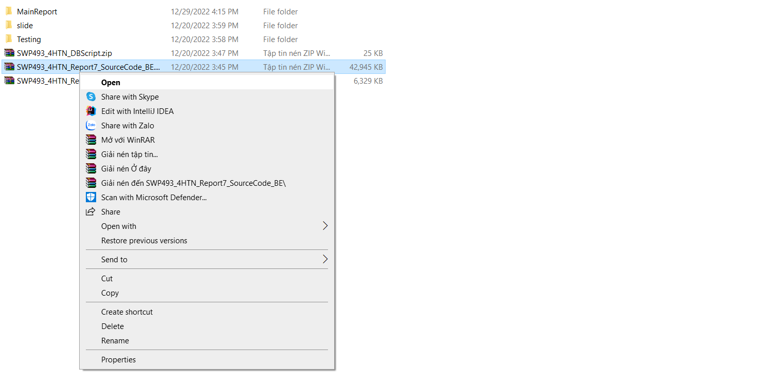

Step 3: Open "IntelliJ IDEA" when the setup is done. Then click the “Open” button.

ステップ 3: セットアップが完了したら、「IntelliJ IDEA」を開きます。次に、「Open」ボタンをクリックします。

Step 4: Select the destination folder where the downloaded files are saved. Click "OK" to continue.

ステップ 4: ダウンロードしたファイルの保存先フォルダを選択します。 [OK] をクリックして続行します。

Waiting for intellij IDEA download and configure plugins.

intellij IDEA のダウンロードとプラグインの構成を待っています。

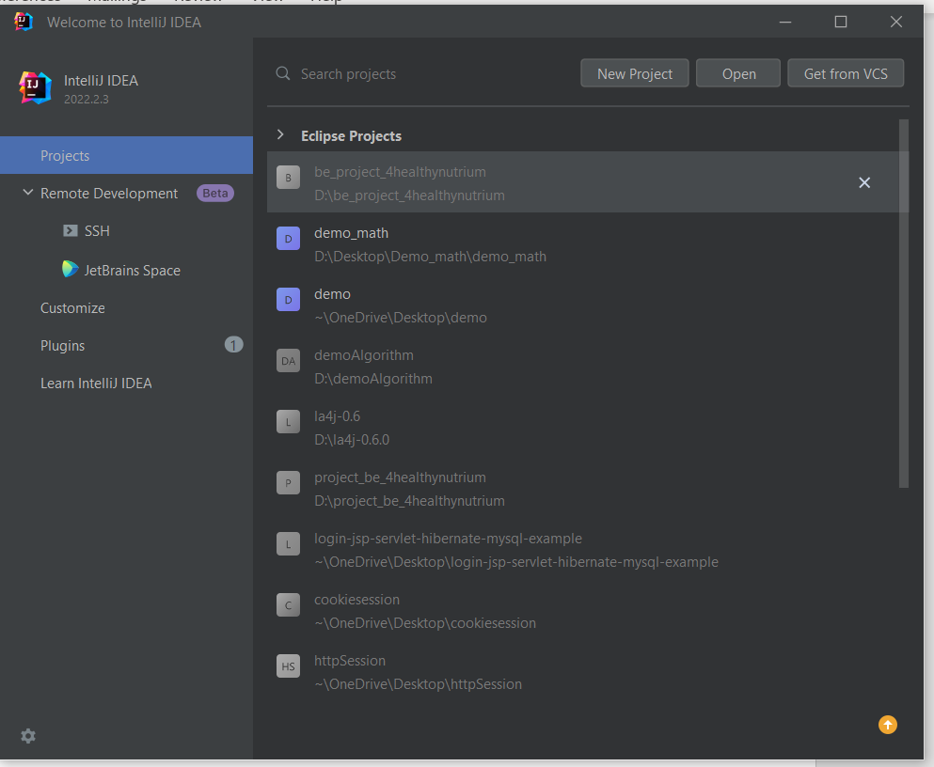

If you want to run the backend, click Ctrl + shift + F10 or click the button in the red circled area on the figure.

バックエンドを実行する場合は、Ctrl + Shift + F10 を実行するか、図の赤い丸で囲まれた領域のボタンをクリックします。

**2.3.2 Front-end Installation フロントエンドのインストール。**

Step 1: Go to the GitHub homepage to download or clone the frontend project by following the link below. Click "Code" then click "Download ZIP".

ステップ 1: GitHub ホームページに移動し、以下のリンクに従ってフロントエンド プロジェクトをダウンロードまたはクローンします。 [コード] をクリックし、 [ZIP をダウンロード] をクリックします。

[GitHub - milim217/fe_project_4healthy-nutrium at sonnd](https://github.com/milim217/fe_project_4healthy-nutrium/tree/sonnd)

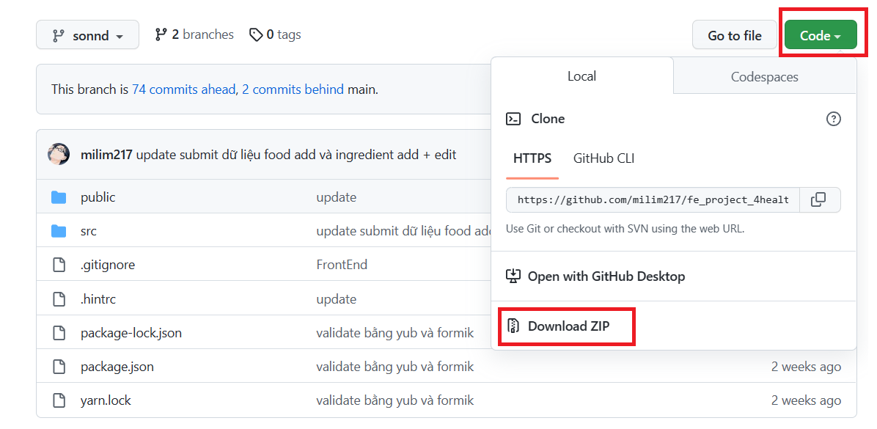

Step 2: Unzip the downloaded zip file.

ステップ 2: ダウンロードしたzipファイルを解凍します。

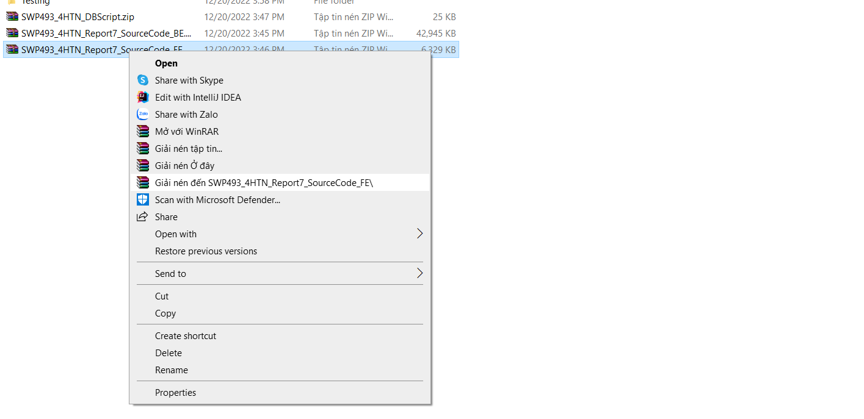

Step 3: Open "Visual studio code" when the setup is done. Then click the “File”.

ステップ 3: セットアップが完了したら、「Visual studio code」を開きます。次に、「File」ボタンをクリックします。

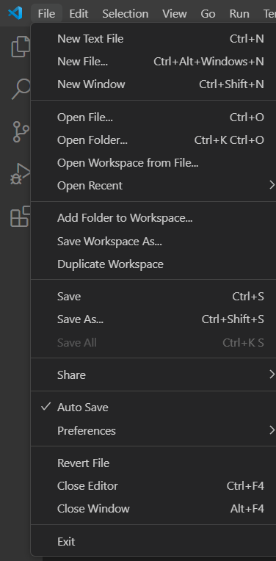

Step 4: Then click ""Open Folder”. Select the destination folder where the downloaded files are saved. Click "Select Folder" to continue.

ステップ 4: 次に、[フォルダーを開く] をクリックします。ダウンロードしたファイルの保存先フォルダーを選択します。[フォルダーの選択] をクリックして続行します。

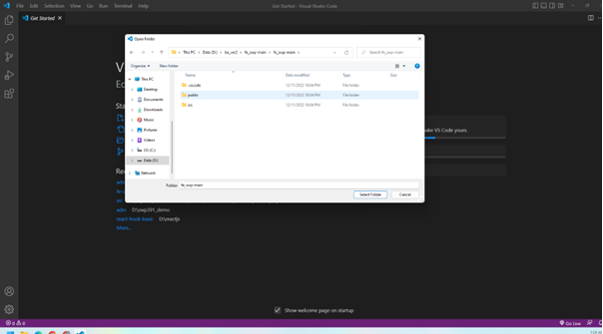

Step 5: After opening the user interface folder, type the command "npm install". It will set up the node modules.

ステップ 5: ユーザー インターフェース フォルダーを開いた後、コマンド「npm install」を入力します。 ノードモジュールをセットアップします。

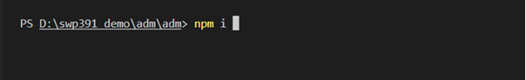

Waiting for minutes, the system installs node modules and libraries.

数分待ってから、システムはノード モジュールとライブラリをインストールします。

Step 6: After setting up successfully , you type the command "npm start" to run the frontend.

ステップ 6: セットアップが完了したら、「npm start」コマンドを入力してフロントエンドを実行します。

## 3. User Manual ユーザーマニュアル

### 3.1 Overview 概要

Basically, our system has 3 roles: admin, user, nutrition expert.

基本的に、私たちのシステムには、管理者、店主の 3 つの役割があります。

* Admin: The admin is the person who manage the accounts.

管理者: 管理者は、アカウントを管理する人です。

* Nutrition Expert: Nutrition expert is the person who manage the food and ingredient.

栄養専門家：栄養専門家は、食品と食材を管理する人です.

* User: User is the person who can receive diet and searching for food and ingredient information.

ユーザー：ユーザーは、ダイエットや食材・食材情報の検索ができる人です。

The following accounts can be used for testing before the thesis defense by the project grading committee.

次のアカウントは、プロジェクトの採点委員会による論文審査前のテストに使用できます。

* User :

Username: [longnv140920@gmail.com](mailto:longnv140920@gmail.com)

Password: long1234

* Admin:

Username: [4healthynutrium@gmail.com](mailto:4healthynutrium@gmail.com)

Password: 12345678

* Nutrition Expert

Username: [viet1410@gmail.com](mailto:viet1410@gmail.com)

Password: viet1410

### 3.2. Common 普通

**3.2.1 Login ログイン**

Step 1: Start Back-End after Type "npm start" to run local Front-End.Input <http://localhost:3000/> from the keyboard URL into the browser and click the “Đăng nhập” on the landing page.

ステップ 1: 「npm start」と入力してバックエンドを起動し、ローカル フロントエンドを実行します。キーボードの URL から [http://localhost:3000](http://localhost:3000/) / をブラウザに入力し、ランディング ページの「Đăng nhập」をクリックします。

Then, the following login screen will be displayed:

すると、以下のようなログイン画面が表示されます。



Step 2: In order to successfully login, the requirements are:

ステップ 2：正常にログインするための要件は次のとおりです。

➢ The account must exist in the 4HTN system

アカウントは 4HTN システムに存在する必要があります。



➢ The username and password entered must correspond to each other in the system.

入力したユーザー名とパスワードは、システム内で互いに対応している必要があります。

➢ Make sure the “Email” field cannot be empty and invalid.

「Email」フィールドを空にすることはできず、ユーザー名が有効であることを確認してください。

➢ “Mật khẩu” field must have a length between 8-20 characters and not contain space and make sure that the password is valid.

「Mật khẩu」フィールドの長さは 8 ～ 20 文字で、スペースを含めず、パスワードが有効であることを確認してください。

Step 3: Click on the “Đăng nhập” button to log into the system.

ステップ 3：「Đăng nhập」ボタンをクリックしてシステムにログインします。

If the login failed, a message will be displayed. Please check your username and password again.

ログインに失敗した場合は、メッセージが表示されますので、ユーザー名とパスワードを再度ご確認く ださい。

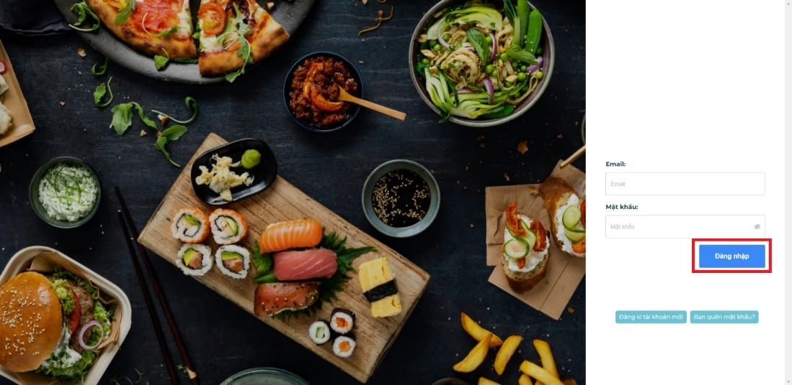

**3.2.2 Logout ログアウト**

Step 1: Click on the avatar in the navigation bar.

ステップ 1：ナビゲーション バーでアバターをクリックします。

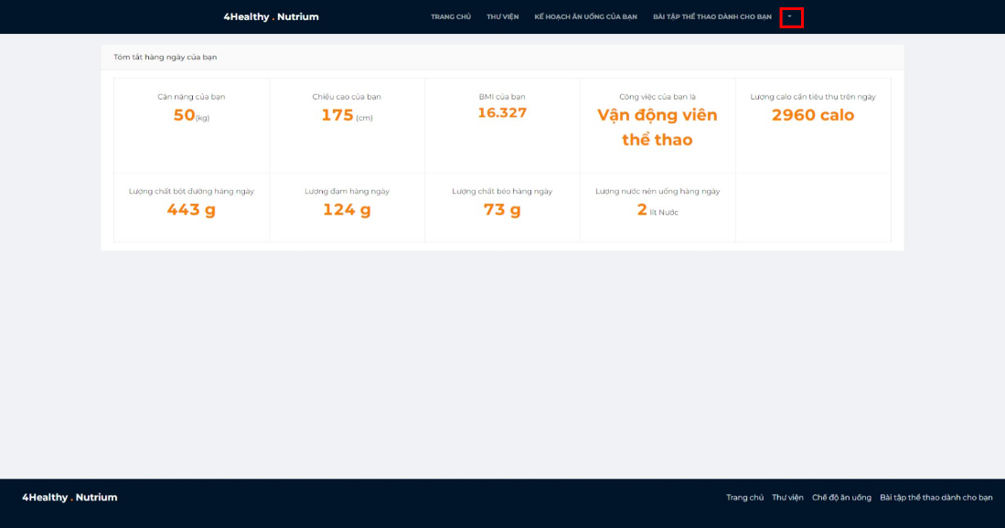

Step 2: A drop-down menu will appear on your screen. Click on the "Đăng xuất" button.

ステップ 2：ドロップダウン メニューが画面に表示されます。「Đăng xuất」ボタンをクリックします。

**3.2.3 Forgot Password パスワードを忘れる**

Step 1: In Login screen, select “Quên mật khẩu?” hyperlink

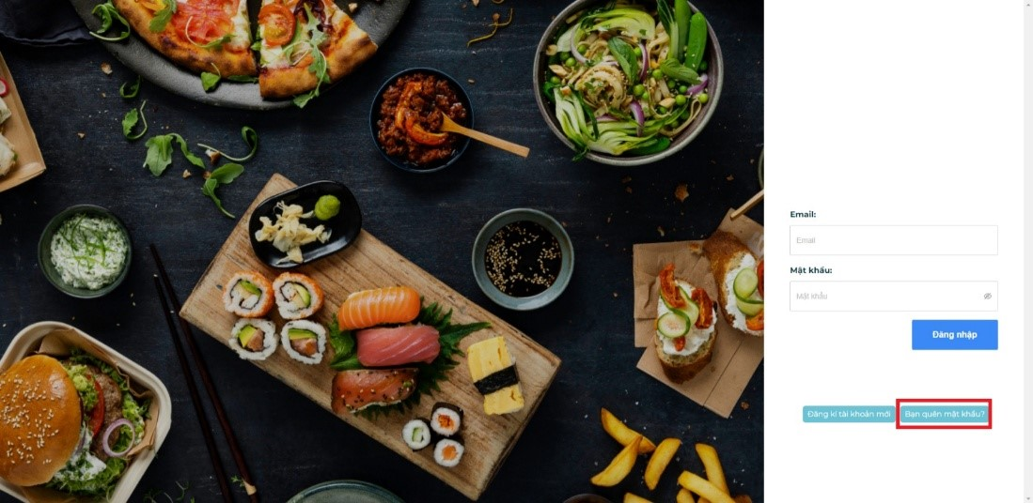

ステップ 1：ログイン画面で、「Quên mật khẩu ?」のハイパーリンクを選択します。



Step 2: Enter your email address then click on the button “Gửi mã xác nhận email” to receive the requested email for changing password.

ステップ 2：メールアドレスを入力し、「Gửi mã xác nhận email 」ボタンをクリックし、パスワード変更のリクエスト されたメールを受信します。

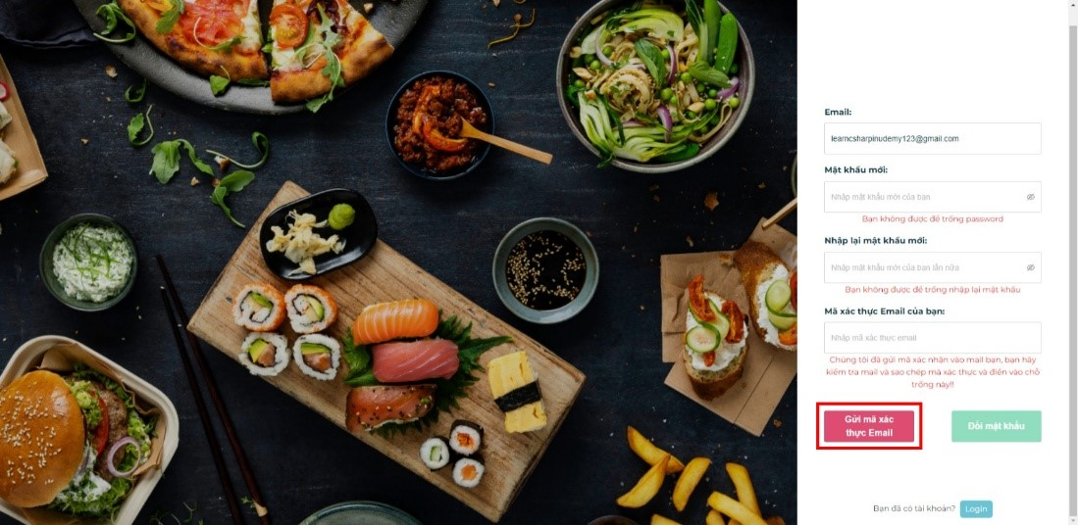

The emails entered must correspond to each other in the system. If entered incorrectly, a message will be displayed.

入力した電子メールは、システム内で互いに対応している必要があります。 間違って入力すると、メッセージが表示されます。

Step 3: If a successful message is displayed, check your email for the OTP code.

ステップ 3：成功メッセージが表示された場合は、電子メールで OTP コードを確認してください。



Step 4: Enter the OTP sent in the mail

ステップ 4：メールで送られてきたOTPを入力して



Step 5: If you enter the correct OTP to go to the password change page. Enter the new password and confirm the password to change the new password. Make sure that the password is 8-20 characters long and contains no spaces.

ステップ 5：正しい OTP を入力すると、パスワード変更ページに移動します。 新しいパスワードを入力し、パスワードを確認して、新しいパスワードを変更します。 パスワードが 8〜 20 文字の長さで、スペースが含まれていないことを確認してください。

**3.2.4 Edit Personal Profile 個人プロフィールの編集**

Step 1: Click on the dropdown in the navigation bar. A drop-down menu appears on the screen. Click on the “Hồ sơ và bảo mật” button.

ステップ 1：ナビゲーションバーのアバターをクリックします。ドロップダウンメニューが画面に表示されます。「Hồ sơ và bảo mật」ボタンをクリックします。

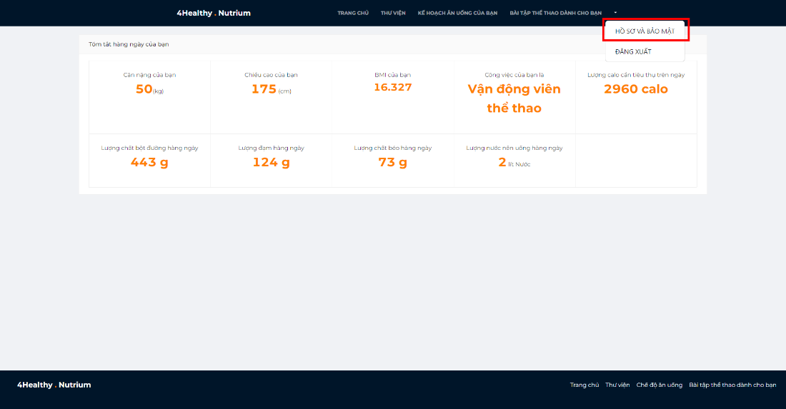

Step 3: The system displays the personal profile form with user information. Click on the “Chỉnh sửa” button. Fill in the information on the field that the user wants to change.

ステップ 3：システムはユーザー情報を含むポップアップフォームを表示します。「Chỉnh sửa」ボタンをクリ ックします。ユ ーザーが変更したいフィールドの情報を入力します。

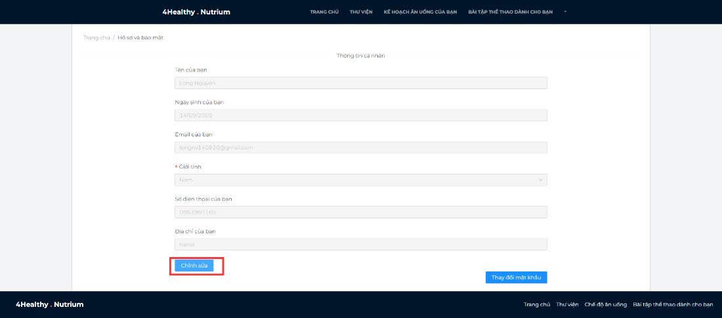

Step 4:

Step 4.1: If the user clicks on the “Lưu” button, the system will save new information.

ステップ 4:

ステップ 4.1：ユーザーが「Lưu」ボタンをクリックしたら、システムは新しい情報を保存します。

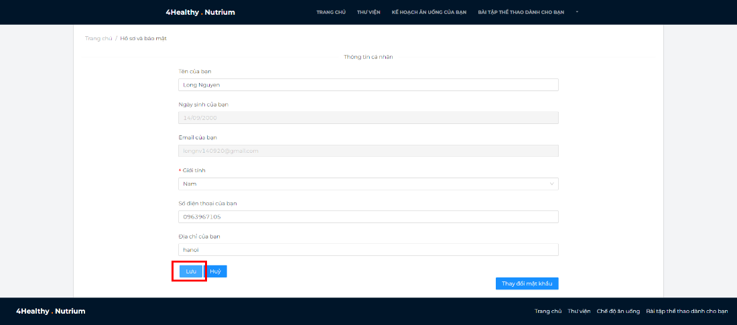

Step 4.2: If the user clicks on the “Hủy” button, the system will back to view the personal profile form and does not change anything.

ステップ 4.2：ユーザーが「Hủy 」ボタンをクリックすると、システムが戻って個人プロフィール フォ ームを表示し、何も変更しません。

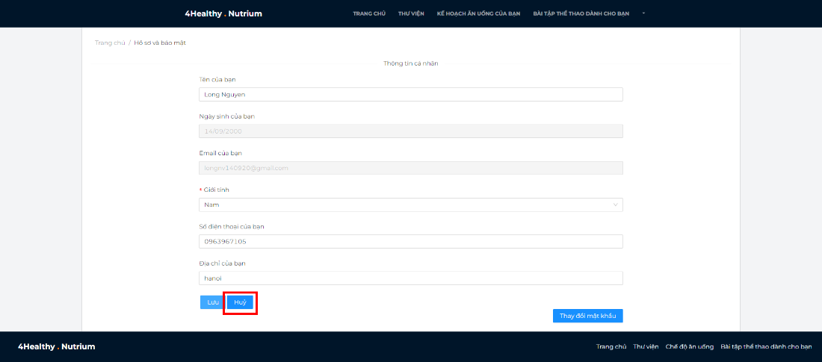

**3.2.5 Change Password パスワードを変更**

Step 1: From view the personal profile form, clicks on the “Chỉnh sửa mật khẩu” button.

ステップ 1: 個人プロフィール フォームの表示から、[Chỉnh sửa mật khẩu] ボタンをクリックします。

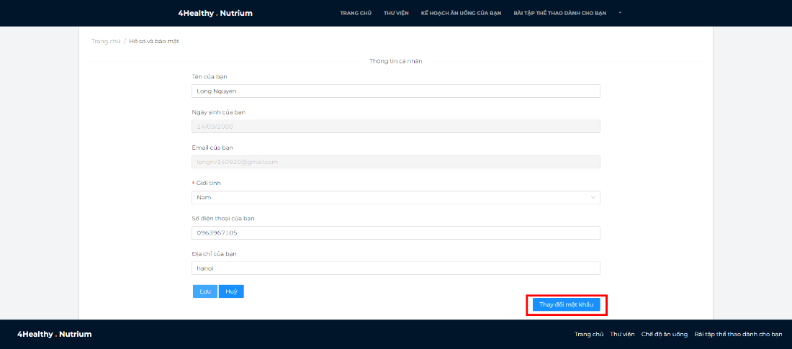

Step 2: The system displays a pop-up form. Fill in a new password.

✓ Enter an old password.

✓ Enter a new password that contains 8-20 characters and does not contain space.

✓ Re-enter a new password that matches the password entered above.

ステップ 2：システムはポップアップフォームを表示します。新しいパスワードを入力します。

✓ 現在のパスワードを入力します。

✓8〜20 文字を含み、スペースを含まず、現在のパスワードと一致しない新しい パスワードを入力し ます。

✓ 上記で入力したパスワードと一致する新しいパスワードをもう一度入力しま す。

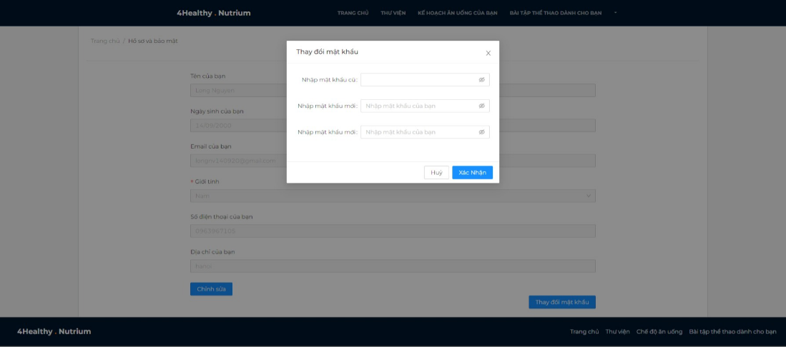

Step 3: The user clicks on the “Xác nhận” button, the system will save a new password.

ステップ 3：ユーザーが「 Xác nhận 」ボタンをクリックしたら、システムは新しいパスワードを保存 します。

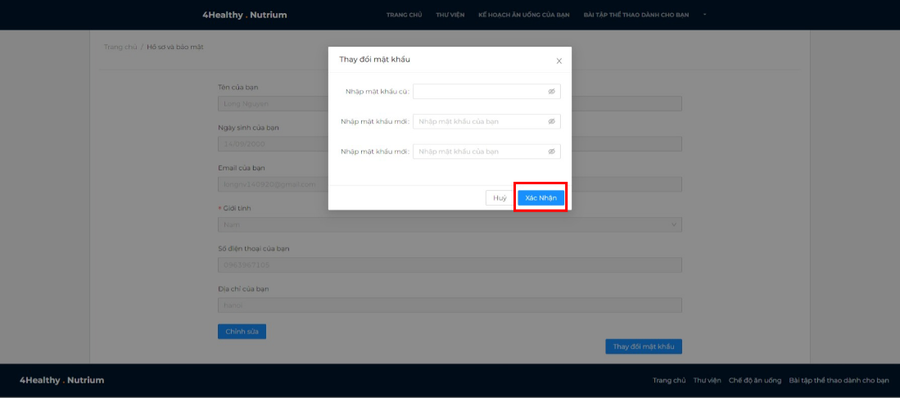

**3.2.6 Register 登録**

Step 1: In Login screen, select “Đăng ký tài khoản mới” button

ステップ 1：ログイン画面で、「 Đăng ký tài khoản mới 」のボタンを選択します。

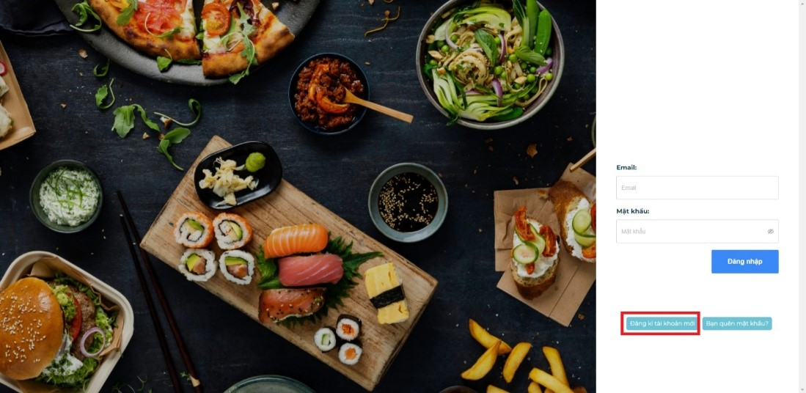

Step 2: Fill all the required field then click on the button “Gửi mã xác nhận email” to receive the requested email for register.

ステップ 2: すべての必須フィールドに入力し、[Gửi mã xác nhận email] ボタンをクリックして、登録用に要求された電子メールを受信します。

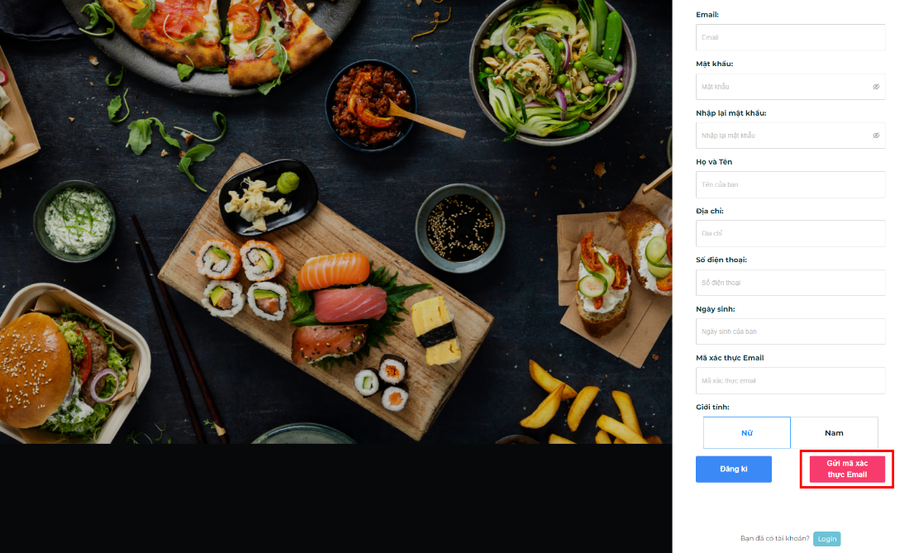

### 3.3 Food and Ingredient Management 食品と成分管理

**3.3.1. Manage Food 食品を管理する**

**3.3.1.1 View List Food リストの食品を表示します。**

Step 1: Access to the Home Page.

ステップ 1: ホームページ画面にアクセスします。

Step 2: Click to “Danh mục” in menu bar or search button in Home Page, the system will redirect to View List Food.

ステップ 2：メニューバーまたはホームページの検索ボタンで「Danh mục」をクリックすると、システムはリストカテゴリの表示にリダイレクトされます。

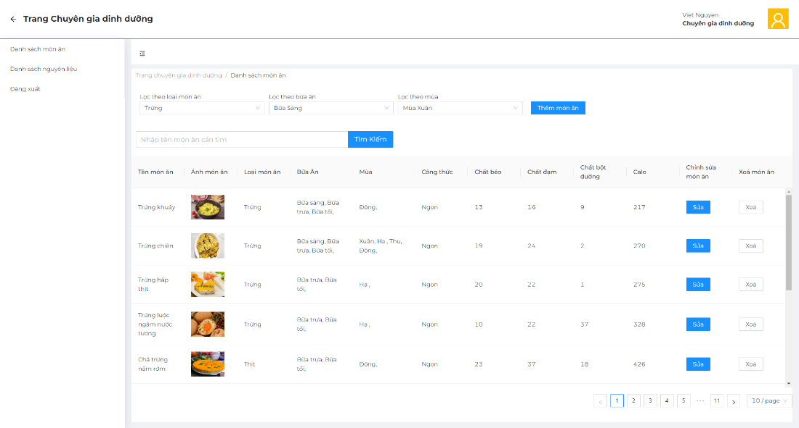

**3.3.1.2. Create new Food 新しい食品を作成します。**

Step 1: Access to the View List Foods screen.

ステップ 1: [リスト 食品の表示] 画面にアクセスします。

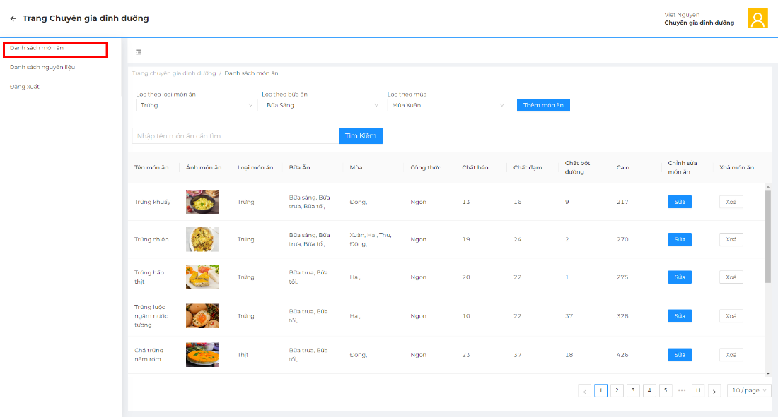

Step2: Click button "Thêm món ăn mới".

ステップ 2: 「Thêm món ăn mới」ボタンをクリックします。

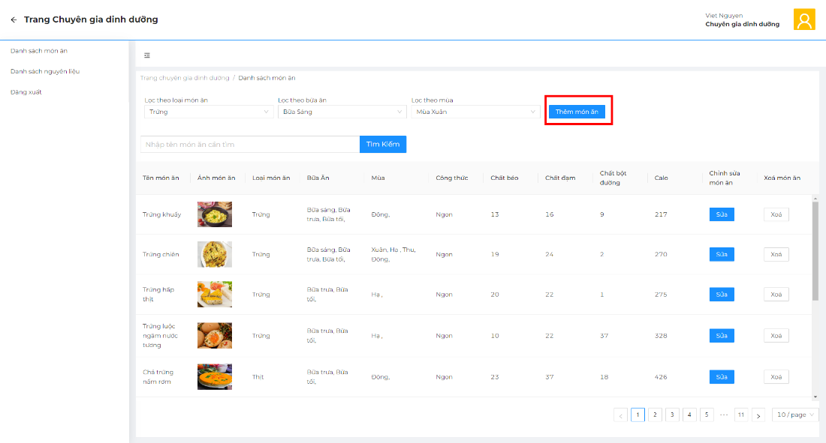

Step 3: System will show dialog. You can fill in information about the food. Then click "Thêm món ăn".

ステップ 3: システムはダイアログを表示します。 食品に関する情報を入力できます。次に、「Thêm món ăn」をクリックします。

* If you enter a new food name that matches an existing one, the system will display an error.

既存のカテゴリ名と一致する新しいカテゴリ名を入力すると、システムはエラーを表示します。

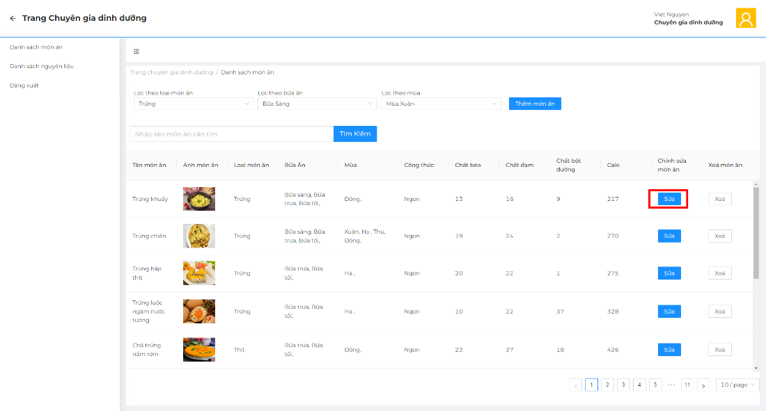

**3.3.1.3. Edit food’s information 情報カテゴリを編集します。**

Step 1: Access to the View List Food screen.

ステップ 1: [リスト カテゴリの表示] 画面にアクセスします。

Step 2: Select the icon circled in red in the image. Fill in the information on the field that the user wants to change.

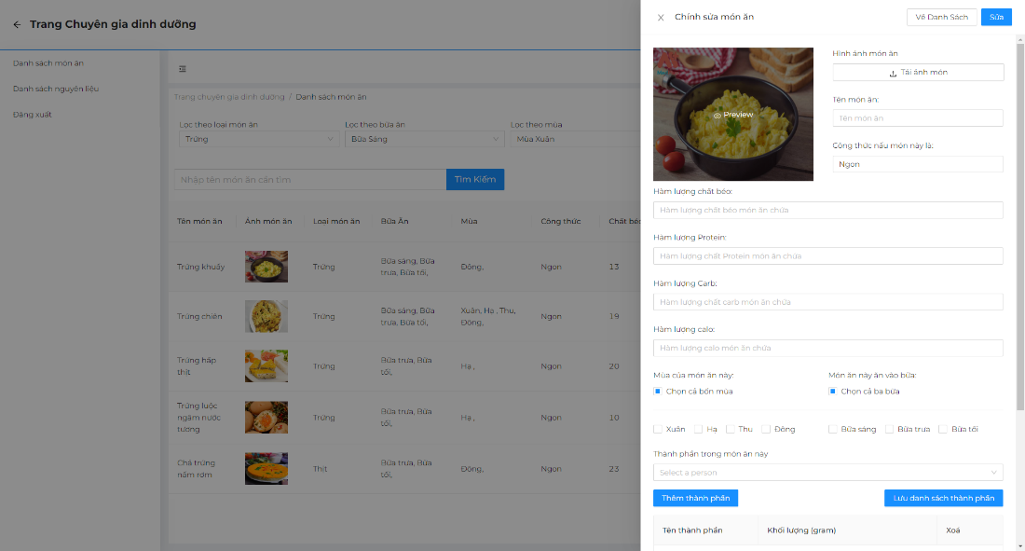

ステップ 2: 画像の赤丸で囲ったアイコンを選択します。 ユーザーが変更したいフィールドに情報を入力します。

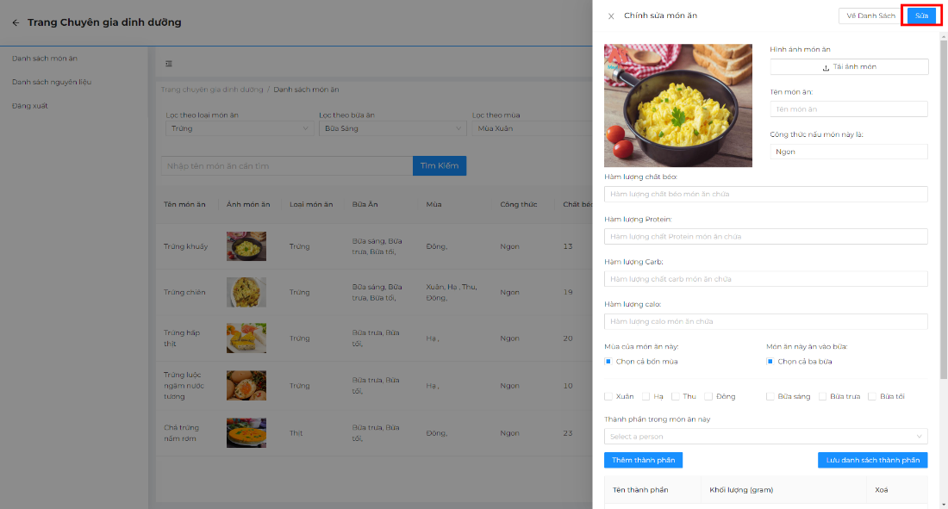

Step 3: The user clicks on the “Sửa” button, the system will save new information.

ステップ 3: ユーザーが「Sửa」ボタンをクリックすると、システムは新しい情報を保存します。

**3.3.2. Manage Ingredient 食品を管理する**

**3.3.2.1 View List Ingredient リストの食品を表示します。**

Step 1: Access to the Home Page.

ステップ 1: ホームページ画面にアクセスします。

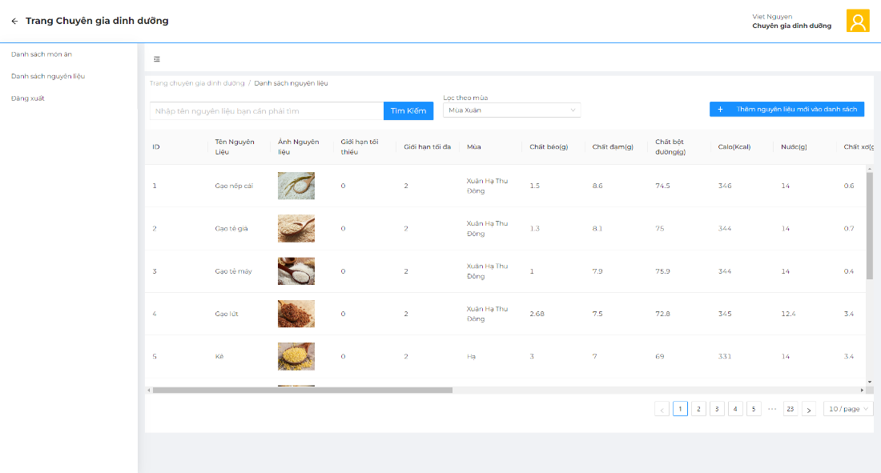

Step 2: Click to “Danh mục” in menu bar or search button in Home Page, the system will redirect to View List Food.

ステップ 2：メニューバーまたはホームページの検索ボタンで「Danh mục」をクリックすると、システムはリストカテゴリの表示にリダイレクトされます。

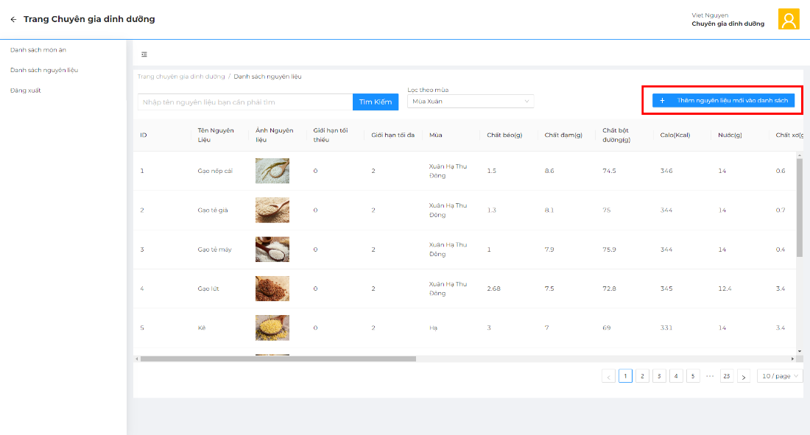

**3.3.2.2. Create new Ingredient 新しい食品を作成します。**

Step 1: Access to the View List Ingredient screen.

ステップ 1: [リスト 食品の表示] 画面にアクセスします。

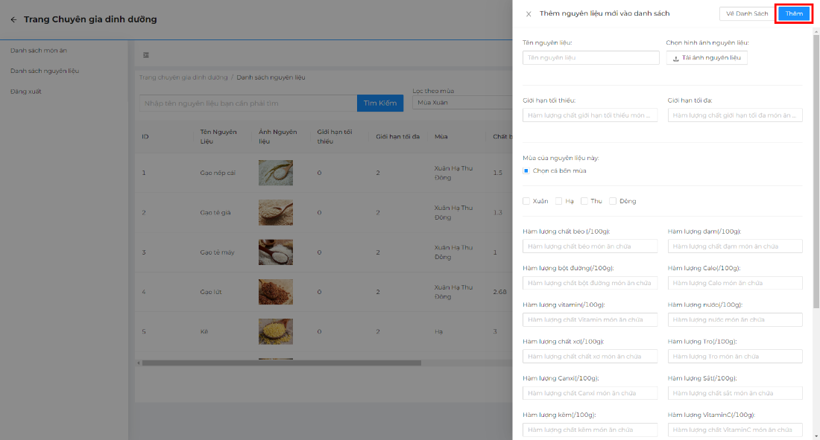

Step2: Click button " Thêm nguyên liệu mới vào danh sách ".

ステップ 2: 「 Thêm nguyên liệu mới vào danh sách 」ボタンをクリックします。

Step 3: System will show dialog. You can fill in information about the category. Then click " Thêm ".

ステップ 3: システムはダイアログを表示します。 食品に関する情報を入力できます。次に、「Thêm」をクリックします。

* If you enter a new food name that matches an existing one, the system will display an error.

既存のカテゴリ名と一致する新しいカテゴリ名を入力すると、システムはエラーを表示します。

**3.3.2.3. Edit Ingredient’s information 情報カテゴリを編集します。**

Step 1: Access to the View List Ingredient screen.

ステップ 1: [リスト カテゴリの表示] 画面にアクセスします。

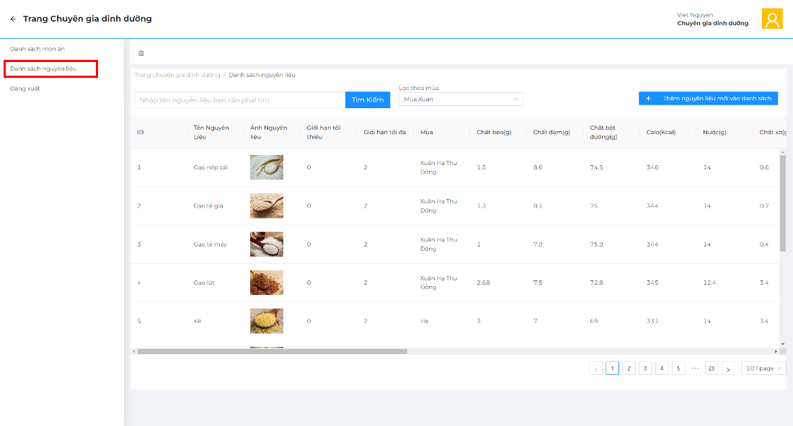

Step 2: Select the icon circled in red in the image. Fill in the information on the field that the user wants to change.

ステップ 2: 画像の赤丸で囲ったアイコンを選択します。 ユーザーが変更したいフィールドに情報を入力します。

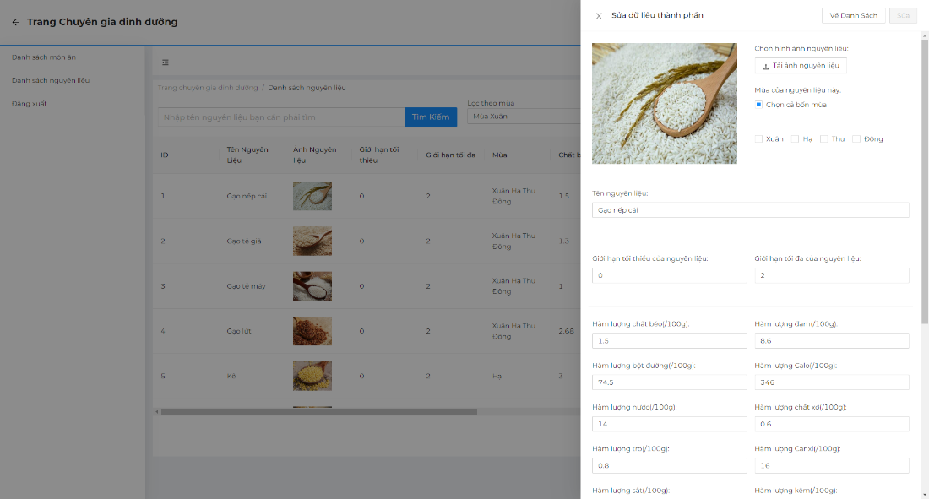

Step 3: The user clicks on the “Sửa” button, the system will save new information.

ステップ 3: ユーザーが「Sửa」ボタンをクリックすると、システムは新しい情報を保存します。

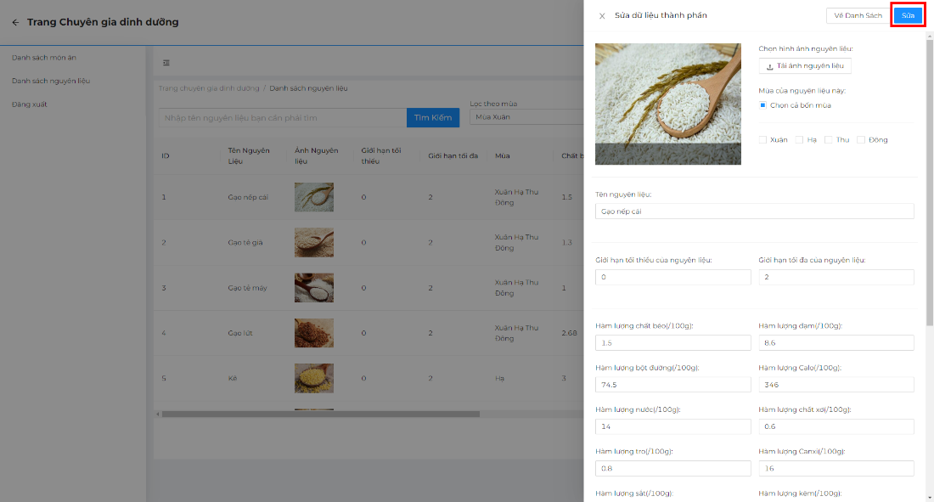

### 3.4 Account Management 倉庫管理

**3.4.1. View a list of accounts 従業員のリストを表示します。**

Step 1: Access the Home page with admin access.

ステップ 1: 管理者アクセスでホームページにアクセスします。

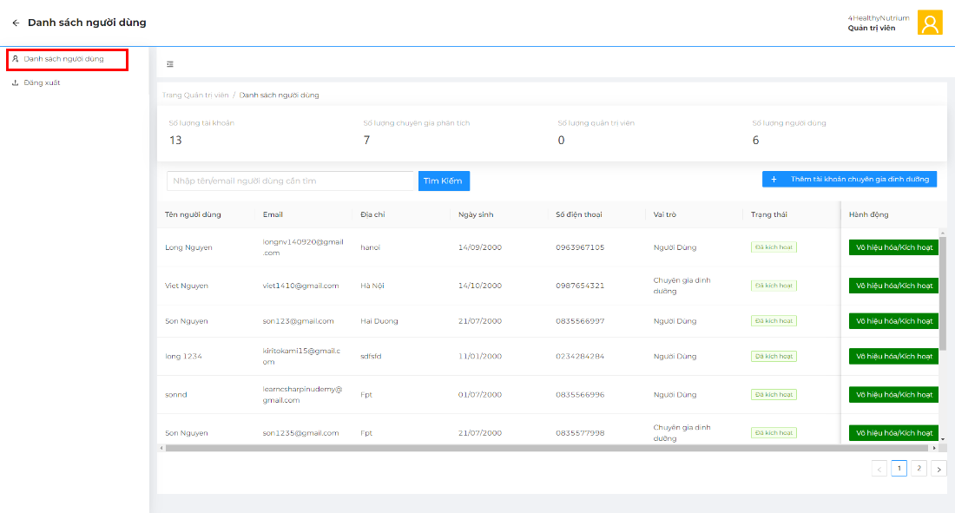

Step 2: Click to “Danh sách người dùng” in the menu bar or search button in Home Page or after creating a new employee successfully, the system will redirect to the view list of employees.

ステップ 2: メニューバーまたはホームページの検索ボタンで「Danh sách người dùng」をクリックするか、新しい従業員を正常に作成した後、システムは従業員のビューリストにリダイレクトされます。

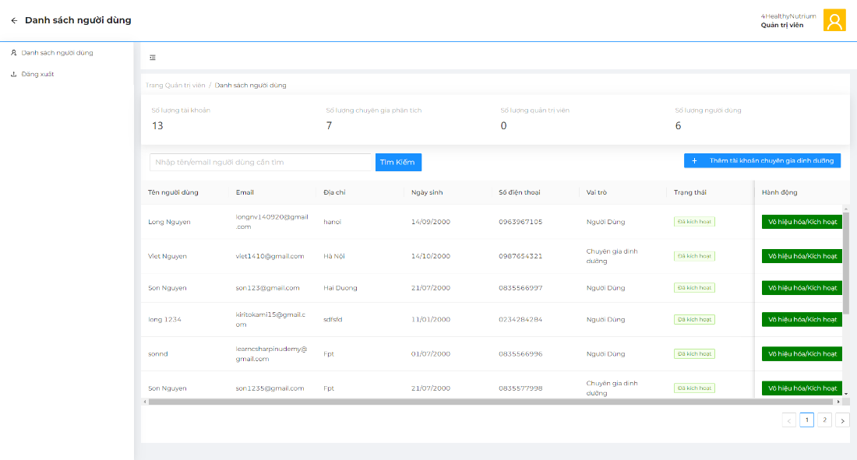

**3.4.2. Search for an account in the list リストで従業員を検索します。**

Step 1: Access the employee list view under admin login.

ステップ 1: 管理者ログインで従業員リスト ビューにアクセスします。

Step 2: You can search name by inputting the number text field "Tìm kiếm người dùng".Then click button "Tìm kiếm".

ステップ 2: 数字のテキスト フィールド「Tìm kiếm người dùng」を入力して、名前を検索できます。次に、「Tìm kiếm」ボタンをクリックします。

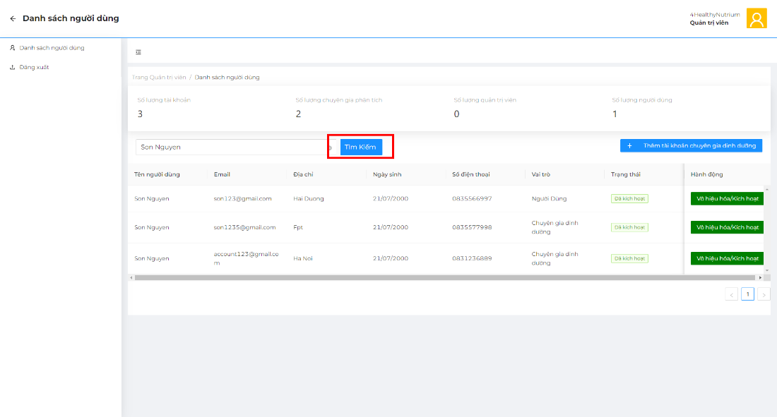

**3.4.3. Edit account status. 情報社員を編集します。**

Step 1: Access the employee list view under admin login.

ステップ 1: 管理者ログインで従業員リスト ビューにアクセスします。

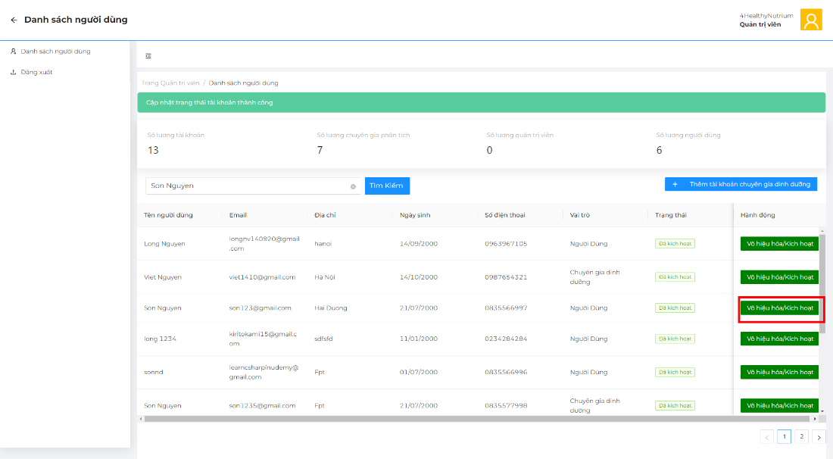

Step 2: You can edit status about the account. Then click "".

ステップ 3: 従業員に関する情報を編集できます。 次に「」をクリック。

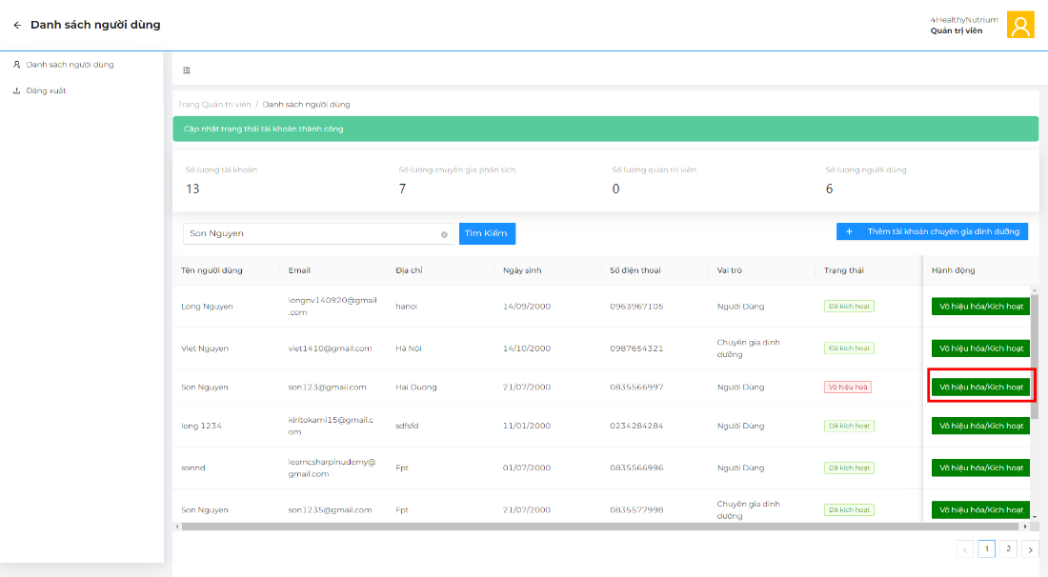

### 3.5 Nutrition Regime Management 栄養管理管理

**3.5.1. View nutrition need. 栄養の必要性を表示します。**

Home User Page:

ユーザーページ:

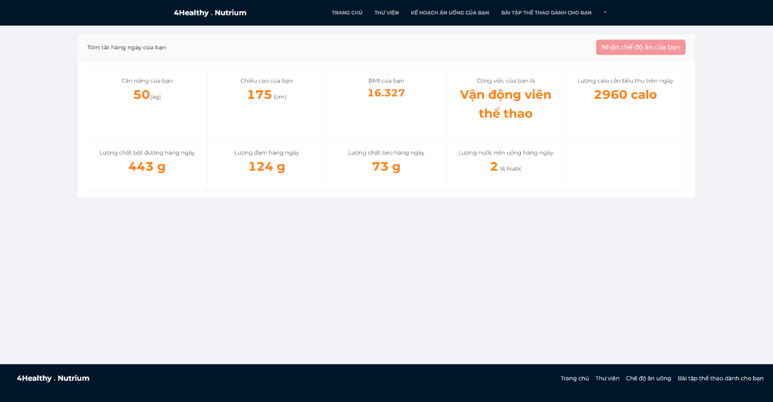

**3.5.2. Receive nutrition regime. 栄養療法を受ける。**

**Case 1:** If user login first time will go the homepage

**ケース 1:** ユーザーの初回ログイン時にホームページに移動する場合

Step 1: Click [ Làm bài kiểm tra của chúng tôi ] to answer the question.

ステップ 1: [ Làm bài kiểm tra của chúng toi ] をクリックして質問に答えます。

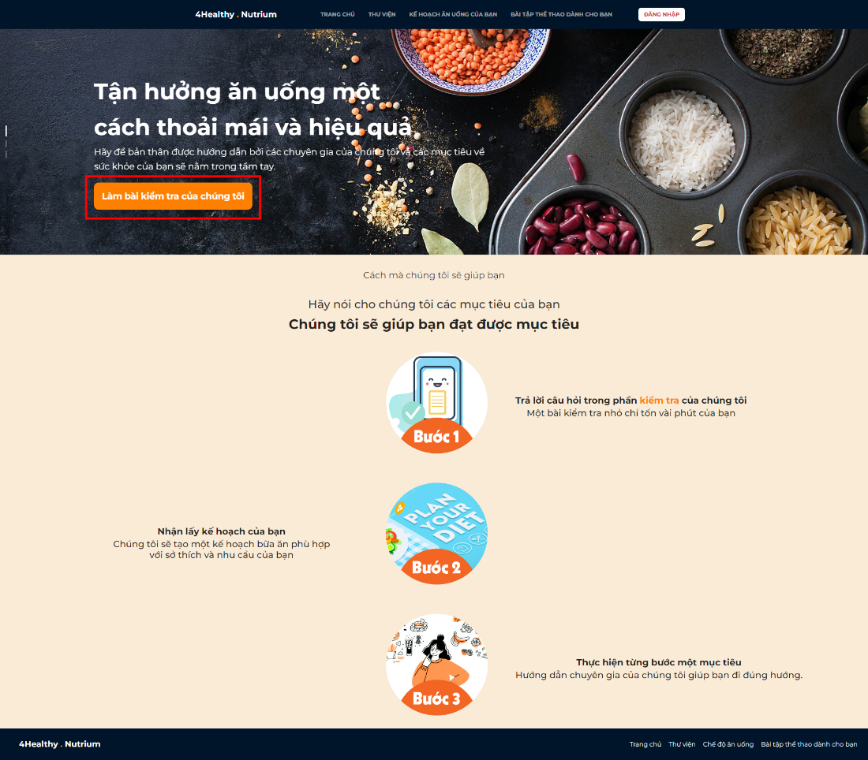

Step 2: Click [ Tiếp tục ] to continue with another question

ステップ 2: [ Tiếp tục ] をクリックして、別の問題に進みます。

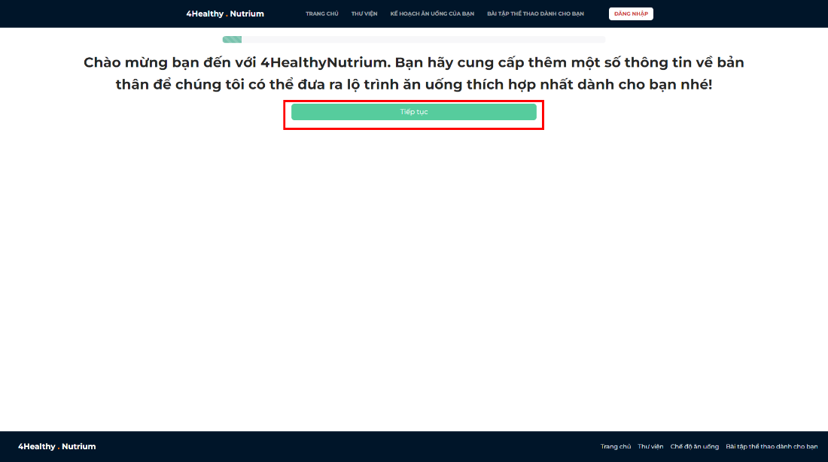

Step 3: Enter your height and weight. Then, click [ Tiếp tục ] to continue with another question

ステップ 3: 身長と体重を入力します。 次に、[ Tiếp tục ] をクリックして、別の質問に進みます。

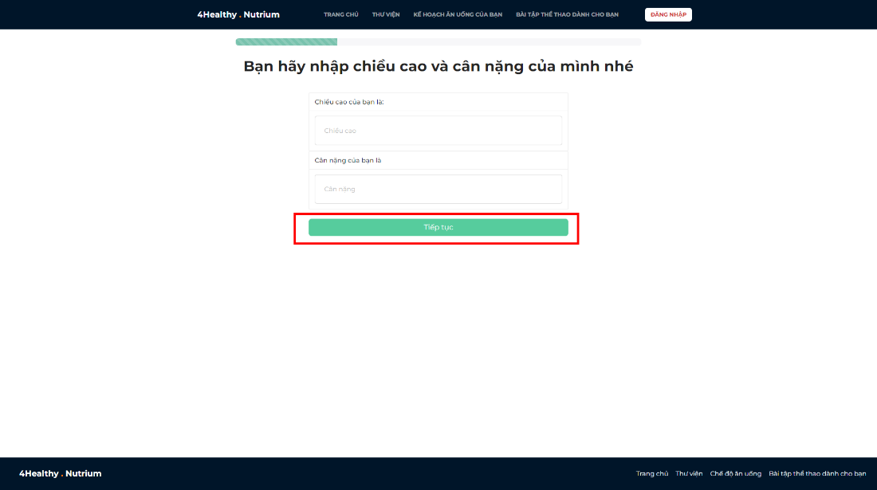

Step 4: Choose your job here. Then, click [ Tiếp tục ] to continue with another question

ステップ 4: ここでジョブを選択します。 次に、[ Tiếp tục ] をクリックして、別の質問に進みます。

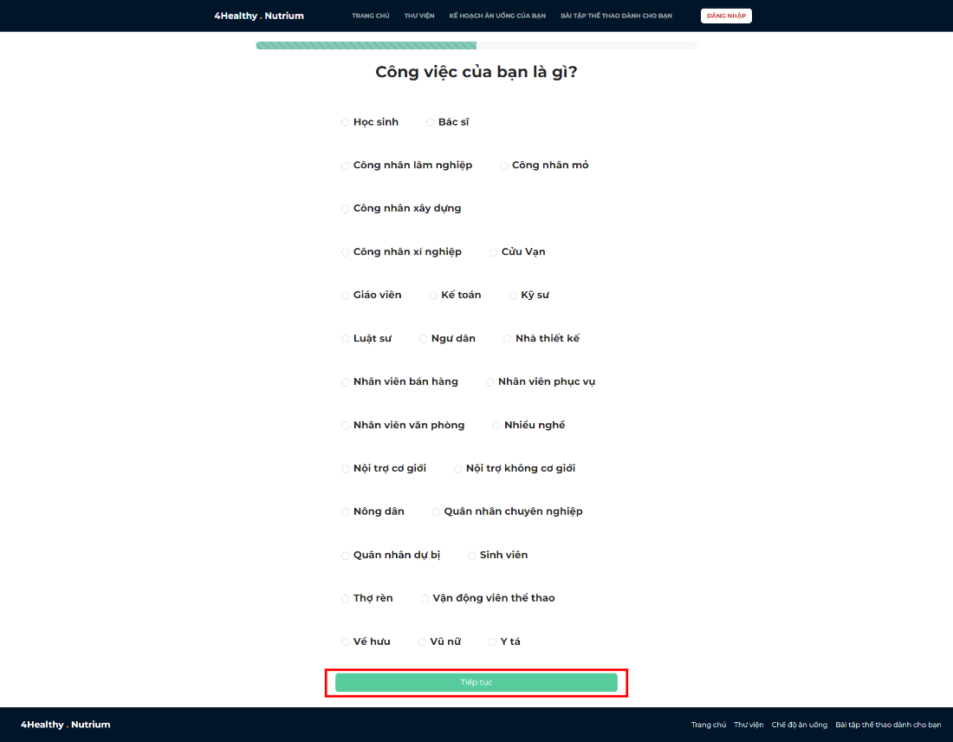

Step 5: Enter the number of dishes you want to eat for breakfast, lunch and dinner. Then, click [ Tiếp tục ] to continue with another question

ステップ 5: 朝食、昼食、夕食で食べたい料理の数を入力します。 次に、[ Tiếp tục ] をクリックして、別の質問に進みます。

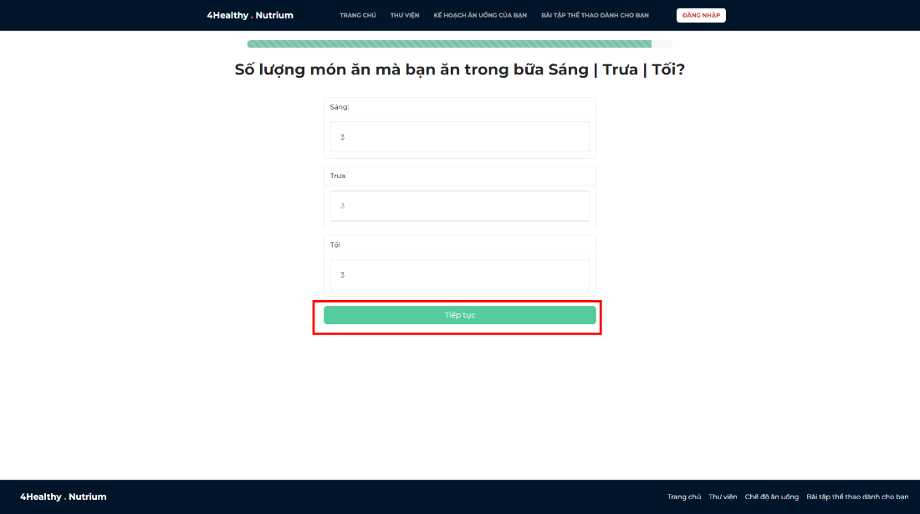

Step 6: When you click [ Lưu thực đơn ]the menu, the website will notify you with the message "Lưu thực đơn thành côngl".

ステップ 6: メニューの [Save menu] をクリックすると、Web サイトから「Save menu successfully」というメッセージが表示されます。

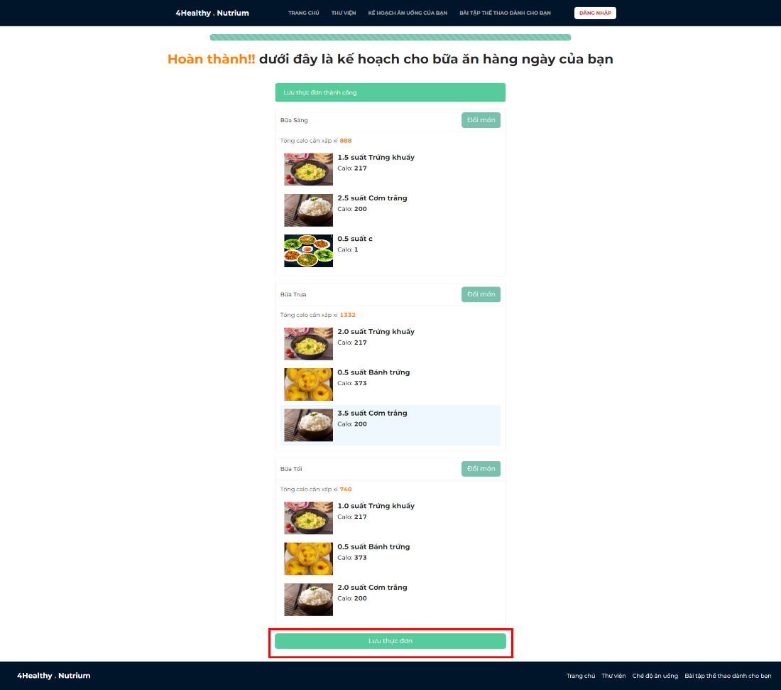

**Case 2:** If the user has logged in for the second time, it will be taken to the home user page.

**ケース 2:** ユーザーが 2 回目にログインした場合、ホーム ユーザー ページに移動します。。

Home User Page:

ユーザーページ:



Step 1: Click [ Nhận chế độ ăn của bạn ] to refresh your information and eating plan

ステップ1： [ Nhận chế độ ăn của bạn ] をクリックして、情報と食事プランを更新します

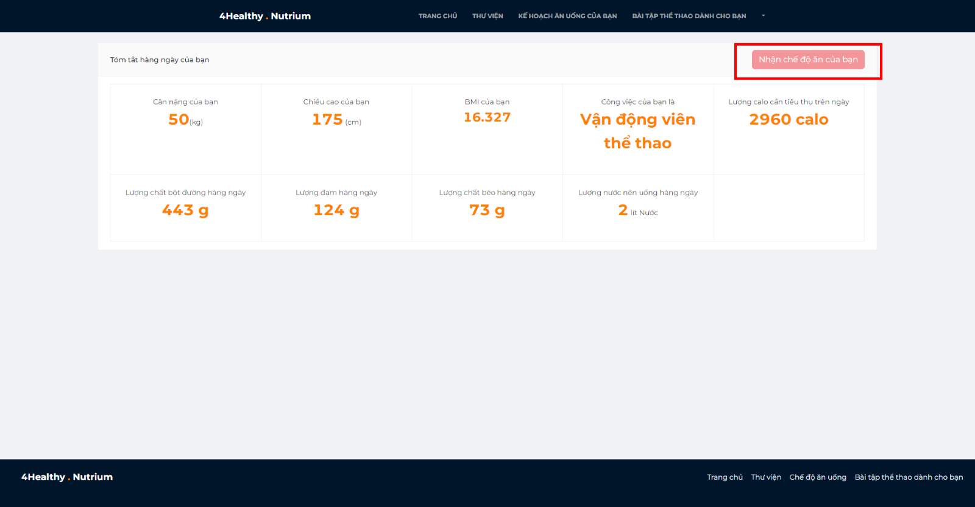

Step 2: Click [ Thay đổi thông tin ] to change career information and body mass index, age

ステップ2：[ Thay đổi thông tin ]をクリックして、キャリア情報と肥満度指数、年齢を変更します

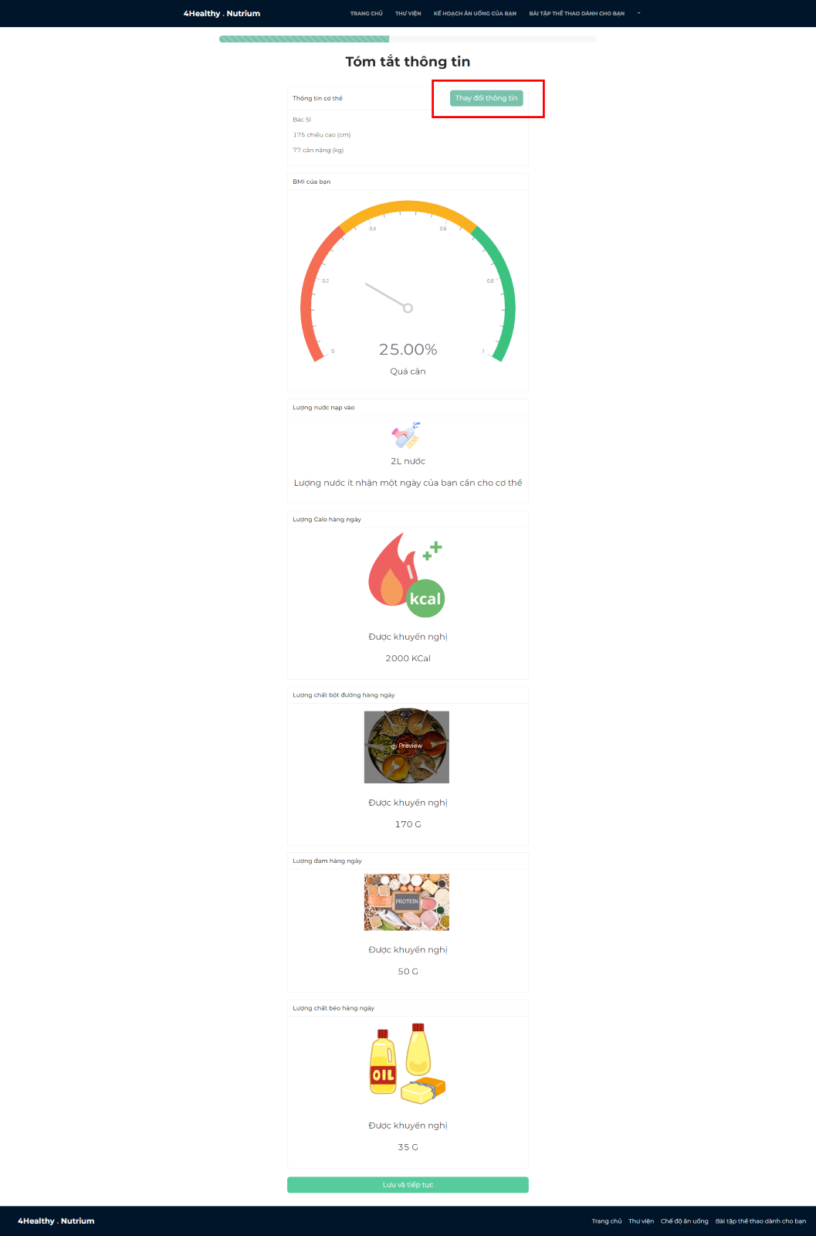

Step 3: Click [ Lưu thay đổi ] to save your new body mass index, occupation, age information

ステップ 3: [ Lưu thay đổi ] をクリックして、新しい体格指数、職業、年齢の情報を保存します。



Step 4: Click [ lưu và tiếp tục ]

ステップ 4: [保存して続行] をクリックします。



Step 5 : Enter the number of dishes you want to eat for breakfast, lunch and dinner. Then, click [ Tiếp tục ] to get your schedule

ステップ 5 : 朝食、昼食、夕食で食べたい料理の数を入力します。 次に、[ Tiếp tục ] をクリックしてスケジュールを取得します。

Step 6: When you click [ Lưu thực đơn ] the menu, the website will notify you with the message "Lưu thực đơn thành công".

ステップ 6: メニューの [ Lưu thực đơn ] をクリックすると、Web サイトから「 Lưu thực đơn thành công 」というメッセージが表示されます。



**3.5.3 Change nutrition regime. 栄養体制を変更します。**

After completing the question we will create the right dish for you, if the dish on our menu list does not match your taste, you can change it by clicking the button [ Đổi món ]. Then, click [ Lưu thực đơn ] to continue with another question.

質問に回答した後、あなたにぴったりの料理を作成します。メニュー リストの料理があなたの好みに合わない場合は、[ Đổi món ] ボタンをクリックして変更できます。 [ Lưu thực đơn ] をクリックして、別の質問に進みます。

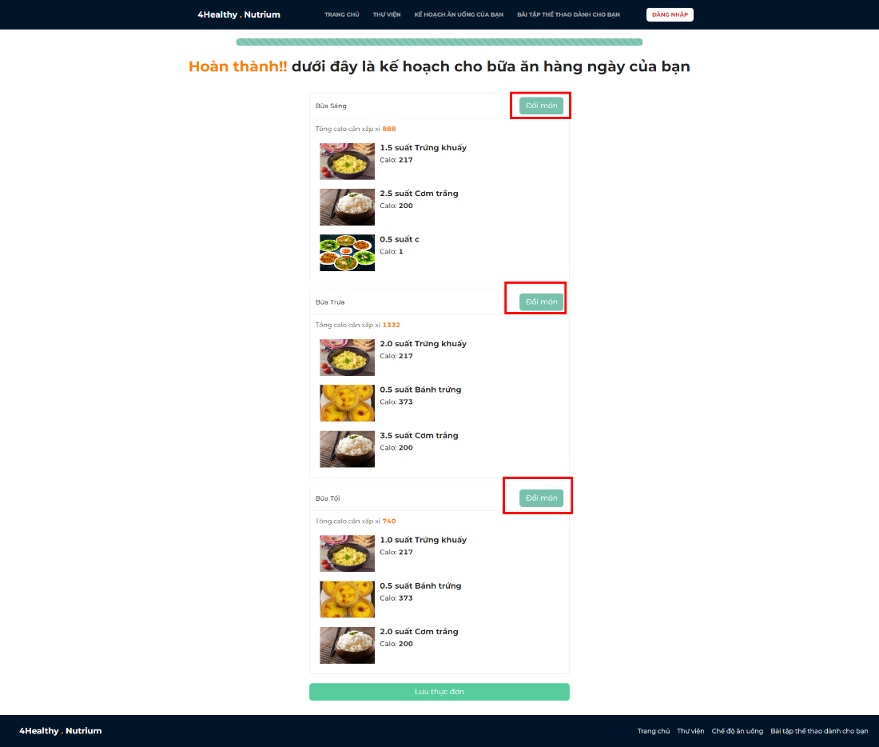

**3.5.3. View nutrition regime schedule. 栄養計画スケジュールを表示します。**  
**Step 1: After answering the question we will save your plan in the [ Kế hoạch ăn uống của bạn ] section of the header page, please click on this title**

質問に答えた後、ヘッダー ページの [ Kế hoạch ăn uống của bạn ] セクションにプランを保存します。このタイトルをクリックしてください。

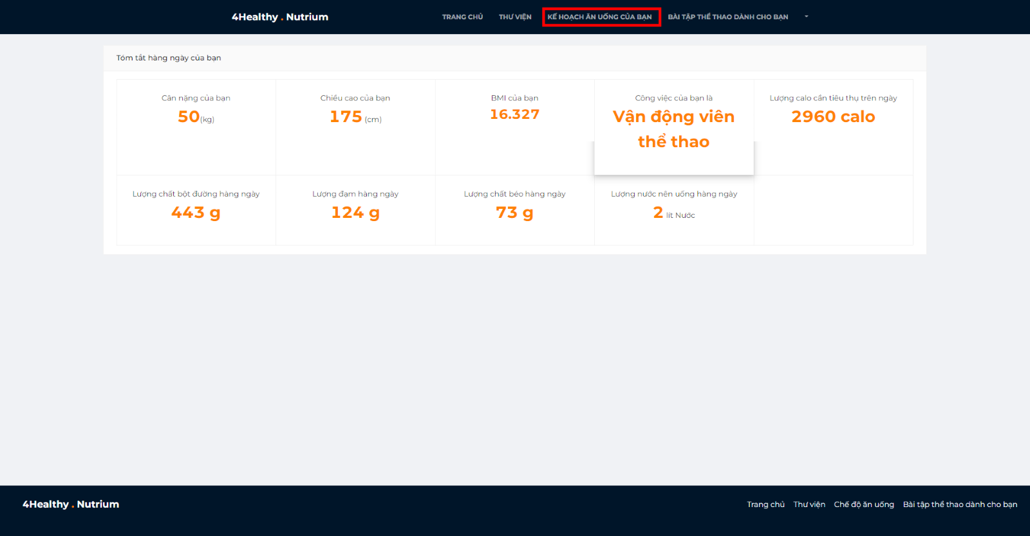

Step 2: Access to the view your schedule

ステップ 2: スケジュールの表示へのアクセス

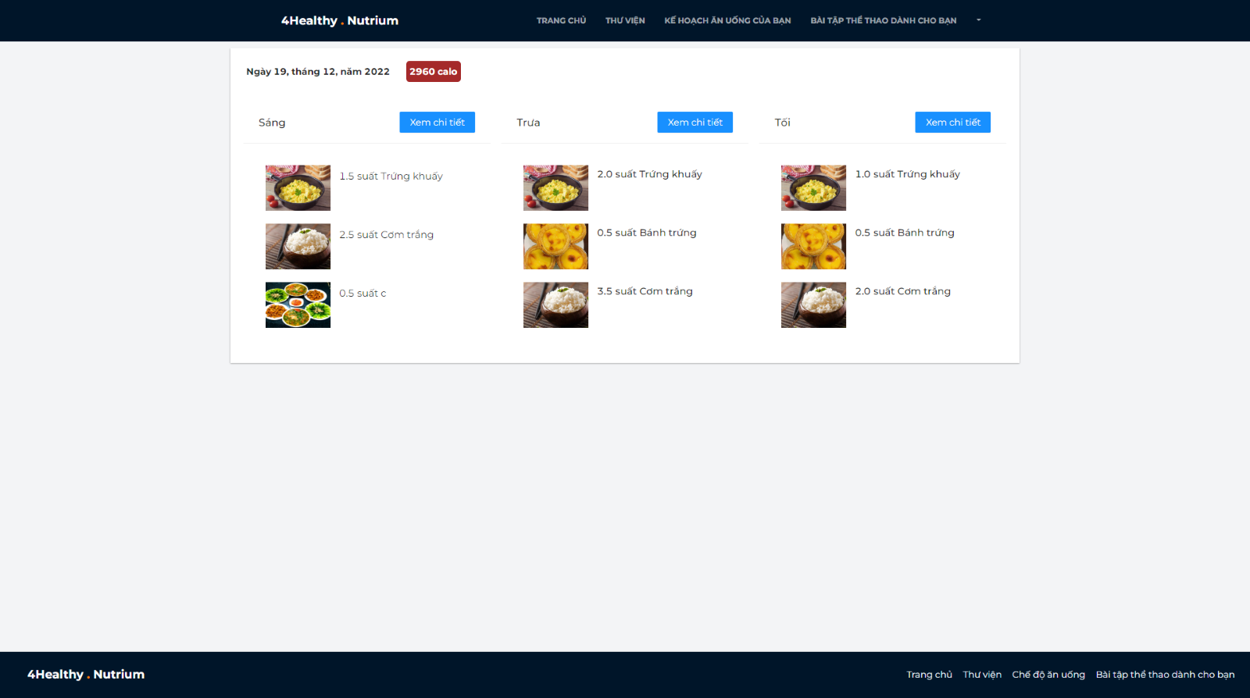

**3.5.3.1 View nutrition regime detail. 栄養管理の詳細を表示します。**

Step 1: Here we will save the menu of the dishes you have just saved and you can view the nutritional information of the substances in your dish by clicking the button [ Xem chi tiết ].

ここで、保存した料理のメニューを保存します。 [ Xem chi tiết ] ボタンをクリックすると、料理に含まれる物質の栄養情報を表示できます。



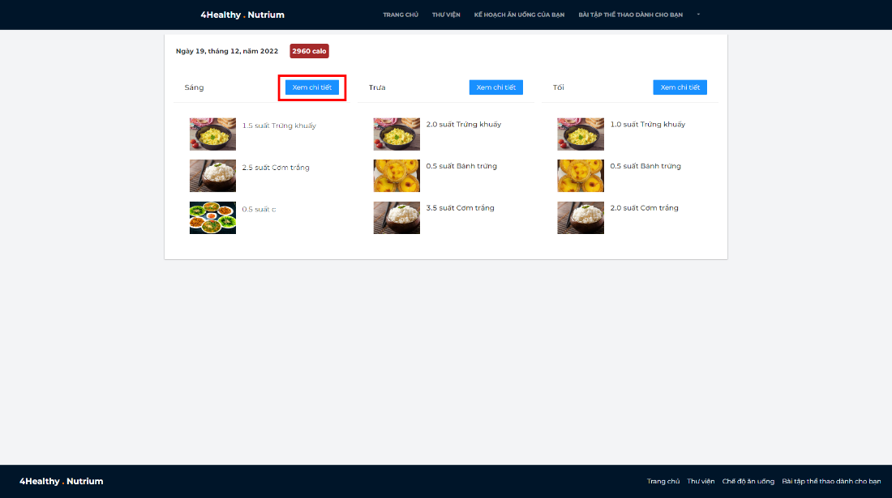

Step 2: Access to the modal view your nutritional information of the substances in your dish

ステップ 2: モーダル物質へのアクセス 料理の栄養情報を表示

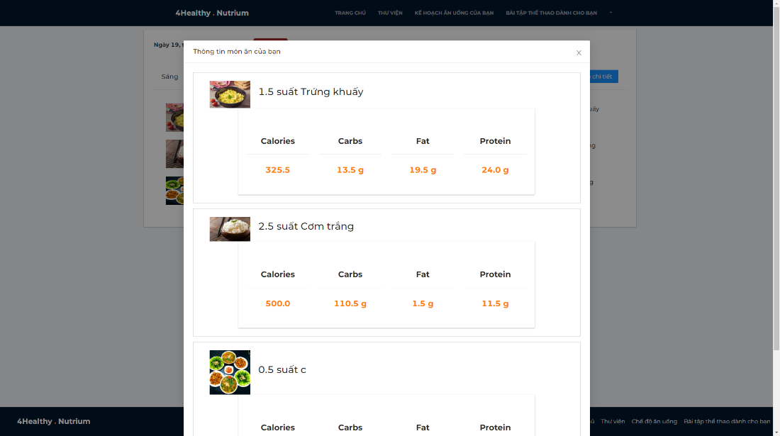

### 3.6 View Food and Ingredient Information (User) 食品食材情報を見る

**3.6.1. View list food. 食品情報を見る**

Step 1: Click on the “Thư viện” in the navigation bar.

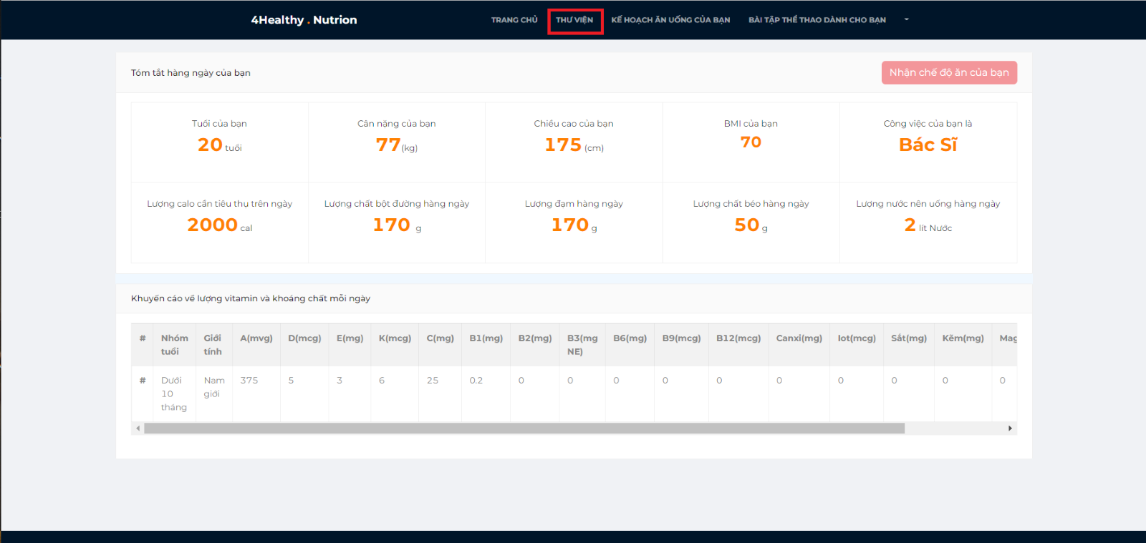

ステップ 1：ナビゲーション バーの [Thư viện] をクリックします。

Step 2: click on "món ăn".

ステップ2：「món ăn」をクリック.

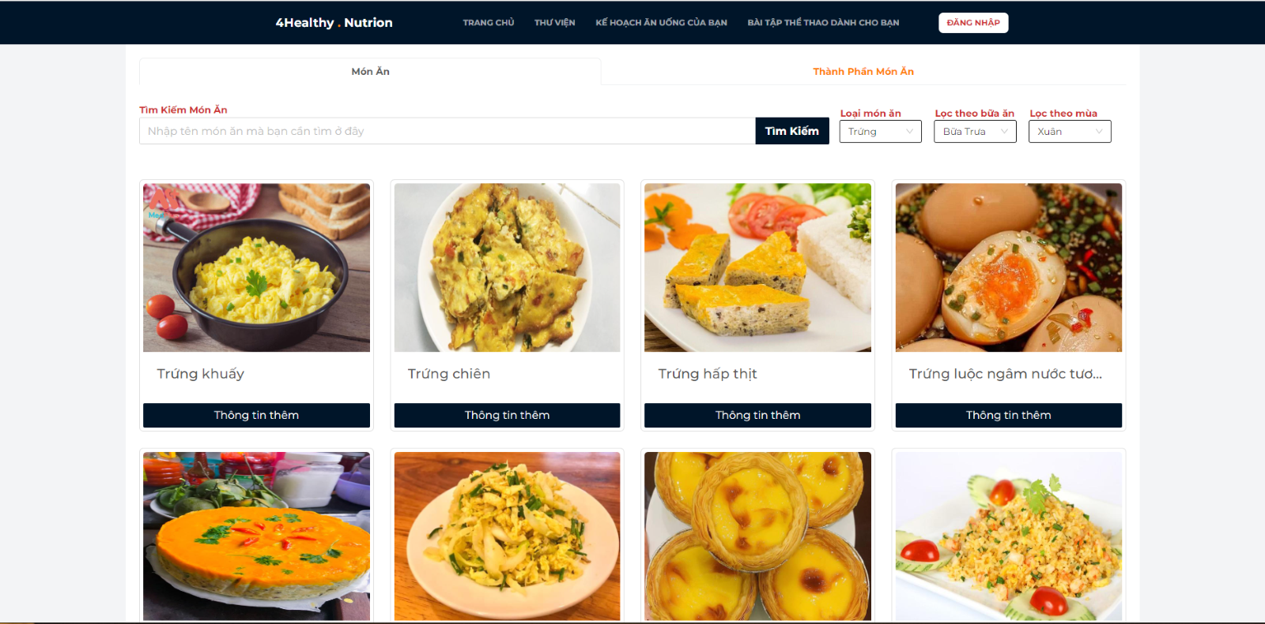

**3.6.2. View food detail. 食品情報を見る**

From List Food Screen, click on food image to see food detail.

料理一覧画面から、料理画像をクリックすると料理の詳細が表示されます。

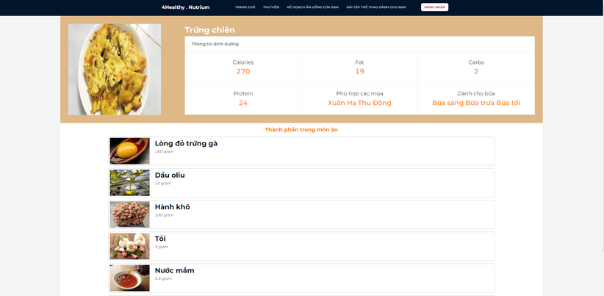

**3.6.3. View list ingredient. 成分表を見る.**

Step 1: Click on the “Thư viện” in the navigation bar.



ステップ 1：ナビゲーション バーの [Thư viện] をクリックします。

Step 2: click on "Nguyên liệu".

ステップ2：「Nguyên liệu」をクリック.

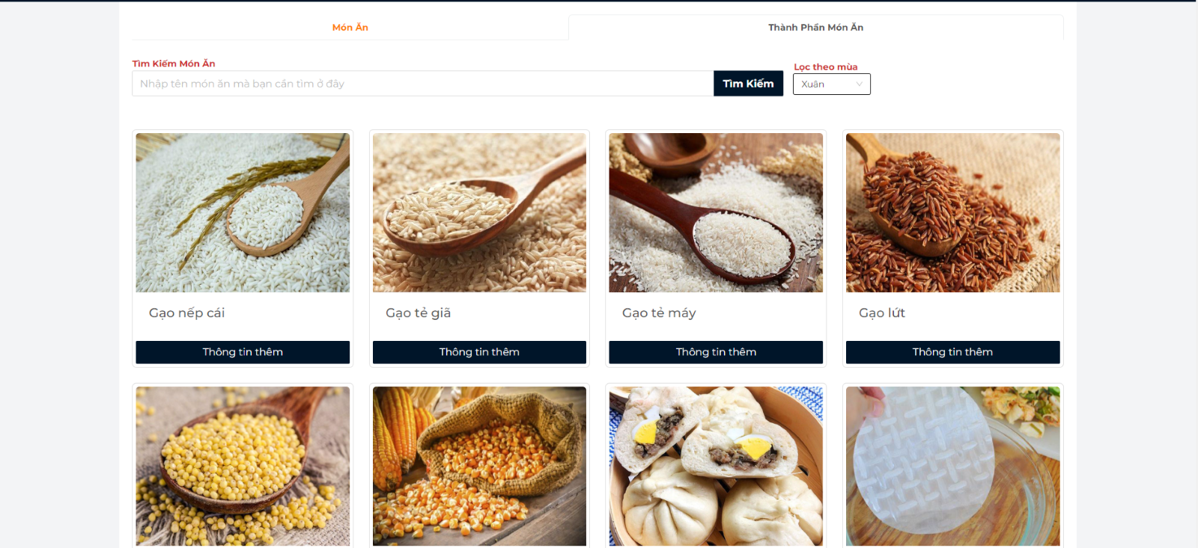

**3.6.4. View ingredient detail. 成分詳細を見る**

From List Ingredient Screen, click on ingredient image to see food detail.

食材一覧画面から、食材画像をクリックすると料理の詳細が表示されます。

